Photovoltaic System Adoption in Water Related Technologies – A Review
M. Vivarª, H. Sharon^{b}∗, M. Fuentesª
ªIDEA Group, EPS Linares, University of Jaén, 23700 Linares, Spain
^{b}Department of Mechanical Engineering, Indian Institute of Petroleum and Energy (IIPE) Visakhapatnam, Andhra Pradesh – 530 003, India
*Corresponding Author: e-mail ID: sharon.mec@iipe.ac.in (H. Sharon)

Abstract
Water and energy are intimately related, as water is required for energy applications and energy is required for water-based technologies. Two large groups of photovoltaic adoptions have been identified in this review: first, those in which the photovoltaic system is separated from the water technology. In second group, the photovoltaic system is in physical contact with the water technology thereby its performance is affected either in a positive or negative way. The novelty of this review work lies in the classification of photovoltaic system adoption in various water related technologies. Apart from classification, discussions on system configurations, working aspects, performance aspects, economic aspects and scope for further investigations have been presented in detail. Wastewater treatment plants are identified to be the most suitable site for photovoltaic module installation and utilization. Among power sectors, hydro power plants are highly compatible with photovoltaic adoption because it enhances hydro power plant’s operation time and utilization. Floating photovoltaic, submerged photovoltaic, agrivoltaic, aquavoltaic and solar photovoltaic + water disinfection are relatively new, highly attractive and have more scope for further improvements. Agrivoltaic and aquavoltaic increases crop & sea food production, enhances farmers’ income, encourage clean energy transition and rural electrification. Research works in the area of unmanned photovoltaic based water vehicles, photovoltaic salt harvest and various applications of water based photovoltaic/thermal modules have also been discussed. This review will serve as a guidebook for researchers and policy makers to identify and select suitable configuration of photovoltaic–water related technologies for implementation and further investigations.
Keywords: water-energy nexus, PV-integration, submerged PV; floating PV, agrivoltaics, aquavoltaic

Word Count: 17838 Words

Highlights
- Classification and critical discussions on PV adopted water technologies
- Some adoptions do not make sense, PV losses does not justify the design
- PV adoption in mining, water treatment, irrigation and desalination sectors
- PV adoption in agriculture, aquaculture, heating and unmanned water vehicles
- Economics and scope for further research directions
Nomenclature
 | Total area of PV cells in each module (m²)
A_{m} | Projected area of ion-exchange membrane (m²)
A_{mem} | RO membrane area (m²)
 | Back surface area of PV module (m²)
 | Front surface area of PV module (m²)
 | Area of the PV/T module (m²)
 | Area available in the reservoir (m²)
C_{el} | cost of electricity (USD/kWh)
C_{f} | Price of the conventional fuel (USD/kWh)
C_{OM} | Operation and maintenance cost (USD/Year)
 | Annual cost savings (USD/Year)
 | Specific heat capacity of circulating water (J/kg K)
CC_{t} | capital cost (USD) over the period “t”
CP | Number of cell pairs in the ED stack
C_{TCF} | Membrane permeability temperature correction factor
d | Discount rate (%)
dr | Degradation rate (%)
 | Daily energy consumption of aerator (Wh/d)
 | Energy cost in the country/location (USD/kWh)
 | Energy generated in a year (KWh/Year)
E_{el,c} | Electricity demand covered by the PV/T module (kWh/ Year)
E_{ex} | Electricity exported to the grid (kWh/Year)
 | Daily energy required to pump water (kWh/d)
 | Energy requirement of the RO system (kWh/d)
EY_{t} | Energy yield (kWh) over the period “t”
 | Faraday’s constant (96500 C/mol)
 | Acceleration due to gravity (9.81 m/s²)
h | Height of the upper reservoir from the river (m)
H_{daylight} | Daylight hours in a day (h/d)
 | Current density (A/m² of ED membrane area)
 | Inflation rate considered for annual fuel savings (%)
 | Benchmark rate of return (%)
 | Current (A)
 | Solar radiation intensity over the PV module (W/m²)
 | Solar radiation intensity over the PV/T module (W/m²)
 | Monochromatic light intensity at water surface (x = 0 m) (W/m²nm)
 | Monochromatic light intensity at a water depth of “x” m (W/m²nm)
 | Permeability of the membrane to water (1.3 x 10⁻⁶ m/bar-h
 | Thermal conductivity of water (W/mK)
 | Absorption length (m)
 | Length of the PV module (m)
MC_{t} | Maintenance cost (USD) over the period “t”
 | Mass flow rate of circulating water (kg/m²s)
 | Number of PV modules
N | Number of cell pairs in the ED stack
 | Number of aerators
OC_{t} | Operation cost (USD) over the period “t”
OF_{t} | Other fee cost (USD) over the period “t”
 | Power rating of an aerator (W)
 | PV capacity over the reservoir (W)
 | RO membrane feed pressure in bar
 | Electric power generation capacity of stored potential energy in upper reservoir (W)
 | Electrical energy needed by the pump to supply water to the higher reservoir from the lower reservoir (W)
 | PV array size or capacity (kW)
 | Prandtl number of water
 | Excess power that can be sold to grid (kW)
 | Thermal output of the PV/T module (W)
 | Quantity of air flow rate required to oxidize the Fe²⁺ ions in acidic mine water (L/min)
 | Actual quantity of air flow rate required to oxidize the Fe²⁺ ions in acidic mine water (L/min)
 | Acidic water flow rate (m³/d)
 | Reject brine flow rate per hour (m³/h)
 | Volumetric flow rate of product water per cell pair in the ED unit (m³/h)
 | Desalinated water flow rate from each stack of the electro-dialysis unit (m³/s)
 | Feed water flow rate in m³/h
 | Fe²⁺ ion loading rate into the treatment/oxidation pond (kg/min)
 | Volume of water available in lower reservoir for storage as of time “t”, “t-1” (m³)
 | Desalinated water flow rate of solar RO unit per hour (m³/h)
 | Volume flow rate of water pumped back to upper basin from lower basin (m³/s)
 | Volume flow rate of river water into lower reservoir (m³/s)
 | Volume flow rate of water released from lower reservoir to river downstream when the lower reservoir is full (m³/s)
 | Volume flow rate of water through the turbine during power generation mode (m³/s)
Q_{th} | Thermal demand covered by the PV/T module (kWh/Year)
 | Volume of water sent to the upper reservoir for storage as of time “t”, “t-1” (m³)
 | Volumetric flow rate of water to the upper reservoir (m³/s)
 | Area resistance of anion exchange membrane (Ohm. m²)
 | Area resistance of cation exchange membrane (Ohm. m²)
 | Area resistance of concentrate stream (Ohm. m²)
 | Area resistance of dilute stream (Ohm. m²)
 | Solubility of air in water for a given pressure and temperature (mL/L)
S_{el} | Selling price of electricity to the grid (USD/kWh)
 | Specific energy consumption of the ED unit (kWh/m³)
 | Ambient temperature (K)
 | Air temperature (K)
 | Artificial fluid temperature weighing with respect to “U” component values (K)
 | Inlet temperature of circulating water (K)
 | Outlet temperature of circulating water (K)
 | PV cell temperature (K)
 | Standard cell testing temperature (298 K)
 | Sky temperature (K)
 | Reservoir water temperature (K)
 | Overall heat loss coefficient (W/m²K)
 | Back overall heat loss coefficient (W/m²K)
 | Front overall heat loss coefficient (W/m²K)
 | Volume of water to be pumped in a day (m³/d)
 | Voltage (V)
 | Wind speed (m/s)
 | Voltage per cell pair (V)
 | Electrode potential (V)
 | Desalinated water flow rate of solar RO unit per day (m³/d)
 | Concentration potential (V)
 | Volume of the storage tank (L)
 | Total voltage potential required by the ED unit (V)
 | Velocity of water (m/s)
 | Optical path length of the light impinging on the water surface (m)
 | Fe²⁺ ion concentration (mg/L)
Abbreviations
AEC | Annual energy consumption of wastewater treatment plant (x 10⁴ kWh/Year)
AEO | Annual energy output of the floating PV system (kWh/Year)
ATC | Annual wastewater treatment capacity of the plant (m³/Year)
CC | Capital cost (USD)
CI | Cash inflow each year (USD/Year)
CO | Cash outflow each year (USD/Year)
DC | Depreciation cost each year (USD /Year)
DTC | Daily wastewater treatment capacity of the plant (x 10⁴ m³/d)
LCOE | Levelized cost of energy/electricity (USD/kWh)
LT | Life span of the project (Year)
PAC | PV capacity installation potential in wastewater treatment plants (MW)
PSH | Daily average peak sunshine hours in a day (h/d)
PV | Photovoltaic
PV/T | Photovoltaic thermal
IR | Interest rate (%)
IRR | Internal rate of return (%)
MC | Maintenance cost (USD/Year)
NPV | Net present value (USD)
OC | Operation cost in a year (USD)
OD | Operation days in a year
SRP | system repayment period (Year)
STP | Storage tank cost (Euro)
TDH | Total dynamic head (m)
Symbols
 | Transmissivity-absorptivity product
 | factor of safety
 | Thermal coefficient of PV power (%/°C)
 | Emissivity of front glass of PV module
 | Density of air (kg/L)
 | Density of water (1000 kg/m³)
 | Boiler efficiency (%)
 | Current efficiency (85 to 90% depending on product salinity)
 | Electrical conversion efficiency of conventional thermal power plant (%)
 | Electrical efficiency of PV/T module (%)
 | Efficiency of feed water transportation pump and motor (70%)
 | Generator efficiency (%)
 | Global efficiency of PV/T module (%)
 | Efficiency of high pressure pump and motor (70%)
 | Motor efficiency (97%)
 | Pump efficiency (80 to 85%)
 | Efficiency of PV array (%)
 | Efficiency of PV module at standard testing condition (%)
 | Efficiency of PV cell with respect to cell temperature (%)
 | Overall PV system efficiency (80 to 85%)
 | Turbine efficiency (%)
 | Thermal efficiency of the PV/T module (%)
 | Stefan-Boltzmann constant (5.67 x 10⁻⁸ W/m²K⁴)
ΔN | Change in normality between feed and desalinated water (mol/m³)
ΔP | Average differential pressure across the RO membrane (bar)
Δt | Time interval
ΔΠ | Average difference in osmotic pressure across the membrane (bar)

1.0 Introduction
The water-energy nexus is a concept that describes the linkage between these two areas: the need of water for energy production, and vice versa, the need of energy for water technologies. Regarding the former, conventional energy production in thermal power plants need water for steam generation in boilers and cooling water in cooling towers. Water is also used in mining and oil industry for minerals and petroleum extraction. Due to negative impacts of climate change and global warming, proposals have been made throughout the globe to replace fossil fuel by renewable energy in various applications. Renewable energy also uses water for their operation and maintenance, (eg. use of water for cleaning PV modules and thermal collectors, use of water as heat transfer fluid and for steam generation in solar thermal collectors’ use of water for biomass harvest etc.). Besides, water bodies have been used for electricity production in hydroelectric power plants. Simultaneously, renewable energy is also utilized nearly in all water related technologies like drinking water production, supply, wastewater treatment, irrigation, agricultural sectors and aquaculture [1, 2, and 3].
All the renewable energy sources are directly or indirectly derived from solar energy. The amount of solar energy intercepted by the earth is about 1.8 x 10¹¹ MW which is several times higher than the instantaneous global energy consumption rate. One of the easiest ways to convert this incident solar radiation into electricity for end use is by utilizing solar photovoltaic (PV) modules [4]. PV cells convert sun light into electricity by photovoltaic effect. A typical PV cell has a current and voltage output of 25-35 mA/cm² and 0.5 V, respectively. A number of cells are connected in series and parallel to form a module [5]. A number of PV modules are connected together to form a panel and a number of panels are connected together to form a PV array. The capacity of PV array can range from few kilo watts (household applications) to Giga watts (large scale centralized applications). Commercial PV modules are of mono-crystalline type (14 to 17.5% light to electricity conversion efficiency), poly-crystalline type (12 to 14% light to electricity conversion efficiency), and amorphous silicon type (4 to 8% light to electricity conversion efficiency). Apart from these, organic PV modules (around 5% light to electricity conversion efficiency), thin film flexible PV modules (above 10 to 12% light to electricity conversion efficiency), dye sensitized cells (around 10% light to electricity conversion efficiency), polymer cells (around 3 to 10% light to electricity conversion efficiency), and the novel perovskite cells (around 23.7% light to electricity conversion efficiency) are the main focus for further improvements and commercialization [6].
Silicon based PV modules occupy 90% of the global PV market and out of which more than 80% is occupied by mono-crystalline PV modules. The global PV installation capacity has increased from 15 GW in 2008 to 1 TW in 2022 [7, 8].The PV module cost has dropped by about 19% for the same capacity within last 35 years and its energy payback time has also dropped from 3.25 year in 1990 to 1.25 year in 2013 [9]. The cost of PV power per watt has dropped from 4.75 USD in 2010 to 0.94 USD in 2020 for utility scale installations in the range of few MWs [10]. The energy requirement of global agricultural sector is about 30% of the global energy demand [11]. Around 80% of the water used for domestic purposes is returned back as wastewater which can be treated and reused for agriculture activities [12]. For treating one m³ of wastewater, around 0.5 to 3.7 kWh of electric energy is required [1]. Solar PV modules have been successfully adopted in these sectors to meet their energy demands. Apart from these a number of applications like irrigation water pumping, and aquaculture can also be benefited from PV module adoption. There are a wide variety of new PV applications that are emerging in water related technologies and are interesting from the technical and future potential point of view. They are difficult to classify, as there are different criteria that can be used: for example classification can be based on industrial or domestic applications, by level of technology development (research/intermediate stages or commercial), by objective of the water treatment (long-term or emergencies), etc. In this review, focus has been made on water related technologies which require or produce electrical energy. There is no published review works which summarizes the important findings, pros, cons of these technologies and suggest suitable path to carry forward these works which are essential for the sustained growth of the society. This review work intends to fulfill this gap. In this review work, classifications have been made based on the criterion of whether the adoption of PV modules in water related technology affects the photovoltaic system or not, i.e. whether the PV components are affected in their design, manufacturing, configuration, operation and performance. Overview of classification of the solar PV adopted water related technology is shown in Figure. 1.
The major objectives of the present review work are:
To identify and classify PV adopted - water related technologies
To discuss system configurations, sizing, major findings, features, economics and latest developments in these technologies
To highlight the research gaps in these technologies for future investigations
To serve as a guide to identify and select most suitable PV adopted-water related technologies for further research and development
PV system adoption in irrigation, desalination, water treatment, hydro power and mining sectors has been reviewed in Section 2.1 to 2.5. Detailed system information along with the latest advancements, pros and cons have been critically discussed by providing scope for future research directions at the end of each section. Emerging technologies namely floating photovoltaic, water based unmanned surface vehicles, submerged photovoltaic, water based Photovoltaic/thermal systems, agrivoltaic, aquavoltaic and hybrid photovoltaic + water disinfection systems in which the PV system has direct interaction with water have been discussed in Section 3.1 to 3.7. Economics associated with the photovoltaic adopted water technologies has been presented in Section 4.0. This review is essential as it provides sustainable solar PV energy based options for addressing the rising energy and water demands of the present and future society. Moreover, this review work is in line with the United Nations sustainable development goal 6 (clean water and sanitation) and goal 7 (affordable and clean energy). The presented contents will be useful for researchers, stake holders and policy makers interested in adoption of PV systems in various water related sectors.
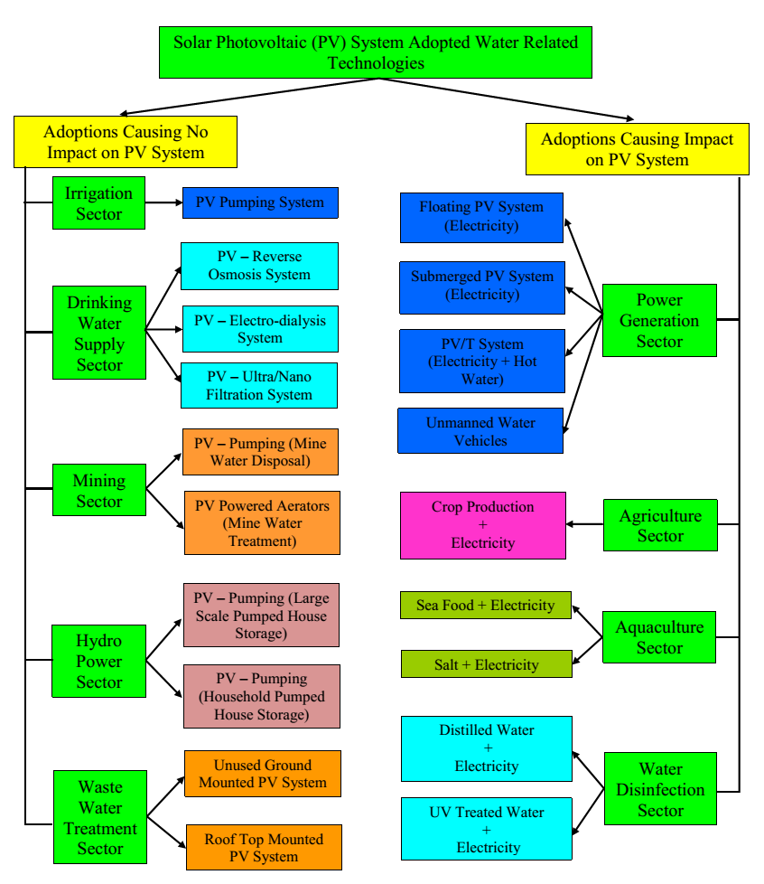
Figure. 1. Classification of solar PV adopted water related technologies

2.0 Adoptions that do not affect the Photovoltaic (PV) system
In this type of adoptions, there will not be any direct interaction between the PV module structure and the water related technology. The electric power generated by the PV system is utilized by the water related technology for its operation and no modification is required on the existing PV system structure, electrical connections, protections etc. The schematic representing such concept is shown in Figure. 2. Adoptions that fall under this category are mainly PV water pumping units which are widely utilized in irrigation sector, drinking water sector, mining sector, hydroelectric power sector and PV aeration systems which are used in wastewater treatment sectors [13].
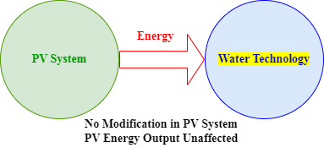
Figure 2: PV system powering a water technology without direct interaction between the two technologies, the PV system is not affected
2.1 Literature review on PV system adoption in irrigation sector
PV water pumping is a matured and well-known commercial technology available in markets. Expected life time of solar PV pumping unit is about 20 to 25 years and solar PV modules occupy major portion of its capital cost [14]. However, the rising cost of fossil fuel-based electricity has opened the window for installations of more and more PV based water pumping units in agricultural water and drinking water supply sectors [15, 16]. Currently, PV water pump can pump water from at least 500 m deep well with large daily flow rates of about 1500 m³/d [14]. It is widely utilized in rural settings and it has replaced diesel power generators in most of the locations. Large scale agricultural areas which are generally away from the conventional electric grid highly relies on these PV powered water pumping units for irrigation. The pump can be of DC or AC type, the latter requires a solar inverter for its operation while integrated with the PV module. DC pumps are mostly portable, highly efficient and are suitable for capacities lower than 3.0 kW. AC pumps are suitable for capacities higher than 3.0 kW and are rigid, reliable and require less maintenance [17].
Pumps are selected based on the required total dynamic head and flow rate. Total dynamic head refers to the summation of static head, drawdown head, friction loss head and tank height [18]. The schematic of PV water pumping with submersible pump used for crop irrigation is shown in Figure. 3. Generally, surface pumps (centrifugal type and reciprocating types) and submersible pumps are used for PV water pumping. Surface pumps are suitable for shallow wells, ponds, cannels or rivers while submersible pumps are suitable for deeper wells. In developing countries, PV module tracking arrangement is generally not recommended for water pumping application as it consumes around 10 to 70% of the total power generated by the integrated PV modules [17]. PV water pumping unit can be operated either in on-grid mode or in off-grid mode. Generally, irrigation is not carried out throughout the year. Hence, in on-grid configuration additional energy generated by the PV modules can be sold to the grid thereby the farmers/firms can earn additional income. Moreover, the payback time of on-grid pumping unit is also slightly lower than off-grid pumping unit [19]. Apart from irrigating cash and food crops, Solar PV water pumping unit is also found to be a suitable option for conserving grasslands which are needed for pasturing. In addition, it can also enhance socio-economic betterment of the rural population [17].
Daily energy required to pump a volume of water at a total dynamic head is estimated by [16],
(1)
The capacity of PV array required for water pumping is estimated by [16],
(2)
One of the drawbacks of solar PV pumping is the case of excess water pumping which can lead to reduced ground water level. This problem can be addressed by rationalized adjustment of cropping pattern, continuous groundwater level monitoring by concerned authorities and permitting the use of solar PV water pumps only in regions with annual rainfall of at least 300 to 400 mm [20]. Moreover, it has been also been suggested to automate the operation schedule of PV water pumping unit based on climatic conditions, hydraulic behavior of irrigation network, crop type and soil moisture level for achieving efficient irrigation [21]. Batteries can be used to store excess solar energy which can then be utilized to pump water whenever needed but this increases the initial investment significantly. Other option is to utilize excess solar energy to pump additional water which can be stored in a storage tank at higher elevation. This stored water can then be utilized for irrigation with the aid of gravity during non-sunshine hours thereby the need for expensive battery storage units are avoided. However, off grid-battery backed PV water pumping unit is recommended to be an ideal option for PV water pumping application in very isolated or remote locations [22]. It has also been found that solar PV water pumping can be economical in locations which are at least 2 km away from the local electric power grid [17].
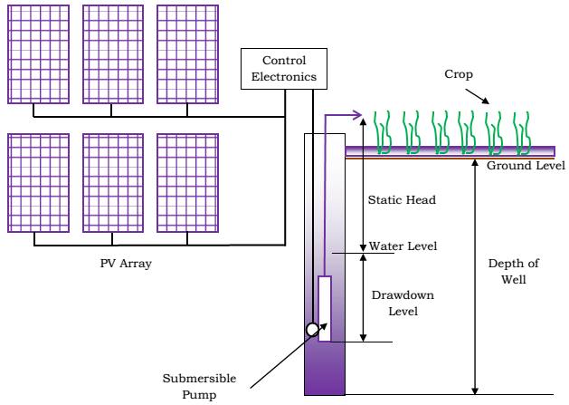
Figure. 3. Concept indicating adoption of PV water pumping in crop irrigation [19]
The major advantages and limitations of solar PV pumping units are [17, 23, 24, and 25]:
Low operating cost, maintenance cost and no/minimal emission than diesel operated pumps
More economical and effective option for remote and rural regions without electric grids
Can be used for irrigation, watering cattle and domestic water supply
Excess electricity can be sold to the grid thereby farmers income can be enhanced
Can be used to protect pasture lands and reclamation of wastelands
High capital cost and less efficient than diesel operated pumps
Performance can be affected by climatic conditions hence expensive battery backup may be required
May increase ground water over exploitation
Not suitable for high head pumping and high flow rates
2.2 Literature review on PV system adoption in drinking water supply sector
Drinking water sector in which PV modules are widely adopted are namely reverse osmosis (RO) desalination unit, Electro-dialysis (ED) unit, standalone ultra-filtration and nano-filtration unit. The second technology that widely adopts PV module for operation is the RO desalination sector. In natural osmosis, a passive diffusion occurs between two solutions with different concentrations of solutes separated by a semi-permeable membrane that allows only the solvent to pass through it; in this case, it is water. Natural osmosis process occurs spontaneously without the need for any external energy input until the concentration equilibrium is reached between the two solutions [26]. In the case of reverse osmosis, external pressure (6 to 8 MPa in case of sea water and 0.6 to 3 Mpa in case of brackish water) is provided to force the water in the concentrated solution to pass to the other side of the membrane, thereby a very concentrated solution is left on one side and completely very little concentrated solution, (ie.) clean water on the other side of the membrane. For desalting 1 m³ of sea water using reverse osmosis process, about 2-5 kilowatt-hours of electric energy is needed [27].
Among global power generation, 1.9% power is generated from solar PV systems [28] and RO occupies 64% of the global desalination market [29]. It also usually happens that places where water desalination is needed are normally rich in solar energy potential, with numerous sun shine days and little or no rain. Hence, PV modules can be effectively adopted in RO based drinking water sectors to mitigate drinking water scarcity. Up to 32% of the renewable energy powered desalination units is solar PV-RO unit. PV incorporated RO water desalination technologies are rapidly developing in Israel, the Emirates, Saudi Arabia, Australia, etc.,[30]. The schematic of PV module operated RO desalination unit is shown in Figure.4. PV module is used to power the motor of the pump supplying feed water from the brackish/saline water well to the storage tank and the booster pump of the RO unit. Battery based PV-RO systems are recommended for winter seasons and cloudy locations [31]. Brackish water RO unit powered by solar PV module of 1.07 kW capacity and battery capacity of 10.95 kWh is capable of generating 1.0 m³ of desalinated water in 7 h at a cost of 3.73 USD/m³ under Egyptian climatic conditions. The life time of the unit is expected to be about 20 years with batteries and RO membranes are expected to be replaced every 5 years [32]. The desalinated water production cost of PV adopted RO unit is about 2.5 times higher than the water production cost of conventional fossil fuel assisted RO units. However, the water production cost of PV adopted 5000 m³/d RO unit can drop rapidly up to 1.50 USD/m³ in near future due to rapid increase in fossil fuel cost, increased government subsidies for clean energy adoption and reduced PV module cost [33].
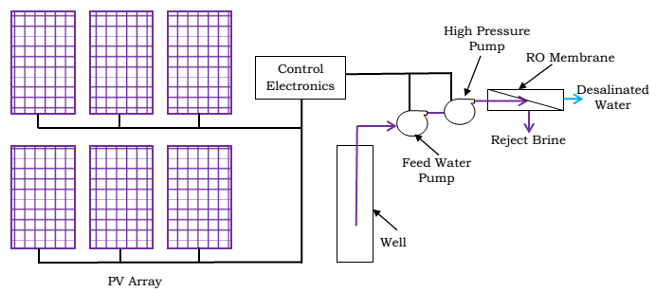
Figure. 4. Schematic of PV module operated RO unit [34]
The required average hourly desalinated water production rate of solar PV powered RO unit during daylight hours is given as [34],
(3)
The total energy requirement of RO system (E_{RO}) is the energy required for pressurizing feed water and energy required for transporting feed water from the deep well or sea. It is estimated by [34],
(4)
(5)
The desalinated water flow rate from the RO membrane is given as [34],
(6)
(7)
(8)
The required solar PV array size is estimated by [34],
(9)
PV powered RO units treating brackish ground water in remote and rural regions have financial payback period higher than three years. The payback period can be reduced significantly if the energy consumption is reduced. Incorporation of energy recovery devices in RO units treating brackish water is not economical as the pressure of the brine leaving the brackish water treating membrane is less compared to the brine leaving the seawater treating RO unit thereby no significant power savings can be achieved. Hence, for treating feed water with low salinity, electro dialysis (ED) unit highly is preferred [26]. In ED unit, ions are separated from the feed water by the application of electric potential. The schematic representing the working principle of ED unit is shown in Figure 5a. The specific energy consumption of RO and ED unit increases with increase in feed water salinity. The specific energy consumption of ED unit is very much lower than RO unit for treating low salinity feed water. However, specific energy consumption of ED unit treating sea water is very high in the range of 10-25 kWh/m³ [29].
The energy cost/m³ of water treated by the ED unit is lower than the RO unit treating feed water with salinity below 5000 ppm. In the case of India, for example, most of the ground water has salinity less than 5000 ppm but are contaminated with arsenic, fluoride, iron, and nitrates, and these ions can be effectively removed by ED unit. Pre-treatment requirement of feed water in ED unit is much lesser than that is actually required in RO unit due to the insensitivity of ED membranes to chlorine levels in feed water. Life time of ED membranes is about 10 years which is about 2 to 3 times higher than that of RO membranes. Hence, due to relatively long life span, less pre-treatment requirement and low energy consumption, ED unit requires only less PV module area for its operation in comparison to the RO unit which makes ED unit more economical in rural regions to treat heavy metal contaminated brackish water with salinity below 5000 ppm [26]. The schematic of solar PV powered ED unit is shown in Figure. 5b. The levelized cost of the drinking water produced by PV-ED unit from feed water of 3000 ppm is below 2.0 USD/m³ [36]. Salt removal and arsenic removal efficiency of PV-ED unit is about 95.0% and 99.9%, respectively [37].
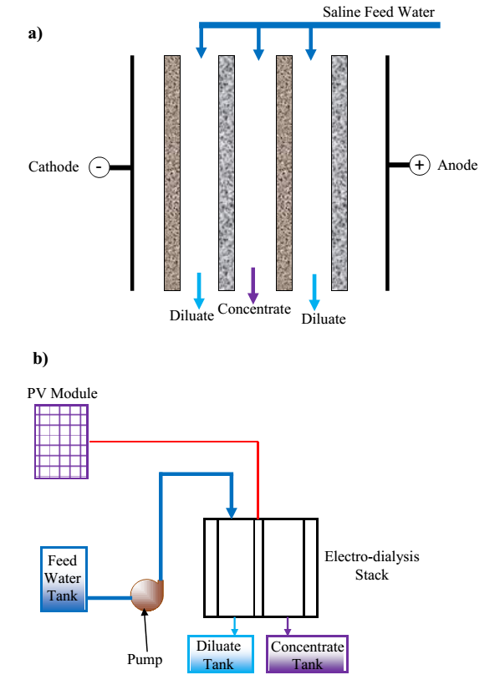
Figure 5 (a-b). Schematic indicating working of electro-dialysis unit [26, 35]
The desalinated water flow rate from each stack of the electro-dialysis unit is estimated by [35],
(10)
The power required to desalinate water using ED unit can be found from the supplied current and voltage potential across the stack based on which PV array has to be designed as discussed earlier. The total voltage potential (V_{total}) required by the ED unit is estimated by [26],
(11)
The specific energy consumption (kWh/m³) of the ED unit is estimated by [38],
(12)
Stand-alone PV module integrated drinking water purification technologies are essentially portable systems and are highly needed in remote areas, rural areas, and under emergency situations. Solar PV powered reverse osmosis and electro-dialysis units are not usually operated in standalone mode due to their relatively high price and high energy consumption, but other techniques like ultra-filtration and nano-filtration units can be used in standalone mode. They are modular systems, which are designed in different sizes according to the final application and the quality of the water required, as well as based on the portability requirements, that is, how the transport will be carried out, (ie.,) by land or by air. Photograph of stand-alone PV powered ultra-filtration unit of capacity 75 L/m²h installed in Perak, Malaysia for drinking water purification is shown in Figure. 6a. Solar PV module of 50 W and battery of 40 Ah capacity is used to operate the feed pump of the unit. The ultra-filtration unit consists of 4.0 m² modified poly-ethersulfone (PES) cross flow hollow membrane of pore size 0.02 μm. The specific energy consumption of the unit is about 0.18 kWh/m³ while the specific energy consumption of the conventional sand/media filtration unit is about 0.15 kWh/m³. However, the ultra-filtration unit does not use any chemical coagulant while the conventional sand filtration unit uses aluminum based chemical coagulant. In addition, the filter cleaning requirement is once in two weeks for ultra-filtration unit while the conventional sand filtration unit requires cleaning daily. Moreover, for feed inlet turbidity of 20 to 30 NTU, the filtrate obtained by the ultra-filtration unit has turbidity less than 0.4 NTU while the turbidity of filtrate obtained in conventional sand filtration unit is about 1 to 2 NTU [39]. Ultra filtration is generally used to reduce the turbidity of RO and nano-filtration unit’s feed water. Ultra filtration seems to remove 62-95% of manganese and about 99% of iron from the feed water [40]. Nano-filtration membranes are more suitable for removing fluoride from the feed water. Solar PV powered (2.25 kW capacity) nano-filtration unit installed in northern Tanzania generates at least 240 L/h of drinking water by removing 98% of fluoride from the feed water (60 mg of fluoride/L). It has been suggested to use the concentrate for washing and toilet flushing [41]. The lab scale nano-filtration unit demonstrated by the Hai Institute for vocational education in Africa is shown in Figure. 6b.
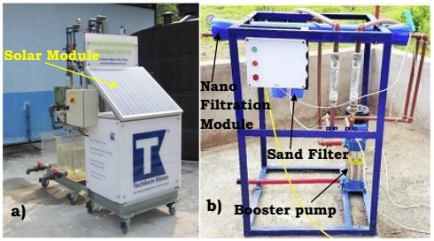
Figure 6. a) Photograph of solar PV powered ultra-filtration unit for application in rural regions of Malaysia b) Photograph of solar PV powered nano-filtration unit in Tanzania [39, 41]
The advantages and limitations of solar PV adopted drinking water supply units are:
Suitable option for providing clean drinking water in rural and remote locations which are away from the conventional grid
Improves hygiene and sanitation of population in underprivileged regions
Reduces burden on women and children in developing countries as they generally spent a lot of time and effort in fetching drinking water for their family
Helps in achieving UN sustainable development goals
Initial investment may be higher due to the need of batteries in standalone systems
Maintenance and troubleshooting may be a problem due to non availability of skilled population in rural and remote regions
Improper management of reject brine may lead to some other ecosystem damage
The scopes for further investigations in PV based drinking water supply are:
Performance of solar PV based pumping and desalination systems are dependent on ambient conditions thereby energy storage systems are necessary for their sustained operation but are expensive. Hence, optimal sizing and operation strategies are required for different climatic conditions
Development and performance investigation of solar PV pumps for high water head operation is required
Studies on PV powered nano-filtration and electro-dialysis systems are very limited hence more studies are needed in this area to increase their reliability and applicability
Detailed economics and environmental impacts of solar PV pumping systems compared to other conventional techniques in various applications under different climatic conditions are required
Strategies and policies are needed to generate profits for farmers and other stakeholders utilizing PV pumping systems

2.3 Literature review on PV system adoption in mining sector
Water flooding and contamination of nearby water streams is a major problem in most of the mining regions throughout the globe. Flooding in mines can be due to underground mine water and rain water. However, flooding can be avoided if the accumulated water is removed at regular intervals. Moreover, the water from the mines can enter the surface water streams which can also cause huge pollution of nearby rivers and lakes. Hence, removal of flooded mine water and re-direction of it to suitable treatment units is a major task in sustainable management of mines [42]. However, one constraint for this task is that the mines are generally located in remote regions which have no essential conventional electric grid infrastructure. Moreover, development of electric grid infrastructure near mines will be very difficult and more expensive. Hence, the removal and re-direction of flood water can be carried out only with the aid of diesel or solar PV powered pumps. Paredes-Sanchez et al. [42] suggested the adoption of 60 W solar pump powered by 21 W solar module and 131 Ah capacity battery to evacuate water from slate mine in Galicia, Spain, to prevent diffusion of pollutants of contaminated mine water into the Cabreira Stream. PV module has also been adopted in acidic mine water treatment units. Acidic mine water outflow from coal and other mineral mines are rich in heavy metals like Fe²⁺ ions and are generally treated by natural purification process. Supply/injection of oxygen to the oxidation plant using aerators is done to enhance and fasten the purification process. Aeration is the process of injecting air/oxygen to any substance at high or low pressures depending on the process requirement using aerators. [43]. The schematic representing off-grid solar PV powered aeration unit in acid mine water treatment facility is shown in Figure. 7. Solar PV array size of 30.1 kW and battery bank of 3384 Ah is needed for powering 13 aeration units each of 35 W with capacity 60 L/min, for treating 1050 m³/d of influent under the climatic conditions (Average annual solar radiation potential 1296.2 kWh/year and ambient temperature 8.9°C) of Hwangji Youchang mine, South Korea [43].
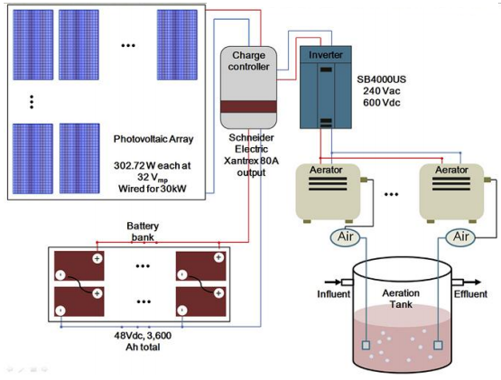
Figure. 7. Schematic of solar PV powered aeration unit for treating acid mine water [43]
The Fe²⁺ ion loading rate into the treatment/oxidation pond is estimated using the acidic water flow rate and its Fe²⁺ ion concentration [43], (13)
It has been estimated that one kg of oxygen can oxidize 6.98 kg of Fe²⁺ ion. Hence, quantity of air flow rate required to oxidize the Fe²⁺ ions in acidic mine water is estimated by [43],
(14)
The factor 0.21 used in the equation represents the mole fraction of oxygen in air (Oxygen occupies 21% of entire volume of air). The actual quantity of air required for aeration by considering factor of safety (usually taken as 5), and solubility of air in water for a given pressure and temperature is estimated by [43],
(15)
Based on the flow rate estimated, aerator is selected. The daily energy consumption of the aeration unit is estimated by,
(16)
Aeration unit operates 24 h per day. The solar PV system including modules, batteries, charge controllers and inverters are designed based on the daily electric load and local solar resource of the mine site.
The advantages and limitations of solar PV adoption in mining sectors are:
Increases sustainability of mining sector by reducing greenhouse emissions and by enhancing proper disposal of mine water
Reduces contamination of nearby lake or river or groundwater stream by mine water due to proper onsite treatment
Can help in mine reclamation
Dust deposition over PV modules will be a major challenge for its adoption in mining sector
Only limited studies are available hence reliability, economics and life cycle aspects are unknown
The scopes for further investigations in the area of PV adoption in mining sector are:
Evaluation of solar energy potential in various mining regions under mining environment
Development of dust repellant coatings and efficient PV panel cleaning techniques in specific to mining sector
Economic aspects and environmental impacts of PV module application in mining sector are not available
Long term studies are needed to identify the performance and material degradation aspects of PV modules under mining environment
2.4 Literature review on PV system adoption in hydro-electric power sector
The PV module utilization in reservoirs of hydro-electric power plants for water pumping to facilitate transfer of water from the lower reservoir to the higher reservoir during sunshine hours is one of the budding areas of PV adoption. This kind of water storage system is called the pumped hydro energy storage system. The potential energy of this stored water will be utilized for power generation during non-sunshine hours by discharging the stored water from the upper reservoir. Global installed capacity of pumped house energy storage system is about 130 GW and it has been widely adopted in China, Japan, USA, Spain and other European countries [44, 45]. Integration of PV module with hydroelectricity power plant in Geesthacht, Germany is carried out by placing the PV system on an adjacent land, next to the water reservoirs [46]. But in new emerging versions, PV modules are allowed to float over the water reservoirs (Details on this has been described in the second classification because this arrangement requires modifications in PV module structure). In some cases, PV modules are integrated to the walls of the dams of the hydro-electric power stations [47]. Integration of PV modules with pumped hydro energy storage system can enhance probability of continuous reliable power supply to the grid by about 99.9% [48]. The schematic representing operation of PV integrated pumped hydro energy storage system is shown in Figure. 8. Martinez-Jaramillo et al. [50] suggested subsidizing of PV modules to enhance smooth 100% transition from nuclear fuel to solar PV-pumped hydro energy storage system in Switzerland.
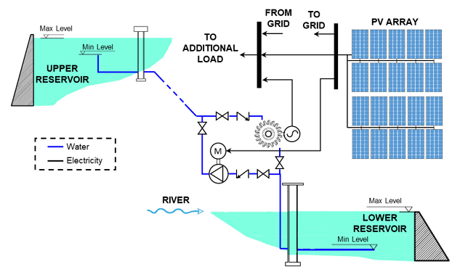
Figure. 8. Schematic representing operation of PV powered pumped hydro energy storage system [49]
The electrical energy needed by the pump to supply water to the higher reservoir from the lower reservoir is estimated by [48],
(17)
The electric power generation capacity of stored potential energy in upper reservoir is given as [48],
(18)
The volume of water pumped to the upper reservoir for storage at any time “t” is estimated by [49],
(19)
The volume of water available in the lower reservoir at any time “t” is given as [49],
(20)
The PV capacity required to be installed can be estimated by considering the power required for pumping water to upper basin and/or by including the excess power that can be sold to grid and is expressed as [49],
(21)
The schematic of household PV-pumped hydro electric system is shown in Figure. 9. In this new concept, water is pumped from household wells to a tank kept at higher elevation (10 to 25 m from ground) using solar PV module powered pumps (950 W) during sunshine hours. The stored water is then allowed to flow at a velocity of 0.03 m/s through a hydro generator of 3000 W capacity to generate power during non-sunshine hours. The generated excess power can be sold to the grid which helps rural population to generate additional income. New concept of household PV-pumped hydro electric systems also seem to be a better option for rural population of Shaanxi province, China to generate additional income of about 44.15 to 76.11USD per year. This small scale system is more attractive due to its low payback period of 6 to 8 years and low environmental impacts due to elimination of chemical batteries for storing excess solar energy [51].
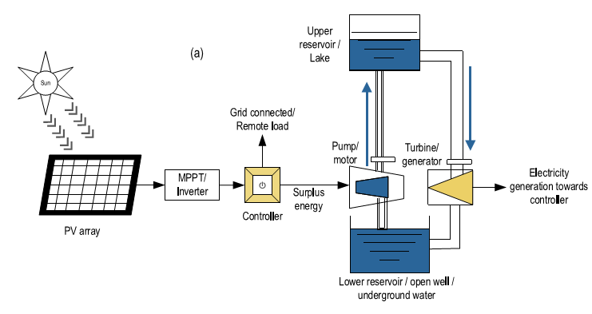
Figure. 9. Schematic of household PV powered pumped hydroelectric system [28]
The advantages and limitations of solar PV adoption in hydroelectric sectors are:
More suitable option as existing grid infrastructure can be utilized
Continuous power generation from hydropower plants is assured
Solar energy potential is effectively stored and utilized
Floating PV modules over the reservoir can prevent water evaporation
Household based small units can create additional income for rural population
May face difficulty in PV installation as landscape around the hydro power plants are not usually flat which may result in increased initial cost
The scopes for further investigations in the area of PV adoption in hydro power plants are:
Investigation on hybridization with other renewable energy sources is required for efficient operation of the system during non-sunny days or months
Feasibility studies on adoption of solar PV modules in existing infrastructures of hydro power plants
Development of operation strategies to utilize the available solar and water resources effectively and efficiently [28]
Household based solar PV assisted pumped house energy storage system needs to be investigated in various locations
Comparative studies on ground mounted PV, floating PV and hydro dam wall mounted PV for viable application in pumped hydro storage
Detailed economic and environmental studies to assess the cost benefits and threat to life in and around the hydro plant

2.5 Literature review on PV system adoption in wastewater treatment plants
Wastewater treatment plants are energy intensive hence there is a huge scope to adopt renewable energy in these plants to cut-off carbon emissions. Energy consumption in aeration, sludge treatment units, pumping units, lighting & buildings, clarifiers, screens and disinfection units of a conventional municipal wastewater treatment unit is about 60%, 15%, 13%, 6%, 3%, 2% and 1%, respectively of its total energy consumption [52]. Colacicco and Zacchei [53] suggested solar PV modules to be an effective candidate in meeting the energy demand of oxidation tanks which consumes nearly 30 to 60% of the entire energy supplied to the wastewater treatment plants. Energy consumption of wastewater treatment plants is in the range of 0.52 kWh to 2.0 kWh/m³. The entire energy consumption of wastewater treatment units has occupied nearly 1.0% of the total energy consumption of some countries. Moreover, it has been estimated that the levelized cost of treated water/m³ in wastewater treatment plant of capacity higher than 1000 m³/d (large scale) adopting renewable energy to cover 90.0% of its energy demand is similar to that of wastewater treatment plant powered by conventional electricity grid [52]. Bio-gas generated from anaerobic digestion of wastewater sludge has also been used to power wastewater treatment plant but it has not been suggested as an economically viable option in some cases. However, adoption of solar PV modules has seen to be more attractive in wastewater treatment units in USA, China and other countries in recent years [54, 55].
Mostly, grid-connected PV systems are adopted in the available spaces, in the vicinity of the plants [56] or they are integrated within the wastewater treatment plant itself. In the latter case, the spaces for integration include building roofs, free spaces between water treatment systems, and the surfaces above the water treatment systems that might require additional special structures (for example, to be installed above the clarifiers or above the primary biological treatment) [57]. Some of the PV adopted wastewater treatment plants in the world is listed in Table. 1. In Spain, it is observed that the installed PV plant size in wastewater treatment plants is small, but an important fact is that the electricity demand of small water treatment plants can be covered more easily by adopting PV modules. This is mainly due to two reasons: first, the overall electricity demand of the smaller wastewater treatment unit is smaller, and secondly, smaller water treatment plants are usually located in areas where the available space is not a problem (rural areas, remote settings, etc.) while large wastewater plants are generally located in big urban cities. Most of the solar PV adopted wastewater treatment plants are located in California, USA. For wastewater treatment plant capacity of above 5 Million Gallons per day inflow, around 8 to 30% of its energy demand is met by solar PV modules. For wastewater treatment plant capacity below 5 Million Gallons per day inflow, solar PV modules address 30 to 100% of its energy demand. However, solar PV system of 1 MWp capacity is installed in most of the wastewater treatment plants of California, USA irrespective of the plant treatment capacity and this is attributed to the maximum size to get the financial incentives from the government [54]. The total PV installation potential in 31 wastewater treatment plants of China is about 465 MW and it can cut-off the carbon emissions of wastewater treatment plants by about 10 to 40% [55].
Table 1. List of few wastewater plants with photovoltaic integration around the world, including some Spanish examples
Location | Installed PV Power | Estimated Annual Power Production | Company | Characteristics
Location | (kW) | (GWh) | Company | Characteristics
Santa Pola, Alicante (Spain) [54] | 971 | 1.7 | AGBAR | Grid connected
Murcia Este (Spain) [58] | 520 | 0.75 | AGBAR | Grid connected
Gurb, Barcelona (Spain) [59] | 47.5 | 0.06 | AGBAR | Grid connected
Sant Joan Despi, Barcelona (Spain) [60] | 165 | 0.21 | AGBAR | Grid connected
Pilar de La Horadada, Alicante (Spain) [61] | 100 | 0.17 (47% of the required power) | CADAGUA-IVEM | Grid connected
Purton (U.K) | 300 | 0.27 | Bristol - Water | Grid connected
Morristown, New Jersey (U.S) [62] | 578 | 0.64 | Vanguard Energy Partners | Grid connected
Lakewood, California (U.S) [63] | 250 | 0.40 | Department of Water Resources (Sunwize) | Grid connected
City of thousand oaks, California (U.S) [64] | 584 | 15% of total required power | Hill Canyon Water Treatment Plant | Grid connected - Tracking
Boulder, Colorado (U.S) [65] | 1000 | 1.55 (15 - 18% of total required power) | City of Boulder (Solon Corporation) | Grid connected
Roger Road, Arizona (U.S) [66] | 1070 | 2.25 (15% of total required power) | The Pima County wastewater reclamation department | Grid connected - Tracking
Upper Malboro and Germantown (U.S) [67] | 2000 | 6.60 (17% of total required power) | Washington suburban sanitary commission | Grid connected
The relation between wastewater treatment plant annual capacity and its annual energy consumption is given as [52],
(22)
Chen and Zhou [55] found that the PV capacity installation potential of wastewater treatment plant is related in a linear way to the treatment unit’s daily capacity and it is given by the relation,
(23)
The advantages and limitations of PV adoption in wastewater treatment sectors are:
Effective use of available space in wastewater treatment plants by solar PV modules
Enhances standalone operation of wastewater treatment plants
Reduces carbon emission by about 10 to 40% in wastewater treatment plants [55]
Due to intermittent nature of solar radiation battery energy storage unit is needed hence higher initial cost is expected [68]
Training must be provided to wastewater treatment plant employees to improve their skill on solar PV maintenance and troubleshooting [68]
The scope for further investigations in the area of PV adoption in wastewater treatment plants are:
Investigations on feasibility of solar PV adoption in existing old wastewater treatment plants
Investigations on technical and economical feasibility of solar PV adoption in wastewater treatment plants of developing nations to address sustainable development goals
Optimum sizing and effective integration of solar PV with other locally available renewable energy sources and fossil fuel power plants for uninterrupted operation of the wastewater treatment plant
Development of training and awareness strategies for PV adoption, maintenance and troubleshooting among wastewater treatment workers
3.0 Adoptions that do affect the Photovoltaic system
In these types of adoptions, there will be direct interaction between the PV modules and the water technology, and this will affect the photovoltaic system performance either in a positive way or in a negative way. Most important aspect is that the production of electricity will be affected, it may be either less, or it may be more, in comparison to the independent photovoltaic system. Changes in some components, which can be modules, structures, etc., and addition of some components like floats etc., may also be needed during these adoptions which may also make these adoptions slightly expensive than the previously discussed one. The schematic representing this adoption is shown in Figure. 10. Adoptions that fall under this category are floating photovoltaic system, agrivoltaic system, aquavoltaic system, water based photovoltaic/thermal system (PV/T), submerged photovoltaic, hybrid PV-solar distillation system, and solar PV - water disinfection system.
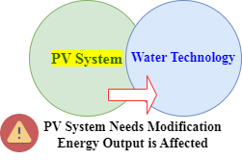
Figure.10. PV system powering a water technology with direct interaction, one or various components of the PV system is modified and the electric energy produced is also affected
3.1 Literature review on Floating photovoltaic system
Floating photovoltaic system is an emerging technology which is being adopted globally in a rapid manner [7, 69]. Due to low efficiency of PV modules, at least 10 m² ground area is required to install a 1.0 kW peak PV system. Floating PV system eliminates the use of expensive land and increase the efficiency of PV module by 12 to 20% in comparison to ground mounted PV modules due to their lower operating temperature over water bodies [70]. The first floating PV system of 20 kWp capacity was installed in Japan in 2007. Currently, the largest floating PV plant record is held by a Chinese plant of 150 MWp capacity. The rapid growth of this technology in recent years has reached an accumulated installed capacity of 1.3 GWp in 2018 [71]. The predicted annual global floating PV module installation for the year 2024, 2025, and 2026 is expected to be about 3.2, 3.6 and 4.1 GW, respectively [72].
The basic configuration of floating PV system includes incorporation of the photovoltaic modules on a floating structure that is anchored to the bottom of the water mass or to the nearby ground if the water mass is small as shown in Figure. 11. It has been estimated that if 10% of the area of man-made freshwater reservoirs in the globe is covered by floating PV system, a power output of about 4044 GW is possible [71]. Integrating floating PV system with hydro power plant has been considered as a good option to meet daily mid-day peak loads [74]. The energy production of hydro power plants worldwide can be enhanced by 35.9% if 2.4% of their surface area is covered by floating PV system. Floating PV system can be used to take care of the daytime load and hydro power unit can be utilized for power generation after sunset hours [75]. Floating PV system power generation capacity must be closer to the power generation capacity of the hydropower plant where it is installed else it seems to be not economical due to the need of additional electrical installations [76]. Moreover, floating PV modules can reduce the evaporation rate from the water bodies by about 90% in comparison to uncovered water bodies [77].
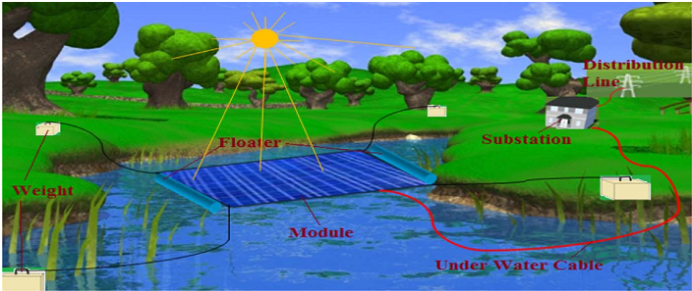
Figure 11: Schematic of a Floating Photovoltaic System (FPV) [73]
The main modification needed is in the structure that must float and protections for the modules from water movements. Appropriate access for maintenance of the modules must also be considered during structure design. Flexible coupling is also needed between the modules to get adjusted itself with the variation of water level and water reservoir landscape [78]. Structures have evolved since the very basic ones in 2011 to the current ad-hoc designed ones. Figure. 12a and 12b., represents the floating PV and the structure utilized in Suvereto Project in Italy. Figure. 12c., represents a modern floating structure for floating PV application.
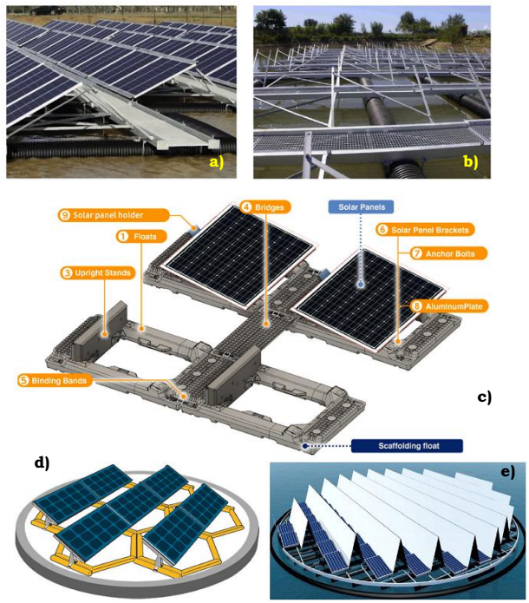
Figure 12: a-b) Structure from Suvereto Project in Italy in 2011 [71, 79] c) Modern structure [71, 80] d) Structures including tracking system (turning tables) e) Structures including tracking system (turning tables) and reflectors [71, 81]
These floating PV systems can be of fixed (non-tracking) type or tracking type (one or two axis). Figure. 12(d-e) shows an example of a floating PV system using a turning table tracking system (2-axis) and concentrator, respectively. Cost of floating PV system is about 30% higher than the commercial ground mounted PV system [71]. Conventional well known frequently used floats are not suitable for floating PV systems especially during harsh weather conditions [82]. More details on the different types of floating PV systems and their design aspects are given in [83]. The average useful life of the floating structure is between 5 and 10 years, and is less than the photovoltaic module life span (25-30 years). Other considerations include the protections against oxidation of the PV components due to continuous exposure to water. Modifications are also needed on the transmission cables to prevent electric shocks [79].Regarding the PV module, conventional modules are currently used without any type of modification, although there are research centers that are studying about possible improvements to the module in particular for this adoption. For example, changing the back material of PV module to improve its resistance to humidity & water-based corrosion. Elminshawy et al. [84] observed enhancement in floating PV electrical efficiency by 22.82% and 28.11% with the addition of twelve aluminum U-shaped solid and perforated fins (as shown in Figure. 13.), respectively in comparison to the floating PV module without fins. One end of these fins is in contact with the water thereby, they transfer heat energy from the PV module to the water resulting in about 33.31% lower operating temperature of the floating PV module.
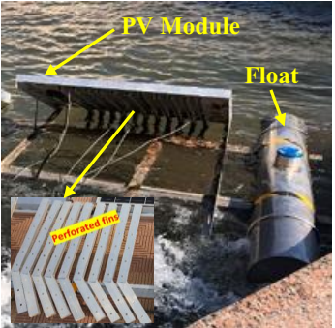
Figure. 13. Schematic of floating PV module with perforated fins (one end in contact with the water) attached to its back [84]
In addition, introduction of new technologies like thin film floating PV modules, foam-based photovoltaic modules, and organic PV modules have also been tested and planned [85, 86].The photograph of thin film floating PV system is shown in Figure. 14. There are also initiatives that propose the use of active cooling of the modules, either by thin water film flow or by water spraying using the water from the water mass available below these installations [7]. Other aspects that are currently under study are the operation and reliability of the components in long term run. It must be taken into account that the oldest floating PV system installations have not yet exceeded fifteen years and the large plants are only around four years old. Hence, exhaustive monitoring of the floating PV systems performance is highly required to assess its reliability. Anchorages at greater depths are one of the future research areas to expand the technology to other water masses, along with the potential installations in the sea (with the appropriate protections against strong swell). Apart from these, exhaustive research is also needed on the aspects of bio-fouling, resistance to salt water corrosions and development of sustainable float & module materials for successful deployment of floating PV modules in sea/oceans [88].
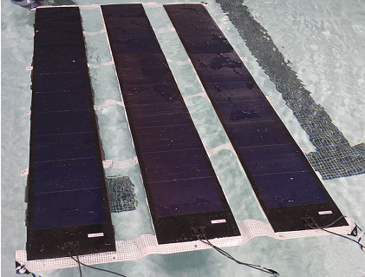
Figure. 14. Photograph of thin film floating PV system [87]
It has been experimentally found that the power output of floating photovoltaic system with thermal contact with water is about 5 to 6% higher than the power output of air- cooled ground/roof mounted PV system [85, 89]. The temperature of solar cell in floating photovoltaic system in contact with water can be estimated by [89],
(24)
The overall “U” value is calculated by [89],
(25)
The U-value components are estimated by [89],
(26)
(27)
The fluid temperature associated with the overall “U” calculation is based on the artificial fluid temperature weighting with respect to U-value components. The fluid temperature is generally closer to the temperature on the dominant heat flow side of the module. The fluid temperature is estimated by [89],
(28)

The overall “U” value for water contact floating PV modules is relatively high and is about 70-80 W/m²K and is always recommended to include water temperature during estimation of floating PV cell/module temperature [89].
The capacity of PV unit that can be installed over the water body is limited by the area of the reservoir and is given as [90],
(29)
The actual power output of the installed system by considering effect of PV cell temperature is given as [90],
(30)
The annual energy output of the floating PV array is estimated by [90],
(31)
The effect of soiling and dirt over the conventional PV module installations is still a negative issue: while it is shown that floating PV modules suffer less from the effects of dust. However, in certain cases, floating PV installations seem to attract more bird populations that increase the bird droppings over the modules as shown in Figure. 15a., which have more catastrophic consequences than normal dust [91]. Heavy winds, waves, snow and ice accumulation over floating PV modules can cause uneven distribution of load and lead to pontoon damage as shown in Figure. 15b. Apart from these, damaged electrical connections, loose bolt & nuts, vibration due to waves, and corrosion of metal components due to water are some of the problems faced by floating PV modules [82]. In case of thin film floating PV module, algae deposits over the foam located underside of the module are observed as shown in Figure. 15c. Surface and internal algae deposits are observed in polyethylene foam. Surface accumulation of algae is observed in Mincel T foam. Apart from algae deposits, debris struck between the gaps is observed in neoprene foam [87]. Forty five day experimental study on a laminated thin film floating PV module indicated drop in electrical efficiency by 0.5% and 1.0% due to water absorption and dirt accumulation over the module, respectively [92].
Trapani and Miller [85] observed 0.5% drop in electrical efficiency of thin film floating PV system within 45 days of test due to sediment occlusion over the modules. One of the advantages of thin film floating PV module is the cleaning of PV surface by water waves itself [87]. Finally, the environmental impact of the floating PV systems on the water bodies must also be taken into account. The environmental impact will be dependent on the type of water body: if it is an artificial irrigation pond or an industrial cooling pond, the effect will be negligible as there will be no ecosystem below., If the water mass is a natural lake or pond or sea with an aquatic ecosystem then it becomes necessary to evaluate the effect of these systems on the aquatic life and water quality [93]. Some studies have reported that implantation of floating PV system over water bodies can reduce dissolved oxygen content and algae concentration [71]. Moreover, it is also recommended covering only 40 to 60% of water body surface to prevent revenue losses from hydropower plant and to have recommended amount of algal concentration in the water body [76]. The environmental impact monitoring process must be continuous. In addition to simulated studies, experiments under various conditions is also necessary to predict the effect of coverage ratio, float type, and array type on water body quality, floating PV performance and reliability [73].
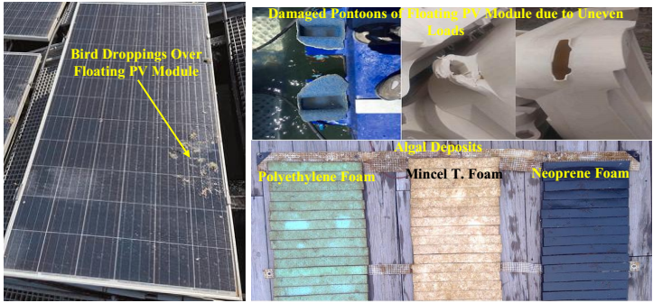
Figure 15: a) Heavy soiling from bird droppings on a floating photovoltaic system [91] b) Damaged pontoons [82] c) Algal deposits over the foam of thin film floating PV [87]
Main advantages and limitations of the floating PV systems are:
Reduced useful land occupancy by placing the systems over lakes, reservoirs, irrigation ponds, reservoirs of dams, old flooded mines, etc;
Easy coupling with hydropower plants to increase capacity factor [94]
Water evaporation reduction with the consequent saving of water in water bodies that are used for irrigation [78, 86]
Easy PV array cooling and requirement of low energy consuming tracking arrangement in comparison to land mounted PV array [73, 94]
Prevents algal bloom and balances albedo effect [95]
Relatively low electricity production cost (0.24 USD/kWh) than ground mounted polycrystalline (0.43 USD/kWh) and thin film PV plants (0.54 USD/kWh) [96]
High initial cost [73]
May affect water body ecosystem and biodiversity [73]
Plastic and metallic structure affects water quality of the water body [73]
Electrical accidents is highly possible [73]
May affect fishing and water related transport [73]
The scopes for further investigations in the area of floating PV are:
Identification and development of low cost, eco friendly materials for floats and PV support frames
Optimum sizing of the system with concentrators and trackers for viable deployment of floating PV in water bodies of various countries
Development of innovative mooring and adjustable float to withstand natural phenomena like heavy winds, currents, and tides
Development of safe transmission lines from floating PV system to the grid as aquatic animals is sensitive to electric field
Detailed real time experimental studies on thin film floating PV systems in fresh and saline water bodies
Development of effective integration strategies for floating PV with aquaculture to acquire dual benefit of power generation, sea weed & sea food harvest in an economical way
Performance and feasibility studies on floating PV system in ponds of wastewater treatment plants
Detailed environmental impact studies and strategy development for effective maintenance of floating PV systems
3.2 Literature review on PV module adoption in unmanned surface vehicles
PV modules have been used for powering of unmanned underwater/surface vehicles which are used for bridge, underwater tunnels and marine explorations [97, 98]. Application of unmanned vehicles for marine environmental monitoring and their associated challenges is presented in [99]. Annual mean global horizontal solar radiation intensity over oceans is in the range of 1.0 to 12.0 kWh/m²d. This energy falling over the oceans can be harnessed using solar PV modules to power unmanned water vehicles. Photograph of unmanned under water vehicle SAUV-II is shown in Figure. 16. The main components of SAUV-II used for surveillance and monitoring of oceans are 1.0 m² solar module and 32 V, 2.0 kWh electrical energy storage system [100]. Solar energy has been recommended as a supplementary energy source for unmanned surface vehicle named “iDroneboat” shown in Figure. 17., to enhance endurance navigation in real time water quality monitoring of water bodies [101].
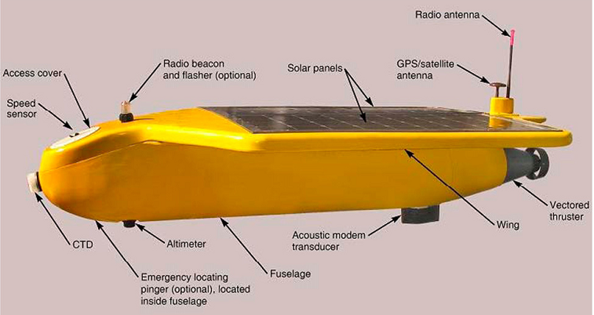
Figure. 16. SAUV-II unmanned solar PV powered underwater vehicle [100]
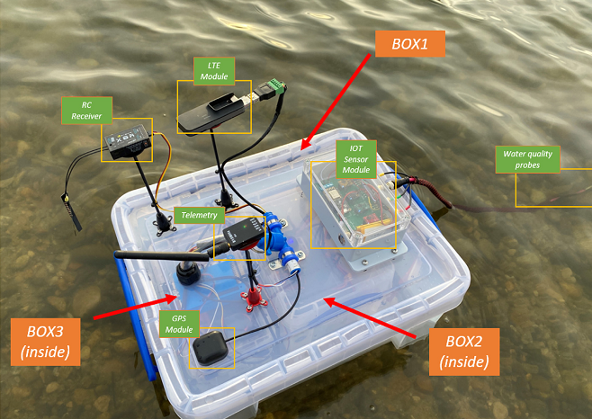
Figure. 17. Photograph of “iDroneboat” [101]
Unmanned surface vehicle named “Morvarid” developed by Iran shown in Figure. 18a., is a plug in hybrid type solar powered vehicle provided with 8.0 m² single axis tracking solar PV modules and 8.0 kWh battery energy storage system. The vehicle is used for bathymetry and can work for seven hours per day during continuous three cloudy days without any external charging requirement. The PV module can generate at least 5.8 kWh of energy per day [102]. The energy flow in Morvarid vehicle is shown in Figure. 18b. The utilization of solar PV module in unmanned surface vehicle made of composite material shown in Figure. 19a., has resulted in saving of about 30 to 50% of the primary energy consumed from the grid for charging the battery (1.42 kWh) up to 90% state of charge at the end of the day. The required power of the vehicle is about 63.72 W during sailing and 38.07 W during measurement. Power produced by the PV module (62.6 W) is used to match part of the load required by the vehicle and charge the battery pack during the measurement periods [103] as shown in Figure. 19b. Hybrid energy system utilizing solar energy (19.6%), wave energy (5.526%), fuel cell (35.22%) and battery pack (39.63%) has been recommended to meet the round clock energy requirements of unmanned surface water vehicle during long missions [104].
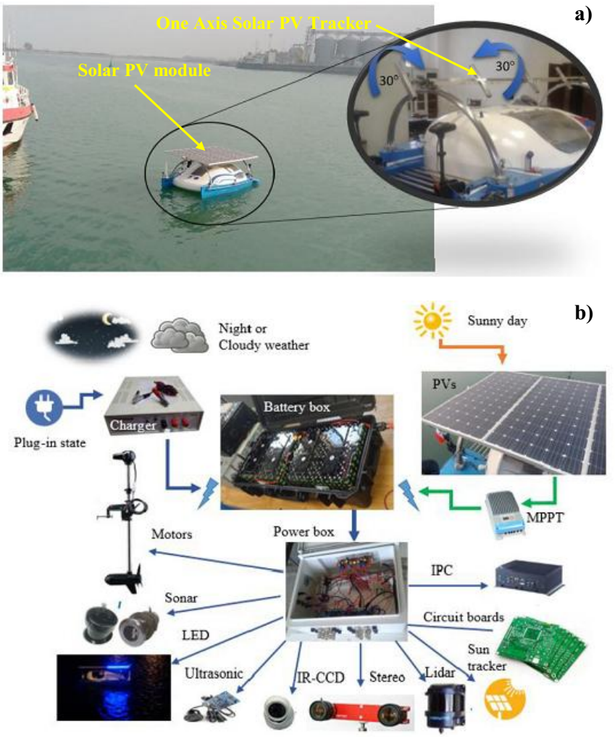
Figure. 18. a) Photograph of “Morvarid” – solar PV powered unmanned surface vehicle b) Energy flow and utilization in “Morvarid” [102]
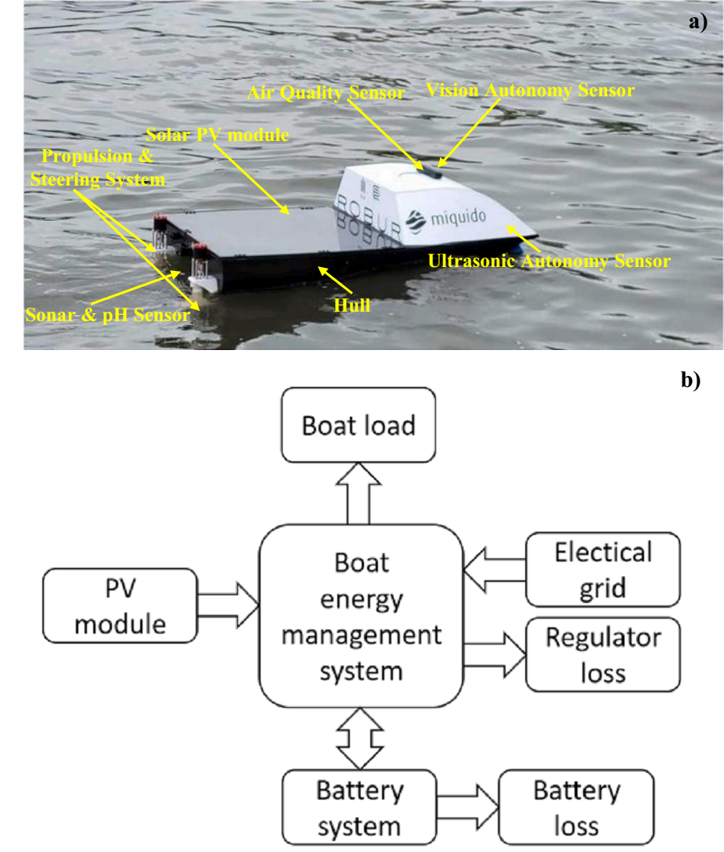
Figure. 19. a) Solar PV powered water quality monitoring unmanned boat b) Energy management in the unmanned boat [103]
The summary of works done in the area of solar PV powered unmanned water vehicles is tabulated in Table. 2.

Table. 2. Summary of research works in the area of solar PV powered unmanned water vehicles
S.No | Overview of the work | Nature of the work | Outcome | Reference
1. | Review on the applications of unmanned vehicles for monitoring marine environments | Theoretical | Different types of unmanned vehicles used for marine exploration has been discussed in detail | [99]
2. | Review on power systems for underwater unmanned vehicles | Theoretical | Different energy sources, batteries and tether power systems for powering unmanned vehicles has been reviewed  Wave energy is found to be suitable because of its availability round the clock in spite of its low conversion efficiency | [100]
3. | Development of low cost unmanned vehicle for water quality measurement | Experiment | Readily available materials are used for development of “iDroneboat”  Effective in collecting and transmitting water quality parameters from small ponds | [101]
4. | Development of solar PV powered unmanned water vehicle | Simulation & Experiment | Procedure for estimating power requirement of the unmanned vehicle, PV module sizing, battery pack sizing has been presented in detail  Can carry out bathymetry for three continuous cloudy day (7h/day operation) | [102]
5. | Development of solar PV powered unmanned small boat for environmental measurements | Simulation &  Experiment | Use of PV reduces consumption of about 30 to 50% of conventional grid energy for charging the battery of the boat | [103]
6. | Optimization of Hybrid energy powered unmanned surface vehicle | Simulation | Identification of optimal hybrid energy sources for powering unmanned vehicles  Solar energy, wave energy, fuel cell and battery pack are found to be effective hybrid energy source for 24 h operation of the unmanned surface vehicle | [104]

The scope for further investigations in unmanned PV water vehicles are:
Feasibility studies on solar PV powered unmanned surface vehicles in large water bodies like lakes and oceans
Rectification of data transmission limitation and navigation hazards by developing suitable navigation algorithm and incorporating latest cellular technologies
Development of low weight batteries, and low weight composite material based structures for the unmanned vehicle to reduce the required PV module size
3.3 Literature review on submerged photovoltaic system adoption
Performance of solar PV modules can be enhanced by reducing incident light reflection and module temperature. Submerging PV module in water can mitigate light reflection due to the variation in refractive index between the air and water interface. In the mean time, the PV module temperature rise is also mitigated by the cooling effect provided by the water pool. Water is a strong absorber of long wave radiation beyond 800 nm and is transparent to visible spectrum between 350 to 800 nm. The intensity of visible spectrum of light reaching the submerged PV module kept at depth “x” varies according to Beer-Lamberts law [105].
(32)
Elminshawy et al. [106] proposed the concept of partial submerged PV module to effectively remove heat to improve PV performance. In this concept, a fraction of the PV module is submerged inside the water pool as shown in Figure. 20. In this case, a portion of the PV module receives unaltered solar radiation while the submerged portion receives altered solar radiation due to selective absorption of solar spectrum by the water. The mean operating temperature of the PV module decreases from 42.4°C to 36.4°C with increase in submerged ratio from 0% to 20%. The daily mean power generated by the module at 0%, 5%, 10% and 20% submerged ratio is about 37.38, 40.84, 44.20 and 38.51 W, respectively. Submerged ratio refers to the ratio of length of the submerged portion of the module to the total length of the module. For submerged ratio beyond 10%, the refracted rays skip the submerged PV portion resulting in low electrical performance of the module. Alternation in visible spectrum is generally observed for water depth on or above 5.0 cm. The major issue in this arrangement is non-homogeneous temperature distribution over the module which may cause thermal stress leading to deformation of the PV module. Partial submerged PV module system is recommended for installation in low saline shallow water, choppy water, canals and rivers [106]. Increased wind speed and northerly & westerly wind flow direction has positive impact on the performance of south oriented partially submerged PV module system [107].
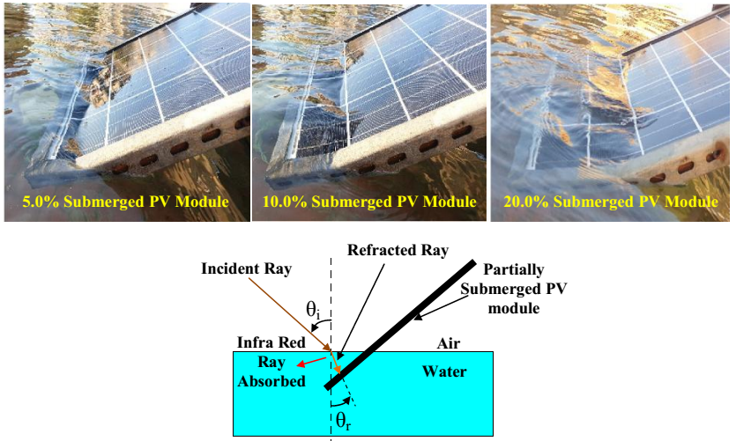
Figure. 20. Photographs of partially submerged PV modules and schematic indicating altered portion of solar spectrum reaching submerged portion of PV module [106]
PV module can also be fully submerged in water as shown in Figure. 21a. Submerged PV module has applications in swimming pool heating and salt harvest. The electrical efficiency of the emerged PV module, submerged PV module (at 4.0 cm depth) and submerged PV module (at 40.0 cm depth) is about 11.9 to 13.0%, 13.7 to 14.4% and 9.1 to 9.4%, respectively. The lower efficiency at high water depth is attributed to the increased spectral absorptance of water at higher water depth. In addition, it is interesting to notice that no drop in efficiency of submerged PV module was observed between its one month cleaning intervals. Moreover, homogeneous temperature distribution is observed over the submerged PV modules. On contrary about 10% drop in efficiency was observed in emerged PV module between the same cleaning intervals. The relative efficiency of submerged PV modules is higher than emerged module for water depth below 10.0 cm, 15.0 cm and 20.0 cm for mono-crystalline (-0.55%/°C temperature coefficient), poly-crystalline (-0.45%/°C temperature coefficient) and amorphous silicon (-0.25%/°C temperature coefficient) PV modules, respectively [109]. The relative efficiency is higher for submerged amorphous silicon PV module in comparison to other submerged PV modules which can be seen from Figure. 21b. This observation can be justified through the least percentage drop in power output of submerged (20 cm depth) amorphous PV module from its peak power at emerged (0 cm depth) condition in comparison to drop in power observed for submerged mono-crystalline and poly-crystalline PV modules which can be seen clearly in Figure. 21c. The variation in power drop with light source confirms the spectral response of solar PV modules [110]. The exergy efficiency of submerged PV module is about 3.07% and 43.65% higher than the exergy efficiency of floating PV module and ground mounted PV module, respectively in spite of lower solar radiation exergy reaching the submerged PV module [111]. The summary of relevant research works on submerged PV modules is tabulated in Table. 3.
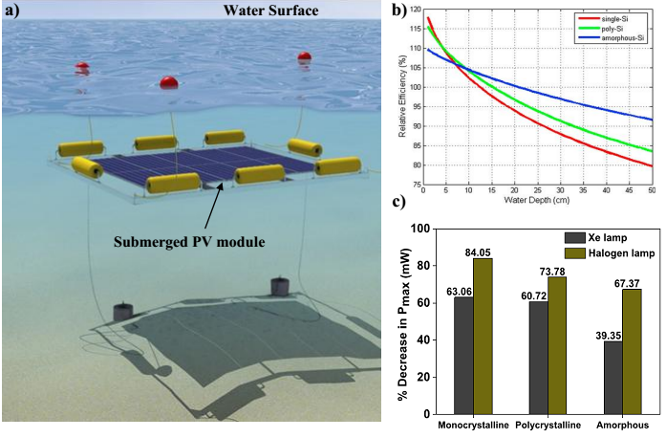
Figure. 21. a) Conceptual representation of submerged PV module [108] b) Relative efficiency of different submerged modules at different water depths in comparison to emerged panel [109] c) Percentage drop in peak power for submerged modules in comparison to emerged panels for various spectrum of light source [110]
Table. 3. Summary of research works in the area of submerged PV modules
S.No | Overview of the research work | Type of work | Outcome | Reference
1. | Optical and thermal behavior of submerged PV module | Simulation and Experiment | Presence of water layer above the module reduces incident solar radiation reflection.  Gain in transmission is about 2 to 8% with increase in incident angle  Submerged PV modules can be installed in horizontal position in locations within 20° latitude  Increased PV electrical conversion efficiency by 15% at water depth of 4 cm | [105]
2. | Impact of wind speed and wind flow direction over partially submerged PV module | Experiment | Wind speed and direction has positive impact on power output of partially submerged PV module  Over sizing can be prevented if wind speed and direction are considered during plant design  Northerly (180°) and westerly (90°) wind has positive impact on reducing south oriented partially submerged PV module temperature  Levelized cost of electricity generation is about 0.054 to 0.062 USD/kWh | [107]
3. | Impact of submerged fraction on submerged PV module performance and economics | Experiment | Submerged fraction of 10% is optimum  Reduction in average module temperature and increased power output by 14.16% and 18.25%, respectively in comparison to land mounted PV module  Levelized cost of electricity generation is about 0.059 USD/kWh | [106]
4. | Impact of water depth on performance of submerged PV module | Experiment | Optimum depth of submersion is 4 cm beyond this depth efficiency of submerged mono-crystalline PV module is lower than emerged PV module | [109]
5. | Comparison of submerged mono-crystalline, poly-crystalline and amorphous silicon PV module | Experiment | Power output of PV modules declines with submersion depth  Percentage drop in power output of amorphous PV module is lower than other modules | [110]
6. | Comparison of exergy efficiency of thin film PV module in ground mounted, floating and submerged conditions | Experiment | Exergy input to submerged PV module is the lowest  Electrical exergy of floating PV is the highest  Exergy efficiency of submerged PV is the highest | [111]

The scopes for further investigations in the area of submerged PV technology are:
Long term studies on the performance pattern, degradation aspects and mechanical properties of the submerged modules in fresh water and saline water to assess the impact of water bodies
Development of strategies to utilize submerged PV modules in existing swimming pools or water bodies without affecting their infrastructure and aesthetics
Identification of suitable applications for effective utilization of underwater modules due to low power output of underwater modules at increased depths
Mostly amorphous silicon module has been utilized for under water studies. Studies with other modules and thin-films for various water depths are needed
3.4 Literature review on water based Photovoltaic thermal (PV/T) module adoption in swimming pool heating, desalination and other applications
Solar radiation absorbed by the PV module gets converted into electricity and heat energy. Performance of PV module can be enhanced if the generated heat energy is dissipated effectively. In some PV modules, the heat energy is made to dissipate to a working fluid circulated below or above the module. These types of PV module generate both electricity and hot fluid and are termed as PV/T modules [112]. The thermal efficiency of PV/T module is lower than conventional solar collector however, PV/T generates electricity thereby its global or total efficiency will be high [113]. Recovery of waste heat from the module improves its electrical output and global efficiency of the PV/T module. Apart from water, glycol water, molten salts, hydrocarbon oils, pentahydrate, petroleum jelly, air, water-air and nano-fluids have also been used to effectively dissipate waste heat from the PV modules to improve electrical efficiency [114, 115]. Area required for producing same amount of electricity and thermal energy separately by PV module and solar collector is about 60% higher than the area of PV/T module [116]. The schematic of PV/T module assisted water heating system is shown in Figure. 22. Cross section of PV/T module is shown in Figure. 23. A detailed review on the classification of concentrator assisted PV/T modules based on different working fluid/heat transfer fluid temperature is presented in [119]. However, in this review, studies with water as working fluid in PV/T systems are only considered.
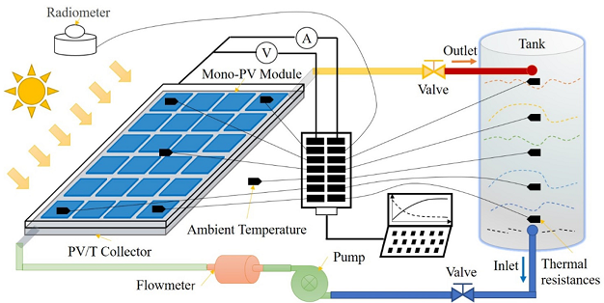
Figure. 22. Schematic of PV/T module assisted water heating system [117]
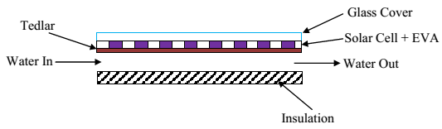
Figure. 23. Cross section of a basic simple PV/T module [118]
Water is an inexpensive and non-toxic heat transfer fluid which can be utilized in PV/T collectors for potential applications in domestic and industrial sectors for carrying out water heating, space conditioning, desalination and swimming pool heating activities [114, 120]. The global PV/T module installation capacity has increased by 9.0% between 2018 and 2020. More research has been carried out in the use of efficient heat transfer fluids and development of optimal heat exchanger geometry for PV/T module [115]. The comparison of various commercially available PV/T modules based on performance and price is shown in Figure. 24. The thermal output of majority of the water based PV/T modules is higher than the air-based PV/T modules. In addition, for the required thermal and electrical output, water based PV/T modules are much cheaper than air-based PV/T modules. Moreover, among global PV/T module installations, 57% and 2% are unglazed and glazed water based PV/T module and the rest are air based PV/T modules [120].
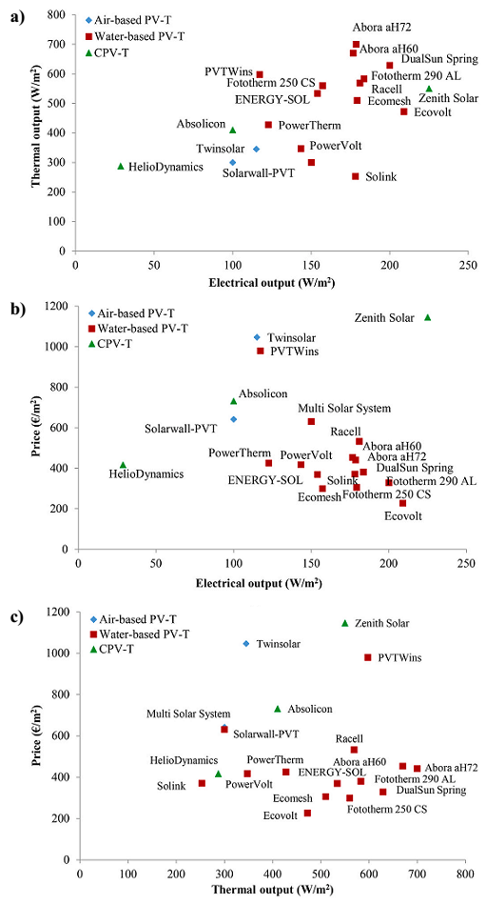
Figure. 24. Comparison of commercially available water based, air based and concentrated PV/T modules a) Thermal output for rated electrical output b) price for the rated electrical output c) price for the rated thermal output [120]
The electrical efficiency of PV/T module is the ratio of its electrical power output to the solar radiation incident over it and is estimated by [121],
(33)
The thermal power output is the rate, at which heat energy is recovered from the PV/T module by the circulating fluid and is expressed as [121],
(34)
The thermal efficiency of the PV/T module is ratio of its thermal power output to the solar radiation incident over it and is estimated by [121],
(35)
The overall or global efficiency of PV/T module based on first law of thermodynamics is expressed as the summation of its electrical and thermal efficiency [121]. However, due to the difference in quality of electrical and thermal energy the global efficiency of PV/T module can be expressed in two ways:
The electrical efficiency is converted into equivalent thermal efficiency by dividing it by electrical conversion efficiency of conventional thermal power plant which is then added to the thermal efficiency of PV/T module to estimate its global efficiency [121].
(36)
The efficiency of conventional power plants is about 34 to 36%. In other way, the thermal power output of PV/T module is multiplied with the Carnot efficiency factor and summed up with its electrical efficiency to obtain its global efficiency [121].
(37)
The global efficiency of water based PV/T module ranges between 60 to 70% in general while air based PV/T modules has about 2% lower global efficiency than water PV/T module. However, air based PV/T module is easy to fabricate due to the requirement of thin sheet for fabrication [122]. The electrical efficiency of mono-crystalline, poly-crystalline, amorphous-silicon, cadmium telluride, and cadmium indium gallium sulfide water based PV/T module is about 12.3%, 10.98%, 6.08%, 6.60% and 7.71%, respectively [123]. Unglazed PV/T module with high PV cell packing factor has high electrical efficiency and low thermal efficiency. However, PV/T module with single glass cover and conductive heat transfer coefficient of at least 100 W/m²K is highly preferred for optimal performance of PV/T module [124].
Annual energy demand in swimming pools is in the range of 600 to 6000 kWh/m², which is highest among all the sport facilities. This high energy demand is due to the requirement of pool water heating, ventilation, space conditioning and continuous operation of water circulation pumps. The heating energy demand of swimming pool can be met by solar collectors, waste heat, heat pump, geothermal energy and biomass based heating units [125]. Moreover, outdoor swimming pool is one of the best locations to install PV/T modules to generate electricity and heat by utilizing the outdoor solar radiation. PV/T modules can be used to heat pool water, produce sanitary hot water and required electricity for the swimming pools. However, due to high cost associated with PV/T modules this concept is not profitable in Naples, Italy [126]. The 4000 m² PV/T solar combined heating and power system (PVT-S-CHP) shown in Figure. 25., for meeting the swimming pool heating demand, space heating demand and electricity demand of University Sports Centre, Bari, Italy has a payback period of about 8.6 years higher than the internal combustion engine operated combined heating and power system (IC-CHP) [128]. However, the PVT-S-CHP can mitigate about 450 tons of CO₂ per year which is about 1.4 and 17.8 times higher than PV-ETC (50%-50%)-S–CHP and IC-CHP, respectively [127].
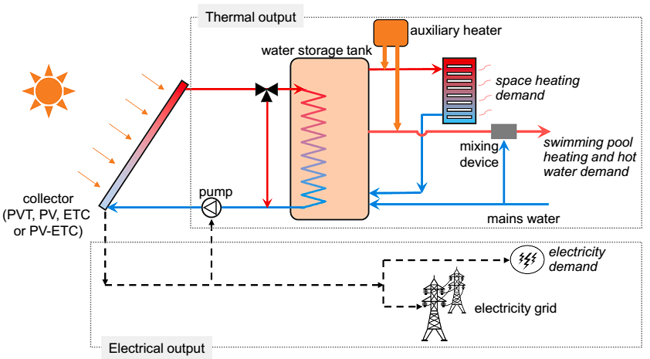
Figure. 25. Schematic of PV/T module based water heating and power supply system for sports centre [127]
PV/T modules can be installed at the bottom and on the edges of overflow or skimmer swimming pool as shown in Figure. 26a., and Figure. 26b., respectively. Even though this configuration looks like submerged PV it has been considered as submerged PV/T module as it produces both electricity and heat. Amorphous silicon module and polycrystalline solar modules are recommended for installations at the bottom and edges of the swimming pool, respectively. Amorphous silicon module is relatively tolerant to partial shading than other type of modules [129].
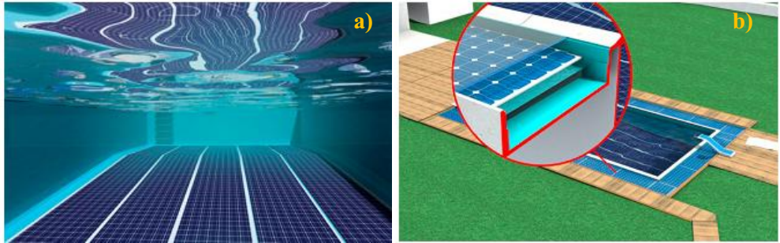
Figure. 26. Swimming pool heating with PV/T module a) PV module installed over the swimming pool floor b) PV module installed over the edges of swimming pool [129]
Integration of PV/T module with adsorption desalination facilitates both PV module cooling and fresh water production. In this arrangement, heat energy dissipated by the PV/T module is utilized for evaporation of saline water in the low pressure evaporator section of adsorption desalination system to produce potable water as shown in Figure. 27. The electrical efficiency, thermal efficiency and electrical efficiency improvement rate of PV/T module integrated with adsorption desalination system is about 11.5, 77.5 and 17.5%, respectively [130]. PV/T modules have also been integrated with basin solar stills to improve potable water production rate by preheating feed water. The feed water from the still is preheated by circulating it through the heat exchanger incorporated at the back side of PV/T module [131]. The potable water production rate of PV/T module integrated solar still is about 2.79 times higher than the still without PV/T module [132]. Detailed review on the application of PV and PV/T modules for water distillation is found in [133]. Abdelgaid et al. [134] proposed a concept of solar PV powered hybrid humidification-dehumidification-Reverse Osmosis desalination system whose schematic is shown in Figure. 28. The feed water preheated by the recovered waste heat energy of PV module is further heated using evacuated tube collector and is then sprayed inside the humidifier section. Hot air heated using solar air heaters entering the humidifier gets saturated by this sprayed water and moves towards the dehumidifier where vapor condenses as potable water. The un-evaporated sprayed water is treated using RO unit to generate more potable water. The cumulative potable water production rate of this system is about 200 L/h at a recovery ratio and specific energy consumption of 49.8% and 1.22 kWh/m³ of water, respectively [134].
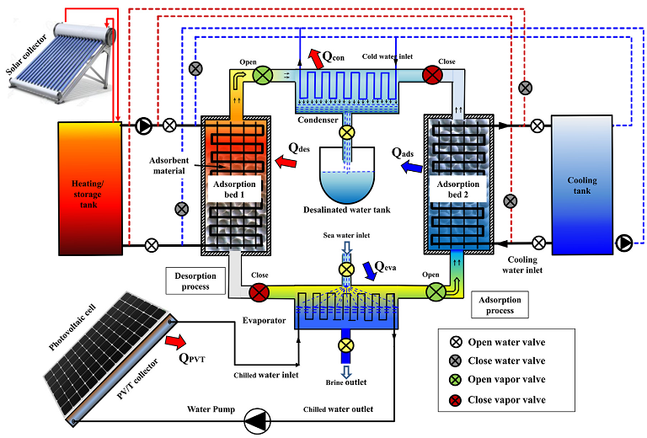
Figure. 27. Schematic of PV/T module assisted adsorption desalination system [130]
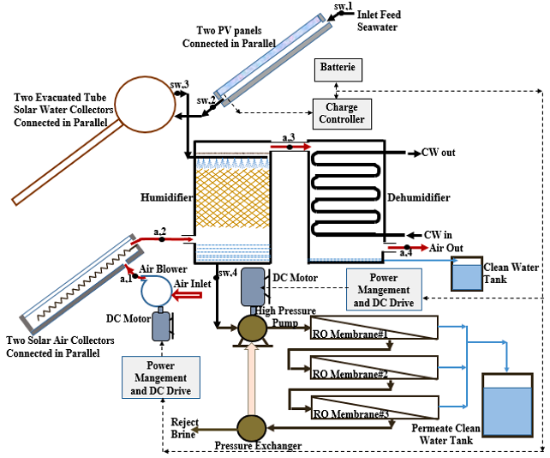
Figure. 28. Schematic of PV/T module assisted humidification-dehumidification-reverse osmosis desalination system [134]
PV/T module based hot water generation system finds application in space conditioning in cold regions and domestic hot water supply in other regions. Incorporation of PV/T module with heat pump can reduce the electrical energy consumption of heat pump significantly [135]. Concept of utilizing hot water from PV/T module for hydrogen generation [136] is shown in Figure. 29. The optimum flow rate of water in PV/T modules is estimated to be around 0.001 to 0.008 kg/m²s. However, some studies have reported flow rate of 0.015 kg/m²s as optimum [122]. Hence design, configuration and application might be the factors influencing the optimum flow rate of water in PV/T modules. The detailed information required to fabricate a PV/T module can be found in [116]. A lot of works have been done in the area of PV/T module assisted hot water generation system out of which few important findings/applications have been summarized in Table. 4.
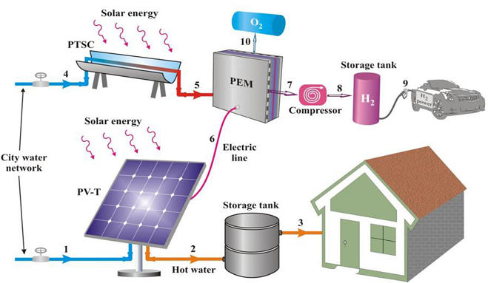
Figure. 29. Schematic showing concept of utilizing PV/T module for hydrogen generation [136]
Table. 4. Summary of research works on application of water based PV/T module
S.No | Overview of the research work | Type of Work | Outcome | Reference
1. | Comparison of PV and water veil cooled PV/T module | Experiment | Electrical efficiency of water veil cooled PV/T module with polycarbonate cover is about 10.7% lower than PV module because of reduced transmission in polycarbonate cover | [121]
2. | Impact of insulation thickness, wind speed, solar radiation, water mass flow rate on PV/T performance | Experiment and Simulation | Optimum insulation thickness – 0.08 to 0.14 m  Thermal efficiency drops from 70% to 40% with increase in wind speed from 1 m/s to 5 m/s  Electrical efficiency of the module drops with increase in solar radiation intensity  Water outlet temperature of 49°C for water inlet mass flow rate and temperature of 0.05 kg/s and 25°C, respectively | [137]
3. | Comparison of PV/T module and PV/T module with air gap between panel and glass cover | Simulation | Provision of air gap reduces heat losses from the PV/T module to the ambient in cold locations  Hot water at 60°C and 43°C is obtained from PV/T module with air gap and PV/T module, respectively at a water flow rate of 0.175 kg/min  Thermal and electrical efficiency of PV/T module with air gap is about 47.0% and 12.03% (0.94% lower than PV panel), respectively | [138]
4. | Comparison of PV/T module and PV module | Experiment | PV/T module produces 6.34% higher power output than PV module at water mass flow rate of 0.02 kg/s | [139]
5. | Impact of reflectors on PV/T module performance | Experiment and Simulation | Optimal tilt angle of bottom reflector of PV/T module tilted at 45° with vertically oriented top reflector is about 37.87° and 5.12° during summer solstice and winter solstice day, respectively  The total electrical and thermal energy generated by the reflector incorporated PV/T module is about 12% and 8% higher than PV/T module without reflector, respectively  Thermal and electrical efficiency of PV/T module with reflector is about 9.78% and 1.39% lower than PV/T module without reflector, respectively | [140]
6. | Performance investigation of PV/T module | Experiment and Simulation | Temperature of PV/T module is about 15 to 20% lower than PV module  Thermal efficiency drops with increase in solar radiation intensity | [141]
7. | Modeling of PV/T module assisted hot water system | Simulation | Detailed 3D thermal and electrical model of PV/T module assisted hot water system | [142]
8. | Second law analysis of PV/T module | Simulation | Operation of PV/T module at low fluid inlet temperatures is not recommended as the generated thermal energy is useless at low temperatures  Exergy efficiency can be improved by supplying inlet water at optimum temperature corresponding to the operating condition  Optimum inlet temperature lies between 30 to 50 for solar radiation intensity between 400 to 900 W/m² | [143]
9. | Performance of PV/T module with nano-fluids | Experiment | Use of nano-fluids reduces PV/T cell temperature by 15 to 30°C  Single wall carbon nano tube/water and multi wall carbon nano tube/water based nano-fluids (0.02 wt%) increases power output of PV/T module by 51.08% and 31.43%, respectively compared to PV module | [144]
10. | Impact of absorber tube configuration on performance of nano-fluid assisted PV/T | Simulation | The absorber tube with internal porous ribs is better than plain absorber tube due generation of less entropy and enhanced heat transfer  The thermal exergy efficiency of PV/T with porous ribbed absorber is around 46% and 50% higher than absorber tube with ribbed and plain surfaces, respectively | [145]
11. | Impact of spectrally selective absorbing nano-fluids on PV/T performance | Experiment and Simulation | Ag-SiO₂ nano-particle suspended in water is used as a filter to split spectrum suitable for solar module to generate electricity  No contact between heat transfer surface and PV module  Temperature of the heat transfer fluid does not affect the PV performance  12% higher power output than sole PV module | [146]
12. | Impact of modification on PV/T module performance (Tedlar layer is replaced with 0.2 mm thick copper plate  Water is circulated between the copper plate and aluminum tray  Testing with and without outer glazing) | Experiment | Modified PV/T module’s top layer is hotter than PV module  Electrical efficiency of modified PV/T module is similar to PV module  Incorporation of upper glazing reduces electrical efficiency and increases thermal efficiency | [116]
13. | Impact of glass cover and horizontal bottom & vertical top reflectors on performance of PV/T collector | Experiment | Electrical efficiency with and without glass cover is 9.01 and 11.72%, respectively  Thermal efficiency with and without glass cover is 49.94 and 38.25%, respectively  Tilt angle of bottom reflector has significant effect on performance  Optimum tilt angle of bottom reflector is 0°  The electrical and thermal efficiency with both reflectors is 9.96 and 71.07%, respectively | [147]
14. | Impact of PV/T cooling water flow rate on hydrogen production | Simulation | Payback period PV/T drops from 8.093 to 7.734 year with increase in cooling water flow rate from 5 to 50 g/s  Increased cooling water flow rate enhances power output of PV/T module thereby leading to enhanced hydrogen production  Increased ambient temperature has negative impact on power output of PV/T and hydrogen generation capability | [136]
15. | Development of novel thermal model for PV/T module | Experiment and Simulation | Ohmic heating and contact resistance are considered in the thermal model  Outlet water temperature is affected by surface contact resistance between the tedlar and absorber  Electrical efficiency is dropped due to Ohmic heating | [148]
16. | Comparison of PV/T module with serpentine and channeled heat exchange coil | Experiment and simulation | Temperature of PV/T module with channeled heat exchange coil is about 20 °C and 11°C lower than PV module and PV/T module with serpentine heat exchange coil, respectivley | [149]

Major advantages and limitations of water based PV/T module are:
Both heat energy and electricity are generated in the same unit with improved overall efficiency thereby space is also saved [150]
PV/T module is a suitable option to replace building roofing material and to have minimum payback period [150]
Electricity requirement of heat pump can be minimized by integrating with PV/T modules
PV/T modules are suitable for applications where both electricity and heat are required simultaneously thereby energy storage is necessary for utilizing PV/T module if the hour of need is different [151]
Auxiliary heaters are essential for operation of PV/T module in winter to meet the heating demand [151]
Relatively costly compared to sole PV module and sole solar collector [151]
The scope for further investigations in the area of water based PV/T adoptions are:
Development of automatic control for adjustment of optimum inlet water temperature for the corresponding solar radiation intensity to have best performance
Development of techniques to establish improved contact between the PV-module and absorber to improve conductive heat transfer coefficient to recover more thermal energy
Development of polymer based absorbers to reduce weight, manufacturing complexity and cost of PV/T modules
Development of less weight PV//T modules for suitable installation in old and new building infrastructures
Stability studies on water based nano-fluids at high temperatures for application in concentrated PV/T modules
Identification of suitable water-nano particle mixture to absorb infra red spectrum for improved thermal efficiency of PV/T module with spectral splitter
Optimal sizing of thermal and electrical energy storage for application in PV/T modules
Development of polices and awareness to enhance utilization of PV/T modules among public and private industries
3.5 Literature review on agrivoltaic systems
Another important PV adoption that is very new and related to water is Agrivoltaics. In Agrivoltaic applications, the land area is utilized for both agriculture/livestock and electricity production from the installed photovoltaic systems. It is related to water because it affects the water needs for agriculture and the land itself. The environmental impact of agrivoltaic is similar to the traditional land mounted PV system however it has potential additional benefits like effective land utilization [152]. Moreover, in locations with arid climates, agrivoltaic can offer protection for the crops/livestock against excessive solar radiation, heat and/or drought [153]. The schematic representing the concept of agrivoltaic is shown in Figure. 30. In agrivoltaic, the modifications in the PV system can be in the structure or in the module. Structures need to account for the height required for the passage of machinery, and are usually between 4 -7 m higher from the ground. PV modules must also be further separated to optimize shading requirement according to the crop type. Gutters should be installed at the end of the structures to collect the water and to prevent soil erosion and crop damage in the case of heavy rains. The first agrivoltaic adoption was taken place in France and the PV modules were installed at a height of 4 m from the ground to facilitate smooth accessibility for farm workers and farm machinery to the cultivated crop [153, 154].
It has been estimated that the electric energy used for crop production is only about 1% of the total energy generated by the agrivoltaic unit installed over the agricultural lands. Shading helps to improve the productivity of crops like lettuce. Shading of agricultural land by about 40% and 20% can be achieved by covering 50% and 25% of the land with agrivoltaic, respectively [154]. However, for poor shade tolerant crops like grapes (grapes require good sun shine), it is recommended to install the PV modules in the available space (1.5 to 2.5 m) between the trellises as shown in Figure. 31., to minimize shading over the grape crop. It has been estimated that the annual revenue generated per acre of agrivoltaic incorporated grape farm is about 6.3% and 93.6% from grapes and PV electricity, respectively. Most of the agricultural lands are in rural regions thereby adoption of agrivoltaic helps in rural electrification to a large extent [156].
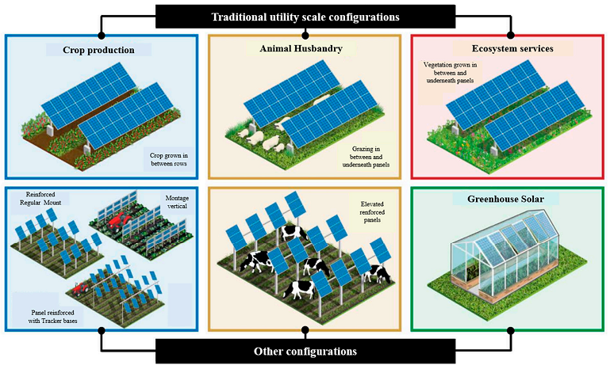
Figure 30: Concept of agrivoltaic system [155]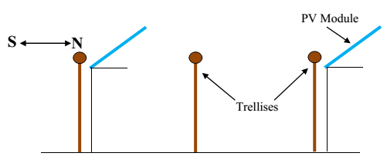
Figure. 31. PV Module arrangement in a grape farm [156]
Silicon based PV modules are nearly opaque, rigid, brittle, and require heavy structures for installations. In addition, it is highly suitable for crops requiring shade or low solar radiation intensity. Due to its opaqueness the entire agricultural field cannot be covered with conventional PV modules. These drawbacks can be overcome by adopting tinted semi-transparent solar PV modules [157] and engineered flexible thin film organic photovoltaic modules [158] which are capable of producing electricity by sharing solar spectrum with plants and using the spectrum unused by plants for electricity generation, respectively [158]. The agrivoltaic concept implemented using tinted semi-transparent PV modules in basil harvest is shown in Figure. 32. Some of the issues to be considered during adoption of PV modules are the type of crop that occupies the land. Depending on the sensitivity of the plant and the climate of the place, there may be losses in production due to shading, or on the contrary, there may be some gain in production too. For example, in a study from the Fraunhofer ISE [153] with Chinese cabbages, when there was excessive shading, production was significantly lower (up to 70% losses) than in the case of normal sun exposure. But in the case of potato cultivation, partial shading under a hot climate slightly benefited its production by about 3%. Microclimate observed below the agrivoltic modules indicates its potential to mitigate climate stress and save water [159]. Adoption of agrivoltaic helps to reduce evapo-transpiration by about 14 to 29% depending on the level of shade and type of crop [160]. Life cycle assessment indicates that pasture based agrivoltaic system produces around 69.3% less greenhouse gas emissions and requires 82.9% lower fossil fuel than separate rabbit farming and PV power production [161].
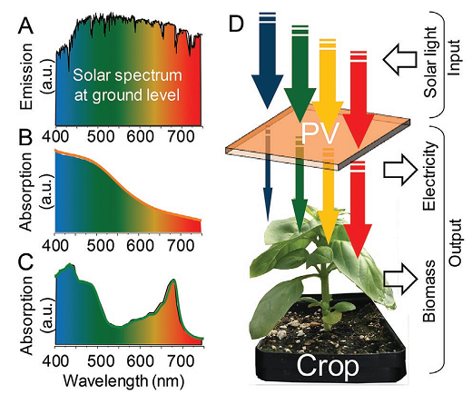
Figure. 32. Agrivoltaic concept implemented using tinted semi-transparent PV modules in basil harvest [157]
Main advantages of agrivoltaic system are:
Renewable energy generation and utilization [151]
Increased land productivity (ie.) both power and food from same land [154]
Preserves agricultural land
Reduced greenhouse gas emissions
Relatively high crop yield and reduced evapo-transpiration [161]
Reduced crop irrigation water requirements
Crop protection from excess solar radiation intensity and adverse weather like hails, drought and heat stress [161]
Additional revenue generation for farmers [162]
Local employment generation and local food production [162]
Can serve as charging points for electric vehicles [163]
Some factors that limit the application of agrivoltaic systems are [162, 163, 164]:
Lower power density per area due to incorporation of spacing between modules and utilization of semitransparent modules
Requirement of high capital cost compared to conventional farming
Lack of proper policies and sustainable business models in this area
Inconvenience of farmers to work along with PV modules in farmlands
Flexibility in crop selection is limited due to adoption of agrivoltaic as different crops require different levels of shade or solar intensity for high yield
Being a new technology (less than 15 year from first installation) a number of long-term studies are needed to prove its potential benefits
The scope for further investigations in the area of agrivoltaic adoptions are:
Economic feasibility of agrivoltaic for different crops in different locations
Behavior of crops under agrivoltaic and selection of suitable PV modules
Optimization of agrivoltaic spacing, tilt and clearance from the ground achieve desired radiation and shade as required by the crop
Impact of various functional units on the agrivoltaic life cycle analysis results
More experimental studies on tinted semi transparent agrivoltic module as they can be designed crop specific
Cropland attracts birds hence bird dropping over agrivoltaic will be a issue hence cost effective and efficient module cleaning technique at required intervals needs to be developed/identified
Development of suitable novel crop specific agrivoltaic structures
Safety guidelines, industry-farmer partnerships and insurance policies needs to be prepared for farmers and workers working in agrivoltaic adopted crop lands and pasture lands to attract positive response from farming community
3.6. Literature review on aquavoltaic systems
Aquaculture generally refers to the farming of aquatic organisms like fish, shrimp, seaweeds etc. Aquaculture is one of the fastest growing industries and nearly 43% of the seafood comes from aquaculture [165]. Conservation of water and use of clean energy becomes mandatory for the survival of aquaculture industry and for meeting the future food demnds. Solar PV modules can be used in hatchery, grow-out, cage on-shore and cage off-shore type aquaculture as shown in Figure. 33. Utilization of PV modules over the aquaculture water bodies can reduce their evaporation rates by about 85%. This dual use of water for both solar PV based electric power production and aquaculture is called aquavoltaic. The electric energy generated by the aquavoltic system can be used to power aeration units, light emitting diodes, water pumps of the aquaculture tank, and other electric loads like lights, fan, fridges etc., [166]. Overall energy requirement in aquaculture for producing one kg of aquatic food depends on the type of aquatic species and it ranges between 1 to 772 MJ/kg. The water quality of aquaculture industry can be improved by aquavoltaic powered aeration process [165]. Aeration is an important process as it helps to enhance dissolved oxygen content and removes certain dissolved gases and minerals in water. Moreover, aeration process is carried during late night hours to early mornings during which the dissolved oxygen content in water is lower [167]. Aeration is also one of the energy consuming activities in aquaculture. Solar PV modules are more suitable for powering blowers for aeration of aquaculture ponds [168]. In addition, aquavoltaic powered light emitting diodes having selective spectral range is also helpful in enhancing fish growth and sea food productivity [166].
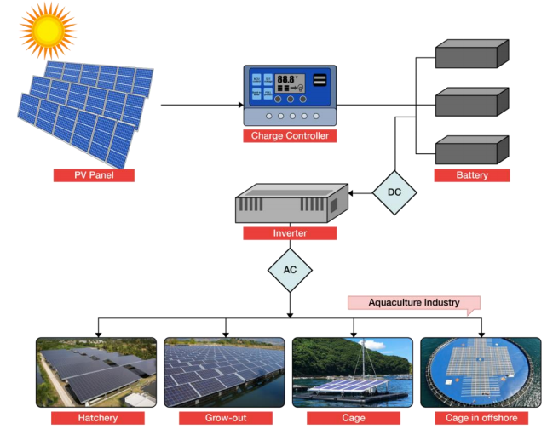
Figure. 33. Solar PV energy adoptions in aquaculture [165]
Kim et al. [169] demonstrated aquavoltic system in a salt farm in which both salt and electricity are harvested. The schematic representing such a concept is shown in Figure. 34. Salt farms are generally situated in regions with high solar radiation potential but due to financial losses many farmers generally rent their land for solar power production instead of salt harvesting. Salt farms consist of reservoir (1 to 3 wt/wt% salinity), evaporation pond (first zone: 3 to 8 wt/wt% salinity; second zone: 8 to 18 wt/wt% salinity) and crystallization pond (27 to 30 wt/wt% salinity). Installation of waterproof PV modules at the bottom of the evaporation section (occupies 85% of the total farm area) at a depth to 10 to 20 cm is suggested to enhance the profits for farmers and to conserve salt production. It has been observed that the solar energy intensity in the wavelength range from 0.3 to 0.6 μm has not changed up to a saline water depth of 30 cm. However, energy intensity of solar spectrum above 0.6 μm has dropped considerably with water depth which can be seen from Figure. 35. In short term, the electric power output of the submerged PV modules is found to be higher than land mounted modules due to the cooling effect of the modules caused by the saline water. Moreover, it was also observed that the submerged PV modules have enhanced evaporation rates in evaporation ponds. However, foreign matter deposition over the modules with time degrades the PV power output considerably with time. In spite of this, it was observed that the annual power output of submerged PV modules (1910 kWh) is nearly equivalent to ground mounted PV output (1962 kWh). Hsiao et al. [170] suggested that the success of aquavoltic in improving aquaculture sector and enhancing renewable energy utilization is only possible through strong partnerships between the civic society, governments, academic community and the locals.
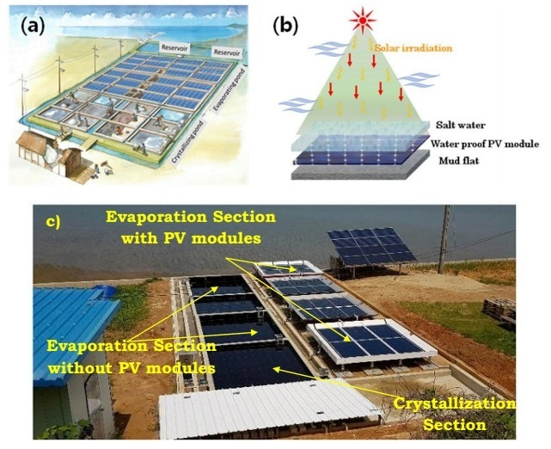
Figure. 34. Solar PV adoption in salt farm [169]
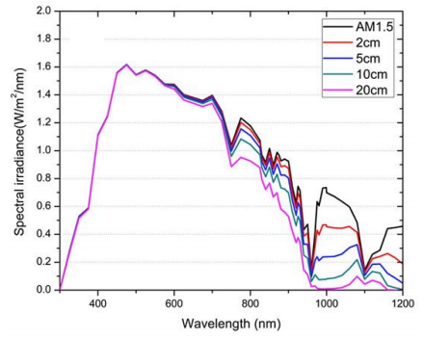
Figure. 35. Solar energy spectrum at various water depth in comparison to spectrum at Air mass ratio 1.5 [169]
The major advantages and limitations of incorporating aquavoltaic are [170, 171]:
Reduces fossil fuel dependence and energy cost
Mitigate greenhouse gas emissions and enhance sustainability in long term run
Improves fish harvest, farmers income and improves social status of local communities
Land occupancy by PV modules and water evaporation can be minimized/avoided by aquavoltaic adoption
High initial, maintenance and operating cost
Impact on fishpond water quality and ecosystem is unknown
Exploitation of fish pond areas by landowners due to lack of policies
The scopes for further investigations in the area of aquavoltaic adoption are:
Quality of salt produced by submerged PV system adopted salt farm needs to evaluated and reported as components in PV modules react with saline water
Long term studies are needed to identify the degradation pattern of quality and power output of submerged PV
Techniques and mechanisms need to be developed for efficient cleaning and maintaining of submerged PV system in salt farms
Simulation and experimental studies are needed in various salt farming locations to predict and prove the effectiveness of submerged PV system salt farming technique
Policies, awareness, training programs for salt farmers and subsidy frameworks needs be developed to successfully commercialize submerged PV system salt farming technique
Economic aspects of solar PV adopted aquaculture and salt farming is needed
3.7. Literature review on hybrid solar water disinfection + PV system
The objective of solar water disinfection is to eliminate pathogenic micro-organisms from drinking water using the energy of the sun to make it suitable for human consumption. Main pathogenic microorganisms that cause diarrhoea are Escherichia coli, fecal enterococci or Clostridium perfringens. Combined disinfection and distillation can be carried out using solar water distillation unit. This technology uses the sun’s energy to heat the water to speed up evaporation, and then condenses the vapor thereby contaminant-free distilled water is obtained. For example, E.coli is a bacterium in water with an optimum growth temperature of 37 ºC, but when water temperature reaches 46 ºC, its growth stops and then the denaturation of the proteins and death of the microorganism begins. Solar PV module has also been adopted in solar distillation system as solar still’s absorber surface, condensing surface and reflector [132]. The first option of PV module as absorber does not seem to have a real advantage since the solar radiation losses will be very high as the light has to go through a glass layer, air layer, water layer and then reach the PV module. Apart from this salts and soiling that will accumulate on top of the PV module when the water evaporates also affects the performance of the PV module in a negative way [172]. The second option of PV module as condensing surface seems attractive but condensation heat transfer on the backside of the module may affect the operating temperatures of module but this effect have not been studied/reported so far. It should be noted that this proposal was only theoretical and currently lacks an experimental proof [173]. The third option of PV module as reflector is really ineffective as the PV module just act as reflector and it will not be oriented at its optimum inclination angle which will affect the PV module’s performance negatively [174].

Figure 36: The SODIS method [175]
The second way to disinfect water with solar energy is to use the SODIS (Solar Water Disinfection) method in which effect of solar ultraviolet (UV) radiation is utilized [26]. Solar UV rays causes damage to the DNA and RNA of the microorganisms. UV rays can be divided into UVC, UVB and UVA radiation. UVC is the most effective and fastest. However, the atmosphere filters this powerful radiation and only UVB and UVA reach us which are slower and less effective, but still this can be used for water disinfection and the production of safe drinking water. UVC is the one obtained using artificial mercury ultraviolet lamps in labs. In SODIS method, water filled transparent plastic bottles are exposed to the sun for six hours on a sunny day and two days if it is cloudy as shown in Figure. 36. It is a simple method that does not change the water taste, but it is slow and has the danger of the migration of toxic compounds from the plastic bottle into the water. Due to the slow nature of the process, it is typically used for water treatment at household levels in developing and underdeveloped countries and it is not practiced at industrial level. Moreover, the environmental impact of the plastic needs to be considered since the bottles must be changed every six months [175].
To increase the speed, efficiency of the SODIS process, to avoid the use of plastics, and to size the treatment system at the community level, a new photovoltaic-photochemical hybrid system [176] has been proposed (SolWat system), in which a water treatment reactor is built on a photovoltaic module. The concept of SolWat system and modifications made in PV module is shown in Figure. 37(a-b). When solar radiation reaches the system, the water absorbs and uses part of the ultraviolet (5% of the total) and far infrared for water disinfection. The visible and near infrared components are transmitted by the water to the photovoltaic module which utilizes them to produce electricity. It is a chemical free, energy independent system with a lower environmental impact as it uses renewable energy and avoids the use of plastic. It is also a faster process due to its geometry (optimum inclination). Moreover, the maintenance is also simple [177].
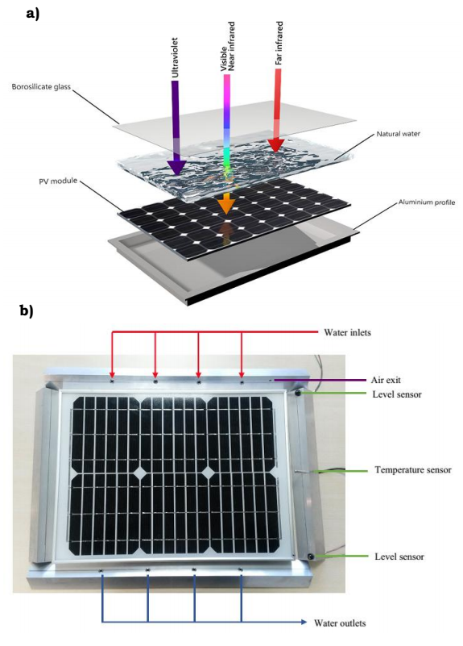
Figure 37: SolWat system: a) concept b) modifications made on PV module [177]
The SolWat system has been built and tested with several experimental campaigns and its viability has also been demonstrated, which confirms the capability of the system in simultaneous production of both electricity and drinking water [178-181]. One of the main results is that the energy generated by the hybrid module (with the water reactor on top) is the same as that generated by the independent photovoltaic module during the 6 h of water treatment during the experimentation [177, 182, and 183]. This is because of two mechanisms that compensate each other. The module receives less solar radiation because it has a layer of water on top that removes the ultraviolet, rays which, although used with little efficiency, contributes to the generation of electric current, and this translates into current losses of approximately 5 %. However, the layer of water cools down the module, and causes a voltage increase. The difference observed between both modules is about 9 ºC, i.e. the photovoltaic module of the SolWat hybrid system is 9 ºC cooler than the conventional PV module. Therefore, the current losses are compensated with the voltage increase and finally the generated energy is the same during those 6 h of treatment. Regarding the water disinfection, the water treatment time could be reduced to four hours depending on the initial water quality. It could be used in both drinking water applications and wastewater treatment [184].
The major advantages and limitations of hybrid solar water disinfection + PV system are:
Both clean drinking water and electric power are produced from the single unit
Cooling effect caused by the water sustains PV module performance
More suitable for improving hygiene in remote, rural and under developed regions
Can be scaled to desired size as per requirement
Cannot be used for treating highly turbid or muddy water
Long term performance studies for various feed water quality and PV performance degradation due to slit deposition or algal growth are missing
The scopes for further investigations in the area of PV water disinfection system are:
Studies on solar concentrator assisted SolWat system to assess its improvement in water treatment capacity, pollutant removal efficiency and PV electrical efficiency
Research to evaluate the SolWat performance with anti-reflective coatings for glass cover and varying feed water supply rate & residence time
Evaluation of suitability of various PV module types for SolWat system
Integration on the potential of SolWat system with commercial water treatment plants for tertiary water treatment
Evaluation of economic and environmental impact aspects of SolWat system for commercial viability
4.0 Economics of PV adopted water related technologies
Levelized cost of energy/electricity (LCOE) is defined as the minimum cost for which the energy/electricity can be sold to obtain break-even of the investment over the life span of the energy/electricity generation system. LCOE is an effective parameter to compare the economics of various energy/electricity systems. Mathematically, LCOE is the ratio of total cost associated with the energy/electricity generation system over its life span to the energy/electricity generated by the system over its life span [114].
(38)
If degradation rate (0.50% per year) of the PV module is considered then levelized cost of system is estimated by [105, 106],
(39)
The time taken to regain the amount invested in the PV based energy system is called the system repayment period and is mathematically expressed as [136],
(40)
The payback period of the PV or PV/T module based system can also be estimated by [126],
(41)
The annual cost saving due to installation of PV or PV/T module based systems can be estimated by [126],
(42)
The profitability of a project can be determined by net present value. If the net present value is greater than zero then the project is profitable else it will be a loss. Net present value is defined as the summation of net cash flows associated with the project over its intended duration which is then converted back to the present value at the initial/beginning phase of the project [55].
Net present value is expressed mathematically as [55],
(43)
The benchmark rate of return must be at least equal to or greater than internal rate of return for the project to be economically acceptable. The internal rate of return (IRR) can be estimated by equating the net present value formula to zero [55],
(44)
The associated costs are capital, insurance, tax, design, engineering, installation, operation and maintenance cost [114]. Tax will be varying with location hence some studies have not included tax while estimating LCOE [107]. The cost associated with floating PV system is about 0.22, 0.23, 0.10, 0.41, 0.10, and 0.04 USD/W for PV module, balance of system, inverter, engineering procurement & construction, floater, and moorings & anchors, respectively [107]. The cost of floating structure made of high density polyethylene is about 2.40 USD/kg. The annual operation & maintenance cost of floating PV system is about 0.026 USD/W. The LCOE of floating PV system and floating PV system in windy locations is about 0.074 USD/kWh and 0.054 USD/kWh, respectively [107]. The LCOE of partially submerged PV module system is around 0.059 to 0.063 USD/kWh [106].
The components of capital cost associated with agrivoltic system are PV module, inverter, mounting structures & hardware, combiner box, electrical components, site preparation & installation cost, system design, management & administration cost, due diligence including yield certificate, legal cost, grid connection cost, soil protection and tender procedure cost which are about 319.0, 66.0, 445.6, 16.5, 329.0, 40.5, 27.5, 13.8, 110.0, 34.0 and 5.5 USD/kWp, respectively. The components of operating expenses in agrivoltaic system are land costs, maintenance cost, surveillance cost, monitoring cost, commercial management cost, inverter replacement reserve cost, insurance cost, repair services and other miscellaneous cost which are about 1.85, 0.09, 1.58, 2.64, 6.05, 1.10, 1.49, 1.87, and 1.21 USD/kWp per acre, respectively. The LCOE of agrivoltaic system in Germany is about 0.091 USD/kWh which is about 38.0% higher than the LCOE of ground mounted PV system. The higher LCOE of agrivoltaic is associated with the requirement of tall mounting structures and soil protection measures [185]. LCOE for agrivoltaic system in arable and permanent crops (low clearance requirement) farming is about 0.120 and 0.087 USD/kWh, respectively [186].
PV/T systems are more economical in regions with abundant solar radiation potential. Even though amorphous silicon based PV/T modules are less efficient, they have better cost to benefit ratios than polycrystalline based PV/T modules [187]. The cost of PV/T collector per piece (1.55 m²), hydraulic components per set, expansion vessel per set, pipe per meter, heat transfer fluid per litre, mounting structures per collector, and installation cost per m² are about 331.0, 412.5, 154.0, 12.0, 65.0, and 44.0 USD, respectively. The operation and maintenance cost is about 1.0% of the capital cost [126]. The required capacity of water storage tank per m² of solar collector is about 50 L. The cost of water storage tank (in Euro) is related to the volume by the following relation [126].
(45)
The electricity cost, payback period and profit of grid connected PV/T module with nano fluid (water+SiO₂) as working fluid is about 0.196 USD/kWh, 8 year and 10218.14 USD, respectively [188, 189]. The annual profit obtained from PV/T system with and without solar still is about 879.72 and 333.77 USD, respectively. Integration of solar still has increased profits by 2.63 times compared to the PV/T system without still. The thermal and PV part of the PV/T system has a life span of about fifteen and thirty years, respectively. Periodic cleaning of solar still and circulation pump replacement every seven year is essential [132]. The payback period of 4000 m² PV/T –combined heat & power system having a capital cost of 1.44 Million USD used for heating swimming pool, generating hot water and electricity in Italy is capable of meeting 51.2% of thermal demand, 38.2% of electricity demand of the university sports centre and it has a payback period of about 11.6 year [127]. The levelized cost of heat and levelized cost of electricity of the PV/T-combined heat and power system is about 0.0605 USD/kWh and 0.132 USD/kWh, respectively [128].
The potential of using wastewater treatment plants for solar PV projects is found to be economically viable in twenty six urban sites of China. Self consumption of the PV power by the waste water treatment plant and solar radiation potential of the plant plays an effective role in deciding the economic viability of this initiative. The feed-in-tariff of the electricity generated by PV modules in wastewater treatment plants in China ranges between 0.034 to 0.063 USD/kWh [55]. The water treatment/desalination cost with PV module based reverse osmosis and electro-dialysis is highly dependent on the size of the desalination system. Water desalination cost of very small scale, small scale and medium scale PV powered reverse osmosis system is about 15.6, 6.5 to 12.8 and 0.8 to 8.4 USD/m³, respectively. Small scale PV powered electro-dialysis system treating brackish water has a water treatment cost of about 0.2 to 16.0 USD/m³ [27]. The non-discounted payback period of PV powered household based hydro power system is about 6.41 to 8.41 years in rural China [51]. The levelized cost of stored energy in hydro power plant incorporated with floating PV system is about 0.053 USD/kWh in India [90]. The cost of electricity generated by PV-pumped hydro power storage system in Africa used for meeting the energy demands in irrigation is about 0.129 USD/kWh which is nearly 0.292 USD/kWh lower than the cost of electricity generated by PV-battery storage system [48]. The cost of electricity from solar PV-pumped hydro storage ranges between 0.10 to 1.35 USD/kWh [28]. The cost of energy produced by PV pumping system is about 0.309 USD/kWh [13].The payback period of PV pumping system operating at a water head of 14.5 m ranges between four to six years. It can pump water at a cost of 0.04 USD/m³ at a flow rate of 60 m³/d [16].
Electricity and thermal energy can be extracted from PV module while both can be extracted in PV/T module. The generated electricity can be supplied to the grid or it can be used to desalinate water or treat wastewater or power accessories. Excess electricity generated in PV water pumping and PV based membrane desalination systems are pumped to the grid to generate additional revenue. In case of floating PV and agrivoltaic system, the generated electricity is pumped to the grid and these systems also prevent water evaporation from water bodies and soil, respectively thereby the cost associated with water supply is eliminated. In case of SolWat system, the generated excess electricity is supplied to the grid and at the same time tertiary treatment of wastewater is also carried. The performance index (PI) of these various PV adopted-water related technologies can be compared and ranked by the following relation
(46)
Floating PV system installed over the water bodies supplying drinking water and/or agricultural farm irrigation water provides electric power and also prevents water evaporation. This saved water prevents water scarcity and also eliminates the need for purchasing tanker water thereby significant monetary expenses is prevented. It has been estimated that covering 30.0% of the global reservoirs with floating PV can prevent evaporation loss of 106 km³ of water per year [190]. The cost of 14000 litre tanker water in Pune, India is about 21.63 USD [191] and this amount can vary with locations. Similarly, floating PV installed over dams can increase the operation time of the associated hydro power plant due to elimination of water evaporation loss. The monetary savings or benefits in both the cases may differ which has not been quantified in any of the existing research works. Moreover, water savings are also possible with agrivoltaic and aquavoltaic. Hence, it can be concluded that the floating PV system, agrivoltaic, and aquavoltaic system will be highly competitive to other PV module adopted water technologies due to their additional benefits.
5.0 Summary and conclusions
In this review work, PV adoption in various water technologies have been classified and critically reviewed highlighting their operating principle, advantages, limitations and their impact on PV module structure, performance and economics. PV module based pumping units, and stand-alone desalination units have reached commercial stage. Application of PV pumping in mining sector has been less explored. Agrivoltiac and aquavoltaic are attractive as they increases food productivity and provide additional income to farmers. However, requirement of huge initial investment is one of the limitations of agrivoltaic and aquavoltaic hindering their immediate acceptability among the farmers. Floating PV installations are rising exponentially due to its no land requirement, improved performance and flexibility with hydro power plant. Unmanned PV water vehicles are at the developing stage but have huge scope in upcoming years in the area of marine and other water body explorations. Water based PV/T modules are well commercialized and are widely adopted in various sectors. SolWat system proposed for water disinfection and power generation is highly suitable for under developed regions of the globe to supply both clean water and power. Economics of the reviewed systems are closer to levelized cost of electricity from fossil fuel. PV adopted water technologies are more promising in achieving the United Nations sustainable development goal 6 (clean water and sanitation) and 7 (affordable and clean energy). Moreover, they help to mitigate climate change, emissions, water scarcity and provide additional employment opportunities which justifies the growth opportunities of industries in these sectors. Any new developments in PV modules and materials for floating structures will benefit these technologies. However, more research is needed on the thermal, electrical modeling, environmental aspects, economic feasibility and reliability of these systems for effective end use and commercialization.
Acknowledgements
The authors acknowledge funding from the Spanish Ministry of Science and Innovation, ‘Research Challenges 2018 R+D+i Projects’ Programme, Grant number RTI2018-099308-A-I00. M. Vivar acknowledges funding from the Spanish Ministry of Economy and Competitiveness, ‘Ramón y Cajal’ Programme, Grant number RYC-2015-17306. H. Sharon acknowledges ‘Start-up Research Grant’ funding from the Science & Engineering Research Board (SERB), Department of Science & Technology (DST), Government of India, (Grant No. SRG/2023/000017).
The authors thank and acknowledge Elsevier publications for permitting to use Figure. 6b, Figure 7, Figure 8, Figure 9, Figure 11, Figure 12, Figure 13, Figure 14, Figure 15(a-c), Figure 16, Figure 18, Figure 19, Figure 20, Figure 21(b-c), Figure 22, Figure 25, Figure 26, Figure 27, Figure 28, Figure 29, Figure 34, Figure 35, Figure 36, and Figure 37 through Rightslink copyright services and Figure 17 & Figure 24 through CC-BY open access license. Thanks are extended to John Wiley & Sons publication for permitting to use Figure 21a through Rightslink copyright services and Figure 32 through CC-BY open access license. The authors acknowledge MDPI publishers for permitting to use Figure 30 and Figure 33 through CC-BY open access license. Acknowledgement is also extended to IWAP publication for permitting us to use Figure 6a that is “Reprinted from Water Supply, volume 19, issue number 6, pages 1758-1766, with permission from the copyright holders, IWA Publishing.”.
Conflict of Interest
The authors declare that there is no conflict of interest
References
- Brandoni C, Bosnjakovic B. HOMER analysis of the water and renewable energy nexus for water-stressed urban areas in sub-Saharan Africa. Journal of Cleaner Production 2017; 155: 105-118.
- Albatayneh A, Hindiyeh M, AlAmawi R. Potential of renewable energy in water-energy-food nexus in Jordan. Energy Nexus 2022; 7: 100140.
- Pietrasanta AM, Mussati SF, Aguirre PA, Morosuk T, Mussati MC. Water-renewable energy nexus: optimization of geothermal energy-powered seawater desalination systems. Renewable Energy 2022; 196: 234-246.
- Parida B, Iniyan S, Goic R. A review of solar photovoltaic technologies. Renewable and Sustainable Energy Reviews 2011; 15: 1625-1636.
- El Hammoumi A, Chtita S, Motahhir S, El Ghzizal AE. Solar PV energy: From material to use and the most commonly used techniques to maximize the power output of PV systems: A focus on solar trackers and floating solar panels. Energy Reports 2022; 8: 11992-12010.
- Venkateswari R, Sreejith S. Factors influencing the efficiency of photovoltaic system. Renewable and Sustainable Energy Reviews 2019; 101: 376-394.
- Gorjian S, Sharon H, Ebadi H, Kant K, Scavo FB, Tina GM. Recent technical advancements, economics and environmental impacts of floating photovolataic solar energy conversion systems. Journal of Cleaner Production 2021; 278: 124285.
- Fraunhofer, https://www.ise.fraunhofer.de/content/dam/ise/de/documents/publications/studies/Photovoltaics-Report.pdf/; 2022 (Accessed 17th October 2022).
- Sampaio PGV, Gonzalez MOA. Photovoltaic solar energy: Conceptual framework. Renewable and Sustainable Energy Reviews 2017; 74: 590-601.
- NREL, https://www.nrel.gov/news/program/2021/documenting-a-decade-of-cost-declines-for-pv-systems.html/;2023 (Accessed 5th October 2022).
- Gorjian S, Ebadi H, Trommsdorff M, Sharon H, Demant M, Schindele, S. The advent of modern solar-powered electric agricultural machinery: A solution for sustainable farm operations. Journal of Cleaner Production 2021; 292: 126030.
- Reddy KS, Sharon H, Krithika D, Philip L. Performance, water quality and enviro-economic investigations on solar distillation treatment of reverse osmosis reject and sewage water. Solar Energy 2018; 173: 160-172.
- Kazem HA, Al-Waeli AHA, Chaichan MT, Al-Mamari AS, Al-Kabi AS. Design, measurement and evaluation of photovoltaic pumping system for rural areas in Oman. Environ Dev Sustain 2017;19: 1041–1053.
- Islam MR, Sarker PC, Ghosh SK. Prospect and advancement of solar irrigation in Bangladesh: A review. Renewable and Sustainable Energy Reviews 2017; 77: 406–422.
- Aliyu M, Hassan G, Said SA, Siddiqui MU, Alawami AT, Elamin IM. A review of solar-powered water pumping systems. Renewable and Sustainable Energy Reviews 2018; 87: 61–76.
- Chandel SS, Naik MN, Chandel R. Review of solar photovoltaic water pumping system technology for irrigation and community drinking water supplies. Renewable and Sustainable Energy Reviews 2015; 49: 1084-1099.
- Hilarydoss S. Suitability, sizing, economics, environmental impacts and limitations of solar photovoltaic water pumping system for groundwater irrigation-a brief review. Environmental Science and Pollution Research 2023; 30: 71491-71510.
- Khatib T, Saleh A, Eid S, Salah M. Rehabilitation of Mauritanian oasis using an optimal photovoltaic based irrigation system. Energy Conversion and Management 2019; 199: 111984.
- Nikzad A, Chahartaghi M, Ahmadi MH. Technical, economic, and environmental modeling of solar water pump for irrigation in Mazandaran province in Iran: A case study. Journal of Cleaner Production 2019; 239: 118007.
- Yu Y, Liu J, Wang H, Liu M. Assess the potential of solar irrigation systems for sustaining pasture lands in arid regions – A case study in Northwestern China. Applied Energy 2011; 88: 3176–3182.
- Mérida García A, Fernández García I, Camacho Poyato E, Montesinos Barrios P, Rodríguez Díaz, JA. Coupling irrigation scheduling with solar energy production in a smart irrigation management system. Journal of Cleaner Production 2018; 175: 670-682.
- Rezk H, Abdelkareem MA, Ghenai C. Performance evaluation and optimal design of stand-alone solar PV battery system for irrigation in isolated regions: A case study in Al Minya (Egypt). Sustainable Energy Technologies and Assessments 2019; 36: 100556.
- Belgacem BG. Performance of submersible PV water pumping systesm in Tunisia. Energy for Sustainable Development 2012; 16: 415-420.
- Mokeddem A, Midoun A, Kadri D, Hiadsi S, Raja IA.Performance of a directly-coupled PV water pumping system. Energy Conversion and Management 2011; 52: 3089-3095.
- Okakwu IK, Alayande AS, Akinyele DO, Olabode OE, Akinyemi JO. Effects of total system head and solar radiation on the techno-economics of PV groundwater pumping irrigation system for sustainable agricultural production. Scientific African 2022;16: e0118.
- Wright NC, Winter AG. Justification for community-scale photovoltaic-powered electrodialysis desalination systems for inland rural villages in India. Desalination 2014; 352: 82-91.
- Zhang Y, Sivakumar M, Yang S, Enever K, Ramezanianpour M. Application of solar energy in water treatment processes: A review. Desalination 2018; 428: 116-145.
- Javed MS, Ma T, Jurasz J, Amin MY Solar and wind power generation systems with pumped hydro storage: review and future perspectives. Renewable Energy 2020; 148: 176-192.
- Mir N, Bicer Y. Integration of electrodialysis with renewable energy sources for sustainable freshwater production: A review. Journal of Environmental Management 2021; 289: 112496.
- Carvalho PCM, Carvalho L A D, Filho JJ H, Oliveira R S H. Feasibility study of photovoltaic powered reverse osmosis and pumping plant configurations. IET Renewable Power Generation 2013; 7(2): 134-143.
- Saleem MW, Abbas A, Asim M, Uddin GM, Chaudhary TN, Ullah A. Design and cost estimation of solar powered reverse osmosis desalination system. Advances in Mechanical Engineering 2021; 13(6): 1-11.
- Ahmad GE, Schmid J. Feasibility study of brackish water desalination in the Egyptian deserts and rural regions using PV systems. Energy Conversion and Management 2002; 43: 2641-2649.
- Fiorenza G, Sharma VK, Braccio G. Techno-economic evaluation of a solar powered water desalination plant. Energy Conversion and Management 2003; 44: 2217-2240.
- Bilton AM, Wiesman R, Arif AFM, Zubair SM, Dubowsky S. On the feasibility of community-scale photovoltaic powered reverse osmosis desalination systems for remote locations. Renewable Energy 2011; 36: 3246-3256.
- AlMadani HMN. Water desalination by solar powered electrodialysis process. Renewable Energy 2003; 28(12): 1915-1924.
- He W, Amrose S, Wright NC, Buonassisi T, Peters IM, Winter AGV. Field demonstration of a cost-optimized solar powered electrodialysis reversal desalination system in rural India. Desalination 2020; 476: 114217.
- Gonzalez A, Grageda M, Ushak S. Assessment of pilot scale water purification module with electrodialysis technology and solar energy. Applied Energy 2017; 206: 1643-1652.
- Patel SK, Biesheuvel PM, Elimelech M. Energy consumption of brackish water desalination: Identifying the sweet spots for electrodialysis and reverse osmosis. ACS EST Engg 2021;1: 851-864.
- Chew CM, Ng KMD. Feasibility of solar powered ultrafiltration membrane water treatment systems for rural water supply in Malaysia. Water Supply, 2019; 19(6): 1758-1766.
- Schafer AI, Richards BS. Testing of a hybrid membrane system for groundwater desalination in an Australian national park. Desalination 2005; 183: 55-62.
- Bouhadjar SI, Kopp H, Britsch P, Deowan SA, Hoinkis J, Bundschuh J. Solar powered nanofiltration for drinking water production from fluoride-containing groundwater – A pilot study towards developing a sustainable and low-cost treatment plant. Journal of Environmental Management 2019; 231: 1263-1269.
- Paredes-Sanchez J.P. Villicana-Ortiz, E., Xiberta-Bernat, J., Solar water pumping system for water mining environmental control in a slate mine of Spain. Journal of Cleaner Production 2015; 87: 501-504.
- Song J, Choi Y. Design of photovoltaic systems to power aerators for natural purification of acid mine drainage. Renewable Energy 2015; 83: 759-766.
- Barbour E, Wilson IAG, Radcliffe J, Ding Y, Li Y. A review of pumped hydro energy storage development in significant international electricity markets. Renewable and Sustainable Energy Reviews 2016; 61: 421-432.
- Ichimura S. Utilization of cross-regional interconnector and pumped hydro energy storage for further introduction of solar PV in Japan. Global Energy Interconnection 2020; 3(1): 68-75.
- Vattenfall, https://powerplants.vattenfall.com/geesthacht/; 2022 (Accessed 6th October 2022).
- Axpo, https://www.axpo.com/dk/en/energy-knowledge/pioneer-project-in-the-swiss-alps.html/;2022 (Accessed 6th October 2022).
- Onu UG, Silva GS, Zambroni de Souza AC, Bonatto BD, Ferrira da Costa VB. Integrated design of photovoltaic power generation plant with pumped hydro storage system and irrigation facility at the Uhuelem-Amoncha African Community. Renewable Energy 2022; 198: 1021-1031.
- Petrollese M, Seche P, Cocco D. Analysis and optimization of solar-pumped hydro storage systems integrated in water supply networks. Energy 2019; 189: 116176.
- Martinez-Jaramillo J.E, Ackere AV, Larsen ER. Transitioning towards a 100% solar-hydro based generation: A system dynamic approach. Energy 2022; 239: 122360.
- Yang Z, Sun G, Behrens P, Ostergaard PA, Egusquiza M, Egusquiza E, Xu B, Chen D, Patelli E. The potential for photovoltaic powered pumped hydro systems to reduce emissions, costs and energy insecurity in rural China. Energy Conversion and Management X 2021; 11: 100108.
- Campana PE, Mainardis M, Moretti A, Cottes M. 100% renewable wastewater treatment plants: Techno-economic assessment using a modelling and optimization approach. Energy Conversion and Management 2021; 239: 114214.
- Colacicco A, Zacchei E. Optimization of energy consumptions of oxidation tanks in urban wastewater treatment plants with solar photovoltaic systems. Journal of Environmental Management 2020; 276: 111353.
- Strazzabosco A, Kenway SJ, Lant PA. Solar PV adoption in wastewater treatment plants: A review of practice in California. Journal of Environmental Management 2019; 248: 109337.
- Chen X, Zhou W Economic and ecological assessment of photovoltaic systems for wastewater treatment plants in China. Renewable Energy 2022; 191: 852-867.
- Solarworldonline, https://www.solarpowerworldonline.com/2019/05/greenskies-finishes 137-kw-solar-array-at-water-treatment-plant/;2022 (Accessed 6th October 2022)
- Kyocera, https://americas.kyocera.com/press-releases/pressreleases_201503232288.htm/; 2022 (Accessed 6th October 2022)
- Aguaresidues, https://www.aguasresiduales.info/revista/noticias/region-de-murcia-destina-3-me-a instalar-placas-fotovoltaicas-en-sus-edar-gssbn/; 2022 (Accessed 6th October 2022).
- Esamur, https://www.esamur.com/public/file/PlantafotovoltaicasfondosFEDER.pdf/; 2022 (Accessed 12th October 2022).
- Compromis, https://compromis.net/26389/cebrian-visita-la-planta-depuradora-de-pilar-de-la-horadada-ejemplo-de-reutilizacion-y-eficiencia-energetica/; 2022 (Accessed 12th October 2022).
- Elmundo, https://www.elmundo.es/elmundo/2010/03/21/valencia/1269170067.html/; 2022 (Accessed 12th October 2022).
- Morristownnj, https://morristownnj.govoffice3.com/index.asp?SEC=F92EE406-08FF-4166-ACC6-5C99729DF633&DE=DF581BC3-1F54-46AC-97FB-5171A93397EB&pri=0/; 2022 (Accessed 12th October 2022).
- Hartmanely, https://www.hartmanelyinvestments.com/community-solar/; 2022 (Accessed 12th October 2022).
- Kold, https://www.kold.com/story/10198522/roger-road-treatment-plant-goes-solar/; 2022 (Accessed 12th October 2022).
- Barkerone, https://barkerone.com/projects/roger-road-wastewater-treatment-facility-solar-plant/; 2022 (Accessed 12th October 2022).
- Waterworld, https://www.waterworld.com/wastewater/article/16207590/acres-of-solar-panels-to-power-major-md-wastewater-treatment-plants/; 2022 (Accessed 12th October 2022).
- Renewablesnow, https://renewablesnow.com/news/wssc-unveils-4-mw-of-solar-projects-in-maryland-388110/; 2022 (Accessed 12th October 2022).
- Pandey AK, Kumar RR, Kalidasan B, Laghari IA, Samykano M, Kothari R, Abusorrah AM, Sharma K, Tyagi VV. Utilization of solar energy for wastewater treatment: Challenges and progressive research trends. Journal of Environmental Management 2021; 297: 113300.
- World Bank. Where Sun Meets Water: Floating Solar Market. World Bank Group, ESMAP and SERIS1, 2019;1–131.
- Hammoumi AE, Chtita S, Motahhir S, Ghzizal AE. Solar PV energy: From material to use, and the most commonly used techniques to maximize the power output of PV systems: A focus on solar trackers and floating solar panels. Energy Reports 2022; 8: 11992–12010.
- Kumar M, Niyaz HM, Gupta R. Challenges and opportunities towards the development of floating photovoltaic systems. Solar Energy Materials and Solar Cells 2021; 233: 111408.
- Ghosh A. A comprehensive review of water based PV: Flotavoltaics, under water, offshore & canal top. Ocean Engineering 2023; 281: 115044.
- Sahu A, Yadav N, Sudhakar K. Floating photovoltaic power plant: A review. Renewable and Sustainable Energy Reviews 2016; 66: 815-824.
- Rauf H, Gull MS, Arshad N. Complementing hydroelectric power with floating solar PV for daytime peak electricity demand. Renewable Energy 2020; 162: 1227-1242.
- Cazzaniga R, Rosa-Clot M, Rosa-Clot P, Tina GM. Integration of PV floating with hydroelectric power plants. Heliyon 2019; 5: e01918.
- Haas J, Khalighi J, Fuente Ade la, Gerbersdorf SU, Nowak W, Chen Po-Jung. Floating photovoltaic plnts: Ecological impacts versus hydropower operation flexibility. Energy Conversion and Management 2020; 206: 112414.
- Taboada ME, Caceres L, Graber TA, Gallegillos HR, Cabezza LF, Rojas R. Solar water heating system and photovoltaic floating cover to reduce evaporation: Experimental results and modeling. Renewable Energy 2017; 105: 601-615.
- Santafe MR, Soler JBT, Romero FJS, Gisbert PSF, Gozalvez JJF, Gisbert CMF. Theoretical and experimental analysis of a floating photovoltaic cover for water irrigation reservoirs. Energy 2014; 67: 246-255.
- Cazzaniga R. Floating PV Structures. Floating PV Plants. In: Rosa-Clot M, Tina GM, editors. Floating PV plants, Academic Press; 2020 ,p. 33–45.
- PV-Float, https://pv-float.com/english/; 2022 (Accessed 6th October 2022).
- Eqmagpro, https://www.eqmagpro.com/wpcontent/uploads/2020/02/floating-solar-PV-report_compressed-31-40.pdf/; 2022 (Accessed 6th October 2022).
- Kaymak MK, Sahin AD, Problems encountered with floating photovoltaic systems under real conditions: Anew FPV concept and novel solutions. Sustainable Energy Technologies and Assessments 2021; 47: 101504.
- Rosa-Clot M, Tina GM. Submerged and floating photovoltaic systems: Modelling, Design and Case Studies. Academic Press; 2018.
- Elminshawy NAS, Elminshawy A, Osama A. An innovative cooling technique for floating photovoltaic module: Adoption of partially submerged angle fins. Energy Conversion and Management X 2023; 20: 100408.
- Trapani K, Millar DL. The thin film flexible floating PV (T3F-PV) array: The concept and development of the prototype. Renewable Energy 2014; 71: 43-50.
- Hayibo KS, Pearce JM. Foam-based floatovoltaics: A potential solution to disappearing terminal natural lakes. Renewable Energy 2022; 188: 859-872.
- Mayville P, Patil NV, Pearce JM. Distributed manufacturing of after flexible floating photovoltaic modules. Sustainable Energy Technologies and Assessments 2020; 42: 100830.
- Claus R, Lopez M. Key issues in the design of floating photovoltaic structures for the marine environment. Renewable and Sustainable Energy Reviews 2022; 164: 112502.
- Kjeldstad T, Lindholm D, Marstein E, Selj J. Cooling of floating photovoltaics and the importance of water temperature. Solar Energy 2021; 218: 544-551.
- Shyam B, Kanakasabapathy P. Feasibility of floating solar PV integrated pumped storage system for a grid-connected microgrid under static time of day tariff environment: A case study from India. Renewable Energy 2022; 192: 200-215.
- Tina GM, Scavo FB, Merlo L, Bizzarri F. Analysis of water environment on the performances of floating photovoltaic plants. Renewable Energy 2021; 175: 281-295.
- Trapani K, Martens S, Challagulla K, Yong S, Millar D, Maloney S. Water absorption characterization, electrical reliability and mechanical testing of a submerged laminated a-Si thin film photovoltaic (PV) cells. Microelectronics Reliability 2014; 54: 2456–2462.
- Liu H, Krishna V, Lun Leung J, Reindl T, Zhao L. Field experience and performance analysis of floating PV technologies in the tropics. Progress in Photovoltaics: Research and Applications 2018; 26(12): 957-967.
- Hooper T, Armstrong A, Vlaswinkel B. Environmental impacts and benefits of marine floating solar. Solar Energy 2021; 219: 11-14.
- Cazzaniga R, Rosa-Clot M. The blooming of floating PV. Solar Energy 2021; 219: 3-10.
- Clemons SKC, Salloum CR, Herdegen KG, Kamens RM, Gheewala SH. Life cycle assessment of a floating photovoltaic system and feasibility for application in Thailand. Renewable Energy 2021; 168: 448-462.
- Ajitha A, Kumar NM, Jiang XX, Reddy GR, Jayakumar A, Praveen K, Kumar TA. Underwater performance of thin-film photovoltaic module immersed in shallow and deep waters along with possible applications. Results in Physics 2019; 15: 102768.
- Carlson DF, Fursterling A, Vesterled L, Skovby M, Pedersen SS, Melvad C, Rysgaard S. An affordable and portable autonomous surface vehicle with obstacle avoidance for coastal ocean monitoring. HardwareX 2019; 6: e00059.
- Yuan S, Li Y, Bao F, Xu H, Yang Y, Yan Q, Zhong S, Yin H, Xu J, Huang Z, Lin J. Marine environmental monitoring with unmanned vehicle platforms: Present applications and future prospects. Science of the Total Environment 2023; 858: 159741.
- Wang X, Shang J, Luo Z, Tang L, Zhang X, Li J. Reviews of power systems and environmental energy conversion for unmanned underwater vehicles. Renewable and Sustainable Energy Reviews 2012; 16: 1958–1970.
- Ryu JH. Prototyping a low-cost open-source autonomous unmanned surface vehicle for real-time water quality monitoring and visualization. HardwareX 2022; 12: e00369.
- Makhsoos A, Mousazadeh H, Mohtasebi SS, Abdollahzadeh M, Jafarbiglu H, Omrani E, Salmani Y, Kiapey A. Design, simulation and experimental evaluation of energy system for an unmanned surface vehicle. Energy 2018; 148: 362-372.
- Sornek K, Wiercioch J, Kurczyna D, Figaj R, Wojcik B, Borowicz M, Wielinski M. Development of a solar-powered small autonomous surface vehicle for environmental measurements. Energy Conversion and Management 2022; 267: 115953.
- Khare N, Singh P. Modeling and optimization of a hybrid power system for an unmanned surface vehicle. Journal of Power Sources 2012; 198: 368–377.
- Tina GM, Rosa-Clot M, Rosa-Clot P, Scandura PF. Optical and thermal behavior of submerged photovoltaic solar panel: SP2. Energy 2012; 39, 17-26.
- Elminshawy NAS, Osama A, Saif AM, Tina GM. Thermo-electrical performance assessment of a partially submerged floating photovoltaic system. Energy 2022; 246: 123444.
- Elminshawy NAS, Osama A, El-Damhogi DG, Oterkus E, Mohmed AMI. Simulation and experimental performance analysis of partially floating PV system in windy conditions. Solar Energy 2021; 230: 1106–1121.
- Trapani K, Santafe MR. A review of floating photovoltaic installations: 2007– 2013. Progress in Photovoltaics: Research and Applications 2015; 23: 524-532.
- Rosa-Clot M, Rosa-Clot P, Tina GM, Scandura PF. Submerged photovoltaic solar panel: SP2. Renewable Energy 2010; 35: 1862–1865.
- Enaganti PK, Dwivedi PK, Srivastava AK, Goel S. Analysis of submerged amorphous, mono-and poly-crystalline silicon solar cells using halogen lamp and comparison with xenon solar simulator. Solar Energy 2020; 211: 744–752.
- Kumar NM, Subramaniam U, Mathew M, Ajitha A, Almakhles DJ. Exergy analysis of thin-film solar PV module in ground-mount, floating and submerged installation methods. Case Studies in Thermal Engineering 2020; 21: 100686.
- Aste N, Pero CD, Leonforte F. Water flat plate PV–thermal collectors: A review. Solar Energy 2014; 102: 98–115
- Ahmed OK, Algburi S, Daoud RW, Aziz EF. Photovoltaic storage solar collector: Experimental assessment. Energy Reports 2022; 8: 13698–13707.
- Mostakim K, Hasanuzzaman M. Global prospects, challenges and progress of photovoltaic thermal system. Sustainable Energy Technologies and Assessments 2022; 53: 102426.
- Allouhi A, Rehman S, Buker MS, Said Z. Recent technical approaches for improving energy efficiency and sustainability of PV and PV-T systems: A comprehensive review. Sustainable Energy Technologies and Assessments 2023; 56: 103026.
- Michael JJ, Selvarasan I, Goic R. Fabrication, experimental study and testing of a novel photovoltaic module for photovoltaic thermal applications. Renewable Energy 2016; 90: 95-104.
- Pang W, Cui Y, Zhang Q, Yu H, Zhang L, Yan H. Experimental effect of high mass flow rate and volume cooling on performance of a water-type PV/T collector. Solar Energy 2019; 188: 1360–1368.
- Reddy SR, Ebadian MA, Lin Cheng-Xian. A review of PV–T systems: Thermal management and efficiency with single phase cooling. International Journal of Heat and Mass Transfer 2015; 91: 861–871.
- Lamnatou C, Vaillon R, Parola S, Chemisana D. Photovoltaic/thermal systems based on concentrating and non-concentrating technologies: Working fluids at low, medium and high temperatures. Renewable and Sustainable Energy Reviews 2021; 137: 110625.
- Herrando M, Wang K, Huang G, Otanicar T, Mousa OB, Agathokleous RA, Ding Y, Kalogirou S, Ekins-Daukes N, Taylor RA, Markides CN. A review of solar hybrid photovoltaic-thermal (PV-T) collectors and systems. Progress in Energy and Combustion Science 2023; 97: 101072.
- Rosa-Clot M, Rosa-Clot P, Tina GM, Ventura C. Experimental photovoltaic-thermal Power Plants based on TESPI panel. Solar Energy 2016; 133: 305–314.
- Charalambous PG, Maidment GG, Kalogirou SA, Yiakoumetti K. Photovoltaic thermal (PV/T) collectors: A review. Applied Thermal Engineering 2007; 27: 275–286.
- Sultan SM, Efzan MNE. Review on recent Photovoltaic/Thermal (PV/T) technology advances and applications. Solar Energy 2018; 173: 939–954.
- Rejeb O, Dhaou H, Jemni A. A numerical investigation of a photovoltaic thermal (PV/T) collector. Renewable Energy 2015; 77: 43-50.
- Li Y, Nord N, Huang G, Li X. Swimming pool heating technology: A state-of-the-art review. Building Simulation 2021; 14: 421–440.
- Buonomano A, De Luca G, Figaj RD, Vanoli L. Dynamic simulation and thermo-economic analysis of a PhotoVoltaic/ Thermal collector heating system for an indoor–outdoor swimming pool. Energy Conversion and Management 2015; 99: 176–192.
- Wang K, Herrando M, Pantaleo AM, Markides CN. Technoeconomic assessments of hybrid photovoltaic-thermal vs. conventional solar-energy systems: Case studies in heat and power provision to sports centres. Applied Energy 2019; 254: 113657.
- Wang K, Herrando M, Pantaleo AM, Markides CN. Thermoeconomic assessment of a PV/T combined heating and power system for University Sport Centre of Bari. Energy Procedia 2019; 158: 1229-1234.
- Rosa Clot M, Rosa-Clot P, Tina GM. Submerged PV Solar Panel for Swimming Pools: SP3. Energy Procedia 2017; 134: 567–576.
- Ghazy M, Ibrahim EMM, Mohamed ASA, Askalany AA. Experimental investigation of hybrid photovolataic solar collector (PV/T)- adsorption desalination system in hot weather conditions. Energy 2022; 254: 124370.
- Gaur MK, Tiwari GN. Optimization of number of collectors for integrated PV/T hybrid active solar still. Applied Energy 2010; 87: 1763–1772.
- Sotehi O, Chaker A, Maalouf C. Hybrid PV/T water solar collector for net zero energy building and fresh water production: A theoretical approach. Desalination 2016; 385: 1 –11.
- Sharon H, Vivar M, Fuentes M. A review on role of solar photovoltaic (PV) modules in enhancing sustainable water production capacity of solar distillation units. Journal of Environmental Management 2022; 320: 115781.
- Abdelgaied M, Kabeel AE, Kandeal AW, Abosheiasha HF, Shalaby SM, Hamed MH, Yang N, Sharshir SW. Performance assessment of solar PV-driven hybrid HDH-RO desalination system integrated with energy recovery units and solar collectors: Theoretical approach. Energy Conversion and Management 2021; 239: 114215.
- Kang A, Korolija I, Rovas D. Photovoltaic Thermal District Heating: A review of the current status, opportunities and prospects. Applied Thermal Engineering 2022; 217: 119051.
- Atiz A, Erden M, Karakilcik M. Investigation of electricity, and hydrogen generation and economical analysis of PV-T depending o n different water flow rates and conditions. International Journal of Hydrogen Energy 2023; 48: 22766-22776.
- Abdin ZU, Rachid A. Bond graph modeling of a water-based photovoltaic thermal (PV/T) collector. Solar Energy 2021; 220; 571–577.
- Thinsurat K, Bao H, Ma Z, Roskilly AP. Performance study of solar photovoltaic-thermal collector for domestic hot water use and thermochemical sorption seasonal storage. Energy Conversion and Management 2019; 180: 1068–1084.
- Kazem HA. Evaluation and analysis of water-based photovoltaic/thermal (PV/T) system. Case Studies in Thermal Engineering 2019; 13: 100401.
- Kostic LT, Pavlovic TM, Pavlovic ZT. Optimal design of orientation of PV/T collector with reflectors. Applied Energy 2010; 87: 3023–3029.
- Khelifa A, Touafek K, Moussa HB, Tabet I. Modeling and detailed study of hybrid photovoltaic thermal (PV/T) solar collector. Solar Energy 2016; 135: 169–176.
- Pierrick H, Christophe M, Leon G, Patrick D. Dynamic numerical model of a high efficiency PV–T collector integrated into a domestic hot water system. Solar Energy 2015; 111: 68–81.
- Evola G, Marletta L. Exergy and thermoeconomic optimization of a water-cooled glazed hybrid photovoltaic/thermal (PVT) collector. Solar Energy 2014; 107: 12–25.
- Ahmadlou LA, Najafi G, Loni R, Kasaeian A, Mamat R, Ghazali MF, Abdullah A, El-Shafy AS, Mousa M. Experimental investigation of PV/T and thermoelectric systems using CNT/ water nanofluids. Applied Thermal Engineering 2023; 227: 120350.
- Hai T, El-Rahman MA, Li S, Malekshah EH, Aybar HS, El-Shafay AS. The entropy generation analysis and optimization of a water/silver nanofliud flow inside a photovoltaic thermal collector considering plain, ribbed, and porous-ribbed absorber tubes. Journal of the Taiwan Institute of Chemical Engineers 2023; 148: 104695.
- Crisostomo F, Hjerrild N, Mesgari S, Li Q, Taylor RA. A hybrid PV/T collector using spectrally selective absorbing nanofluids. Applied Energy 2017; 193: 1–14.
- Ahmed OK, Bawa SM. Reflective mirrors effect on the performance of the hybrid PV/thermal water collector. Energy for Sustainable Development 2018; 43: 235 –246.
- Das D, Kalita P, Dewan A, Tanweer S. Development of a novel thermal model for a PV/T collector and its experimental analysis. Solar Energy 2019; 188: 631–643.
- Selimli S, Dumrul H, Yilmaz S, Akman O. Experimental and numerical analysis of energy and exergy performance of photovoltaic thermal water collectors. Solar Energy 2021; 228: 1–11.
- Kumar A, Baredar P, Qureshi U. Historical and recent development of photovoltaic thermal (PVT) technologies. Renewable and Sustainable Energy Reviews 2015; 42: 1428–1436.
- Sathe TM, Dhoble AS. A review on recent advancements in photovoltaic thermal techniques. Renewable and Sustainable Energy Reviews 2017; 76: 645–672.
- Pascaris AS. Examining existing policy to inform a comprehensive legal framework for agrivoltaics in the U.S. Energy Policy 2021; 159: 112620.
- Fraunhofer, https://www.ise.fraunhofer.de/content/dam/ise/en/documents/publications/studies/APV-Guideline.pdf/; 2022 (Accessed 6th October 2022).
- Dupraz C, Marrou H, Talbot G, Dufour L, Nogier A, Ferard Y. Combining solar photovoltaic panels and food crops for optimising land use: towards new agrivoltaic schemes. Renewable Energy 2011; 36(10): 2725 –2732.
- Sarr A, Soro YM, Tossa AK, Diop L. Agrivoltaic, a Synergistic Co-Location of Agricultural and Energy Production in Perpetual Mutation: A Comprehensive Review. Processes 2023; 11: 248.
- Malu PR, Sharma US, Pearce JM. Agrivoltaic potential on grape farms in India. Sustainable Energy Technologies and Assessments 2017; 23: 104-110.
- Thompson EP, Bombelli EL, Shubham S, Watson H, Everard A, D’Ardes V, Schievano A, Bocchi S, Zand N, Howe CJ, Bombelli P. Tinted semi-transparent solar panels allow concurrent production of crops and electricity on the same cropland. Advanced Energy Materials 2020; 10: 2001189.
- Meitzner R, Schubert US, Hoppe H. Agrivoltaics- The perfect fit for the future of organic photovoltaics. Advanced Energy Materials 2021; 11: 2002551.
- Marrou H, Dufour L, Werry J. How does a shelter of solar panels influence water flow in a soil-crop system? European Journal of Agronomy 2013; 50: 38-51.
- Pascaris AS, Handler R, Schelly C, Pearce JM. Life cycle assessment of pasture-based agrivoltaic systems: Emission and energy use of integrated rabbit production. Cleaner and Responsible Consumption 2021; 3: 100030.
- Cuppari RI, Higgins CW, Characklis GW. Agrivoltaics and weather risk: A diversification strategy for landowners. Applied Energy 2021; 291: 116809.
- Pearce JM. Agrivoltaics in Ontario Canada: Promise and Policy. Sustainability 2022; 14: 3037.
- Pascaris AS, Schelly C, Burnham L, Pearce JM. Integrating solar energy with agriculture: Industry perspectives on the market, community and socio-political dimensions of agrivioltaics. Energy Research & Social Science 2021; 75, 102023.
- Leon A, Ishihara KN. Assessment of new functional units for agrivoltaic systems. Journal of Environmental Management 2018; 226: 493-498.
- Vo TTE, Ko H, Huh Jun-Ho, Park N. Overview of solar energy for aquaculture: The potential and Future Trends. Energies 2021; 14: 6923.
- Pringle AM, Handler RM, Pearce JM. Aquavoltaics: Synergies for dual use of water area for solar photovoltaic electricity generation and aquaculture. Renewable and Sustainable Energy Reviews 2017; 80: 572-584.
- Prasetyaningsari I, Setiawan A, Setiawan AA. Design optimization of solar powered aeration system for fish pond in Sleman Regency, Yogyakarta by HOMER software. Energy Procedia 2013; 32: 90-98.
- Dauioglu MA. Experimental study on design and operational performance of solar powered venturi aeration system developed for aquaculture – A semi floating prototype. Aquacultural Engineering 2022; 98: 102255.
- Kim B, Lee Seung-min, Kang Seong-hyun, Jeong Moon-sun, Gim HH, Park J, Lim C. Aquavoltaic system for harvesting salt and electricity at the salt farm floor: Concept and field test. Solar Energy Materials & Solar Cells 2020; 204: 110234.
- Hsiao Yao-Jen, Chen Jyun-Long, Huang Cheng-Ting. What are the challenges and opportunities in implementing Taiwan’s aquavoltaics policy? A roadmap for achieving symbiosis between small-scale aquaculture and photovoltaics. Energy Policy 2021; 153: 112264.
- Setiawan A, Setiawan AA. Community development in solar energy utilization to support fish farming in Sendangsari village. Energy Procedia 2013; 32: 39-46.
- Al-Nimr MA, Al-Ammari WA. A novel hybrid PV-distillation system. Solar Energy 2016; 135: 874–883.
- Yari M, Mazareh AE, Mehr AS. A novel cogeneration system for sustainable water and power production by integration of a solar still and PV module. Desalination 2016; 398: 1–11.
- Alawee WH, Mohammed SA, Dhahad HA, Abdullah AS, Omara ZM, Essa FA. Improving the performance of pyramid solar still using rotating four cylinders and three electric heaters. Process Safety and Environmental Protection 2021; 148: 950–958.
- McGuigan KG, Conroy RM, Mosler Hans-Joachim, Preez Mdu, Ubomba-Jaswa E, Fernandez-Ibanez P. Solar water disinfection (SODIS): A review from bench top to roof top. Journal of Hazardous Materials 2012; 235-236: 29-46.
- Vivar M, Skryabin I, Everett V, Blakers A. A concept for a hybrid solar water purification and photovoltaic system. Solar Energy Materials and Solar Cells 2010; 94: 1772–1782.
- Vivar M, Fuentes M, Pichel N, Lopez-Vargas A, Rodrigo MJ, Srithar K. Photovoltaic and solar disinfection technology meeting the needs of water and electricity of a typical household in developing countries: From a Solar Home System to a full-functional hybrid system. Science of the Total Environment 2020; 747: 141082.
- Fuentes M, Vivar M, Scott J, Srithar K, Skryabin I. Results from a first autonomous optically adapted photocatalytic photovoltaic module for water purification. Solar Energy Materials and Solar Cells 2012; 100: 216-225.
- Vivar M, Fuentes M, Dodd N, Scott J, Skrybin I, Srithar K. First lab-scale experimental results from a hybrid solar water purification and photovoltaic system. Solar Energy Materials and Solar Cells 2012; 98: 260–266.
- Pichel N, Vivar M, Fuentes M. Performance study of a hybrid photovoltaic and solar water disinfection system considering climatic variations over a year. Energy Conversion and Management 2017; 144: 312-321.
- Pichel N, Vivar M, Fuentes M. Performance analysis of a solar photovoltaic hybrid system for electricity generation and simultaneous water disinfection of wild bacteria strains. Applied Energy 2016; 171: 103-112.
- Pichel N, Vivar M, Fuentes M, Eugenio-Cruz K. Study of a hybrid photovoltaic-photochemical technology for meeting the needs of safe drinking water and electricity in developing countries: First field trial in rural Mexico. Journal of Water Process Engineering 2020; 33: 101056.
- Pichel N, Vivar M, Fuentes M. Results from a first optimization study of a photovoltaic and solar disinfection system (SOLWAT) for simultaneous energy generation and water purification. Energy Conversion and Management 2018; 176: 30–38.
- Torres J, Vivar M, Fuentes M, Palacios AM, Rodrigo MJ. Performance of the SolWat system operating in static mode vs. dynamic for wastewater treatment: Power generation and reclaimed water. Journal of Environmental Management 2022; 324: 116373.
- Schindele S, Trommsdorff M, Schlaak A, ObergfellT, Bopp G, Reise C, Braun C, Weselek A, Bauerle A, Hogy P, Goetzberger A, Weber E. Implementation of agrophotovoltaics: Techno-economic analysis of the price-performance ratio and its policy implications. Applied Energy 2020; 265: 114737.
- Trommsdorff M, Dhal IS, Ozdemir OE, Ketzer D, Weinberger N, Rosch C. Agrivoltaics: solar power generation and food production. In: Gorjian S, Campana PE, editors. Solar Energy Advancements in Agriculture and Food Production Systems. Academic Press; 2022, p. 159-210.
- Daghigh R, Ruslan MH, Sopian K. Advances in liquid based photovoltaic/thermal (PV/T) collectors. Renewable and Sustainable Energy Reviews 2011; 15: 4156–4170.
- Al-Shamani AN, Alghoul MA, Elbreki AM, Ammar AA, Abed AM, Sopian K. Mathematic al and experimental evaluation of thermal and electrical efficiency of PV/T collector using different water based nano-fluids. Energy 2018; 145: 770-792.
- Al-Waeli AHA, Sopian K, Kazem HA, Chaichan MT. Nanofluid based grid connected PV/T systems in Malaysia: A technoeconomical assessment. Sustainable Energy Technologies and Assessments 2018; 28: 81–95.
- Jin Y, Ziegler AD, Gibson L, Campbell JE, Xu R, Chen D, Zhu K, Zheng Y, Ye B, Ye F, Zeng Z. Energy production and water savings from floating solar photovoltaics on global reservoirs. Nature Sustainability 2023; 6: 865-874.
- Vadic, https://vadic.vigyanashram.blog/2022/03/29/case-study-1/; 2022 (Accessed on 17th October 2023).

