4
Materials in ELT: The case of textbooks
At the end of this chapter, you should be able to:

- Discover the range of materials available for ELT purposes.
- Find how to classify ELT materials and rank them by order of preference and suitability to your teaching context.
- Outline advantages and disadvantages of textbooks (the core type of materials).
- Distinguish between textbook analysis and evaluation.
- Describe several forms of textbook evaluation.
- Use a checklist to evaluate one textbook unit.
- Suggest adaptations to the textbook unit evaluated.

Choosing the right materials for students can be a difficult task, particularly if the teacher lacks experience. Nowadays the choice is enormous, making the selection task even more challenging. What would be the most appropriate materials for a given group of learners? There is no easy answer. One of those materials, the textbook, constitutes one of the most widely used teaching/learning resources, as they provide a set of guidelines and materials that facilitate the teaching task, give a sense of security to the learners and follow educational guidelines. However, choosing a suitable textbook is deemed to be one of the most challenging tasks that EFL teachers often face. To get a good picture of the suitability of a textbook, a careful analysis of the material aspects of the text needs to be undertaken, which should then be followed by an evaluation of that text for a particular teaching/learning context. This chapter suggests a procedure to help teachers decide whether a textbook is appropriate for his/her classroom. Once this decision has been made, there are some examples of how to adapt the text, to adjust it to your needs and those of your classroom.

4.1. Definition and role of materials in ELT

Food for thought 4.1

In your experience as a foreign language learner, what materials are the most frequently used in the classroom?

Materials, in a wide sense, are all those media, resources and mechanisms that can be used to facilitate the comprehension, learning and teaching of a second/foreign language. They include course books, but not exclusively. Tomlinson (2011, p. 2) gives a comprehensive definition of what materials are:

The term is used to refer to anything which is used by teachers or learners to facilitate the learning of a language. Materials could obviously be videos, DVDs, emails, YouTube, dictionaries, grammar books, readers, workbooks or photocopied exercises. They could also be newspapers, food packages, photographs, live talks by invited native speakers, instructions given by a teacher, tasks written on cards or discussions between learners. In other words, they can be anything which is deliberately used to increase the learners’ knowledge and/or experience of the language.
In a stricter sense, materials should not be confused with activities, techniques or even teaching methods (i.e. Total Physical Response method–TPR). To clarify their role, Figure 4.1 illustrates their place in the teaching framework (see also Sánchez, 2009).

Figure 4.1. Role of materials within a teaching framework (from Richards & Rodgers, 2014).
The use of diverse materials in the classroom constitutes a very important tool to facilitate the teaching and learning process. From the learners’ perspective, materials can be adapted to their needs and their cognitive styles. Additionally, they may increase motivation, selective attention, creativity and classroom performance, and they can promote a positive attitude to learning, increasing the students’ engagement in the classroom and reducing monotony. From the teacher’s perspective, they facilitate the teaching of contents difficult to understand or explain, and sometimes, they can save teaching time. Their use may also reduce the teacher’s tediousness when having to repeat the same class/contents over and over again, or when forced to use the same textbook for an extended period of time. In short, they improve and assist classroom teaching and learning.

There are several ways to classify materials. Classifications include first, whether materials have a technical or non-technical support; second, the channel by means of which they can be processed (visual, audio visual and auditory); third, their purpose, namely, if they have been specifically created for language learning, or, conversely, if they are not adapted in any way, but taken directly from the target language; that is to say, authentic versus non-authentic or adapted materials. Fourth, who has created or chosen those materials, the teacher or the learners (see Figure 4.2).

Figure 4.2. Diverse ways to classify materials.
These classifications are not exclusive. As an example, technical materials can also be audiovisual, selected by learners, and not specific for language teaching, for example, a YouTube video. Another example would be a non-technical visual material created by the teacher specifically for language learning such as flashcards. Although the classification of materials into authentic vs. non authentic has been traditionally the most widely used in ELT, we have considered the first classification, nontechnical and technical, as it exemplifies our current social reality of learners as digital natives in a global world. If you want to know more about the notion of authenticity, you can read Mishan (2005). Consequently, the first category, nontechnical, includes materials such as blackboards, flashcards, posters, board games, photos, magazines and newspapers, literature, cartoons and comic strips, objects, graded readers, dictionaries, textbooks, pamphlets, flyers and menus. These traditional materials may be lengthy to create or select, but they can be reused may times with different groups of learners. They are cheap, and easy to use, particularly when teachers do not feel comfortable with (not so new) technologies. Technical resources require some specialized knowledge, which not every teacher feels ready to learn, and they develop fast, so it is difficult to stay up to date in this world of technology. However, students are digital natives, they live in a digital world and that world must be brought into the classroom. Materials within this category include CD and DVD players and recorders (for songs, films, recordings and lip-ups) radio, television, computer-based activities, interactive whiteboards, web-based activities (pod-casts, wikis, web-quests, emails or blogs), Apps, and in the last decade, digital textbooks.

This classification is not, by any means, extensive, and you may also consider other resources to be added in Table 4.1 below.
Table 4.1. Materials in the language classroom (adapted from Almagro et al., 2015)

Nontechnical materials |  | Technical materials
 | Black/whiteboard |  | CD player
 | Flashcards |  | DVD player
 | Posters |  | Radio
 | Board games |  | Television
 | Photos |  | Computer-based act.
 | Magazines& Newspapers |  | Interactive whiteboard
 | Literature |  | WEB-based activities
 | Cartoons & strips |  | Apps
 | Objects |  | Digital textbooks
 | Graded readers
 | Dictionaries
 | Textbooks
 | Pamphlets & flyers

Over to you 4.1.

Order the previous list of materials according to your preferences. Give reasons.

4.2. Why use textbooks? Advantages and disadvantages

Food for thought 4.2.

Do you like textbooks? Why? Are textbooks necessary to teach EFL? Why?

Among the many materials a teacher may use, the textbook (or course book) constitutes one of the most widely used resources in the language classroom. Nowadays, they can adopt a printed format, a digital one, or a combination of both, as many textbooks include a computer version for the classroom interactive board or a students’ one for a tablet.

Many teachers depend on course books, because they save time and money, they reduce their workload and provide both methodological support and a set of ready-made resources and activities for use in the classroom. They are convenient and efficient, as they are designed for a wide range of learners and teaching situations, and they can be used when teachers lack training in materials design, experience, or have no time to prepare their own materials. Furthermore, they provide accountability, as educational authorities–and teachers–can check whether course books ascribe to official regulations as regards level, contents, methodology or even timetables.
In the case of learners, it gives them a sense of confidence, security and progress, as they have a contents map and a set of organized activities to complete. They offer a predictable structure and design, and provide opportunities for preparation and revision. In general, then, course books guarantee that teachers and learners will have a predictable and effective structure of teaching and learning.
However, arguments against the use of course books are also frequent. Course books are designed for an extended, prototypical type of audience, so they cannot fit the specific needs of their users at a particular time and place. Frequently, printed pages may disempower both learners and teachers, as the written page seems more valid and permanent than what participants may believe, suggest or require. This may result in few or no course book changes, regardless of how necessary those changes are perceived. In fact, textbooks usually provide a series of recipe-like methodological steps, which followed to the letter reduce the teacher’s role to that of someone who implements the material others have designed, restricting his/her flexibility, creativity, or even his/her motivation for teaching. This predictability in content and format may also cause boredom, in turn leading to discipline problems. Finally, to increase sales, textbooks may implicitly follow fashions and tendencies which have no connection with scientifically supported pedagogical approaches. In other words, they are “cultural artifacts” affected by external influences (Littlejohn, 2012, p. 283). Their (extreme) efficiency and (total) predictability forms part of what this author has termed “Mcdonaldization”.

In short, textbooks combine a series of positive and negative aspects which every teacher must outweigh to decide for him/herself. Figure 4.3 shows a summary of the benefits and drawbacks of textbook use. As illustrated in this Figure, sometimes the same notion can be considered either as a positive or a negative aspect, depending on the gradient or point of view. For instance, predictability can be considered both a positive aspect, as learners and teachers know what to expect, and also, a negative one, in the sense too much predictability leads to boredom.

+ Advantages | - Disadvantages
- Time saving & efficiency  - Compensate lack of experience and/or resources  - Contents map //structure for teaching & learning  - Predictability: participants know what to expect  - Accountability: the textbook follows educational laws  - Confidence. Opportunities for practice and revision | - Efficiency: all audiences. "One fits all"  - Recipe-like methodological steps. No room for creativity  - Restrictive and predictable: monotony because of recurring structure  - Predictability: nothing new, no effort to pay attention  - Accountability: little room for variability, diversity or alternative thinking styles  - Affected by external influences: cultural artifacts  - Challenge to alter printed information

Figure 4.3. Advantages and disadvantages of course book use.

4.3. Textbook analysis versus textbook evaluation

Food for thought 4.3.

Have you ever considered the possibility of examining the contents of a textbook before using it? And after using it? Which differences do you think may emerge?

Most classroom teachers use a textbook for the lessons, because it is convenient, practical, and it saves time and effort. Additionally, most current textbooks follow educational guidelines and are equipped with a myriad of extra support materials, both technical and non-technical. In fact, to increase sales and adapt to the law, current course books are expected to provide guidelines and additional activities for any classroom situation.
Textbooks may assist teachers, but this material should not control all language learning processes. Teachers need to adopt a critical stance towards them, so as not to run the risk mentioned by Hemsley (1997, p. 72) “if the guide [textbook] is the master, does the teacher become a mere servant?” However, as the main written support in the classroom, it is difficult to ignore textbooks even when the situation may require doing so.
To solve this excessive reliability on the printed page, teachers (or textbook users) should undertake a close analysis of the underlying features of course books, to shed light on their internal nature, that is to say, what they imply in terms of language, learning and teaching. This analysis involves examining what materials contain, namely, what transpires in the pages, regardless of the situation in which this material may be implemented.
According to Littlejohn (2011), the process involves looking at physical aspects (publication) and design (aims, task selection and sequencing, activities, classroom dynamics…), and it includes three levels of analysis (see Figure 4.4):

Figure 4.4. Levels of analysis (based on Littlejohn, 2011, p. 185).
Level 1, objective description, requires observing physical aspects related to how the material is presented and organised. Level 2, subjective analysis, considers what learners and teachers are expected to do at each particular stage, and level 3, subjective inference, illustrates how the description of material aspects and the analysis of the tasks implies a number of implicit choices made by textbook creators. These choices involve which aims have been selected, what type of sequencing is proposed, which teacher and learner roles are recommended and the type(s) of materials selected (also see Figure 4.1, above).
This analysis must come before textbook evaluation, as the second process involves considering whether the material is appropriate for a particular teaching and learning context. Besides, an analysis in depth of what a course book actually contains eliminates possible biases included in evaluation rubrics and checklists, as these instruments involve the designer views about what learning, teaching and language should be. Hence, a neutral description of the material (what is there?) and a description of a particular teaching/learning context (where will it occur?) should form the basis for an evaluation of that material for a specific situation, as Figure 4.5 illustrates.

Figure 4.5. Core elements for evaluating textbooks.
To conclude, any textbook exemplifies a specific set of choices regarding objectives, values and methodology. Carrying out an analysis in depth may shed light on both its material aspects and its hidden agenda (Hutchinson & Torres, 1994), as this analysis may help becoming aware of those textbook issues which are not explicit at first sight.
4.4. Several types of ELT textbook evaluation
Food for thought 4.4.

Have a look at different ELT textbooks. Which are the sections that you consider more important?

Besides analysing the printed (or digital) page, teachers must establish their contextual needs, and synchronize the textbook with their situation by means of a comprehensive evaluation, which involves answering the question:

Will this book fit my needs?

Essentially, the book may not be inadequate or badly designed, but:

- it may not adjust to the teacher’s style and views on education,
- it may not be adapted to the official curriculum, or
- it may not be adequate for an specific group of learners in a specific class.

First, course books should be adapted to teachers, to their cognitive style, and, additionally, to their views on methodology in particular and education in general. A very good but inadequate textbook will lose its supporting role in the classroom. Second, textbooks should adjust to the official curriculum established by the country where they are going to be used. Third, textbooks should be selected in terms of the learners’ specific needs. Class size, age, interests, diversity in competence level and/or in other cognitive, social or cultural aspects should determine this choice.
In order to determine whether the textbook fulfills these three requisites, a comprehensive evaluation must be carried out. The problem is that there does not exist an agreed set of criteria for textbook evaluation, although the specialised literature offers several approaches. On grounds of space, only some of those views will be summarized in this chapter (Ellis, 1997; Masuhara, 2011; McDonough, Shaw & Masuhara, 2013).
The first type of evaluation considers textbooks from both an external and internal point of view (McDonough, Shaw & Masuhara, 2013). External evaluation means looking at the material from the outside, and this would involve noticing aspects such as the blurb -claims made by the back cover-, the introduction, table of contents, layout and inclusion of digital and/or evaluation materials (see left column in Table 4.2). Internal evaluation has to do with methodology, that is to say, revising how the different skills and components are developed, how contents are graded, classroom dynamics and other pedagogical decisions. This type of evaluation also includes answering to the question of how engaging the textbook seems to be (see right column in Table 4.2). All the questions introduced have a yes-no answer, to facilitate the evaluation process.
Table 4.2. External and internal criteria for textbook evaluation

 | EXTERNAL |  | INTERNAL
1 | Blurb | Does it achieve what it promises in the cover? | Skills  development | Are the skills developed in an appropriate way, including pre, while and follow up activities? Is there a balance among them?
2 | Introduction & table of  contents | Are contents well organized and suitable for the teacher’s needs? | Components | Are language components (grammar, vocabulary and pronunciation) adequately introduced and exploited?
3 | Layout and presentation | Is the layout too dense? is it useful? Is the presentation adapted to the age level? | Contents sequencing | Are contents  appropriately  sequenced/graded?
4 | Visuals | Are visual elements useful for vocabulary /language  development and presentation of material, or just there for cosmetic value? | Authenticity of texts and tasks | Are there authentic listening and reading texts? Are there  authentic tasks?
5 | Vocabulary & grammar  index | Does the book include an index for vocabulary and/or grammar at the end? | Types of  activities & exercises | Does the book include a sufficiently wide range/typology of  activities for  presentation, practice and production?
6 | Cultural  specificity | Does the text present cultural biases/stereotypes? | Communicative value | Does the course book include communicative activities?
7 | Diversity | Does the teacher’s book provide alternative activities for different levels /situations? | Classroom dynamics | Does the book include individual, pair-work, group-work and whole class activities? In a balanced way?
8 | Digital  materials | Are there digital materials? Are they accessible? Are they useful for learners and/or teachers? | Inclusion of learning  strategies | Does the course book include learning tips and techniques?
9 | Tests | Does the course book offer exams? Are they complete? Can they be  re-used? | Engagement | Is the book engaging? Are texts and activities developed in an attractive way?
10 | Supplementary materials | Does the textbook offer supplementary materials? Are they useful? | Teachers’ guide | Does the teachers’ book really support teaching? Does it  provide (alternative) solutions and  activities?

These external and internal criteria enumerated in Table 4.2 attempt to offer an impressionistic view of the material under study, and they can be applied at different stages, that is to say, before, during or after the textbook has been used.
In the same vein, other authors (Masuhara, 2011) have also approached textbook evaluation focusing on the phase at which the assessment is done, namely, pre-use evaluation, whilst-use evaluation and after-use evaluation (see Figure 4.6).
- Predictive evaluation (in Ellis, 1997). It may deal with general issues or be more specific, addressing the teacher’s particular situation. Additionally, it can be created by the teacher or taken from literature. A first stage within this type of evaluation consists of collecting information and opinions about the book. Secondly, an impressionistic pre-use evaluation is implemented, based on the teacher subjective feelings or ideas about the material. It includes looking at the table of contents, layout, physical format and audio-visual elements. Third, a systematic pre-use evaluation may be done, and again the teacher can generate his/her own evaluative criteria or use expert checklists (see section 4.5).

- Whilst-use evaluation. It consists of an analysis of subjective data by the teacher, in which he/she observes how the classroom interacts with the textbook. Additionally, it would involve keeping a record of those moments in which supplementary materials, adaptations, or eliminations had to be applied to the course book.

- After-use evaluation (also called retrospective evaluation). It should be undertaken once the textbook has been used. Two processes are included: an initial impressionistic evaluation and a systematic (empirical) post-use evaluation. The impressionistic one is more subjective and the teacher may use questionnaires, interviews, a classroom journal or a diary, to keep track of what worked well, what was a disaster, what took too long, what was too easy or too difficult or anything which, according to his/her views, may have been missing. The second type, systematic or empirical post-use evaluation, is more meticulous and detailed, and it involves employing expert checklists or itemized criteria to perform an in-depth analysis of the material. This kind of evaluation allows being used by more than one teacher, and if those checklists or criteria are scientifically validated, results can be generalized to a wider educational context.

Figure 4.6. Types of evaluation (adapted from Masuhara, 2011).
In general, in order to obtain reliable data, textbook evaluation should involve both impressionistic and empirical methods, as they are equally useful, and additionally, they complement each other. Ultimately, no evaluation is complete until the book is analyzed/evaluated after being used in the classroom.

4.5. Textbook evaluation: a suggested procedure
Food for thought 4.5.

Which aspects would you take into account in a textbook evaluation?

Evaluation is a dynamic and complex process, and it should provide feedback on how appropriate a course book may be for a specific situation. Evaluating a textbook would involve, then, obtaining an initial general impression by answering to questions such as the ones appearing in Table 4.2 (see section 4.4) or the areas considered in Figure 4.7 (below), and combining this impression with a more objective point of view, for instance with the use of a checklist.

Figure 4.7. Areas to consider when initiating an impressionistic evaluation.
A checklist can be defined as a guide, a compilation or inventory that enumerates specific elements or items which will be graded or scored according to previously defined and accepted criteria. In other words, it is an instrument that helps teachers, editors and textbook designers to evaluate course books and other materials. Checklists can be quantitative or qualitative. The first ones allow for an objective evaluation, and they can be designed to provide different types of answers, such as numerical or categorical ones. Numerical answers require a quantity (as in “how many…” in Figure 4.8), whereas categorical ones offer a number of responses to choose from, such as yes/no, multiple choice (also illustrated in Figure 4.8), or Likert style rating scales (see question 1 in Figure 4.9). The multiple-choice option can exclude all answers but one or allow for more than a single response.

H How many Close (only one correct answer) |  |  |  | Nº
I How many Open (more than one correct answer) |  |  |  | Nº
J Type of CLOSE |  |  |  | Tick below
 | 1 Matching or ordering (including pronunciation exercises)
 | 2 True/false
 | 3 Multiple choice
 | Filling the gaps or completing maps, grids, tress, etc. |  |  | Tick below
 |  | 4.1 Without options
 |  | 4.2 With options
 | 5 Finding mistakes or differences
 | 6 Rewriting False statements into True statements
K Type of OPEN |  |  |  | Tick below
 | 1 Short written answer
 | 2 Long written answer
 | 3 Long answer taking notes or making a short composition
L how many authentic (everything similar to an authentic conversation with authentic tasks which require some kind of understanding, not reading or pronunciation) |  |  |  | Nº

Figure 4.8. Example of numerical and categorical questions (taken from Bueno-Alastuey & Luque-Agulló, 2015, p. 87)

Qualitative checklists use open-ended questions to gather in depth information which cannot be categorized or quantified, that is to say, more subjective but equally valid evidence (see question 2 in Figure 4.9). Quantitative checklists are more reliable and more convenient for team evaluations (Mukundan et al., 2011), but a combination of both, qualitative and quantitative items/checklists, would achieve a more comprehensive evaluation.

Textbook evaluation

Give a general impression of the textbook. 1 means you strongly dislike the textbook, 2 you dislike the material, 3, you have neutral feelings, 4 you like the material and 5 you strongly like it.

 | 1 | 2 | 3 | 4 | 5
strongly dislike |  |  |  |  |  | strongly like

- Rate the textbook
- Justify your answer
I like the textbook because…

Figure 4.9. Example of Likert scale question (1) and open-ended question (2).
In this chapter a skill-based checklist for one textbook unit is suggested (see Table 4.3), because it is simple, easy to use, it does not contain too many items, and it avoids vagueness. Additionally, its conciseness and the fact that it only applies to one unit will not make it too demanding in terms of time or expertise. Hopefully, prospective teachers/textbook evaluators will find it realistic and useful, sufficiently explicit and concrete enough for their needs. However, if they feel the checklist lacks elements, readers can complement it in any way they think makes it more convenient for their situation. For example, they may analyze which activities can be ascribed to each of these categories: presentation, practice and production. Or, optionally, they could evaluate how communicative tasks/exercises are, how authentic the texts included, or, in short, any other criteria deemed important.
Table 4.3. Abbreviated checklist for one unit (adapted from Almagro, Luque-Agulló & Ortega, 2015)

GENERAL LAYOUT |  |  | Comments
 | Density
 | Variety
 | Length
SKILLS |  |  | Percentage | Circle if present
 | Listening |  | % | Pre |  | While |  |  |  | After
 |  |  |  | Accuracy |  |  | Fluency
 | Speaking |  | % | Production |  |  | Interaction
 |  |  |  | Accuracy |  |  | Fluency
 | Reading |  | % | Pre |  | While |  |  |  | After
 | Writing |  | % | Controlled |  | Guided |  |  |  | Free
LANGUAGE COMPONENTS |  |  | Percentage | Circle if present
 | Grammar |  | % | Inductive presentation |  |  | Deductive presentation
 | Vocabulary |  | % | Presentation | Consolidation/ practice |  |  |  | Revision
 | Pronunciation | % |  | Receptive |  |  | Productive
OTHER TYPES OF ACTIVITIES
 | Cultural activities |  |  | Yes |  |  | No
 | Game-like activities |  |  | Yes |  |  | No
SPECIFIC ASPECTS OF ACTIVITIES
 | Classroom dynamics |  |  | Individual | Pair work |  |  | Group work
 | Learning strategies |  |  | Yes |  |  | No
 | Web-resources |  |  | Yes |  |  | No
REVISION
 | Revision units/sections with self-assessment |  |  | Yes |  |  | No
INSTRUCTIONS FOR COMPLETING THE CHECKLIST
1. General layout: | Use one or several words that give your general impression about the unit.
2. Circle correct answer: | With the exception of yes/no answers, all the remaining ones are not exclusive, that is to say, more than one option can be chosen.
3.Percentages: | To calculate percentages, count the number of activities in the unit. Then count the number of activities for each skill or component. Multiply this second number by 100, and then divide it by the total number of activities. That would be the percentage. For example, if there are 45 activities in the unit, and 12 are devoted to the reading skill:  12 x 100 = 1200  1200/45 = 26.66 %
4. Skills and components: | Sometimes some activities may involve two skills or one skill and one component at the same time. For instance, a listening for accuracy in which students have to fill in gaps with specific vocabulary or grammar tenses. In the first case, the activity would count as listening + vocabulary, in the second, listening + grammar (as in Figure 4.11), although, if we had to mark it for methodology, may be this listening would not include pre, while or follow up related activities.

The checklist includes an initial section with general (impressionistic) information, then two sections about skills and language components are developed, including the proportion of each in relation to the rest of the elements in the unit. Third, it also contains a section on whether specific types of activities and/or materials have been incorporated, and finally, a section dealing with evaluation aspects.
The general layout considers, in the form of open-ended questions, three concepts: density, variety and length of the unit. Density refers to the quantity or amount of activities, exercises or tasks found in each page. Variety involves whether those activities introduced are different from each other or they always follow the same model, for instance, information gap, complete, match, and so on. The length of the unit concerns the number of pages per unit. All three items are closely connected to the students’ age and level. Thus, the same number of activities found in a unit for younger learners and/or beginners can be a too high a number or an appropriate one for other types of students.
The skills section quantifies the proportion of the four skills within the textbook unit, and it also analyzes how each skill is implemented. Receptive skills such as listening and reading require answering whether there are activities before, during and after the development of the skill. All three possibilities are not exclusive and can be selected, and this would show a pedagogically appropriate development. For instance, Example 4.1 illustrates how the listening skill is developed. In this case there are pre-listening activities to trigger background knowledge and support aural processes (exercise 3.a and 3.b), while-listening activities (exercise 3.c and 3.d) and a post-listening one (exercise 3.e).

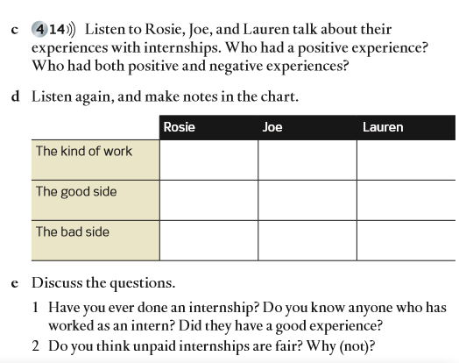
Figure 4.10. Example of development of the listening skill. In Oxenden, Latham-Koenig and Seligson, 2014. English File intermediate plus. Demo unit. Oxford: Oxford University Press España. pp. 38-39. Retrieved from http://www.oupe.es/es/ELT/EOIs/newenglishfile/Recursos%20Destacados/EF3-IntPlus%20sample%20pages_r.pdf
Example 4.1.

Development of the listening skill.

From Oxenden, C., Latham-Koenig, C. & Seligson, P. (2014). English File intermediate plus third edition. Student’s book. OUP. Activities 3a, 3b, 3c, 3d and 3e (pp. 38-39).

The topic of the listening section is internships. There are five activities (3.a-3.e).
The first two are pre-listening activities which trigger background knowledge and support aural processes Activity 3.a asks the students “Would you ever consider doing a job for no pay? Why (not)?” Activity 3.b instructs the students to read a short expository text about internships and answer two general questions.
The whilst-listening stage is covered by activities 3.c and 3.d. Activity 3.c requires the students to listen to three people talking about their internships and decide whether they had a positive experience or not and identify those who had both positive and negative experiences. Activity 3.d asks the students to listen to the same text again and make notes in a chart for each character in the following aspects: the kind of work, the good and the bad side.
Finally, activity 3.e entails the post-listening stage, where the students are told to discuss four questions related to their own experience with internships. For instance: “Have you ever done an internship? Do you think that internships are fair? Why (not)?”.

In the oral skills (listening & speaking) the checklist contemplates two complementary dimensions, fluency (based on meaning) and accuracy (oriented to forms), and whether either or both of them are developed in the activities. Whereas Example 4.1 illustrates an example of listening developed mostly for fluency, exercise 9 in Example 4.2 reflects listening exclusively for accuracy, as learners are expected to understand the exact words for each slot. General meaning in accuracy-based listening activities does not have to be achieved exclusively through listening to the text, as learners may understand the meaning through a previous reading.
The speaking section of the checklist also includes whether both production (one learner speaking) and interaction (dialogues or conversations) are considered or not (as an example of either, depending on how it is developed, you can see the post-listening activity 3e in Example 4.1, where one or several learners are asked to speak).
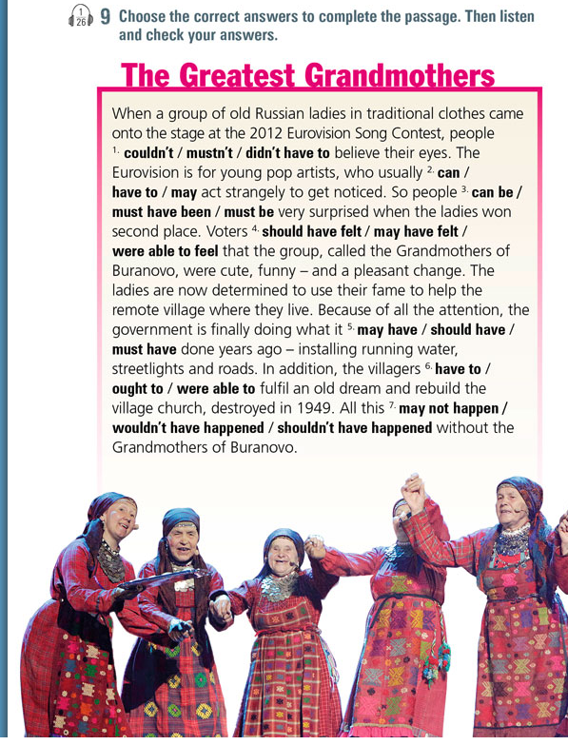
Figure 4.11. Listening for accuracy. In Grant and Edwards, 2014. Living English 1 Student's Book. Sample unit. Limassol: Burlington, p. 32. Retrieved from https://webbook.burlingtonbooks.com/WebBook/#/book/56
Example 4.2.

Listening for accuracy.

From Grant, E., & Edwards, K. (2019). Living English Bachillerato 1. Student’s book. Burlington Books (p. 35). Activity 9. Available at
http://www.burlingtonbooks.com/Spain/Catalogue/?catalogueID=9

The topic of the 18-line written text is the ‘Grandmothers of Buranovo’, a group of old Russian ladies who represented Russia at the 2012 Eurovision Song Contest dressed with traditional peasant costumes. The instructions read as “Choose the correct answers to complete the passage. Then listen and check your answers”. The answers deal with modals and modal perfects, which had been previously explained and worked upon by the students in controlled, sentence-based examples of language. For instance: “When a group of old Russian ladies in traditional clothes came on to the stage at the 2012 Eurovision Song Contest, people couldn’t / mustn’t / didn’t have to believe their eyes”.

In the case of writing, what the checklist considers is how many and which types of activities are aimed at developing writing. Controlled activities are very similar to copying processes, and they would be associated to lower levels, whereas guided ones tend to include a number of previous activities and behaviors targeted at the subsequent development of a future final written text (see exercises in Example 4.3).
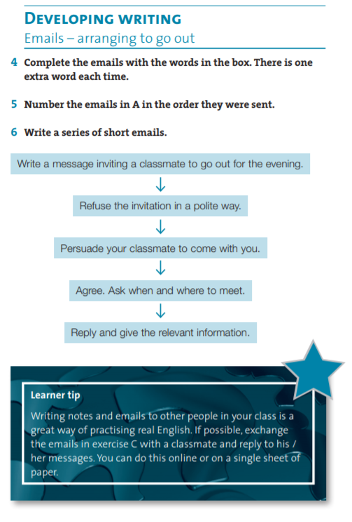
Figure 4.12. Guided writing. Sample Unit. In Dellar and Walkley, 2015 Outcomes Intermediate. Workbook unit. National Geographic (ELT). p. 62. Retrieved from file:///C:/Users/UJA/Downloads/Outcomes_2e_Intermediate_WorkBook_Unit%2010.pdf
Example 4.3.

Guided writing.

From Dellar, H. and Walkley, A. (2015). Outcomes intermediate student’s book. National Geographic Learning. Cengage. Activities 4, 5 and 6 (p. 62).

The title of the section is “Developing writing. Emails–arranging to go out”. In activity 4, the students are asked to complete five short emails with the words in the box above each one of them, taking into account that there is one extra word each time. In activity 5, the students number the same emails from activity 4 in the order in which they were sent, as they belong to a single email thread: a friend persuading another friend to attend a comedy at the new arts centre in town and inviting that person to such a play. Finally, in activity 6, the students write a series of short emails. The following prompts are offered in a consecutive way separated by downward arrows: “Write a message inviting a classmate to go out for the evening. Refuse the invitation in a polite way. Persuade your classmate to come with you. Agree. Ask when and where to meet. Reply and give the relevant information”.

The language components section of the checklist includes grammar, vocabulary and pronunciation. The checklist offers a slot for the frequency of activities devoted to the first two components, but pronunciation is not usually developed as much as the other components and skills. This component tends to include mechanical activities involving recognition and/or production of sounds, developed in the form of very short (if any) activities isolated from other components or skills (see Example 4.4).
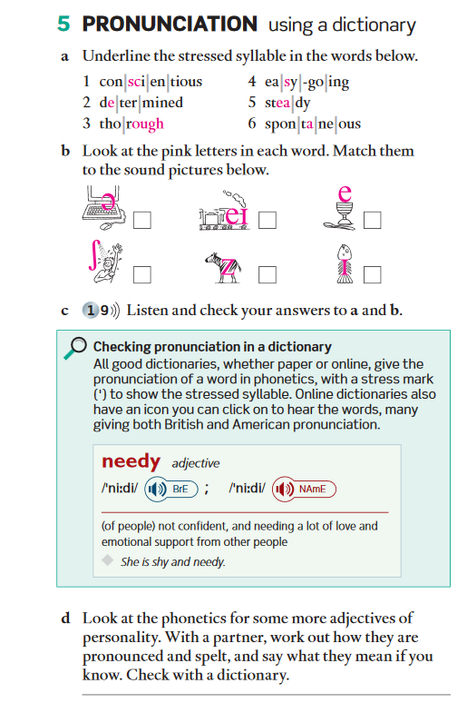

Figure 4.13. Pronunciation activities. In Latham-Koenig, Oxenden, and Lambert, 2015. English File Upper Intermediate. 3rd. edition. Sample Unit. Oxford: Oxford University Press, p.6. Retrieved from http://oxfordeltcatalogue.es/wp-content/uploads/2016/03/StudenBook-EnglishFile-Advanced.pdf
Example 4.4.

Pronunciation activities.

From Latham-Koenig, C. & Seligson, P. (2014). English File intermediate plus third edition. Student’s book. OUP. Activities 5a, 5b, 5c, 5d and 5d (p. 6).

The section is titled as “Pronunciation. Using a dictionary”.
In activity 5a, the learners underline the stressed syllable in a list of six words. The syllables of each word are typographically signaled with vertical bars and the letters corresponding to the targeted phonemes are highlighted in pink (in bold here). For instance: conǀsciǀce targeted phoough.
As for activity 5b, the students look at the pink letters in each work and match them to the sound pictures which are located below the instructions. For example, the phoneme /∫/ appears next to the picture of a person having a shower; the phoneme /z/ is included in the middle of a zebra, etc.
In activity 5c, the learners listen and check their answers to 5a and 5b.
Before activity 5d a note about how to check pronunciation in both paper and online dictionaries is included (stress marks to show the stressed syllable and an icon to click on to listen to the words in online dictionaries). In the actual activity 5d, the students are asked to look at the phonetics for some adjectives of personality. They also have to work collaboratively with a partner to discern how such adjectives are pronounced and spelt and to say their meaning if known by the students, who are finally asked to check their answers with a dictionary.

As regards vocabulary, the checklist considers whether the unit provides exercises for memorization, consolidation and revision in different contexts or situations. The grammar section, besides its proportion, contemplates whether it is presented with a deductive approach, in which rules are directly stated to the students and then practiced, or an inductive approach, where contextualized examples of the language item are provided to the students, who must infer the rule and then practise it, as in Example 4.5. See also Examples 5.1, 5.2 and 5.3 in Chapter 5.

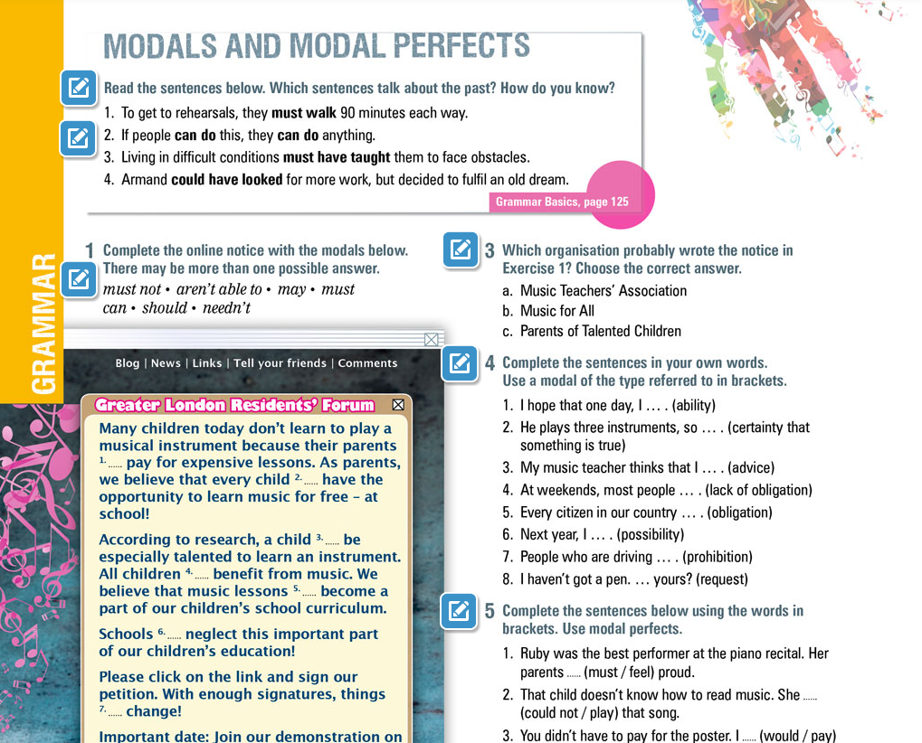
Figure 4.14. Example of the inductive approach for grammar rule presentation. In Grant and Edwards, 2014. Living English 1 Student's Book. Sample unit. Limassol: Burlington, p. 34. Retrieved from https://webbook.burlingtonbooks.com/WebBook/#/book/56
Example 4.5.

Inductive approach for grammar rule presentation.

From Grant, E., & Edwards, K. (2019). Living English Bachillerato 1. Student’s book. Burlington Books (p. 34). Activities 0 (unnumbered in the original source), 1, 4, 5 and 6. Available at
http://www.burlingtonbooks.com/Spain/Catalogue/?catalogueID=9

The linguistic topic is modal and modal perfects. In the first and unnumbered activity (0 for our purposes of identification), the students are asked to read four sample sentences from a previous written text which contains instances of such linguistic forms. The learners had processed the text for meaning and worked upon gerunds and infinitives. They have to identify and explain which sentences talk about the past. For instance: “To get to rehearsals, they must walk 90 minutes each way”; “If people can do this, they can do anything”. Next to this activity there is a note directing the students to consult the related grammar rules on page 125.
Following this inductive presentation of grammar forms, three controlled practice activities (numbers 1, 4 and 5) and one semi-controlled activity (number 6) are included, which are described here so that you can understand the difference between (inductive) grammar presentation and practice activities.
After being asked to devise a poster with slogans related to the previous text and answering a reading comprehension question (activities 2 and 3 respectively), in activity 4 the students are asked to complete eight sentences in their own words by using a modal of the type/notion referred to in the brackets for each sentence. The notions are ability, certainty that something is true, advice, lack of obligation, obligation, possibility, prohibition and request. For instance: “I hope that one day, I _______ (ability)”; “Next year, I _______ (possibility)”.
Similarly to activity 4, activity 5 is sentence-based and intends to trigger students’ output. Instead of drawing on prompts signaling the type/notion of the modal verbs, the students are asked to complete six sentences and use modal perfects by drawing on the modal verb and infinitive supplied. For instance: “You were very critical of the performance. You _______ (should not/be) so rude”; “It’s a pity you never learned to play an instrument. You _______. (could/take) lessons, but you never asked your parents”.
Finally, in activity 6, the students are provided an imaginary situation that happened in the past. They have to write sentences using the modal perfects provided to respond to each of the six prompts offered. The situation is about one of the students’ friends first musical performance, which went wrong. For instance: “I forgot the lyrics of the song. (should have); “Some people asked for their money back. (can’t have)”. As can be seen, the nature of this practice activity is different from the three previous ones. Although the students must use pre-selected targeted forms (modal perfects) as in activities 1, 4 and 5, they can choose the content or what they say as there is more than one possible answer. Hence, activity 6 is a semi-controlled practice activity.

The fourth part of the checklist, other types of activities, incorporates two subsections: cultural and game-like activities. Cultural activities frequently propose students to get familiarized with facts and routines of the L2 countries (as in Example 4.6):

Figure 4.15. Examples of cultural activities. In Puchta, Stranks, Carter and Lewis-Jones, 2010. English in Mind. Demo unit. Cambridge: Cambridge University Press. Retrieved from https://www.cambridge.es/catalogo/secundaria/cursos/english-in-mind-2/componentes#student-s-book
Example 4.6.

Cultural activities.

From Puchta, H., Stranks, J., Carter, R., & Lewis-Jones, P. (2010). English in Mind student’s book. Second edition. CUP. Activities 01 and 02 (unnumbered in the original source) (p. xxx).
The topic is The United Kingdom and the cultural elements belong to “Cultural facts and products” (see Over to you 2.1 in Chapter 2). A coloured map of the United Kingdom and four colored pictures of world-famous landmarks from London (Buckingham Palace, The London Eye, The Globe Theater, Covent Garden) are included. The map depicts important mountains and lakes with their names and it also comprises the names of the capital cities.
Activity 01 asks the students to look at the map and complete a table with the geographical data for each country of the United Kingdom. Such geographical data appear above the table: London, Belfast, the river Bann, Ben Nevis, Loch Ness, Cardiff. The categories of geographical data included in the table are mountains, rivers, lakes and capital cities. Below the table there is note about facts related to the map (countries, languages and population).
In activity 02, the students read four paragraphs, each about a different landmark from London, and match them with the correct pictures which depict such landmarks.

Game-oriented activities may involve role-plays, jumbled tasks, information-gap activities, treasure hunts or songs, among others. Their use is associated to younger learners, but they should not be restricted to that specific age range. The fifth section, specific aspects of activities, includes three items which deal with aspects related to how the activities are developed. Classroom dynamics refers to the types of interaction patterns developed in the unit (individual, pair-work and group-work). Learning strategies are facilitating hints addressed at improving learning outcomes in any of the aspects of the unit. For instance, strategies may involve giving some piece of advice to students about how to improve their listening by reducing their anxiety, how to find out the meaning of words without using reference materials, or providing some clues to speak more fluently (see the two examples illustrated in Example 4.7). The last item considered within this section of the checklist is whether Web-resources have been included in the unit. In the era of digital natives, all learners make a very efficient use of technologies for learning, including computer programs, special websites, apps, or even their own downloaded digital and interactive version of the textbook. Thus, teaching material, as well as course books, should incorporate effective web resources. Learners, and many teachers, already use them.
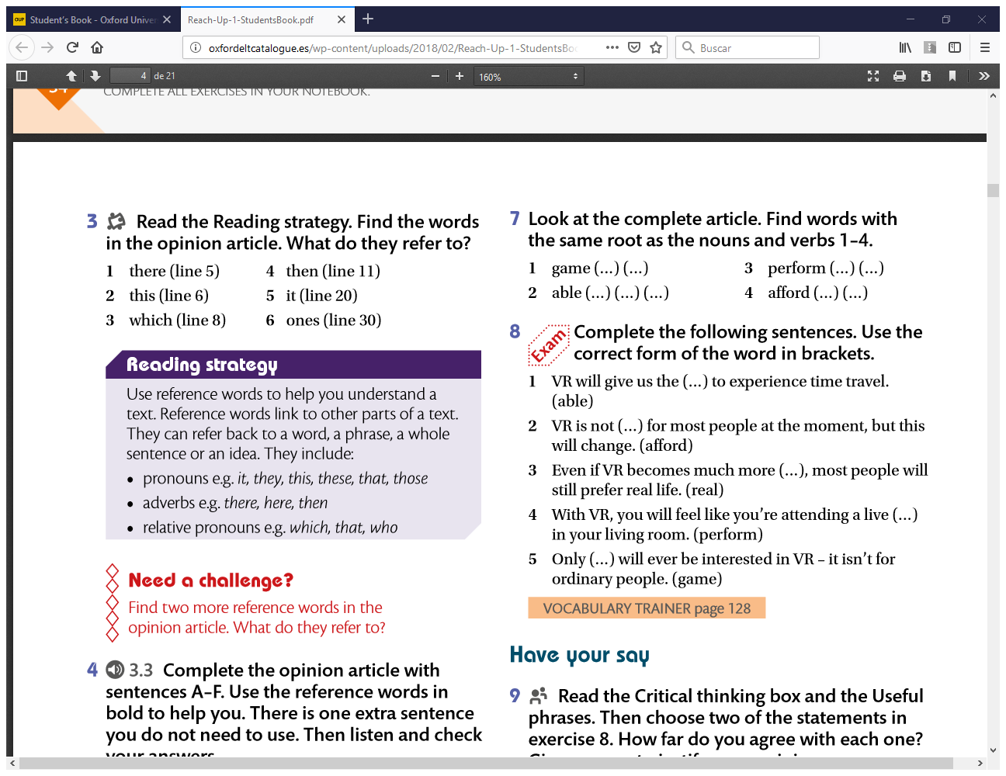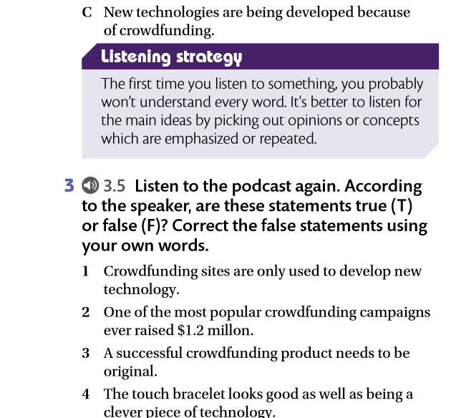
Figure 4.16. Examples of learning strategies. In Krantz, C. and Roberts, R. (2018). Reach Up 1. Student's Book. Demo unit. Oxford: Oxford University Press España. p. 38. Retrieved from http://oxfordeltcatalogue.es/wp-content/uploads/2018/02/Reach-Up-1-StudentsBook.pdf

Example 4.7.

Learning strategies.

From Krantz, C., & Roberts, R. (2018). Reach up 1. Student's book. OUP. Activity 3 (p. 35) and activity 2 (p. 38). Available at
https://www.blinklearning.com/coursePlayer/librodigital_html.php?idcurso=1466509&idclase=84578370&_from_related=1
In activity 3 on page 35, learners are told to read the reading strategy provided before finding words in an article and identifying what they refer to. The reading strategy reads as “Use reference words to help you understand a text”. A brief explanation follows regarding the function of reference words and types (pronouns, adverbs and relative pronouns).
In activity 2 on page 38, the learners are asked to read the listening strategy in which they are advised what to do the first time they listen to an aural text, since it is possible that they will not understand every word: they have to pay attention to opinions and ideas which are emphasised or repeated. Then the students listen to a podcast about crowdfunding and number the three written ideas provided in the order in which they are uttered.

The last section of the checklist, revision, refers to whether the textbook incorporates revision units with or without self-assessment. This type of units includes sets of exercises designed to be completed by students in an independent way, and they are used to go over all or part of the previous contents. As a type of additional information on evaluation aspects, it may be interesting to check whether that revision is useful, and additionally, whether it is complete or it only focuses on some of the aspects taught and learned at the unit (for example, only grammar and vocabulary). However, to maintain simplicity, this information has not been included in the checklist.
4.6. Finding solutions: Adapting and supplementing

Every (printed or digital) textbook, regardless of its quality, must be adapted to match specific teachers, learners and classroom situations. This adaptation process may take place while or after the teacher has used the material, and frequently, it occurs at both points in time, because decisions about choosing one course book or another do not usually depend on the teacher, but on educational policies, economic issues, availability, or all three at the same time. This means that even if a textbook did not work well in a classroom or received a poor evaluation, it cannot be changed from one year to the next, as, particularly in mainstream education, it should (or must) be reused to make it worth its cost. That is why adaptations are fundamental.

Adaptations may deal with the quality of the information, its quantity, or both (McDonough, Shaw & Masuhara, 2013), and teachers or those using a course book are probably familiarised with most of them:

- Adding involves expanding or extending, and it can be material/contents created by the teacher or taken from other sources. Extending means supplying more of the same, for example extra grammar practice. Expanding involves adding something different to complement what is already there, for example including communicative activities if the unit does not offer them.
- Deleting implicates the minor adaptation of subtracting part of an exercise or task, or the major change of abridging a content, function, etc., because there is no time, or it may not prove useful for learners, among other reasons.
- Modifying includes rewriting or rewording, which involves minor changes, and restructuring, when the teacher has to change the focus or dynamics of some content/section completely, to adapt to his own situation or that of his learners.
- Simplifying tasks, instructions, or texts involve grammar, lexical, sentence or discourse modifications/reductions.
- Reordering processes hint at minor changes in the order of exercises, skills, forms, functions or any other element within the unit or major changes to be applied to whole units/sections/blocks.

These adaptations reflect the changes teachers would apply to a textbook after having used it in the classroom. This process assumes the teacher has also evaluated the material, implicitly, explicitly, or both, having analysed the textbook, focused on how the printed page fits his/her classroom situation and consequently, having effected subsequent adaptations or, in other words, improvements. In this way, the teacher will be able to make the textbook fit his needs and those of his/her learners.
Generally, adapting a textbook is a dynamic and complex process, as the same book may require different adaptations for diverse classrooms, or in different years.

Concluding, every teacher, every learner and every classroom is different. No textbook can suit all three of them. Thus, an analysis, an evaluation and one or several adaptations may be needed to harmonize the classroom and its components with the course book (as summarised in Figure 4.10).

Figure 4.10. Finding solutions for textbook use.

Summary

In this chapter we have reflected on the role of materials for ELT (English Language Teaching). First, a general description and classification of those materials that can be used in the classroom has been contemplated, following different criteria such as their origin, channel, usage or author (section 4.1). Second, and focusing on a specific type of materials, that is to say, course books, a reflection on the benefits and drawbacks of textbook usage has been developed, including both the teacher and learners’ perspectives (section 4.2). Following this discussion, a distinction between analysing what is found in the textbook and evaluating the teaching/learning situation has been introduced (section 4.3). Because no textbook can be ideal for any given learning context, and to synchronise these two elements, namely, the printed page and classroom needs, several types of course book evaluation have been enumerated and described (section 4.4). Then, a briefer and more operative type of evaluation by means of a checklist for one textbook unit has been suggested, exemplifying its use with several textbook samples (section 4.5). Finally, taking into account the conclusions derived from the process of evaluating a textbook or a unit, diverse adaptations are suggested and explained, so as to improve the material and make it more suitable for a specific classroom (section 4.6).

Self-assessment
1. Choose the most appropriate definition for materials.
- Materials are those resources which are used by learners.
- Materials are resources used in the classroom by teachers and learners.
- Materials are resources such as printed and digital textbooks.
- Materials refer to the techniques and activities used in the classroom.

2. This is a listing of advantages and disadvantages for textbook use. Underline positive aspects and circle negative ones. Sometimes both answers are possible.
Textbooks…

3. Choose the correct answer.
3.1. The difference between textbook analysis and evaluation is…
- Textbook analysis focuses on the classroom situation whereas evaluation deals with the page.
- Textbook evaluation involves carrying out an analysis of the page and the classroom situation.
- Textbook evaluation considers what is on the page and what this implies for teaching.
- Textbook analysis and evaluation are two mutually exclusive aspects.

3.2. Systematic evaluation (more than one answer is possible):
- Includes open-ended questions
- Has more reliability than impressionistic evaluation.
- Complements and supports impressionistic evaluation.
- Has to be taken from scientific literature.

3.3. Impressionistic evaluation (more than one answer is possible):
- Is developed after the textbook has been used.
- Is developed by means of diaries, journals or open-ended questionnaires.
- Includes a series of items which can be quantified.
- Is developed before and after the textbook is used.

3.4. Types of answers in checklists. Link with the correct option.

1. Likert scale questions | A. Can be completed with a sentence explaining an idea, a feeling or thought
2. Multiple choice questions | B. Offer two or more (exclusive or not exclusive) options to be selected
3. Open ended questions | C. Offer several options to choose from, but only one is valid
4. Categorical questions | D. Offer four or more options of a quantified element or item.

4. Fill in the blanks with the correct word.
There are several types of evaluation. One of them, _________ looks at sections such as the blurb, the table of contents, density of activities and the like. The second type, _________, considers methodological issues and how they are developed. From another point of view, evaluation can be carried out _________ , _________ , and _________ the textbook is used. Despite the phase in which evaluation is carried out, it may involve expert checklists or itemized criteria, called__________, or open ended questions, interviews, diaries and journals. This second type has been termed _________ evaluation. Both complement each other.

5. Say whether these statements about textbook adaptations are true or false and justify your reasons in the latter case.
- Simplifying always involves eliminating sections of texts or exercises.
- The difference between abridging and subtracting is that abridging is a minor adaptation whereas subtracting involves major changes.
- Modifying involves minor changes such as rewriting or rewording, and major changes, or restructuring, when changes to the focus or dynamics of some content/section must be applied.

Self-assessment key
1.
B.
2.
Textbooks…
- save time
- are cultural artefacts
- facilitate accountability
- motivate students
- are predictable
- introduce a contents map
3.
3.1-B
3.2-B and C
3.3-B and D
3.4.
1-D
2-C
3-A
4-B

4.
external evaluation
internal evaluation
before
while
after
systematic or empirical evaluation
impressionistic

5.
- F. Modifying is also possible.
- F. The reverse is true.
- T

Hands-on review
- Evaluating your textbook: a reflection exercise
Choose a unit of any textbook you have used or can borrow and evaluate it by completing the checklist provided in the appendix. Follow the instructions below the checklist if you have any difficulty. After completing the checklist, you may also want to justify your choices by selecting how particular activities/skills/exercises/components have been developed throughout the unit. In this justification, you can use, as a model, Examples 4.1-4.7.

- Adapting the textbook.
Once you have evaluated the textbook unit, and depending on your results in the checklist, you may suggest possible adaptations following Figure 17 or section 4.6. The goal of these adaptations is to compensate for what you found was lacking according to the checklist you completed in task 1. Even if the textbook unit was excellent, you should apply some of the adaptation techniques suggested in section 6, to adapt the unit to your unique needs, derived from your context of teaching.

Bibliography
Almagro, A. Luque-Agulló, G. and Ortega, A. (2015). Devising and Assessing Teaching Materials. Online Master of English Studies. Learning module. Jaén: Servicio de publicaciones de la Universidad.
Bueno, M. C. and Luque, G. (2015). A tool to analyze oral competence development in EFL textbooks. Revista Española de Lingüística Aplicada/Spanish Journal of Applied Linguistics 28(1), 73-96. https://doi.org/10.1075/resla.28.1.04bue
Ellis, R. (1997). The empirical evaluation of language teaching materials. ELT Journal, 51(1), 36-42. https://doi.org/10.1093/elt/51.1.36
Hemsley, M. (1997). The evaluation of teachers’ guides-design and application. ELT Journal 3(1), 72-83.
Hutchinson, T. and Torres, E. (1994). The textbook as agent of change. ELT Journal 48(4): 315-328. https://doi.org/10.1093/elt/48.4.315
Littlejohn, A. (2011). The analysis of language teaching materials: inside the Trojan Horse. In B. Tomlinson (ed.) Materials Development in Language Teaching. (pp. 179-211). Cambridge: Cambridge University Press.
Littlejohn, A. (2012). Language teaching materials and the (Very) big picture. Electronic Journal of Foreign Language Teaching 9(1): 283-297. http://eflt.nus.edu.sg/v9s12012/littlejohn.pdf

McDonough, J., Shaw, C., and Masuhara, H. (2013). Materials and methods in ELT (3rd ed.). Oxford, UK: Blackwell.
Masuhara, H. (2011). What do teachers really want from coursebooks? In B. Tomlinson (ed.) Materials Development in Language Teaching. (pp. 236-266). Cambridge: Cambridge University Press.
Mishan, F. (2005). Designing Authenticity into Language Teaching Materials. Bristol, UK: Intellect Books.
Mukundan, J., Hajimohammadi, R., & Nimehchisalem, V. (2011). Developing an English language textbook evaluation checklist. Contemporary Issues in Education Research, 4(6), 21-28. https://doi.org/10.19030/cier.v4i6.4383

Richards, J., & Rodgers, T. (2014). Approaches and Methods in Language Teaching. Cambridge: Cambridge University Press.
Sánchez, A. (2009). La enseñanza de idiomas en los últimos cien años. Métodos y enfoques. Madrid: SGEL, S.A.

Glossary

Adapting. A process that reflects the changes teachers would apply to a textbook after having used it in the classroom. This process assumes the teacher has also evaluated the material, implicitly, explicitly, or both, having analysed the textbook, focused on how the printed page fits his/her classroom situation and consequently, having effected subsequent adaptations or, in other words, improvements.

After-use evaluation. It is also called retrospective evaluation, and it is undertaken once the textbook or material has been used. It can include two types of assessment, an initial impressionistic evaluation and a systematic or empirical one.

Authentic material. This type of material was not originally created for learning/teaching, so it is not adapted or simplified in any way. Realia, or real objects, can be included in this category. Sometimes, however, material can have an authentic format but still be somewhat simplified for teaching purposes. In this case it is considered adapted material.

Checklist. An inventory that lists several items which must be graded, scored or selected from a set. It is an instrument that helps evaluate in a systematic way a material, process, competence or skill, among other elements.

Deductive/inductive grammar teaching. Deductive grammar would provide the rule(s) and offer learners practice exercises to apply that rule. Inductive grammar provides examples of the rule within a context or a text, and the learner must deduce the rule by looking at the examples.

ELT material. Anything (printed or digital) used by teachers or learners to facilitate the learning of a language. It can be created by teachers or learners or selected from diverse sources.

Fluency/accuracy. Tasks for the development of language competence may be addressed at achieving accuracy, which aims at providing exact, correct forms, or fluency, in which learners process and/or produce language targeted at communicative messages, despite possible errors (which should not impede the flow of communication).

Learning strategies. Techniques used by learners to improve their learning process or outcomes. Learning techniques can be explicitly suggested in books or by teachers.

Pre-use evaluation. Assessing a course book or another material before actually employing it in the classroom.

Production/interaction. Oral production involves a person speaking, whereas interaction involves two or more people taking part in a dialogue.

Supplementing. One of the processes included in adapting a textbook/material. It involves adding extra items or elements in order to make it more suitable to specific classroom needs.
Technical/non-technical material. If the material can be presented/used by means of a computer, tablet or mobile phone, it is considered technical material, whereas non-technical material has printed support and does not involve use of technology. Realia (see ‘authentic material’) is also considered non-technical material.

Textbook / course book. These are two synonyms used interchangeably. In general, they refer to a type of book used to study a subject, in this case, English, which includes systematically organised contents about the referred subject.

Textbook analysis. An in-depth study of the underlying features of course books, to shed light on their internal nature, that is to say, what they imply in terms of language, learning and teaching. This study involves examining what materials contain, regardless of the situation in which this material may be implemented.

Textbook evaluation. It consists on the systematic judgment of the value of the material in relation to its aims and to the objectives of the learners and teachers using them. It is carried out after analysing the textbook.

Whilst-use evaluation. It consists of an analysis of subjective data by the teacher, in which he/she observes how the classroom interacts with the textbook/material. It also involves keeping a record of those moments in which supplementary materials, adaptations, or eliminations had to be applied to the course book.

