The problem of drinking water access: A review of disinfection technologies with an emphasis on solar treatment methods

N. Pichel^{a,*}, M. Vivar^{b}, M. Fuentes^{a,b}
ª IMDEA Water Institute, Alcalá de Henares 28805, Spain.
^{b} Grupo IDEA, EPS Linares, Universidad de Jaén, Linares 23700, Spain
*Corresponding author e-mail: natalia.pichel@imdea.org

Abstract

The lack of access to safe drinking water is one of the biggest challenges facing humanity in the 21th century. Despite the collective global effort that has been made, the drinking water sources of at least 2 billion people are faecally contaminated, resulting in more than half a million diarrhoeal deaths each year, with the majority occurring in developing countries. Technologies for the inactivation of pathogenic microorganisms in water are therefore of great significance for human health and well-being. However, conventional technologies to provide drinking water, although effective, present limitations that impede their global application. These treatment methods often have high energy and chemical demands, which limits their application for the prevention of waterborne diseases in the most vulnerable regions. These shortcomings have led to rapid research and development of advanced alternative technologies. One of these alternative methods is solar disinfection, which is recognised by the World Health Organization as one of the most appropriate methods for producing drinkable water in developing countries. This study reviews conventional technologies that are being applied at medium to large scales to purify water and emerging technologies currently in development. In addition, this paper describes the merits, demerits, and limitations of these technologies. Finally, the review focuses on solar disinfection, including a novel technology recently developed in this field.

Keywords: drinking water, waterborne diseases, conventional technologies, emerging technologies, SODIS, SOLWAT

1. Introduction

All organisms, including humans, require water for their survival. Therefore, ensuring adequate water supply is fundamental for human well-being. However, the lack of access to safe drinking water is still one of the main challenges that humanity is facing in the 21th century (WWAP, 2009). This problem, rather than being solved, could be aggravated in the future by climate change, which directly affects the hydrological cycle and the quantity and quality of water resources (DelGenio et al., 1991; Loaciga et al., 1996; Trenberth, 1999; Held and Soden, 2000; Arnell et al., 2001; Oki and Kanae, 2006; IPCC, 2014).

Other factors such as demographic processes, economic growth, social change, technological innovation, policies, and laws also exert pressure on water resources (WWAP, 2009). Increasing human population and industrialisation have led to a wide range of physico-chemical contaminants and pathogens within the water bodies. Unfortunately, the alteration of water masses endangers human health, which is greatly affected by unsafe water, and prevents adequate sanitation and hygiene (Fenwick, 2006), which in turn increases the risk of contracting and transmitting waterborne diseases. The consumption of water contaminated with faeces, poor faecal disposal, and poor hygienic practices favour the spread of pathogenic microorganisms, including viruses, bacteria, and parasites (Fig. 1). These microorganisms are responsible for various waterborne illnesses, and they have become a leading cause of malnutrition due to poor digestion of food eaten by people stricken by faecal bacteria and enteric viruses, reduction of resistance to infections, and impaired physical growth and cognitive development (Shannon et al., 2008; Guerrant et al., 2013). Therefore, the same water that is essential to life may be the cause of illnesses that could lead to suffering, chronic disability, and death.

On 28 July 2010, through Resolution 64/292, the United Nations General Assembly formally recognised the right to safe and clean drinking water and sanitation as a human right that is essential for the full enjoyment of life and all human rights (A/RES/64/292). The World Health Organization defined ‘drinking water’ as water that ‘does not represent any significant risk to health over a lifetime consumption, including different sensitivities that may occur between life stages’ (WHO, 2011). In accordance with this resolution, everybody has the right to sufficient, continuous, safe, clean, physically accessible, and affordable water for personal and domestic use (to sustain life and health and meet basic needs for drinking, cooking, and hygiene) and to sanitation. In this context, sanitation is defined as facilities that ensure hygienic separation of human excreta from human contact (WHO, 2016).

To achieve universal access, there is a need to guarantee adequate water supply, sanitation, and hygiene (WASH) given the huge implications of these issues for public health, food security, poverty reduction, and equality. Nonetheless, nowadays, access to a safe source of drinking water is a distant dream to many around the world.

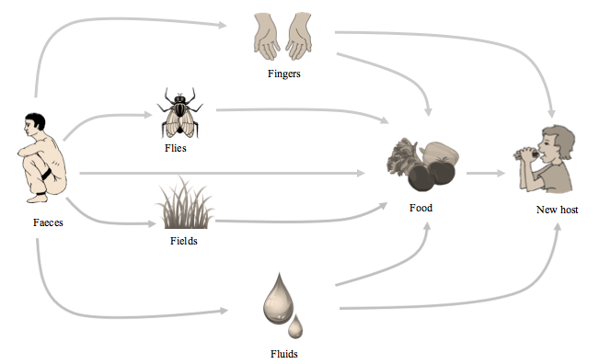 Fig. 1. Transmission of viruses, bacteria, and parasites that are responsible for waterborne diseases due to the lack of sanitation facilities, poor hygienic practices, and the intake of faecally contaminated water (Vivar et al., 2017a).

In recent years, much progress has been made. In 2000, the Members States of the United Nations signed the Millennium Declaration adopting a set of eight Millennium Development Goals (MDGs). The MDG7, to ensure environmental sustainability, challenged the international community to halve the proportion of populations without safe drinking water and basic sanitation between 1990 and 2015. In 1990, the global coverage of improved drinking water access and sanitation facilities stood at 76% and 54%, respectively. The MDG targets for these improvements were 88% and 77%, respectively, by 2015 (WHO/UNICEF, 2015). The target for drinking water was met since 89% of the global population at that time used an improved drinking water source (WHO/UNICEF, 2017). However, what qualified as ‘improved’ drinking water sources under the international monitoring criteria (protected wells and springs, public taps, household connections, rainwater harvesting) do not necessarily correspond to potable water sources; hence, the population with a true access to safe drinking water is likely to be significantly lower than the reported estimate (UNESCO, 2015). On the other hand, during the MDG period, the use of improved sanitation facilities rose from 54% to 68% (WHO/UNICEF, 2017). Although the MDG target was missed, significant progress was made since 2.1 billion people gained access to toilets or covered latrines (WHO/UNICEF, 2017). In 2015, the United Nations adopted a new sustainable development agenda, and among its 17 Sustainable Developments Goals was included the achievement of universal and equitable access to safe and affordable drinking water for all (SDG6) over the next 15 years (Sustainable Development Goals, UN).

Behind the global headlines, the problems relating to WASH differ between industrialised and developing countries. In high-income countries, complete access to drinking water and sanitation has been nearly achieved, and thus, the predominant objectives are the maintenance and replacement of water supply infrastructures and the improvement of wastewater treatment from urban and industrial discharge (UNESCO, 2015). On the other hand, in developing countries, the provision of drinking water and sanitation does not cover all the population, and thus, the main challenge continues to be ensuring global access (UNESCO, 2015). Furthermore, disparities also exist within developing countries between urban and rural areas. One out of every three people who live in rural environments is still without improved drinking water sources, and two out of every five of these people are without improved sanitation facilities (WHO/UNICEF, 2017). Moreover, due to the rapid growth of the slum populations in the developing world, it is estimated that the urban areas in developing countries will be more vulnerable in the near future (UNESCO, 2015).

The countries with the lowest levels of progress are concentrated in sub-Saharan Africa (Fig. 2), where nearly half of the population use unimproved drinking water sources, and the majority of the population uses rivers, lakes, ponds, and irrigations canals as their main water source (WHO/UNICEF, 2017). These sources are probably faecally contaminated since 80% of wastewater resulting from human activities in these areas is discharged into surface waters without treatment (Egli and Wehrli, 2010; WWAP, 2017; UNESCO, 2018), thereby exacerbating the risk of waterborne diseases.

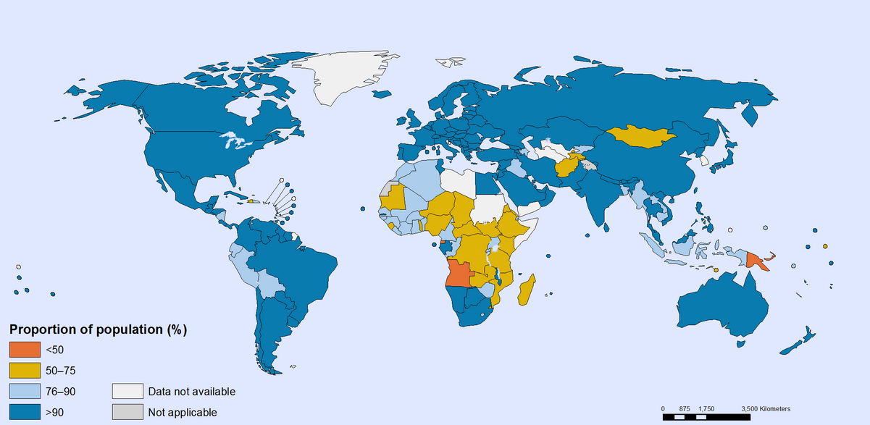
Fig. 2. Proportion of county populations using an improved drinking water source in 2015 (Global Health Observatory Map Gallery, WHO).

To address the need for safe drinking water, a variety of technologies have been developed and exploited since the 19th century. These treatment methods are widely described in the literature. However, most of the published papers have focus on a specific issue of a particular technology (Fujishima and Honda, 1972; Maness et al., 1999; Jyoti and Pandit, 2001; Rizzo, 2009; Ray and Jain, 2014;). Although some technical manuals and reviews have complied different disinfection treatment methods (EPA, 2011; WHO, 2017a; WHO, 2017b; National Research Council, 1980; National Research Council, 1987; Gadgil, 1998; Pandit and Kumar, 2012; Zhang et al, 2018), they do not offer an overall vision of available technologies (developed and currently under development). Thus, the present status of drinking water treatment technologies is not clearly known. On the other hand, regarding the high energy consumption required for treating water in conventional drinking water treatment plants (DWTPs) (Gude, 2015; Molinos-Senante and Sala-Garrido, 2017) and the global energy crisis driven by the increasing demand for energy, the depletion of many oil reserves and emission of large amounts of greenhouse gases. A sustainable drinking water supply technology cannot be achieved without considering the energy required in the treatment process. In this regard, solar energy is the most abundant renewable energy source (Blanco et al., 2009), and coincidentally, it is most abundant in the regions that need clean water and electricity. Thus, technologies for integrating solar energy could address the lack of access to safe drinking water and electricity. The main objective of this work is to summarise the current knowledge of the major issues and challenges relating to the lack of access to safe drinking water, and to provide a summary of conventional drinking water treatment technologies. In addition, this work highlights the emerging research directions on potable water treatment, with emphasis on solar energy technologies.

2. The problem of drinking water access

2.1 Water quality and health

Few issues carry as great an importance to public health as does water. Despite the great efforts that have been made, currently, at least 2 billion people globally use a drinking water source that is contaminated with faeces (WHO, 2018), and 2.3 billion people still lack improved sanitation facilities (WHO/UNICEF, 2017). These are ideal conditions for contracting and transmitting waterborne diseases, which remain the major cause of morbidity and mortality in the world at more than 2.2 million deaths per year, the majority of which occurs in developing countries (WHO, 2009) and in children under five years of age (Efstratiou et al., 2017).

Cholera (Vibrio cholera), typhoid fever (Salmonella typhi), dysentery (Shigiella), helminthic infections (e.g. Ascaris lumbricoides), protozoan infections (e.g. Cryptosporidium parvum), hepatitis A virus, trachoma (Chlamydia trachomatis), and schistosomiasis (Schistosoma) are among the diseases commonly transmitted through faecal contamination of water (Fanucchi, 2017). Most of these diseases are manifested as acute diarrhoea, which is responsible for 1.5 million deaths per year, of which more than half a million are specifically produced by the consumption of water contaminated with faeces (WHO, 2018). Escherichia coli, Intestinal enterococci, and Clostridium perfringens are also common bacteria related to faecal microbiological contamination of water. These bacteria, despite being present in the normal intestinal flora of humans and animals, may cause infections when they enter into other parts of the body via ingestion.

Regarding developing countries, health risks are mainly associated with water contaminated with faeces (Gadgil, 1998). Indeed, it is indicated that most of the wastewater generated in these countries is discharged without any form of treatment, thereby polluting surface waters and generating the perfect environment for the transmission of waterborne diseases (UNESCO, 2018). Furthermore, health problems could be aggravated in the future by an increase in the frequency and intensity of tropical storms, floods, and droughts due to climate change (Oki and Kanae, 2006). The distribution of pathogens and the incidence of waterborne disease outbreaks are closely linked to environmental and climatic conditions. In the 20th century, one third of the population was affected by natural disasters, of which 86% were caused by floods and droughts (ISDR, 2007). Flooding is associated with an increased risk of diarrhoea illness through the contamination of drinking water facilities by the dispersion of faecal pollutants. Water shortages due to drought can increase these health problems. In addition, natural disasters (floods, earthquakes, tsunamis, etc.) can also impact electricity supply facilities, which in turn hinder drinking water supply, sanitation, hospital operations, industrial process, and many other aspects of daily life. Developing countries, which have the fewest resources for disaster mitigation and adaptation, are the most vulnerable to these impacts.

On the other hand, in developed countries, an enormous amount of wastewater is generated by industry and municipalities (Egli and Wehrli, 2010). Although 50−95% of these amounts passes through wastewater treatment plants (WWTP) (Egli and Wehrli, 2010), municipal treatment aims at eliminating nutrients (carbon, nitrogen, and phosphorous), but not the pathogenic microorganisms because of high costs and lack of municipal financial resources. The discharge of un-disinfected treated water becomes relevant when such water is reused for irrigated agriculture. The main disadvantage is that the presence of pathogens can pose health risks to the farmers and the consumers of the products irrigated with treated sewage (Al- Sa`ed, 2007). Bacteria, viruses, and parasites can survive in the environment sufficiently long to pose health risks (WHO/UNEP, 2006a: WHO/UNEP, 2006b), and in fact, disease outbreaks have been associated with the use of treated effluent for the irrigation of vegetables (WHO/UNEP, 2006a: WHO/UNEP, 2006b). In addition, the lack of adequate tertiary treatment also threatens communities situated downstream or near to the municipal sewage outfalls and endangers recreational users since these receiving water bodies may become a source of waterborne diseases either by ingestion or contact.

The availability of freshwater is currently a high priority issue for society. Accelerated population growth, hydrological variability and growing agricultural and industrial needs increase dependence on water, turning the reuse of treated wastewater into a highly valued water source, especially in regions where it is scarce. This problem, occurring even in regions currently considered water-rich, is expected to worsen in the coming decades (Fenwick, 2006), highlighting the need to reuse this limited resource. Hence, finding technologies suitable for water recycling, which provide water that does not contain microorganisms, but not necessarily of potable quality, are fundamental to reduce freshwater consumption and wastewater discharges.

2.2 Energy issues associated with the production of drinking water

Water and energy are two essential, inseparable, and inextricably linked resources that cannot be produced or supplied without one involving the other (Gude, 2015). The interconnection between water and energy, the energy−water nexus (Fig. 3) (Gleick, 1994), has recently received growing attention because of concerns about the increasing demand of energy in the water sector and the increasing demand of water in the energy sector (Scott et al., 2011; Bazilian et al., 2011; Marsh, 2008; Carrillo and Frei, 2009; Siddiqi and Anadon, 2011, Bartos and Chester, 2014; Zhou et al., 2013; Rasul, 2014; Macknick et al., 2012, Li et al., 2011 and Chavez-Rodriguez and Nebra, 2014).

Energy for water refers to water consumed in the construction, operation, and maintenance phases of the water sector. Urban water systems require a significant amount of energy. In the process of providing drinking water to the population, energy is required to pump freshwater from its source, to treat raw water in DWTPs, which are energy intensive facilities, and to supply water to consumers over different distances and infrastructures (Molinos-Senante and Sala-Garrido, 2017). The energy requirements of water treatment depend on the initial water quality (groundwater treatment demands less energy than surface water), technology, and age of the infrastructure. Conventional DWTPs (chemical coagulation and flocculation, sedimentation, filtration, and chlorination) require 0.25−1 kWh/m³ (Gude, 2015), which is about 2–3% of worldwide energy consumption. This consumption is likely to grow to meet the increasing demand for higher levels of water quality and the increasing demand for drinking water (Molinos-Senante and Sala-Garrido, 2017).

Given the relevance of energy for treating raw water in conventional DWTPs, currently, access to safe drinking water usually depends on the link between the DWTP and the local electricity network. However, energy production to feed the electrical grid is also strongly affected by freshwater resources. Energy is tightly interlinked with water since all sources of energy require water in their production process (e.g. for fuel extraction, transportation, refining and processing of fossil fuels, thermal processing, cooling during power generation, and irrigation of biofuels feedstock crops), which are generally water intensive (UNESCO, 2018). The energy sector is the 2nd largest user of water in the world (Hightower and Pierce, 2008). It was estimated that 15% of global water withdrawals was used in the energy sector in 2010 (IEA, 2012), and the demand for freshwater is expected to grow by 20−30% as a result of the increasing demand for energy, which is expected to grow by more than 70% by 2035 (UNESCO, 2018). The amount of water required for energy production varies significantly with energy processes and technologies, from negligible quantities used for wind (0.004 L/kWh), solar photovoltaic (PV) (0.11 L/kWh) (Saidur et al., 2011), and geothermal energy generation, to the vast amounts used for the cultivation of biofuel feedstock crops (Hightower and Pierce, 2008). Therefore, increasing the capacity of renewable sources of energy will be a key to mitigating the stress on freshwater resources, other users of water, and the environment owing to the influence of energy production on regional water uses (Fthenakis and Kim, 2010; Mulder et al., 2010; IEA, 2012).

Fig. 3. The water−energy nexus: energy demand throughout the water cycle (from extraction to recycling) and water usage in the energy production process (Wakeel et al., 2016).

Water extraction
ENERGY
Water treatment
Water distribution
End water use
Wastewater collection
Wastewater treatment
Water recycling

WATER
Hydropower
Biofuels production
Fuel processing
Thermal processing
Mineral and fuel extraction

Despite the increasing demand for energy worldwide, access to energy is still limited. About 1.2 billion people still lack access to electricity, and more than 2.7 billion people rely on the traditional use of biomass for cooking, a practice that is associated with approximately 3.5 million deaths annually from indoor air pollution (IEA, 2012). The close association between respiratory diseases and waterborne diseases indicates that people who lack access to electricity also lack access to safe drinking water (UNESCO, 2015). This finding shows the close link between water and energy and illustrates the alarming situation of populations without access to basic resources.

3. Drinking water disinfection technologies

Disinfection generally constitutes the final step in the drinking water treatment process, and its purpose is to eliminate pathogenic microorganisms that are responsible for waterborne diseases. This step can be controlled through physical and chemical methods that substantially reduce the total number of viable microorganisms within the water, thereby contributing to public health protection.

Conventional drinking water treatment technologies include physical methods such as flocculation and sedimentation, filtration, ultraviolet (UV) radiation and pasteurisation, and chemical methods that consist of the addition of chemicals (e.g. chlorination, chloramination, chlorine dioxide treatment, and ozonation). However, only radiation, heat, and chemical methods can technically be called disinfection, because they inactivate or destroy the pathogenic microorganisms instead of simply removing them. Two kinds of disinfection are possible: primary disinfection to eliminate pathogens in the raw water supply, and secondary disinfection to minimise the effects of re-contamination during storage and distribution.

The suitability of any disinfection technology can be evaluated according to its efficacy against waterborne pathogens, ability to provide residual activity, formation of disinfection byproducts (DBPs), costs (construction, operation, and maintenance), applicability to large-scale operations, and the final quality of the treated water (National Research Council, 1987). Regarding water quality, verification is carried out by the analysis of faecal indicator microorganisms. Escherichia coli has traditionally been used to monitor the microbiological water quality, because it provides conclusive evidence of recent faecal pollution (WHO, 2011). International guidelines, such as the WHO Guidelines for Drinking-water Quality (4th edition) (WHO, 2011), establish Escherichia coli and thermotolerant coliform bacteria as faecal indicators. The European Union (Council Directive 98/83/EC) establishes E. coli and Enterococcus spp. as indicators, while the Spanish legislation (Spain, RD 140/2003), with more stringent regulations, establishes E. coli, total coliforms, Enterococcus spp., and Clostridium perfringens (including their spores) as faecal indicators of drinking water quality. Drinking water should contain no faecal organisms; so, in all cases ‘no detection’ in any 100 ml of sample is required to identify a water source as safe to drink (Table 1).

Table 1. Requirements for the verification of the microbiological quality of water intended for human consumption, as established by the WHO, European Union, and Spanish legislation.
 | WHO | European Union | Spain
Escherichia coli | 0 CFU/100 ml | 0 CFU/100 ml | 0 CFU/100 ml
Thermotolerant coliforms | 0 CFU/100 ml | - | -
Total coliforms | - | - | 0 CFU/100 ml
Enterococcus spp. | - | 0 CFU/100 ml | 0 CFU/100 ml
Clostridium perfringens | - | - | 0 CFU/100 ml

In spite of their immense contribution to public health protection, traditional drinking water disinfection techniques are not always effective in eliminating some pathogens, such as Giardia cysts and Cryptosporidium oocysts. Chemical disinfection can result in the formation of DBPs, which have become a serious concern since their first detection in 1974 because of their potential teratogenicity, carcinogenicity, mutagenicity, and even endocrine disruption proprieties (Gadgil, 1998; Rook, 1974). Furthermore, their implementation in developing regions (currently the most vulnerable to waterborne infectious diseases) is limited due to their dependence on access to chemicals (which is difficult or expensive) and electricity, high costs (of infrastructure, operation, and maintenance), lack of trained operators, and social rejection of water after treatment because of its unsatisfactory taste and odour. These limitations have led to rapid research and development of advanced alternative technologies for use in the field of water intended for human consumption. Some of the specific issues being addressed include energy efficiency, avoiding chemical addition, avoiding harmful DBPs formation, and overcoming bacteria resistance.

3.1 Conventional technologies

Conventional disinfection technologies are those with widely proven and accepted effectiveness for drinking water treatment. They are often chemically, energetically, and operationally intensive and focused on large systems that require considerable infusion of capital, engineering expertise, and infrastructure. Currently, they are widely implemented at large and medium scales and have successfully protected public health against waterborne diseases throughout the world for decades. The main conventional disinfection technologies are reviewed next.

3.1.1. Chlorination

Chlorination (Fig. 4) is the most widely used method for drinking water disinfection. It consists of the addition of chlorine or chlorine byproducts (sodium hypochlorite or calcium hypochlorite) to water, where chlorine reacts to form hypochlorous acid (HOCl) and hypochlorite ion (OCl⁻), usually termed ‘free chlorine’; both products are capable of eliminating pathogenic microorganisms.

Chlorine is a strong oxidising disinfectant and its use is recommended when water is not turbid (< 1 NTU) and the pH is below 8.0. The main advantage of chlorination is that chloride persists in water as residual chlorine after dosing, so its disinfectant activity continues within the distribution and storage systems (WHO, 2017a; National Research Council, 1980).

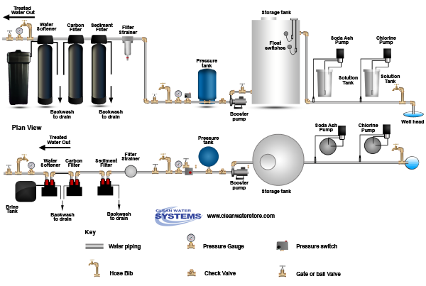
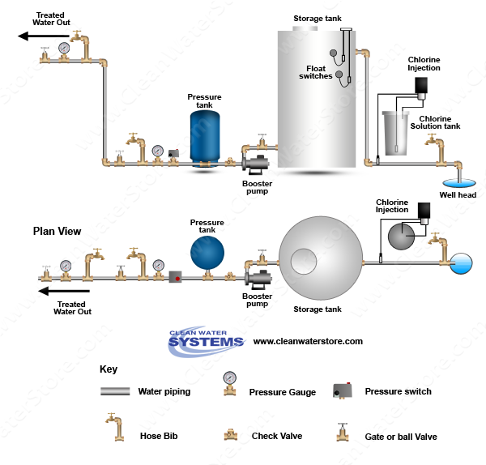

Fig. 4. Chlorination injection system for drinking water treatment (Clean Water Store, 2017).

Nevertheless, despite its great effectiveness as a water disinfection method, chlorination has disadvantages such as unsatisfactory taste and odour, ineffectiveness against cysts and eggs of protozoa (Cryptosporidium and Giardia) and helminths eggs (Drancunculus medinesis and Schistosoma) (WHO, 2017a; EPA, 2011), and the formation of more than 40 different DBPs, with trihalomethanes (THMs) and haloacetic acids (HAAs) being the most abundant (Zhai et al., 2017). Furthermore, conventional automated chlorine-dosing plants that use chlorine gas require highly trained operators, engineers, and repair and maintenance infrastructures (Gadgil, 1998); on the other hand, plants that use diluted chlorine are relatively simple and cost effective and do not require technical expertise.

3.1.2. Chloramination

In chloramination treatment, ammonia and chlorine are dosed in a controlled manner to react and form monochloramine (NH₂Cl), which must be generated at the point of treatment. Its type of disinfection is less effective than chlorination (by about 200 times), and as such, it is generally used as a secondary disinfectant during distribution, rather than for primary disinfection (EPA, 2011).

Chloramination requires similar dosing equipment and trained operators as chlorination, but produces less taste and odour issues and does not form THMs.

3.1.3. Chlorine dioxide

Chlorine dioxide (ClO₂) is a more powerful oxidising agent than chlorine and chloramines. Its disinfectant action is less pH-dependent than that of chorine and it provides a long-lasting residual activity (WHO, 2017a). Because chlorine dioxide is unstable, its application requires on-site synthesis by the action of chlorine or an acid on sodium chlorine, which are then dosed together into the water (WHO, 2017a; EPA, 2011). This process requires constant vigilance, monitoring, and control, and it is much more expensive than chlorination (WHO, 2017a).

Chlorites and chlorates are the main DBPs formed during water treatment with chorine dioxide (EPA, 2011; Korn, 2002), and both contribute to the development of methemoglobinemia and haemolytic anaemia in humans (Al-Otoum et al., 2016). However, THMs and HAAs are formed in lower concentrations in water when using ClO₂ versus chlorine. Other disadvantages of ClO₂ include low level of effectiveness against Cryptosporidium oocysts and taste and odour issues, which limit its use as secondary disinfectant.

3.1.4. Ozonation

Ozone (O₃), generated on-site by passing dry oxygen or air through a system of high-voltage electrodes (tens of thousands of volts) (Gadgil, 1998; Pandit and Kumar, 2012), is currently the most widely used drinking water disinfectant next to chlorine (Gadgil, 1998). It is a very powerful oxidant and much more effective as disinfectant than chlorine and chlorine dioxide. Ozone require less contact time and lower concentrations than chlorine, chloramines, and chlorine dioxide to achieve disinfection. Ozone is particularly effective against spores and cysts, and it is the only chemical that can effectively inactivate either Giardia or Cryptosporidium (EPA, 2011). However, its concentration in water decays more rapidly than other disinfectants; so, it does not provide residual protection against re-contamination in the distribution system. Thus, ozone is suitable as primary disinfectant, but must be coupled with a secondary disinfectant (EPA, 2011).

Ozonation is an expensive technology in terms of capital and operation costs (EPA, 2011). It requires high energy input, on-site generation, highly skilled maintenance, and post treatment to remove the high levels of assimilable and biodegradable organic carbon formed by the oxidation process. Furthermore, ozone is known to react with natural organic matters and bromide ion Br⁻ to produce a range of byproducts, including bromate, aldehydes, ketones, and quinones (EPA, 2011). However, THMs and HAAs are not formed, and their formation can be reduced if chlorine is used as a secondary disinfectant.

3.1.5. UV lamps

UV disinfection of water is normally achieved by passing the water through tubes lined with UV lamps using a wavelength of light around 254 nm (National Research Council, 1980; EPA, 2011). The germicidal effect of UV light occurs because it directly acts on the DNA of the microorganisms to disable them from growing or replicating (National Research Council, 1980; EPA, 2011).

In contrast to many of the chemical disinfectants, UV treatment imparts no taste and odours to the water, and it presents no risk due to overdosing or formation of harmful byproducts (Gadgil, 1998; National Research Council, 1980). Only nitrite can be formed from the reaction of UV light with nitrate. However, UV treatment does not leave a residual in treated water, and thus, it offers no protection against biological re-contamination in the distribution network (EPA, 2011). Moreover, although thoroughly effective against viruses, spores, and cysts, high UV doses are required to inactivate Giardia and Cryptosporidium cysts (Gadgil, 1998).

Furthermore, compounds present in the water can foul the external surfaces of the lamp sleeves, thereby reducing the applied UV intensity and, consequently, the disinfection efficiency (EPA, 2011). Chemical fouling and biological film formation require periodic cleaning with chemical and mechanical methods, which makes maintenance complex and expensive (Gadgil, 1998). In addition, the treatment efficiency can be reduced by inadequate water transmittance. Therefore, supplementary processes are required upstream to clarify the water and significantly improve the effectiveness of the UV disinfection. Such process may include coagulation and filtration to reduce colour and the dissolved organic fraction (EPA, 2011).

The major concern of UV disinfection is that the lamps require significant amounts of energy throughout their lifetime, including their fabrication and operation (they need continuous electricity supply to work), maintenance, and disposal. Regarding maintenance, UV lamps should be replaced every 6–12 months (EPA, 1999), which implies frequent replacements and use of additional energy for manufacturing and transportation. Moreover, the discarded lamps generate a waste management problem because they contain mercury, which is hazardous. The environmental impact of lamps must therefore be reduced by recycling to recover reusable materials and control mercury emissions to the environment. Because the lamps must be replaced every year, recycling represents a significant increase in the use of energy by UV disinfection systems. Another limitation is the low efficiency of the mercury UV lamps, which is around 15−40% (EPA, 1999). Taking into account the electrical conversion efficiency of operating the lamps (35%), the final efficiency would be in the range of 5–15%.

3.1.6. Pasteurisation

Boiling is the oldest method for obtaining safe drinking water, and it is mostly used in developing countries (Gadgil, 1998). Heating water to the boiling point (100 ºC) is strictly not necessary for disinfection; maintaining the water temperature at 70 ºC for six minutes is sufficient. However, owing to the lack of thermometers for household use, the WHO recommends bringing the water to a vigorous roiling boil for a minute (WHO, 2017b) or for five minutes if turbid water is used, as the boiling point is easily recognised by the formation of bubbles.

This method requires a lot of fuel. The WHO (WHO, 2017b) indicates that about 1 kg of wood is needed to boil 1 L of water, while Gadgil (1998) reported that with a cook stove efficiency of 12%, 1 kg of wood can disinfect 3 L of water. In terms of costs, Clasen et al. (2008b) reported a monthly cost of US$ 0.272 for wood collectors and US$ 1.68 for wood purchasers (6 times greater) in rural Vietnam. Regarding urban and peri-urban areas, Psutka et al. (2011) reported that in urban Zambia, the potential cost of fuel and electricity for boiling water is about 5% and 7% of family income, respectively, while in semi-urban India, boiling water costs US$ 0.88 per month for households using liquid petroleum gas and US$ 0.69 for those using wood (Clasen et al. 2008a). In any case, gathering wood for boiling water is a heavy burden on hundreds of millions of women in the developing word, and it is an economically unrealistic and environmentally unsustainable method for daily disinfection of water (WHO, 2017b; Gilman and Skillicorn, 1985).

3.1.7. Filtration

Filtration consists of the physical removal of microorganisms from water, and despite it not being strictly classified within the group of disinfection technologies, filtration is widely used in developing countries as a way to obtain safe drinking water. During filtration, water passes through a porous structure made up of different bed materials or through a thin film (membrane filtration). Depending on the filter pore size, suspended particles, and consequently some microorganisms, present in water are retained by the filter (Betancourt and Rose, 2004).

Simple point-of-use household filters include ceramic filters, stone filters, and sand filters (WHO, 2017b). These filters remove suspended particles by straining through the pores in the filter bed, adsorption of particles to the filter grains, sedimentation of particles while in the media pore, and coagulation while travelling through the pores (Betancourt and Rose, 2004). The efficiency of these filters varies widely, and it is very important to clean them regularly because a dirty filter can add more contamination to the water. For small communities, slow or rapid sand filters are more suitable for water supply because they are more efficient at removing pathogens, despite being more complex and difficult to operate (WHO, 2017b).

In membrane filtration, water is passed through a thin film, which removes pathogens by size exclusion; hence, microbes with sizes greater than the membrane pore size are eliminated from the water. Reverse osmosis (RO) is an established and effective membrane-based technology for both desalination and potable water production and has been widely used in areas with scarce water supplies (as a means of brackish water and seawater desalination). RO is a pressure-driven process whereby a semi-permeable membrane rejects ions, proteins, and organic chemicals present in the feed water (Malaeb and Ayoub, 2011; Sachit and Veenstra, 2014). Although microorganisms can also be removed by RO, it is not recommended for that use (Dvorak and Skipton, 2014) since membrane deterioration can occur due to the recalcitrant biofilms formed by bacteria on membrane surface (Ivnitsky et al., 2005; Tran et al., 2007; Stoica et al., 2018). Currently, this is a critical issue for the operation and cost-effectiveness of membrane systems, which require chemical cleaning and membrane replacement. Furthermore, despite the fact that energy efficiency of RO has significantly increased over the last 40 years (Fritzmann et al., 2007; National Research Council, 2008; Busch and Mickolas, 2004), it still requires a high energy input due to the high consumption of electricity when pressurising the feed flow. The production of one cubic metre of fresh water from brackish water requires 0.5−2.5 kWh, while 3−10 kWh is required if produced from seawater (Ghaffour et al., 2013; Darwish and Al-Najem, 1897; Zotalis et al., 2014).

Another form of membrane filtration involves straining water through a cloth. While this technique is used at the household level in developing countries, it is not considered an appropriate method for drinking water treatment (Sobsey, 2002).

3.1.8. Summary

Chlorination has been the most widely used practised drinking water disinfection method. However, because of the potential toxicity of chlorine byproducts, chlorination has become less attractive; this has increased the focus on alternative disinfectants, including chlorine dioxide, ozone, and UV irradiation lamps, which are now being promoted at a larger scale. Table 2 shows the main advantages and disadvantages of the traditional disinfection technologies.

Table 2. Main advantages and disadvantages of conventional water disinfection technologies.
 | Advantages | Disadvantages/limitations
Chlorination | - Extremely effective for bacteria and virus inactivation  - Residual protection against re-contamination  - Calcium and sodium hypochlorite require simple equipment and instrumentation | - DBPs formation  - Ineffective against Cryptosporidium and Giardia cysts  - Unsatisfactory taste and odour  - Less effective in turbid and organic-rich waters  - Dependence on pH  - Chorine gas is hazardous and extremely corrosive  - Requires trained operators  - Sodium and calcium hypochlorite are more expensive than chlorine gas  - Dependence on chemical access
Chloramination | - Lower DBPs than chlorine  - Residual protection against re-contamination  - Effective against biofilms formation in the distribution system | - Must be manufactured on-site  - Less disinfection capability than other methods  - Chloramines are harmful for patients undergoing dialysis, aquariums, and fish farming enterprises
Chloramination | - Less taste and odour concerns | - Requires trained operators  - Dependence on chemical access
Chlorine dioxide | - Less dependence on pH than chlorine  - Long-lasting residual activity  - Effective against Giardia | - Requires on-site production  - More expensive than chlorine  - Chlorites and chlorates formation  - Low level of inactivation of Cryptosporidium  - Unsatisfactory taste and odour  - Dependence on chemical access
Ozonation | - Effective against bacteria, viruses and protozoa (Giardia and Cryptosporidium)  - No dependence on chemical access | - Requires on-site generation  - Does not provide residual activity  - Associated costs are high compared to other chemical disinfectants  - Expensive to operate  - Requires high energy input  - Requires highly skilled maintenance  - Formation of DBPs (bromate)
UV lamps | - Effective against virus, spores, and cysts  - No taste and odour concerns  - No harmful byproducts formation  - No dependence on chemical access | - Low energy efficiency system  - Lamps should be replaced every 6–12 months  - Lamps contain mercury, which is toxic  - Discarded lamps generate a waste management problem  - Does not provide residual activity  - Effectiveness of disinfection decrease because of chemical fouling, biological film formation, and inadequate transmittance of water
Pasteurisation | - Simple to operate  - No dependence on chemical access | - Requires a lot of fuel  - Economically and environmental unsustainable
Filtration | - Reduces water turbidity and microorganism content  - No dependence on chemical access  - RO: high water quality output | - Pathogens elimination depends on the filter pore size  - Filters must be cleaned regularly  - RO: high energy consumption, high costs, chemicals addition for membranes cleaning  - RO: not recommended for microorganism elimination

3.2 Emerging technologies

Non-conventional water treatment technologies include techniques that are currently in development and those with limited application at large or medium scales. The development of these methods has been driven by discovery of harmful DBPs resulting from the conventional chemical treatments (e.g. chlorination), increasing requirements for higher levels of drinking water quality, and costs associated with conventional methods. Because a universal solution for microbial treatment of potable water does not yet exist, safer, economical, and efficient technological innovations for water treatment are being investigated and developed. While some entirely new methods are being proposed, some other emerging technologies have come from variations of the conventional technologies.

3.2.1. Solar pasteurisation

Solar thermal pasteurisation is a simple and cheap method of producing drinking water. It relies on the use of energy from the sun to heat water to a sufficiently high temperature for a certain period of time, thereby inactivating or destroying pathogenic microorganisms (Ray and Jain, 2014). This method is well known in developing countries, where electricity or firewood is not available, and it can be implemented using devices as simple as often water containers placed in a dark box and covered by a transparent material (Fig. 5a), as first developed by Ciochetti and Metcalf (1984). However, many hours are required to disinfect small amounts of water.

3.2.2. Solar disinfection

Solar disinfection (SODIS) makes use of the bactericidal effect of solar radiation to purify water. It is based on the germicidal effect of UV radiation, the oxidative activity associated with dissolved oxygen, and thermal heating. The method, which depends on radiation intensity, temperature, water turbidity, and water height, is simple and inexpensive. It consisting of placing water into transparent plastic bottles (usually polyethylene terephthalate, PET) under the sun for at least six hours (Downes and Blunt, 1877; Acra et al, 1984). Solar disinfection was recently recognised as an appropriate treatment method for water disinfection by the WHO (Sobsey, 2002). A detailed description of this technology is presented in Section 4.

3.2.3. Photocatalysis

Photocatalysis has recently emerged as an alternative or complementary technology to current drinking water treatment methods (Fig. 5b) (Fujishima and Honda, 1972; Matsunaga et al., 1985). In photocatalysis, electron hole pairs (e⁻/h⁺) are generated when catalytic semiconductor particles are illuminated with UV lamps or sunlight near UV radiation (λ < 400 nm). These pairs can migrate to form oxidising species (·OH) that exhibits strong bactericidal activity (Rizzo, 2009; Maness et al., 1999). TiO₂ is the most widely used photocatalyst owing to its stability and low energy ban-gap (Fujishima et al., 2000; Gaya and Abdullah, 2008). The ability of this advance oxidation technology to inactivate microorganisms in water has been widely demonstrated (Domínguez et al., 1998; Marugán et al., 2006; Marugán et al., 2007: Rincon and Pulgarin, 2004). However, to date, the application of photocatalysis for industrial water treatment faces some challenges. In slurry TiO₂ systems, an additional step is needed for post-recovery of the catalyst particles from the treated water to avoid the loss of catalyst particles and the introduction of new pollutants into the treated water (Yang and Li, 2007). However, if the catalyst is fixed into an inert substrate, the catalytic active areas are reduced and the photon penetration may not reach every single surface site for photonic activation; this feature reduces the level of disinfectant activity (Pozzo et al., 1997). Operational costs associated with photocatalysis vary depending on the spectrum for catalyst activation; the higher-end of the UV spectrum corresponds to high operational costs (Chong et al., 2010).

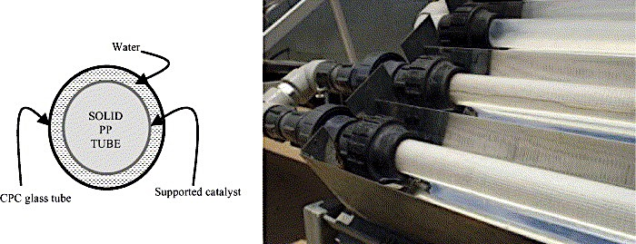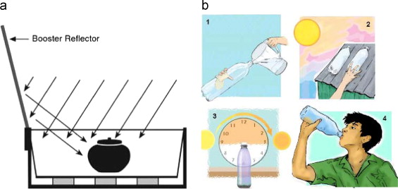
a
b
Fig. 5. (a) Solar-thermal pasteurisation using an opaque vessel with a solar reflector; (b) photocatalytic reactor using compound parabolic collectors (the photocatalyst is built into the glass tubes) (Fernández et al., 2005).

3.2.4. UV-LEDs

Ultraviolet light-emitting diodes (UV-LED) technology (Fig. 6a) have emerged in recent decades with a number of benefits compared to traditional UV mercury lamps. UV-LEDs offer several advantages such as being environmentally friendly (no mercury), compactness and robustness (more durable), potentially less energy consumption, and longer lifetime (Würtele et al., 2011; Ibrahim et al., 2014). These features make this technology a promising alternative to the conventional UV mercury lamps for drinking water disinfection. However, UV-LEDs are currently not economically viable for water disinfection applications, although their prices are expected to decrease in the coming years.

Although investigations on the application of UV-LEDs to water disinfection are scarce, the few published works show that UV-LEDs, especially those emitting around 260 nm, are more effective than UVB and UVA-LEDs for microorganism inactivation. However, the germicidal effect of UV radiation is highly dependent on the spectral sensitivity of the microorganisms, which does not necessarily follow the DNA absorbance spectrum (254 nm) (Chen et al., 2009; Mamane-Gravetz et al., 2005; Linden et al., 2001; Vilhunen et al., 2009). Therefore, UV wavelength is an essential factor for microbial inactivation, and its effectiveness of UV-LEDs may vary for different microorganisms (Linden et al., 2001; Vilhunen et al., 2009).

3.2.5. Cavitation

Cavitation refers to the formation, growth, and collapse of microbubbles within a liquid, which lead to the generation of high pressure and temperature that causes cellular damage (Jyoti and Pandit, 2001). Acoustic cavitation or ultrasonication occurs when microbubbles are formed due to the passage of high frequency sound waves through water, and hydrodynamic cavitation (Fig. 6b) occurs when such bubbles are formed by pressure variations in the liquid due to changes in the geometry of the flowing system (Jyoti and Pandit, 2001). The effects of cavitation on the elimination of bacteria from water have been widely demonstrated by Stanley (2004), Mezule et al. (2010), Arrojo et al. (2008), Loraine et al. (2012), and Balasundaram and Harrison (2006). This technology does not result in the formation of toxic byproducts, but is expensive when compared to chemical disinfectants, does not have the capacity to treat large volumes of water, requires continuous supply of energy, and present high operational costs (Dular et al., 2016). Cavitation is still at the laboratory stage of development for water disinfection.

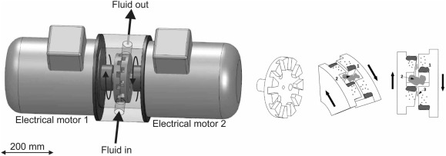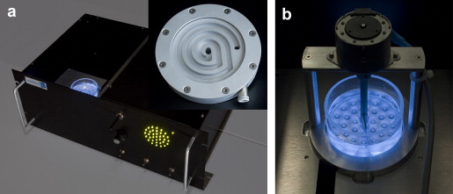
b
a
Fig. 6. (a) UV-LED disinfection reactor: 35 UV LEDs (282 nm) positioned in three concentric circles placed on the base of the water disinfection module (Würtele et al., 2011); (b) ‘shear induced’ hydrodynamic cavitation reactor (cavitation forms between the counter rotating teeth of the rotors) (Dular et al., 2016).

3.2.6. Electrochemical disinfection

Electrochemical disinfection involves the inactivation of microorganisms by passing an electric current through the water by means of suitable electrodes. Electrodes (at least one anode and one cathode) are inserted directly into the volume of water to be disinfected, and a direct current (DC) voltage is applied between them (Mills and Hunte, 1997; Tryk et al., 2000; Bergmann et al., 2002; Bahnemann, 2004). A voltage in the range 1–1500 V is required, depending on the characteristics of the anode and the water (Martínez-Huitle and Brillas, 2008). Two categories of electrochemical disinfection can be distinguished: direct electrolysers, which interface directly with the contaminated water and produce disinfecting species from the water itself, and mixed oxidant generators, which use a concentrated brine solution to generate a mixture of strong oxidising species (e.g. chlorine, chlorine dioxide, and ozone). The latter category has been reported to successfully inactivate Cryptosporidium oocysts (Venczel et al., 1997). In addition, electrochemical disinfection offers the benefits of on-site generation and avoiding the handling and storage hazards of chlorine gas. Furthermore, electrochlorination (the most popular electrochemical disinfection system) has reported more than 50% reduction in THMs compared to chlorination alone (Venczel et al., 1997); however, other byproducts such as chlorate and perchlorate could be formed, depending on the material used in the electrodes (Palmas et al., 2007). This technology has other disadvantages such as variable electrode lifetimes (RuO₂-coated Ti electrodes should be replaced every 3 months, while Ti electrodes may last up to eight years before replacement (Kraft, 2008)) and the formation of calcareous deposits on the electrodes, which limit its efficiency. Furthermore, electrochemical disinfection requires continuous supply of electricity.

3.2.7. Summary

Table 3 shows the main advantages and drawbacks of the emerging disinfection technologies.

Table 3. Main advantages and disadvantages of emerging water disinfection technologies.
 | Advantages | Disadvantages/limitations
Solar pasteurisation | - Simple to use and inexpensive  - No dependence on electricity  - No harmful byproducts formation  - No dependence on chemical access | - Dependence on climatic conditions  - Relatively long time to treat water  - Does not provide residual activity
Solar disinfection | - Simple to use and inexpensive  - No costs to the user after obtaining PET bottles  - No dependence on electricity  - Potentially effective against bacteria, viruses, and protozoa  - Minimal changes in taste and odour  - No harmful byproducts formation  - No dependence on chemical access | - Dependence on climatic conditions  - Relatively long time to treat water  - Need for pre-treatment in highly turbid waters  - Does not provide residual activity
Photocatalysis | - Exhibits strong bactericidal activity | - Dependence on chemical access  - Disadvantages of UV lamps, if used (see Table 2)  - Dependence on climatic conditions, if sunlight is used  - Presents operational challenges for industrial applications
UV-LEDs | - Longer lifetime than UV conventional lamps  - More compact and robust than UV lamps  - Environmentally friendly (no mercury)  - Less energy consumption  - No harmful byproducts formation  - No dependence on chemical access | - Economically unfeasible  - Requires continuous energy supply
Cavitation | - No harmful byproducts formation  - No dependence on chemical access | - Expensive, compared to chemical disinfectants  - Still at the laboratory stage of development  - Requires continuous energy supply
Electrochemical disinfection | - Direct electrolyser: no dependence on chemical access | - Requires continuous energy supply  - Electrodes lifetime  - Mixed oxidant generator: dependence on chemical access  - Efficiency limited by calcareous deposits on electrodes

4. Solar disinfection (SODIS)
The solar irradiance reaching the earth’s surface in a typical cloudless atmosphere in summer at the equator is about 1120 W/m² (McGuigan et al., 2012); hence, 1.12 kJ/m² of free natural energy from the sun is available for use every second. However, this value varies with position (decreasing as latitude increases away from the equator), season (because of the earth’s angle of tilt), and time of the day. In addition, not all the radiation received at the outer layer of the atmosphere reaches the earth’s surface. Water vapour, CO₂, ozone, oxygen, and pollutants present in the atmosphere absorb and scatter various proportions of the solar irradiance. Specifically, UVC radiation (100–280 nm) and a proportion of UVB radiation (280–320 nm) is absorbed by the atmosphere. Thus, solar disinfection activity is limited to wavelengths of more than 290 nm, which includes UVA (320 – 400 nm); this is the main range of UV radiation reaching the earth’s crust.

The disinfecting abilities of sunlight have been known for many years (SODIS has been carried out since Egyptian times), but only during the last few decades has this idea come to practice. Solar disinfection was first studied and reported in the late 1870s by Downes and Blunt (1877), who also indicated the importance of parameters such as sunlight intensity, solar exposure time, and wavelength (with the shorter being more effective) for inactivating bacteria. However, it was not until the 1980s that Aftim Acra and co-workers at the University of Beirut rediscovered solar disinfection as an effective and low-cost method for drinking water treatment (Acra et al, 1984).

Solar disinfection, based on the exclusive utilisation of solar radiation, is a simple, environmentally sustainable, and inexpensive method for drinking water treatment that inactivates pathogenic microorganisms using the germicidal effect of UV radiation and thermal heating (pasteurisation). The technique consists of placing raw water into transparent plastic containers (normally 1−2 L PET bottles) under direct sunlight for at least 6 h if it is a sunny day, or 2−3 days if cloudy, after which time it is safe to drink (SODIS, 2002). Fig. 7 shows a simple guidance for the use of SODIS (SODIS, 2017; Byrne et al., 2011). The main benefits of solar disinfection include no dependence on chemical components and electric sources, low operation and maintenance costs (cost to the user are associated with obtaining the PET bottles that must be replaced every six months), minimal changes in the taste and odour of the water, and no generation of residue (SODIS, 2002). From the user’s point of view, it is simple to operate, safe, and does not require heavy maintenance (Acra et al, 1984). However, it presents several drawbacks, such as many hours needed to treat small volumes of water, dependence on environmental conditions (sunlight intensity, ambient temperature, time of sun exposure, nature of the microbiological contamination, water turbidity levels, and water composition and nutrients present), and the characteristics of the container (optical transmittance, shape, volume and depth influence on the water temperature, and UV penetration). Furthermore, because SODIS does not provide residual activity, the treated water must be consumed within a day in order to prevent microbial regrowth (Sobsey, 2002). Moreover, sunlight can transform the plastic material into photoproducts that can migrate from the containers into water. This constitutes a significant barrier to the increasing usage of SODIS, despite the fact that PET plastic photodegradation products or other harmful or genotoxic substances have not been detected in concentrations above the limit set for drinking water quality (Wegelin et al., 2001; Schmid et al., 2008; Ubomba-Jaswa et al., 2010a).

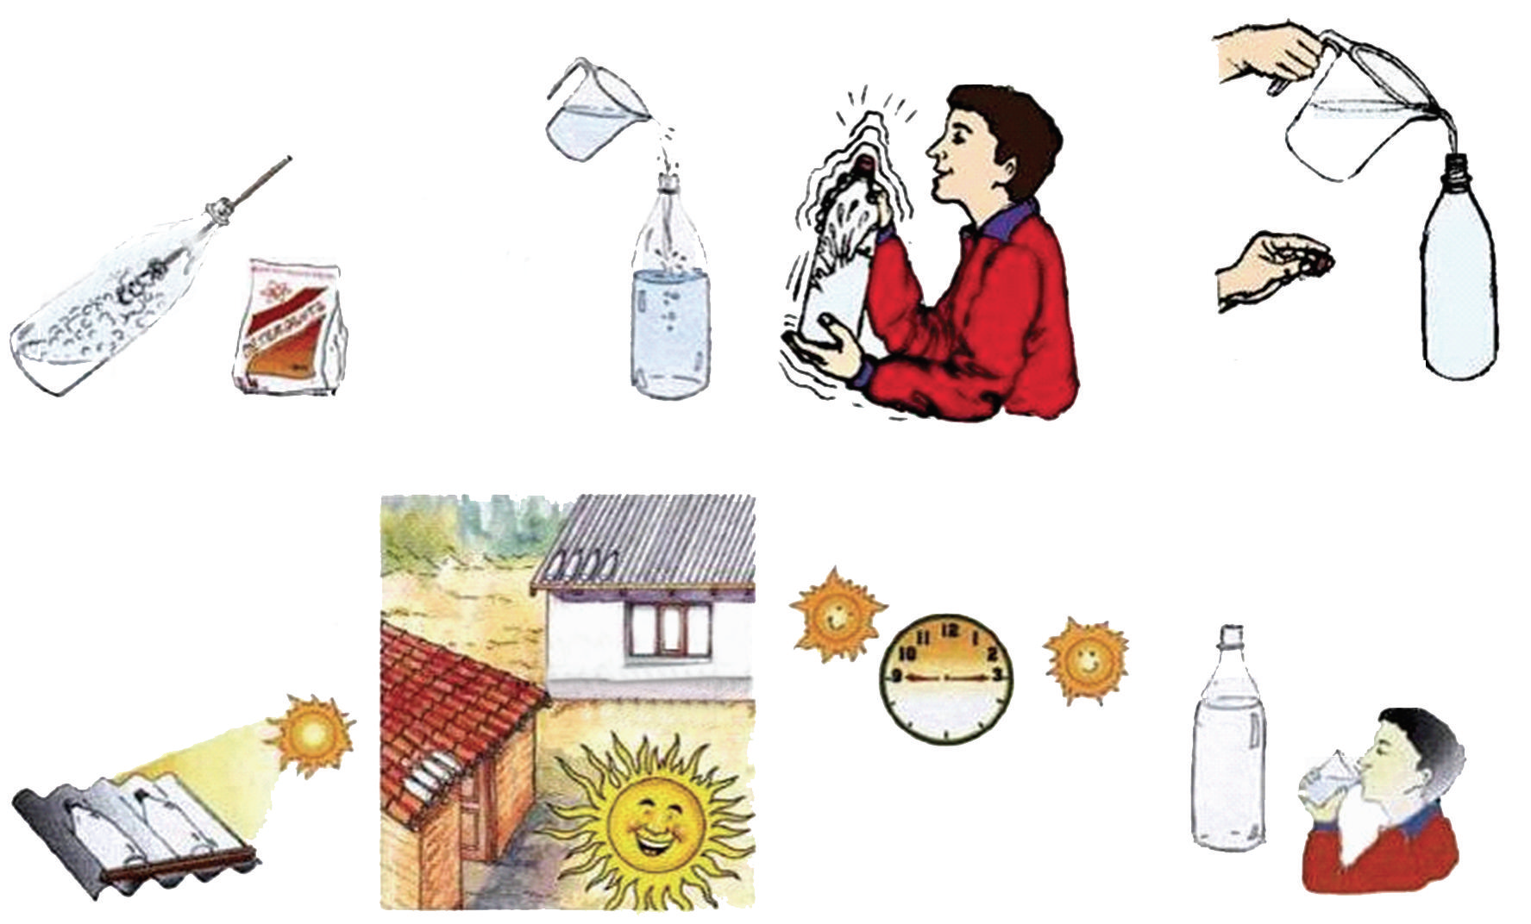
1. Wash the bottle well the first time you use it
2. Fill the bottle with water
3. Place the bottles on a black iron sheet or on the roof
4. Expose the bottle to direct sunlight for at least six hours
5. The water is now ready for consumption
Fig. 7. Graphical description of the SODIS process for household water treatment (SODIS, 2017; Byrne et al., 2011).

Regarding the mechanisms for pathogen inactivation, solar UV can cause damage through direct inactivation, UV photons acting directly on the DNA of microorganisms, or by photosensitisation mechanisms, whereby the UV light is absorbed by endogenous (indirect endogenous inactivation) or exogenous (indirect exogenous inactivation) sensitisers (Fig. 8). When DNA is irradiated with UV light, some of this energy is absorbed by pyrimidine rings of thymine and cytosine bases in the DNA, which leads to the formation of pyrimidine dimers that hinder DNA replication, thus preventing the microorganism from reproducing (Goodsell, 2001). Although UVA radiation is not sufficiently energetic to directly modify DNA bases, it is absorbed by photosensitisers present in the water (humic acids and chlorophylls), which react with oxygen to produce reactive oxygen species (ROS) such as singlet oxygen, superoxide, hydrogen peroxide, and hydroxyl radical. Furthermore, endogenous photosensitisers within cells, such as porphyrins, flavins, quinones, NADH/NADPH, and others, also contribute to the formation of intracellular ROS. These highly reactive oxygen molecules have a disinfectant effect by causing damage to DNA and oxidising amino acids in proteins and polyunsaturated fatty acids in lipids, thereby inducing cellular membrane damage (SODIS, 2017). However, the cell damage can be repaired by photo-reactivation (Thoma, 1999; Sancar, 1994; Kim et al., 1994; Sancar, 1996b; Todo et al., 1997) or dark repair mechanisms (Lindahl and Wood, 1999; Prakash et al., 1993; Sancar, 1996a; Lehmann, 1995, Seeber et al., 1995); cell damage can also be prevented by antioxidant enzymes (Halliwell and Gutteridge, 1989; Fridovich, 1995; Özben, 1998; Cabiscol et al., 2000). Some enzymes can repair pyrimidine dimers in the presence of blue light or even enable the cell to scavenge reactive oxygen species. Moreover, the affected pyrimidine bases or nucleotides can be removed, and both strands of DNA containing a large number of pyrimidine dimers can be cut to be repaired.


Microorganism inactivation
Atmosphere
UVC
UVC
UVA
UVC
UVA
UVB
UVB
UVA
UVB
DNA damage
Photosensitizer
Protein and lipid oxidation
DNA repair
Antioxidant repair system
ROS
Fig. 8. Mechanisms for inactivation of microorganisms by UV radiation: direct inactivation through direct DNA damage and photosensitisation mechanisms (indirect endogenous/exogenous inactivation) (Svobodova et al., 2006).

On the other hand, bacteria disinfection by thermal inactivation has been attributed to the high absorption of far-infrared radiation by water, whereby temperature triggers both synergetic and antagonist effects between optical and thermal processes. A strong synergistic effect has been observed when water temperature exceeds 45 ºC (McGuigan et al., 1998; Wegelin et al., 1994; Vivar et al., 2017b; Vivar et al., 2017c); this effect was attributed to a slow pasteurisation effect and the inhibition of the DNA repair mechanisms (McGuigan et al., 1998), while temperatures of 20–40 ºC were reported to enhance the bacteria growth, thus hindering the disinfection process (Vivar et al., 2017b; Giannakis et al., 2015).

The solar disinfection technique has been shown to be highly effective against a wide range of waterborne pathogens, such as bacteria, viruses, and protozoa, including Giardia and Cryptosporidium (Wegelin et al., 1994; Sommer et al., 1997; Boyle et al., 2008; Heaselgrave et al., 2006; Harding and Schwab, 2012; Mendez-Hermida et al., 2005; Mendez-Hermida et al., 2007; Gomez-Couso et al., 2010; Gomez-Couso et al., 2009a; Gomez-Couso et al., 2009b, McGuigan et al., 2006; Meierhofer and Landolt, 2009). However, the treatment time required varies, depending on the resistance from the microbes. Under approximately 1000 W/m² of global irradiance, 20 min of treatment is sufficient for inactivation of Campylobacter jejuni, 2.5 h for Escherichia coli DH5 a, and 4 h for Giardia muris cysts, while 8 h of SODIS treatment is required for Cryptosporidium parvum oocysts (Malato et al., 2009).

Besides microorganism resistance, the main parameters that affect the disinfection treatment include the amount of UV radiation received, water temperature, container characteristics, and water composition (Acra et al., 1984). Another important factor is the external configuration used for the bottles, which can improve the effectiveness of the process by increasing the UV radiation received or by raising the water temperature. Water within conventional PET bottles (Fig. 9a) rarely reaches the synergetic threshold temperature and usually remains in the range of the optimal growth temperature for the enteric bacteria (20–40 ºC). To accelerate the thermal inactivation process, the use of absorptive materials and painting the underside of the SODIS containers black (Fig.9b) were proposed as ways to enhance in the absorption of solar radiation (Mani et al., 2006; Mustafa et al., 2013). Other designs have focused on increasing the radiation that enters the bottles by using locally available reflective surfaces such as metallic corrugated laminates (Encinas et al., 2005; Vivar et al., 2015) or reflective paper attached to the back of the bottles (Mustafa et al., 2013; Kehoe et al., 2001; Navntoft et al., 2008). More advanced configurations have used compound parabolic concentrators (CPC) and glass tubes of different volumes, N−S or E−W oriented, and tilted to the latitude location angle (Fig. 9c) (Navntoft et al., 2008; Rincon and Pulgarin, 2004; Ubomba-Jaswa et al., 2010b; Alrousan et al., 2012; Nalwanga et al., 2014). The main results obtained show that absorptive or reflective rear surfaces and concentrators achieve faster inactivation rates than that of conventional SODIS treatment. However, they involve additional costs to the users; in particular, the high cost of the CPC reactors makes them unfeasible for household drinking water treatment (McGuigan et al., 2012).

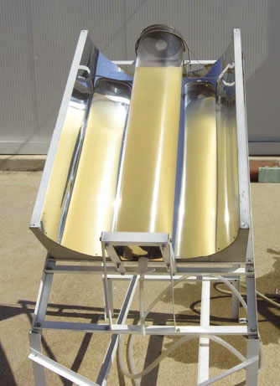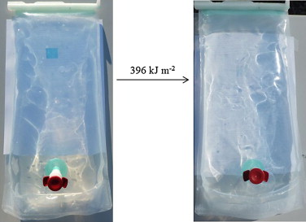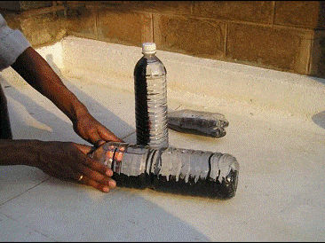
a
b
d
c
Fig. 9. Different solar disinfection configurations: (a) conventional SODIS treatment (SODIS, 2017); (b) bottles painted half black (Civil Engineering Home, 2017); (c) 25-L batch SODIS reactor made with a glass tube of 18 cm external diameter and a CPC reflector (Ubomba-Jaswa et al., 2010b); (d) PET bag (Lawrie et al., 2015).

PET bags (Fig. 9d) have also been used as a solution to maximise the volume of treated water and the area of photon collection, thereby minimising the water layer and improving light penetration (Lawrie et al., 2015; Gutiérrez-Alfaro et al., 2017). These bags can be easily transported and stored in large quantities, which makes them more suitable for emergency situations than PET bottles, as the lack of plastic bottles after a disaster can limit the application of SODIS. Other alternatives such as chemical additives where also studied as a possible improvement of solar inactivation. The additives that were tested include photocatalysts such as TiO₂ (see Section 3.2), sodium percarbonate in combination with citric acid or coper plus ascorbate, lemon juice or pulp, and riboflavin (Harding and Schwab, 2012; Fisher et al., 2012; Heaselgrave and Kilvington, 2010; Heaselgrave and Kilvington , 2011).

SODIS has been repeatedly shown to be effective in the elimination of microbial pathogens from water, thus decreasing the risk of waterborne diseases. It can be applied in treating wastewater from industrial effluents and emergency situations at community level. However, the most widespread application is at the household level in rural areas of the developing world, where solar disinfection in clear plastic bottles is one of the most adequate technologies for drinking water treatment, as recognised and promoted by the WHO (Sobsey, 2002). In fact, currently, solar disinfection is used daily by 4.5 million people in 50 countries mainly in Africa, Latin America, and Asia (Fig. 10) (McGuigan et al., 2012; Byrne et al., 2011; Meierhofer and Landolt, 2009), and this method is contributing to the 16−57% reduction in the incidence of diarrhoea and cholera in the communities that adopt this practice (Meierhofer and Landolt, 2009).

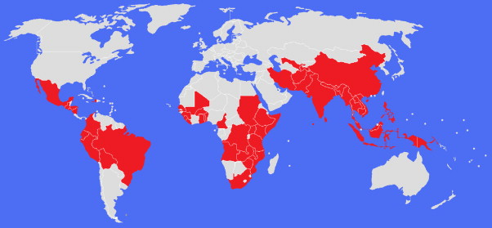
Fig. 10. Countries where SODIS was used daily in 2009 (McGuigan et al., 2012).

5. Photovoltaic−photochemical hybrid system (SOLWAT)
Despite the technological advancement in water disinfection and the increasing efforts devoted to providing safe drinking water worldwide, there is still no optimal solution to disinfecting water efficiently. Indeed, no single solution is easily accessible to entire populations (including small communities, developing countries, and in emergencies) at low cost, safely, and with low energy consumption and low environmental impact.

A short-term approach to developing water disinfection systems that operate with at least the same efficiency as current systems, but with less energy requirements and lower costs, would be through the introduction of renewable energy technologies. Solar energy is considered to be the only practically inexhaustible source of renewable energy that offers feasible solutions to water disinfection at low cost and high efficiency and at a global level. Disinfection systems that rely exclusively on natural UV light have a high potential in using clean energy with no environmental impact. However, these systems use only the UV region of the solar spectrum, which constitutes only 5% of the total available solar energy (Fig. 11). Thus, the efficiency of UV disinfection systems, including solar photovoltaic systems and SODIS PET bottles, is reduced. Therefore, the development of more energy efficient solar water disinfection systems will only be feasible if the solar spectrum is used in the most efficient way possible by taking full advantage of the energy contained in each spectral band.
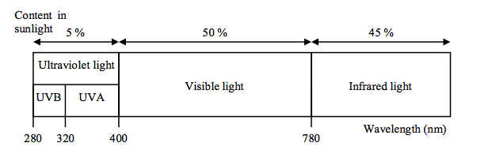
Fig. 11. Solar radiation spectrum at sea level (CIE, 2017).

In this regard, a new technology for water disinfection and simultaneous electricity generation, based exclusively on the use of solar energy, has been proposed recently by Vivar et al. (2010). This technology uses different conversion mechanisms: photovoltaic effect for electricity generation, and thermal and UV light for disinfection. The new system has low energy usage and high performance, and it provides other benefits, including no dependence on electrical energy or chemical components, generation and use of renewable energy, and no production of residues; in addition it offers compact and long-lasting system characteristics within a simple, low-cost design (Vivar et al., 2010).

The new technology consists of a hybrid solar water purification and photovoltaic (PV) system (SOLWAT) that is fully integrated into a single unit and uses the solar spectrum more efficiently. The SOLWAT system combines the germicidal effects of UV light and the thermal pasteurisation effects of far-infrared light to achieve bacteria disinfection; it also uses the visible and near-infrared light for solar PV electricity generation. In general, the SOLWAT system consists of two modules, with one stacked above the other. The PV module serves as the base of the water purification module with a layer of water on top; the layer of water is transparent to visible and near-infrared light. Water disinfection occurs between the glass cover of the water purification module and the PV module (Fig. 12).

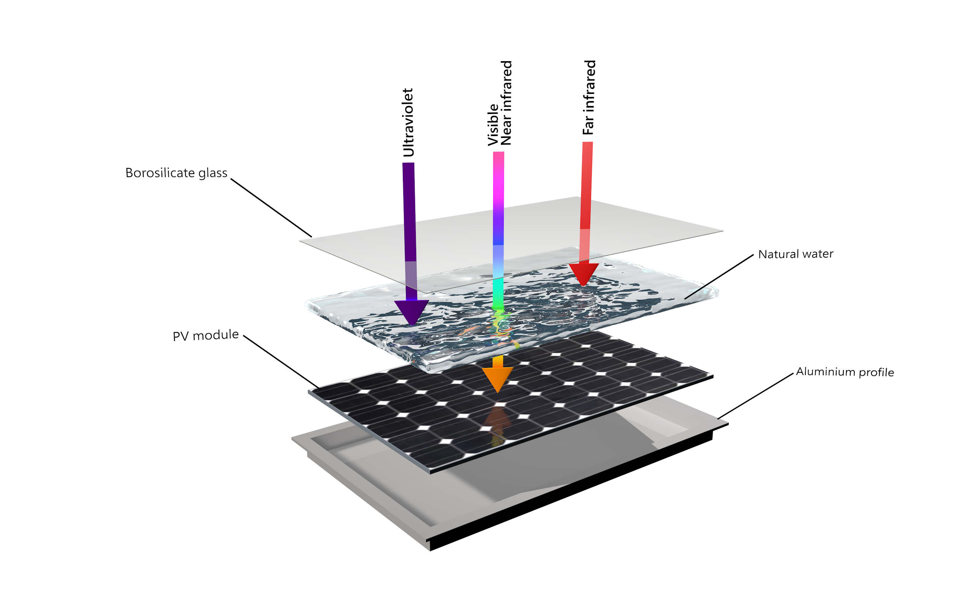
Fig. 12. Schematic diagram of the SOLWAT system (Vivar et al., 2010) showing the integration of the PV module on the bottom with the water disinfection reactor on the top and the use of the full solar spectrum (the UV and far-infrared portions are used for water disinfection, and the visible and near-infrared portions are used for electricity generation).

The feasibility of this concept has been demonstrated in previous studies (Pichel et al., 2016; Wang et al., 2016; Pichel et al., 2017), which found that the disinfection results of the SOLWAT system are always higher than the traditional and most widespread SODIS container (PET bottles). In addition, these studies found that the hybrid system (photovoltaic + disinfection) achieves the same results as two independent systems (photovoltaic module and disinfection reactor, separately), with the same disinfection capability and equal energy production from the PV modules during 6 h of experiments. This last result shows that the PV module beneath the disinfection reactor did not suffer from major losses due to the reduced solar irradiation received (lower I), as these losses are compensated by the cooling effect of the water layer on top of the module (higher V). Thus, this hybrid module could even produce more energy than a single PV module if appropriately optimised.

This combined system can be scaled up for use in the tertiary treatment of both drinking water and wastewater. The use of such improved systems will have a major impact in remote or rural areas of industrialised and developing countries. The SOLWAT system can provide large populations with access to drinking water, while also improving the implementation of wastewater treatment to serve these populations. An innovative aspect of this proposal is the integration of novel autonomous UV disinfection models that can be used where there is no electricity supply. The SOLWAT system would be especially suitable in countries located within a large area called the ‘sun belt’ zone, which lies between latitudes 35º N and 35º S, where irradiance conditions are more favourable for the use of the SOLWAT technology (Fig. 13). Incidentally, this area also covers the majority of populations that need clean drinking water and electricity.

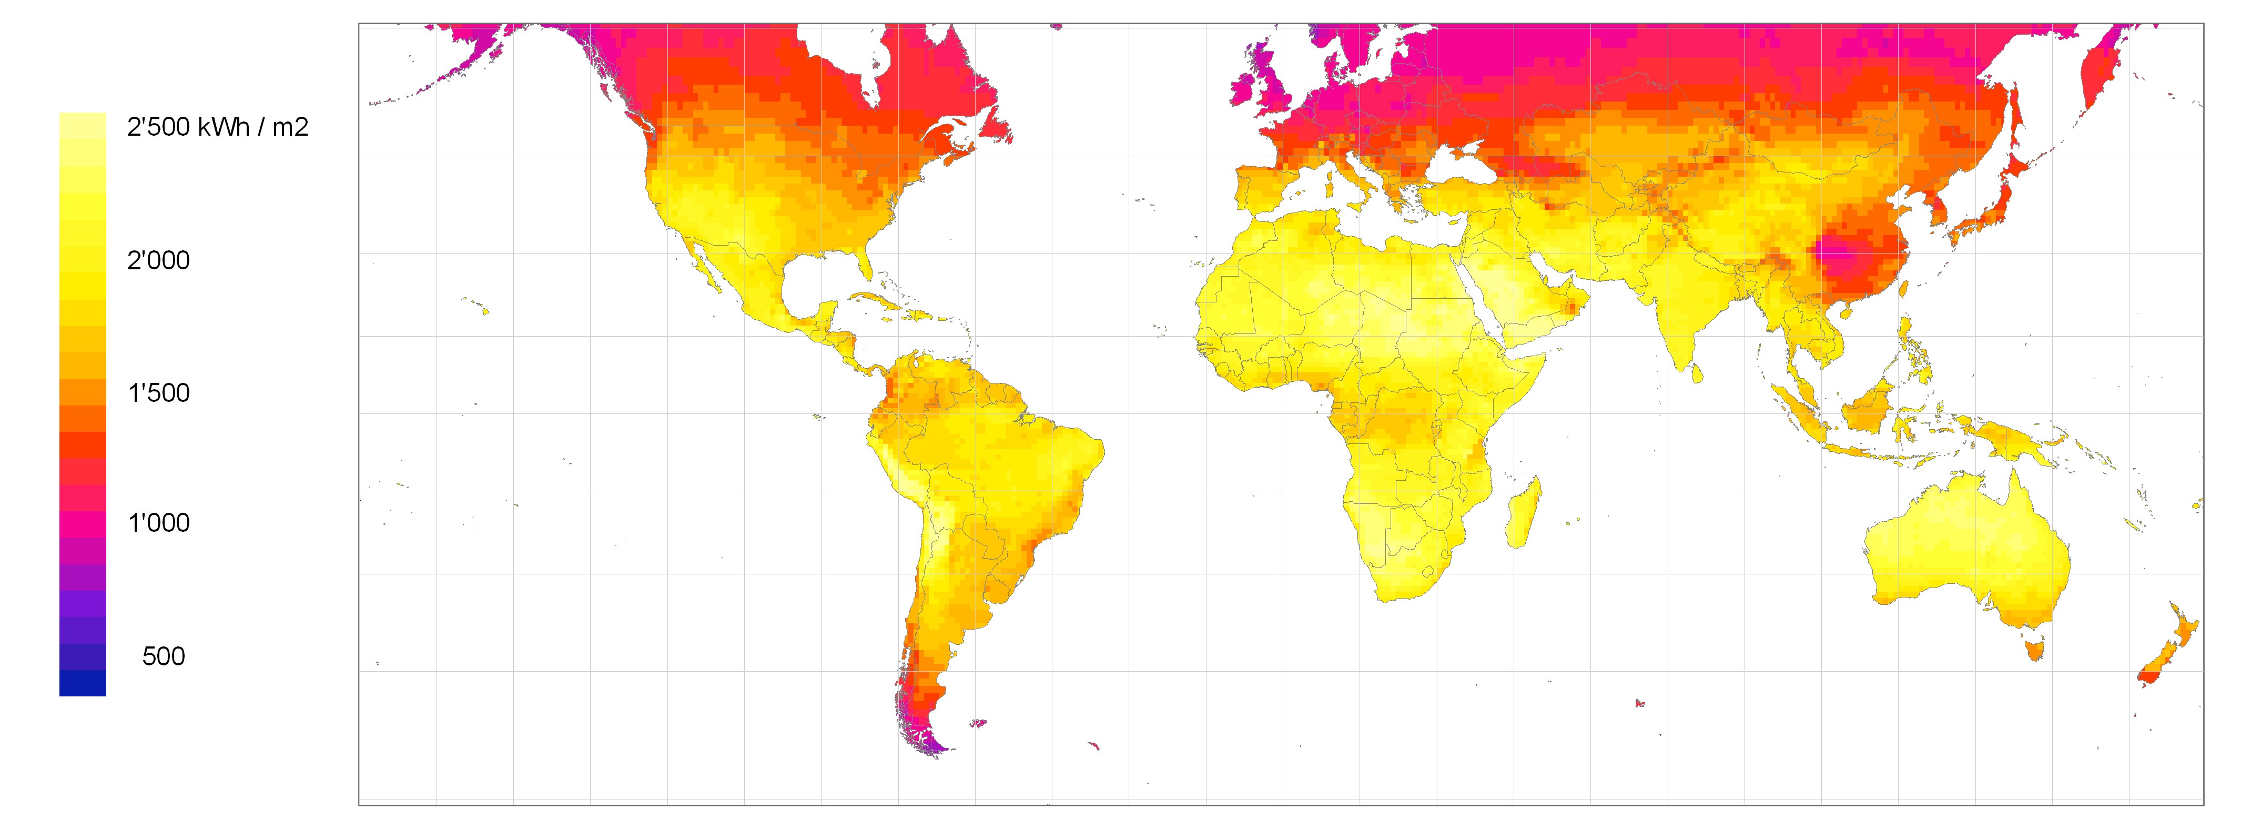
Fig. 13. World map of the annual sum of global irradiance showing the regions with the best conditions for solar energy applications (Meteonorm, 2017).

6. Conclusions

This paper addresses the problem of access to drinking water and presents a detailed, intensive review of conventional and advanced water treatment technologies. The paper also describes solar disinfection as one of the most appropriate methods for drinking water treatment in developing countries, including the SOLWAT system, a novel technology developed in this field.

It has been observed that conventional drinking water treatment technologies present serious limitations that impede their global application, mainly because they are chemically and energetically intensive. Electricity consumption for the production of potable water is a major contributor to the environmental impact of water supply. Many factors that could limit the provision of drinkable water include lack of a functional local electricity network, unbearable costs of electricity consumption, and inaccessible and expensive treatment chemicals (especially in developing countries). These limitations can lead to social rejection of poorly treated water due to unsatisfactory taste and odour. These shortcomings have led to rapid research and development of advanced alternative technologies to provide water intended for human consumption at low cost, low energy usage, and low environmental impact. In this regard, solar disinfection has been found to be one of the most appropriate methods for drinking water treatment, mainly because it is inexpensive and not dependent on electricity or chemicals. SODIS is exclusively based on solar energy utilisation, and its effectiveness for the elimination of pathogens from water has been widely demonstrated. Furthermore, new research studies have shown that if solar water disinfection is properly integrated with solar photovoltaic technology, a more efficient system in terms of solar spectrum utilisation could be obtained. Moreover, the generation of clean energy contributes to mitigating the environmental impacts and costs of potable water supply, while also providing electricity for used at the household or community level.

Finally, despite increasing efforts to develop new drinking water treatment technologies to overcome the disadvantages and limitations of conventional methods, substantial work remains to be done to address high demand for electricity and chemicals. If properly optimised, solar disinfection is a promising approach to producing drinkable water without the use of electricity or chemicals.

Acknowledgements

M. Vivar acknowledges funding from the Spanish Ministry of Economy and Competitiveness, ‘Ramon y Cajal’ Programme, Grant number RYC-2015-17306.

References

A/RES/64/292. The Human Right to Water and Sanitation. Resolution 64/292 adopted by the General Assembly on 28 July 2010. Last access 09/05/2017. URL: http://www.un.org/es/comun/docs/?symbol=A/RES/64/292&lang=E

Acra A., Raffoul Z., Karahagopian Y., 1984: Solar Disinfection of Drinking Water and Oral Rehydration Solutions: Guidelines for Household Application in Developing Countries. Department of Environmental Health Faculty of Health Science - American University of Beirut. UNICEF.

Al- Sa`ed R., 2007: Pathogens Assessment in Reclaimed Effluent Used for Industrial Crops Irrigation. Int. J. Env. Res. Pub. He. 5, 68-75.

Al-Otoum F., Al-Ghouti M.A., Ahmed T.A., Abu-Dieyeh M., Ali M., 2016: Disinfection by-products of chlorine dioxide (chlorite, chlorate, and trihalomethanes): Occurrence in drinking water in Qatar. Chemosphere 164, 649-656.

Alrousan D., Polo-López M., Dunlop P., Fernández-Ibáñez P., Byrne J., 2012: Solar photocatalytic disinfection of water with immobilised titanium dioxide in re-circulating flow CPC reactors. App. Catal. B-Enviro.128, 126-134.

Arnell N.W., Liu C., Compagnucci R., da Cunha L., Hanaki K., Howe C., Mailu G., Shiklomanov I., Stakhiv E., 2001: Hydrology and Water Resources. J.J. McCarthy, O.F. Canziani, N.A. Leary, D.J. Dokken, K.S. White (Eds.), IPCC Climate Change 2001: Impacts, Adaptation & Vulnerability, The Third Assessment Report of Working Group II of the Intergovernmental Panel on Climate Change (IPCC), 1000, Cambridge University Press, Cambridge, UK, pp. 133-191.

Arrojo S., Benito Y., Martínez-Tarifa A., 2008: A parametrical study of disinfection with hydrodynamic cavitation. Ultrason. Sonochem. 15(5), 903-908.

Bahnemann D., 2004: Photocatalytic water treatment: solar energy applications. Sol. Energy 77(5), 445–459.

Balasundaram B. and Harrison S.T.L., 2006: Study of physical and biological factors involved in the disruption of E. coli by hydrodynamic cavitation. Biotechnol. Prog. 22(3), 907-913.

Bartos M.D. and Chester M.V., 2014: The conservation nexus: valuing the interdependent water and energy savings in Arizona. Environ. Sci. Technol. 48(4), 2139-2149.

Bazilian M., Rogner H., Howells M., Hermann S., Arent D., Gielen D., et al., 2011: Considering the energy, water and food nexus: towards an integrated modelling approach. Energ. Policy 39, 7896-7906.

Bergmann H., Iourtchouk T., Schops K., Bouzek K., 2002: New UV irradiation and direct electrolysis - promising methods for water disinfection. Chem. Eng. J. 85, 111-117.

Betancourt W.Q. and Rose J.B., 2004: Drinking water treatment process for removal of Cryptosporidium and Giardia. Vet. Parasitol. 126, 219-234.

Blanco J., Malato S., Fernández-Ibáñez P., Alarcón D., Gernjak W., Maldonado M.I., 2009: Review of feasible solar energy applications to water processes. Renew. Sust. Energ. Rev. 13, 1437-1445.

Boyle M.A., Sichel C., Fernández-Ibáñez P., Arias-Quiroz G.B., Iriarte-Puña M., McGuigan K.G., 2008: Identifying the bactericidal limits of Solar Disinfection (SODIS) of water under real sunlight conditions. Appl. Environ. Microb. 74, 2997–3001.

Busch M. and Mickols W.E., 2004: Reducing energy consumption in seawater desalination. Desalination 165, 299-312.

Byrne J.A., Fernández-Ibáñez P.A., Dunlop P.S.M., Alrousan D.M.A., Hamilton J.W.J., 2011: Photocatalytic Enhancement for Solar Disinfection of Water: A Review. Int. J. Photoenergy 2011, 1-12.

Cabiscol E., Tamarit J., Ros J., 2000: Oxidative stress in bacteria and protein damage by reactive oxygen species. Int. Microbiol. 3, 3-8.

Carrillo A.M.R. and Frei C., 2009: Water: a key resource in energy production. Energ. Policy 37, 4303-4312.

Chavez-Rodriguez M.F. and Nebra S.A., 2014: Assessing GHG emissions, ecological footprint, and water linkage for different fuels. Environ. Sci. Technol. 44(24), 9252-9257.

Chen R.Z., Craik S.A., Bolton J.R., 2009: Comparison of the action spectra and relative DNA absorbance spectra of microorganisms: information important for the determination of germicidal fluence (UV dose) in an ultraviolet disinfection of water. Water Res. 43(20), 5087-5096.

Chong M.N., Jin B., Chow C.W.K., Saint C., 2010: Recent developments in photocatalytic water treatment technology: A review. Water Res. 44, 2997-3027.

CIE, 2017. Comission Interniatonale de l’Eclairage. Last access: 31/07/2017. URL: http://www.cie.co.at/

Ciochetti S.A. and Metcalf R.H., 1984: Pasteurization of Naturally Contaminated Water with Solar Energy. Appl. Environ. Microb. 47(2), 223-228.

Civil Engineering Home, 2017. Last access 19/07/2017. URL: https://theconstructor.org/water-resources/water-quality-checks-in-rainwater-harvesting/5427/

Clasen T., McLaughlin C., Nayaar N., Boisson S., Gupta R., Desai D., Shah N., 2008a: Microbiological effectiveness and cost of disinfecting water by boiling in semi-urban India. Am. J. Trop. Med. Hyg. 79(3), 407-413.

Clasen T.F., Thao H., Boisson S., Shipin O., 2008b: Microbiological effectiveness and cost of boiling to disinfect drinking water in rural Vietnam. Environ. Sci. Technol. 42(12), 4255-4260.

Clean Water Store, 2017. Last access 31/07/2017. URL: http://www.cleanwaterstore.com/

Council Directive 98/83/EC of 3 November 1998 on The Quality of Water Intended for Human Consumption. Official Journal of the European Communities L 330, 32-98. Last access 19/05/2017. URL: http://eur-lex.europa.eu/legal-content/EN/TXT/PDF/?uri=CELEX:31998L0083&from=ES

Darwish M.A. and Al-Najem N.M., 1987: Energy consumption and costs of different desalting systems. Desalination 64, 83-96.

DelGenio A.D., Lacis A.A., Ruedy R.A., 1991: Simulations of the effect of a warmer climate on atmospheric humidity. Nature 351, 382-385.

Domínguez C., García J., Pedraz M.A., Torres A.A., M.A. Galán, 1998: Photocatalytic oxidation of organic pollutants in water. Catal. Today 40(1), 85-101.

Downes A. and Blunt P., 1877: Researches on the Effect of Light upon Bacteria and other Organisms. P. R. Soc. London 26, 488-500.

Dular M., Griessler-Bulc T., Gutierrez-Aguirre I., Heath E., Kosjek T., Klemenc A. K., Oder M., Petkovšek M., Racki N., Ravnikar M., Šarc A., Širok B., Zupanc M., Zitnik M., Kompare B., 2016: Use of hydrodynamic cavitation in (waste)water treatment. Ultrason. Sonochem. 29, 577-588.

Dvorak B.I. and Skipton S.O., 2014: Drinking Water Treatment: Reverse Osmosis. Institute of Agriculture and Natural Resources, University of Nebraska-Lincoln Extension. Last access: 21/08/2018. URL: http://extensionpublications.unl.edu/assets/pdf/g1490.pdf

Efstratiou A., Ongerth J.E., Karanis P., 2017: Waterborne transmission of protozoa parasites: Review of worldwide outbreaks – An update 2011-2016. Water Res. 114, 14-22.

Egli T. and Wehrli B., 2010: Global Water Pollution and Human Health. Annu. Rev. Env. Resour. 35, 109-136.

Encinas P.J., Iriarte M., Wegelin M., Toranzos G., 2005: Evaluación de la Eficiencia del Método SODIS en la Inactivación de Coliformes Fecales en las Tres Regiones de Bolivia (Valle, Altiplano y Trópico). Desinfección Solar del Agua, de la Investigación a la Aplicación, 21-24.

EPA, 1999. The Environmental Protection Agency. Wastewater Technology Fact Sheet – Ultraviolet Disinfection. Office of Water, Washington D.C., EPA 832-F-99-064, September 1999. Last access 22/06/2017. URL: https://www3.epa.gov/npdes/pubs/uv.pdf

EPA, 2011. Water Treatment Manual: Disinfection. ISBN 978-184095-421-0.

Fanucchi M.V., 2017. Drinking Water and Sanitation. In: International Encyclopaedia of Public Health, 2nd edition. Quah, S.R. (Eds.). Publisher: Elsevier. ISBN: 9780128036785.

Fenwick A., 2006: Waterborne Infectious diseases-Could they be consigned to history? Science 313, 1077-1081.

Fernández P., Blanco J., Sichel C., Malato S., 2005: Water disinfection by solar photocatalysis using compound parabolic collectors. Catal. Today 101(3-4), 345-352.

Fisher M.B., Iriarte M., Nelson K.L., 2012: Solar water disinfection (SODIS) of Escherichia coli, Enterococcus spp., and MS2 coliphage: effects of additives and alternative container materials. Water Res. 46,1745–1754.

Fridovich I., 1995: Superoxide radicals and superoxide dismutases. Annu. Rev. Biochem. 64, 97-112.

Fritzmann C., Lowenberg J., Wintgens T., Melin T., 2007: State-of-the-art of reverse osmosis desalination. Desalination 216(1-3), 1-76.

Fthenakis V. and Kim H.C., 2010: Life-cycle uses of water in US electricity generation. Renew. Sust. Energ. Rev. 14, 2039-2048.

Fujishima A. and Honda K., 1972: Electrochemical photolysis of water at a semiconductor electrode. Nature 238, 37-38.

Fujishima A., Rao T.N., Tryk D.A., 2000: Titanium dioxide photocatalysis. J. Photoch. Photobio. C 1, 1-21.

Gadgil A., 1998: Drinking water in developing countries. Annu. Rev. Energ. Env. 23, 253-286.

Gaya U.I. and Abdullah A.H., 2008: Heterogeneous photocatalytic degradation of organic contaminants over titanium dioxide: a review of fundamentals, progress and problems. J. Photoch. Photobio. C 9, 1-12.

Ghaffour N., Missimer T.M., Amy G.L., 2013: Technical review and evaluation of the economics of water desalination: current and future challenges for better water supply sustainability. Desalination 309,197-207.

Giannakis S., Darakas E., Escalas-Cañellas A., Pulgarin C., 2015: Temperature-dependent change of light dose effects on E. coli inactivation during simulated solar treatment of secondary effluent. Chem. Eng. Sci. 126, 483-487.

Gilman R.H. and Skillicorn P., 1985: Boiling of drinking-water: can a fuel-scarce community afford it? B. World Health Organ. 63 (1), 157-163.

Gleick P.H., 1994: Water and Energy. Annu. Rev. Energ. Env. 19, 267-299.

Global Health Observatory Map Gallery. World Health Organization (WHO). Last access 24/08/2018. URL: http://gamapserver.who.int/mapLibrary/app/searchResults.aspx

Gomez-Couso H., Fontan-Sainz M., Ares-Mazas E., 2010: Thermal contribution to the inactivation of Cryptosporidium in plastic bottles during solar water disinfection procedures. Am. J. Trop. Med. Hyg. 82, 35–39.

Gomez-Couso H., Fontan-Sainz M., Fernandez-Alonso J., Ares-Mazas E., 2009a: Excystation of Cryptosporidium parvum at temperatures that are reached during solar water disinfection. Parasitology 136, 393–399.

Gomez-Couso H., Fontan-Sainz M., Sichel C., Fernandez-Ibáñez P., Ares-Mazas E., 2009b: Efficacy of the solar water disinfection method in turbid waters experimentally contaminated with Cryptosporidium parvum oocysts under real field conditions. Am. J.Trop. Med. Hyg. 14, 620–627.

Goodsell D.S., 2001: The molecular perspective: ultraviolet light and pyrimidine dimmers. Oncologist 6, 298-299.

Gude V. G., 2015: Energy and water autarky of wastewater treatment and power generation systems. Renew. Sust. Energ. Rev. 45, 52-68.

Guerrant R.L., DeBoer M.D., Moore S.R., Scharf R.J., Lima A.M., 2013: The impoverished gut – a triple burden of diarrhoea, stunting and chronic diseases. Nat. Rev. Gastro. Hepat. 10(4), 220-229.

Gutiérrez-Alfaro S., Acevedo A., Figueredo M., Saladin M., Manzano M.A., 2017: Accelerating the process of solar disinfection (SODIS) by using polymer bags. J. Chem. Technol. Biot. 92(2), 298-304.

Halliwell B. and Gutteridge J.M.C., 1989. Free Radicals in Biology and Medicine. Oxford University Press, Oxford. ISBN: 9780198717485.

Harding A.S. and Schwab K.J., 2012: Using limes and synthetic psoralens to enhance solar disinfection of water (SODIS): a laboratory evaluation with norovirus, Escherichia coli, and MS2. Am. J. Trop. Med. Hyg. 86, 566–572.

Heaselgrave W. and Kilvington S., 2010: Antimicrobial activity of simulated solar disinfection against bacterial, fungal, and protozoan pathogens and its enhancement by riboflavin. App. Environ. Microb. 76, 6010– 6012.

Heaselgrave W. and Kilvington S., 2011: The efficacy of simulated solar disinfection (SODIS) against Ascaris, Giardia, Acanthamoeba, Naegleria, Entamoeba and Cryptosporidium. Acta Trop. 119, 138–143.

Heaselgrave W., Patel N., Kehoe S.C., Kilvington S., McGuigan K.G., 2006: Solar disinfection of poliovirus and Acanthamoeba polyphaga cysts in water – a laboratory study using simulated sunlight. Lett. Appl. Microbiol. 43, 125–130.

Held I.M. and Soden B.J., 2000: Water vapor feedback and global warming. Annu. Rev. Energ. Env. 25, 441-475.

Hightower M. and Pierce S.A., 2008: The energy challenge. Nature 452 (7185), 285-286.

Ibrahim M.A.S., MacAdam J., Autin O., Jefferson B., 2014: Evaluating the impact of LED bulb development on the economic viability of ultraviolet technology for disinfection. Environ. Technol. 35 (4), 400-406.

IEA, 2012. International Energy Agency. Water for Energy, Is Energy Becoming a Thirstier Resource? Excerpt from the World Energy Outlook, 2012. Last access 28/08/2018. URL: https://www.iea.org/media/publications/weo/WEO_2012_Water_Excerpt.pdf

IPCC, 2014. Climate Change 2014: Impacts, Adaptation, and Vulnerability. Working Group II Contribution to the Fifth Assessment Report of the Intergovernmental Panel on Climate Change. Cambridge, UK/New York, Cambridge University Press. Last access: 23/08/2018. URL: www.ipcc.ch/report/ar5/wg2/.

ISDR, 2007. International Strategy for Disaster Reduction. Words Into Action: A Guide for Implementing the Hyogo Framework. Last access 30/05/2017. URL: http://www.preventionweb.net/files/594_10382.pdf

Ivnitsky H., Katz I., Shimoni E., Chen Y., Tarchitzky J., Semiat R., Dosoretz C.G., 2005: Characterization of membrane biofouling in nanofiltration processes of wastewater treatment. Desalination 185, 255-268.

Jyoti K.K. and Pandit A.B., 2001: Water disinfection by acoustic and hydrodynamic cavitation. Biochem. Eng. J. 7, 201-212.

Kehoe S.C., Joyce T.M., Ibrahim P., Gillespie J.B., Shahar R.A., McGuigan K.G., 2001: Effect of agitation, turbidity, aluminium foil reflectors and volume on inactivation efficiency of batch-process solar disinfectors. Water Res. 35(4), 1061-1065.

Kim S.T., Malhotra K., Smith C.A., Taylor J.S., Sancar A., 1994: Characterization of (6-4) photoproduct DNA photolyase. J. Biol. Chem. 269, 8535–8540.

Korn C., Andrews R.C., Escobar M.D., 2002: Development of chlorine dioxide related by-product models for drinking water treatment. Water Res. 36, 330-342.

Kraft A., 2008: Electrochemical Water Disinfection: A Short Review. Platin. Met. Rev. 52, 177-185.

Lawrie K., Mills A., Figueredo-Fernández M., Gutiérrez-Alfaro S., Manzano M., Saladin M., 2015: UV dosimetry for solar water disinfection (SODIS) carried out in different plastic bottles and bags. Sensor Actuat. B-Chem. 208, 608-615.

Lehmann A.R., 1995: Nucleotide excision repair and the link with transcription. Trends Biochem. Sci. 20, 402–405.

Li H., Chien S.H., Hsieh M.K., Dzombak D.A., Vidic R.D., 2011: Escalating water demand for energy production and the potential for use of treated municipal wastewater. Environ. Sci. Technol. 45, 4195-4200.

Lindahl T. and Wood R. D., 1999: Quality control by DNA repair. Science 286, 1897–1905.

Linden K.G., Shin G., Sobsey M.D., 2001: Comparative effectiveness of UV wavelengths for the inactivation of Cryptosporidium parvum oocysts in water. Water Sci. Technol. 43 (12), 171-174.

Loaciga H.A., Valdes J.B., Vogel R., Garvey J., Schwarz H., 1996: Global warming and the hydrologic cycle. J. Hydrol. 174, 83-127.

Loraine G., Chahine G., Hsiao C.T., Choi J.K., Aley P., 2012: Disinfection of gram-negative and gram-positive bacteria using DynaJets® hydrodynamic cavitating jets. Ultrason. Sonochem. 19 (3), 710-717.

Macknick J., Newmark R., Heath G., Hallett K.C., 2012: Operational water consumption and withdrawal factors for electricity generating technologies: a review of existing literature. Environ. Res. Lett. 7, 1-10.

Malaeb L. and Ayoub G.M., 2011: Reverse osmosis technology for water treatment: State of the art review. Desalination 226(1), 1-8.

Malato S., Fernández-Ibáñez P., Maldonado M.I., Blanco J., Gernjak W., 2009: Decontamination and disinfection of water by solar photocatalysis: Recent overview and trends. Catal. Today 147(1), 1-59.

Mamane-Gravetz H., Linden K.G., Cabaj A., Sommer R., 2005: Spectral sensitivity of Bacillus subtilis spores and MS2 coliphage for validation testing of ultraviolet reactors for water disinfection. Environ. Sci. Technol. 39(20), 7845-7852.

Maness P.C., Smolinski S., Blake D.M., Huang Z., Wolfrum E.J., Jacoby W.A., 1999: Bactericidal Activity of Photocatalytic TiO₂ Reaction: toward an Understanding of its Killing Mechanism. Appl. Environ. Microb. 65, 4094-4098.

Mani S.K., Kanjura R., Singha I.S.B., Reed R.H., 2006: Comparative effectiveness of solar disinfection using small-scale batch reactors with reflective, absorptive and transmissive rear surfaces. Water Res., 40(4), 721-727.

Marsh D.M., 2008: The Water–Energy Nexus: A Comprehensive Analysis In The Context of New South Wales. PhD dissertation, University of Technology, Sydney, Australia.

Martínez-Huitle C.A. and Brillas E., 2008: Electrochemical Alternatives for Drinking Water Disinfection. Angew. Chem. Int. Ed. Engl. 47(11), 1998-2005.

Marugán J., Aguado J., Gernjak W., Malato S., 2007: Solar photocatalytic degradation of dichloroacetic acid with silica-supported titania at pilot-plant scale. Catal. Today 129, 59-68.

Marugán J., Lopez-Muñoz M.J., Gernjak W., Malato S., 2006: Fe/TiO₂/pH interactions in solar degradation of imidacloprid with TiO₂/SiO₂ photocatalysts at pilot-plant scale. Ind. Eng. Chem. Res. 45, 8900-8908.

Matsunaga T., Tomoda R., Nakajima T., Wake H., 1985: Photoelectrochemical sterilization of microbial cells by semiconductor powders. FEMS Microbiol. Lett. 29(1-2), 211-214.

McGuigan K.G., Conroy R.M., Mosler H.J., du Preez M., Ubomba-Jaswa E., Fernández-Ibáñez P., 2012: Solar water disinfection (SODIS): A review from bench-top to roof-top. J. Hazard. Mater. 235-236, 29-46.

McGuigan K.G., Joyce T.M., Conroy R.M., Gillespie J.B., Elmore-Meegan M., 1998: Solar disinfection of drinking water contained in transparent plastic bottles: characterizing the bacterial inactivation process. J. Appl. Microbiol. 84, 1138-1148.

McGuigan K.G., Méndez-Hermida F., Castro-Hermida J.A., Ares-Mazás E., Kehoe S.C., Boyle M., Sichel C., Fernández-Ibáñez P., Meyer B.P., Ramalingham S., Meyer E.A., 2006: Batch solar disinfection (SODIS) inactivates oocysts of Cryptosporidium parvum and cysts of Giardia muris in drinking water. J. Appl. Microbiol. 101, 453–463.

Meierhofer R. and Landolt G., 2009: Factors supporting the sustained use of solar water disinfection – Experiences from a global promotion and dissemination programme. Desalination 248, 144-151.

Mendez-Hermida F., Ares-Mazas E., McGuigan K.G., Boyle M., Sichel C., Fernández-Ibáñez P., 2007: Disinfection of drinking water contaminated with Cryptosporidium parvum oocysts under natural sunlight and using the photocatalyst TiO2. J. Photoch. Photobio. B 88, 105–111.

Mendez-Hermida F., Castro-Hermida J.A., Ares-Mazas E., Kehoe S.C., McGuigan K.G., 2005: Effect of batch-process solar disinfection on survival of Cryptosporidium parvum oocysts in drinking water. Appl. Environ. Microb. 71, 1653–1654.

Meteonorm, 2017. Last access 25/07/2017. URL: www.meteonorm.com

Mezule L., Tsyfansky S., Yakushevich V., Juhna T., 2010: A simple technique for water disinfection with hydrodynamic cavitation: effect on survival of Escherichia coli. Desalination 251, 152-159.

Mills A. and Le Hunte S., 1997: An overview of semiconductor photocatalysis. J. Photoch. Photobio. A 108(1), 1–35.

Molinos-Senante M. and Sala-Garrido R., 2017: Energy intensity of treating drinking water: Understanding the influence of factors. Appl. Energ. 202, 275-281.

Mulder K., Hagens N., Fisher B., 2010: Burning water: a comparative analysis of the energy return on water invested. Ambio 39, 30-9.

Mustafa A., Scholz M., Khan S., Ghaffar A., 2013: Application of solar disinfection for treatment of contaminated public water supply in a developing country: field observation. J. Water Health 11(1), 135-145.

Nalwanga R., Quilty B., Muyanja C., McGuigan K.G., Fernández-Ibáñez P., 2014: Evaluation of solar disinfection of E. coli under Sub-Saharan field conditions using a 25 L borosilicate glass batch reactor fitted with a compound parabolic collector. Sol. Energy 100, 195-202.

National Research Council, 1980. Drinking Water and Health, Volume 2. Washington, DC: The National Academies Press. https://doi.org/10.17226/1904.

National Research Council, 1987. Disinfection Methods and Efficacy. Drinking Water and Health: Disinfectants and Disinfectant By-Products: Volume 7. National Research Council (US) Safe Drinking Water Committee. Washington (DC): National Academies Press (US); 1987.

National Research Council, 2008. Committee on Advancing Desalination Technology, Desalination: A National Perspective (National Academies Press, Washington, DC, 2008).

Navntoft C., Ubomba-Jaswa E., McGuigan K.G., Fernández-Ibáñez P., 2008: Effectiveness of solar disinfection using batch reactors with non-imaging aluminium reflectors under real conditions: natural well-water and solar light. J. Photoch. Photobio. B 93(3), 155-161.

Oki T. and Kanae S., 2006: Global Hydrological Cycles and World Water Resources. Science 313, 1068-1072.

Özben T., 1998. Free Radicals, Oxidative Stress and Antioxidants: Pathological and Physiological Significance. (Nato ASI Series A, Vol. 296.) Plenum Press, New York.

Palmas S., Polcaro M., Vacca A., Mascia M., Ferrara F., 2007: Influence of the operating conditions on the electrochemical disinfection process of natural waters at BDD electrodes. J. Appl. Electrochem. 37, 1357-1365.

Pandit A.B. and Kumar J.K., 2012. Drinking Water Disinfection Techniques. CRC Press, Taylor and Francis Group. ISBN: 9781439877401.

Pichel N., Vivar M., Fuentes M., 2016: Performance analysis of a solar photovoltaic hybrid system for electricity generation and simultaneous water disinfection of wild bacteria strains. Appl. Energ. 171, 103-112.

Pichel N., Vivar M., Fuentes M., 2017: Performance study of a hybrid photovoltaic and solar water disinfection system considering climatic variations over a year. Energ. Convers. Manage. 144, 312-321.

Pozzo R.L., Baltanás M.A., Cassano A.E., 1997: Supported titanium dioxide as photocatalyst in water decontamination: state of the art. Catal. Today 39, 219-231.

Prakash S., Sung P., Prakash L., 1993: DNA repair genes and proteins of Saccharomyces cerevisiae. Annu. Rev. Genet. 26, 33–70.

Psutka R., Peletz R., Michelo S., Kelly P., Clasen T., 2011: Assessing the microbiological performance and potential cost of boiling drinking water in urban Zambia. Environ. Sci. Technol. 45 (14), 6095-6101.

Rasul G., 2014: Food, water, and energy security in South Asia: a nexus perspective from the Hindu Kush Himalayan region. Environ. Sci. Policy 39, 35-48.

Ray C. and Jain R., 2014. Chapter 3 – Solar Pasteurization. Low Cost Emergency Water Purification Technologies, Integrated Water Security Series, 31-53. ISBN: 978-0-12-411465-4.

Rincon A. and Pulgarin A., 2004: Field solar E. coli inactivation in the absence and presence of TiO2: is UV solar dose and appropriate parameter for standardization of water solar disinfection? Sol. Energy 77, 635-648.

Rizzo L., 2009: Inactivation and injury of total coliform bacteria after primary disinfection of drinking water by TiO₂. J. Hazard. Mater. 165, 48-51.

Rook J.J., 1974: Formation of haloforms during chlorination of natural waters. J. Water Treat. Exam. 23, 234-243.

Sachit D.E. and Veenstra J.N., 2014: Analysis of reverse osmosis membrane performance during desalination of simulated brackish surface waters. J. Membrane Sci. 453, 136-154.

Saidur R., Rahim N.A., Islam M.R., Solangi K.H., 2011: Environmental impact of wind energy. Renew. Sust. Energ. Rev. 15, 14459-14467.

Sancar A., 1996a: DNA excision repair. Annu. Rev. Biochem. 65, 43–81.

Sancar A., 1996b: No “end of history” for photolyases. Science 272, 48–49.

Sancar A., 1994: Structure and function of DNA photolyase. Biochemistry 33, 2–9.

Schmid P., Kohler M., Meierhofer R., Luzi S., Wegelin M., 2008: Does the reuse of PET bottles during solar water disinfection pose a health risk due to the migration of plasticisers and other chemicals into the water? Water Res. 42(20), 5054-5060.

Scott C.A., Pierce S.A., Pasqualetti M.J., Jones A.L., Montz B.E., Hoover J.H., 2011: Policy and institutional dimensions of the water–energy nexus. Energ. Policy 39, 6622-6630.

Seeberg E., Eide L. and Bjørås M., 1995: The base excision repair pathway. Trends Biochem. Sci. 20, 391–397.

Shannon M.A., Bohn P.W., Elimelech M., Georgiadis J.G., Mariñas B.J., Mayes A.M., 2008: Science and technology for water purification in the coming decades. Nature 45, 301-320.

Siddiqi A. and Anadon L.D., 2011: The water–energy nexus in Middle East and North Africa. Energ. Policy 39, 4529-4540.

Sobsey M.D.: Managing Water in the Home: Accelerated Health Gains from Improved Water Supply. World Health Organization (WHO) reference number WHO/SDE/WSH/02.07. Genove, 2002.

SODIS, 2002. Solar Water Disinfection – A Guide for the Application of SODIS. SANDEC, Eawag, Duebendorf, 2002.

SODIS, 2017. SODIS Safe Drinking Water for All. How Does it Work? Last access 17/07/2017. URL: http://www.sodis.ch/methode/anwendung/index_EN

Sommer B., Marino A., Solarte Y., Salas M.L., Dierolf C., Valiente C., Mora D., Rechsteiner R., Setter P., Wirojanagud W., Ajarmeh H., AlHassan A., Wegelin M., 1997: SODIS – an emerging water treatment process. J. Water Supply Res. T. 46, 127–137.

Spain, RD 140/2003. Real Decreto 140/2003, de 7 de febrero, por el que se Establecen los Criterios Sanitarios de la Calidad del Agua de Consumo Humano. Boletín Oficial del Estado, 21 de febrero de 2003, núm. 45, 7228 a 7245.

Stanley K., 2004: Inactivation of Escherichia coli O157:H7 and Listeria monocytogenes by High-Intensity Ultrasound in the Presence of Salts (Thesis). University of Tennessee-Knoxville.

Stoica I.M., Vitzilaiou E., Røder H.L., Burmølle M., Thaysen D., Knochel S., den Berg F., 2018: Biofouling on RO-membranes used for water recovery in the dairy industry. J. Water Proc. Eng. 24, 1-10.

Sustainable Development Goals. The United Nations (UN). Last access 03/04/2018. URL: https://sustainabledevelopment.un.org/?menu=1300

Svobodova A., Walterova D., Vostalova J., 2006: Ultraviolet light induced alteration to the skin. Biomed. Pap. Med. Fac. Univ. Palacky Olomouc Czech Repub. 150(1), 25-38.

Thoma F., 1999: Light, dark in chromatin repair: repair of UV-induced DNA lesions by photolyase and nucleotide excision repair. EMBO J. 18, 6585–6598.

Todo T., Kim S.T., Hitomi K., Otoshi E., Inui T., Morioka H., Kobayashi H., Ohtsuka E., Toh H. and Ikenaga M., 1997: Flavin adenine dinucleotide as a chromophore of the Xenopus (6-4) photolyase. Nucleic Acids Res. 25, 764–768.

Tran T., Bolto B., Gray S., Hoang M., Ostarcevic E., 2007: An autopsy study of a fouled reverse osmosis membrane element used in a brackish water treatment plant. Water Res. 41, 3915-3923.

Trenberth K.E., 1999: Conceptual framework for changes of extremes of the hydrological cycle with climate change. Climatic Change 42, 327-339.

Tryk D.A., Fujishima A., Honda K., 2000: Recent topics in photoelectrochemistry: achievements and future prospects. Electrochim. Acta 45(15-16), 2363–2376.

Ubomba-Jaswa E., Fernández-Ibáñez P., McGuigan K.G., 2010a: A preliminary Ames fluctuation assay assessment of the genotoxicity of drinking water that has been solar disinfected in polyethylene terephthalate (PET) bottles. J. Water Health 8(4), 712-719.

Ubomba-Jaswa E., Fernández-Ibáñez P., Navntoft C., McGuigan K.G., 2010b: Investigating the microbial inactivation efficiency of a 25 L batch solar disinfection (SODIS) reactor enhanced with a compound parabolic collector (CPC) for household use. J. Chem. Technol. Biot. 85(8), 1028-1037.

UNESCO, 2015. The United Nations World Water Development Report 2015. Water for a Sustainable World. ISBN 978-92-3-100071-3

UNESCO, 2018. The United Nations World Water Development Report 2018. Nature-Based Solutions for Water. ISBN 978-92-3-100264-9
Venczel L.V., Arrowood M., Hurd M., Sobsey M.D., 1997: Inactivation of Cryptosporidium parvum oocysts and Clostridium perfringens spores by a mixed-oxidant disinfectant and by free chlorine. Appl. Environ. Microb. 63(4), 1598-1601.

Vilhunen S., Sarkka H., Sillanpaa M., 2009: Ultraviolet light-emitting diodes in water disinfection. Environ. Sci. Pollut. R. 16(4), 439-442.

Vivar M., Fuentes M., Castro J., García-Pacheco R., 2015: Effect of common rooftop materials as support base for solar disinfection (SODIS) in rural areas under temperate climates. Sol. Energy 115, 204-216.

Vivar M., Pichel N., Fuentes M., 2017a. Drinking-Water Access and Health in Refugee Camps. In: Handbook of Famine, Starvation, and Nutrient Deprivation: From Biology to Policy. Victor R. Preedy; Vinood B. Patel (Eds.). Springer International Publishing. ISBN: 978-3-319-55386-3.

Vivar M., Pichel N., Fuentes M., López-Vargas A., 2017b: Separating the UV and thermal components during real-time solar disinfection experiments: The effect of temperature. Sol. Energy 146, 334-341.

Vivar M., Pichel N., Fuentes M., 2017c: Solar disinfection of natural river water with low microbiological content (10-10³ CFU/100 ml) and evaluation of the thermal contribution to water purification. Sol. Energy 141, 1-10.

Vivar M., Skryabin I., Everett V., Blakers A., 2010: A concept for a hybrid solar water purification and photovoltaic system. Sol. Energ. Mat. Sol. C. 94, 1772-1782.

Wakeel M., Chen B., Hayat T., Alsaedi A., Ahmad B., 2016: Energy consumption for water use in different countries: A review. Appl. Energ. 178, 868-885.

Wang Y., Jin Y., Huang Q., Zhu L., Vivar M., Qin L., Sun Y., Cui Y., Cui L., 2016: Photovoltaic and disinfection performance study of a hybrid photovoltaic-solar water disinfection system. Energy 106, 757-767.

Wegelin M., Canonica S., Alder A.C., Marazuela D., Suter M.J-F., Bucheli T.D., Haefliger O.P., Zenobi R., McGuigan K.G., Kelly M.T., Ibrahim P., Larroque M., 2001: Does sunlight change the material and content of polyethulene terephthalate (PET) bottles? J. Water Supply Res. T. 50, 125-133.

Wegelin M., Canonica S., Mechsner K., Fleischmann T., Pesaro F., Metzler A., 1994: Solar water disinfection: scope of the process and analysis of radiation experiments. J. Water Supply Res. T. 43(4), 154-169.

WHO, 2009. Global Health Risks: Mortality and Burden of Diseases Attributable to Selected Major Risks. World Health Organization (WHO). ISBN 978 92 4 156387 1.

WHO, 2011. Guidelines for Drinking-Water Quality (4th edition). Last access 09/05/2017. URL: http://apps.who.int/iris/bitstream/10665/44584/1/9789241548151_eng.pdf

WHO, 2016. Sanitation. Last access 11/05/2017. URL: http://www.who.int/topics/sanitation/en/

WHO, 2017a. Fact Sheet 2.16. Fact Sheets on Environmental Sanitation. Disinfectants. Last access 19/06/2017. URL: http://www.who.int/water_sanitation_health/sanitation-waste/fs2_16.pdf?ua=1

WHO, 2017b. Fact Sheet 2.34. Fact Sheets on Environmental Sanitation. Household Water Treatment and Storage. Last access 22/06/2017. URL: http://www.who.int/water_sanitation_health/sanitation-waste/fs2_34.pdf?ua=1

WHO, 2018. Fact Sheet 391. Drinking Water. Last access 03/04/2018. URL: http://www.who.int/mediacentre/factsheets/fs391/en/

WHO/UNEP, 2006a. WHO Guideline for the Safe Use of Wastewater, Excreta and Greywater. Volume 1: Policy and Regulatory Aspects. World Health Organization (WHO) and United Nations Environment Programme (UNEP), 2006. Last access 18/05/2017. URL: http://apps.who.int/iris/bitstream/10665/78265/1/9241546824_eng.pdf

WHO/UNEP, 2006b. WHO Guidelines for the Safe Use of Wastewater, Excreta and Greywater. Volume 2: Wastewater Use in Agriculture. World Health Organization (WHO) and United Nations Environment Programme (UNEP), 2006. Last access 18/05/2017. URL: http://www.who.int/water_sanitation_health/publications/gsuweg2/en/

WHO/UNICEF, 2015. Progress on Sanitation and Drinking Water: 2015 Update and MDG Assessment. Last access: 11/05/2017. URL: https://www.wssinfo.org/fileadmin/user_upload/resources/JMP-Update-report-2015_English.pdf

WHO/UNICEF, 2017. Progress on Drinking Water, Sanitation and Hygiene: 2017 Update and SDB Baselines. Joint Monitoring Program. ISBN 978-92-4-151289-3

Würtele M.A., Kolbe T., Lipsz M., Külberg A., Welyers M., Kneissl M., Jekel M., 2011: Application of GaN-based ultraviolet-C light emitting diodes - UV LEDs – for water disinfection. Water Res. 45(3), 1481-1489.

WWAP (United Nations World Water Assessment Programme), 2009. The United Nations World Water Development Report 3: Water in a Changing World. Paris: UNESCO, and London: Earthscan. Last access: 24/07/2017. URL: http://unesdoc.unesco.org/images/0018/001819/181993e.pdf

WWAP (United Nations World Water Assessment Programme), 2017. The United Nations World Water Development Report 2017. Wastewater: The Untapped Resource. Paris, UNESCO. Last access: 23/08/2018. URL: www.unesco.org/new/en/natural-sciences/environment/water/wwap/wwdr/2017-wastewater-the-untapped-resource/.

Yang G.C.C. and Li C.J., 2007: Electrofiltration of silica nanoparticle-containing wastewater using tubular ceramic membranes. Sep. Purif. Technol. 58, 159-165.

Zhai H., He X., Zhang Y., Du T., Adeleye A.S., Li Y., 2017: Disinfection by-products formation in drinking water sources: A case study of Yuqiao reservoir. Chemosphere 181, 224-231.

Zhang Y., Sivakumar M., Yang S., Enever K., Ramezanianpour M., 2018: Application of solar energy in water treatment processes: A review. Desalination 428, 116-145.

Zhou Y.C., Zhang B., Wang H.K., Bi J., 2013: Drops of energy: conserving urban water to reduce greenhouse gas emissions. Environ. Sci. Technol. 47, 10753-10761.

Zotalis K., Dialynas E.G., Mamassis N., Angelakis A.N., 2014: Desalination technologies: hellenic experience. Water 6(5), 1134-1150.

