Link to publisher version: https://doi.org/10.1016/j.jpba.2019.05.041
Chemical profiling, antioxidant, enzyme inhibitory and molecular modelling studies on the leaves and stem bark extracts of three African medicinal plants
Nabeelah Bibi Sadeer¹, Eulogio J. Llorent-Martínez², Kouadio Bene³, Mohamad Fawzi Mahomoodally¹, Adriano Mollica⁴, Kouadio Ibrahime Sinan ⁵, Azzurra Stefanucci⁴, Alba Ruiz-Riaguas², María Luisa Fernández-de Córdova², Gokhan Zengin^{5*}

¹Department of Health Sciences, Faculty of Science, University of Mauritius, 230 Réduit, Mauritius
²Department of Physical and Analytical Chemistry, Faculty of Experimental Sciences, University of Jaén, Campus Las Lagunillas, E-23071 Jaén, Spain
³ Laboratoire de Botanique et Phytothérapie, Unité de Formation et de Recherche Sciences de la Nature, 02 BP 801 Abidjan 02, Université Nangui Abrogoua, Abidjan, Côte d'Ivoire
⁴Department of Pharmacy University “G. d’Annunzio” of Chieti-Pescara, 66100, Chieti-Italy
⁵Department of Biology, Science Faculty, Selcuk Universtiy, Campus, Konya, Turkey

* Corresponding author: Dr. Gokhan ZENGIN, (gokhanzengin@selcuk.edu.tr)
Abstract
Africa is famous for its floral biodiversity, exploited by local people for therapeutic purposes. However, such plants need to be scrutinised scientifically for the presence of bioactive compounds and possible biological properties. This study attempts for the first time to highlight the pharmacological and phytochemical profile of extracts prepared from leaves and stem barks of three African plants (Macaranga hurifolia Beille, Sterculia tragacantha Lindl. and Zanthoxylum gilletii (De Wild.) P. G. Waterman. The extracts were tested for antioxidant and enzyme inhibitory effects. Free radical scavenging, metal chelator, reducing power and phosphomolybdenum assays were performed to evaluate antioxidant effects. To identify enzyme inhibitory effects, cholinesterases (acetylcholinesterase (AChE) and butrylcholinesterase (BChE)), tyrosinase, α-amylase and α-glucosidase were selected as target enzymes. High performance liquid chromatography-Electrospray tandem mass spectrometry (HPLC-ESI-MS) technique was also used for chemical profiling. ABTS (2,2'-azino-bis(3-ethylbenzothiazoline-6-sulphonic acid) and DPPH (1,1-diphenyl-2-picrylhydrazyl) radical scavenging assays showed that the stem barks of all three African plants were better scavenger than leaf extracts. Sterculia tragacantha was found to be a better metal chelator (64.10±4.66 mg EDTAE/g) among the studied plants. All extracts exhibited good clinical enzyme inhibitory activities. The stem bark of S. tragacantha exhibited the best acetylcholinesterase activity compared to the other plants. HPLC-ESI-MS characterization showed that the most abundant compounds in stem bark were flavonoids in M. hurifolia (4.2±0.2 mg/g DE), proanthocyanidins in S. tragacantha (42±1 mg/g DE) and similar concentrations of phenolic acids and flavonoids in Z. gilletii (2.8-3.1 mg/g DE). Based on the biological activity, the most abundant and relevant bioactive compounds in the extracts were studied using molecular modeling approach against tyrosinase. The studied African plants showed good antioxidant and enzymatic propensities and thus can be considered as potential bioresources for future development of nutraceuticals and/or for pharmaceutical applications.
Keywords: Phenolic; flavonoids; Macaranga hurifolia; Sterculia tragacantha; Zanthoxylum gilletii

Introduction
The co-existence and co-evolution of plants and humans started since the dawn of civilizations. The presence of plants on Earth is acknowledged to be around 500 million years ago and represent the epitome of human remedies for many centuries. Each plant species contains an incredible array of metabolites in their respective metabolome. Numerous drugs have been discovered from the kingdom Plantae and this cannot be better illustrated by the blockbuster anticancer drug, Paclitaxel as an example, which was isolated from the Pacific yew tree (Taxus brevifolia Nutt.). To date, The Plant List has recorded 350,699 plants and Allkin Bob from Royal Botanic Gardens has classified nearly 30,000 plant species as medicinally relevant [1]. Importantly, the African continent is one of the largest continents across the globe and is home to 40,000-45,000 plant species, among which 5,000 are recognized as medicinal plants [2].
African plants have long been appraised for their promising therapeutic values but there is still a paucity of scientific investigations to highlight the medicinal properties of such medicinal plants. This study was therefore designed to study three African medicinal plant species from three different genus, namely Macaranga hurifolia Beille, Sterculia tragacantha Lindl. and Zanthoxylum gilletii (De Wild.) P. G. Waterman. Morphologically, Macaranga hurifolia (Family: Euphorbiaceae) is classified as a small tree or shrub of 9-12 m, with leafless branches and stilt-rooted at base at a mature age [3]. Sterculia tragacantha (Family: Malvaceae) is an aromatic tree with long cylindrical and corky fissured bark, purplish-red flowers containing glands, reddish or brownish fruits containing 2-3 greyish-blue seeds. This plant is locally used to treat syphilis, gonorrhea, fever, boils, digestive disorders, edema, gout and as an anti-inflammatory agent [4]. S. tragacantha is known as ‘African tragacanth’ in United Kingdom, ‘efok afum’ in Cameroon and ‘ezelfou’ in Gabon [5]. On the other hand, Zanthoxylum gilletii (Family: Rutaceae) is a deciduous tree with spreading crown, brown glossy leaves, creamy white flowers, green fruits covered with darker green spots. The root, stem and leaves of this plant are traditionally used against toothache. The stem bark is usually used as an aphrodisiac, anti-diuretic, sedative and a decoction can be a good remedy for diarrhea, dysentery, cholera. Z. gilletii is known as African satinwood in United Kingdom, ‘akombo’ in Cameroon and ‘ata igbo’ in Nigeria [5].
A literature search has revealed both M. hurifolia, S. tragacantha and Z. gilletii are underexplored and thus require much scientific attention. In 2011, Udegbunam et al. [6] conducted anti-inflammatory, antinociceptive and antioxidant studies on the methanolic leaf extract of S. tragacantha. Results showed that mice treated with extracts at dosages 300 and 600 mg/kg demonstrated a relative decrease in the formation of granuloma. Additionally, the same extract significantly inhibited acetic acid induced pain in the mice and possess high scavenging capacity at dosages 200 and 400 µg/mL. Another study conducted by Mogbojuri et al. [4] on S. tragacantha showed potential anti-inflammatory and analgesic activity. Furthermore, phytochemical screening revealed the presence of alkaloids, flavonoids and reducing sugars in powdered leaf material. The essential oil extracted from Z. gilletii showed mosquito-repellent activity with LC50 value of 57.73 mg/mL [7]. However, as far as our literature search could establish, no study has been done yet on the plant M. hurifolia.
In light of the above, the present study aims at establishing additional baseline data on the biological and phytochemical profile of these three African plants. As far as our literature search could ascertain, this study can be considered as the first endeavor to bring in the lime light of the scientific community the biological potential of these three African plants. The respective biological activities, namely, via assessment of any inhibitory action on key clinical enzymes (α-amylase, α-glucosidase, tyrosinase, acetylcholinesterase (AChE and butyrylcholinesterase (BChE)) and also on the antioxidative potential (by free radical scavenging, reducing power, phosphomolybdenum and metal chelating assays) of the methanolic extracts of stem barks and leaves of M. hurofolia, S. tragacantha and Z. gilletii. The phytochemicals were characterized using spectrophotometric methods and high performance liquid chromatography-electrospray tandem mass spectrometry (HPLC-ESI-MS). Furthermore, molecular modelling were conducted to investigate any possible interactions between tyrosinase and the phenolic compounds present in the extracts.

2. Materials and methods
2.1. Plant material
The plant species (Macaranga hurifolia, Sterculia tragacantha and Zanthoxylum gilletii) were collected at summer season of 2017 in Ivory Coast (Nahio city, Issia Department, Haut-Sassandra Region, Côte d’Ivoire, geographical coordinates: the area between 6°25 and 6°70 north latitude, and between 6°00 and 7°00 west longitude). The botanical authentication was carried out by the botanist Dr. Bene Kouadio (Université Nangui Abrogoua, Ivory Coast). The stem barks and leaves were divided and shade dried for 10 days at room temperature. The dried plant materials were then subjected to grinding using a laboratory mill.
2.2. Extraction
To prepare methanol extracts, samples (leaves and stem barks) were stirred overnight (24 h) at room temperature (5 g in 100 mL methanol). After filtration, the extracts were concentrated using a rotary evaporator under vacuum at 40 °C. The residues were stored at +4 °C until further analysis.
2.3. In vitro enzyme inhibitory and antioxidant assessment
The plant extracts (leaves and stem barks) were tested as sources of enzyme inhibitors on some enzymes, including α-amylase, α-glucosidase, cholinesterases and tyrosinase. The procedures of these assays were given reported in our earlier works [8, 9]. The enzyme inhibitor effects were evaluated as equivalents of acarbose (for α-amylase and α-glucosidase), galantamine (for AChE and BChE), and kojic acid (for tyrosinase).
The antioxidant capacity of the plant extracts (leaves and stem barks) was spectrophotometrically screened by different experiments as phosphomolybdenum, quenching of radicals (DPPH and ABTS), reduction potentials (FRAP and CUPRAC), and ferrous ion chelating. The findings were expressed as standard compounds equivalents (mg TE/g and mg EDTAE/g). The procedures of assays were given reported in our earlier works [8,9].

2.4. Profile of bioactive compounds
With reference to our previous studies [8,9], the total amount of phenolics (TPC) (by standard Folin-Ciocalteu method) and flavonoids (TFC) (by AlCl₃ method) were determined. The final results were expressed as equivalents of standard compounds (gallic acid (mg GAE/g) for TPC and rutin (mg RE/g) for TFC), respectively).

2.5. HPLC-ESI-MS^{n}.
All reagents and standards were of analytical reagent grade. Apigenin, 3-O-caffeoylquinic acid, catechin, diosmin, gallic acid, hesperidin, kaempferol, luteolin, neochlorogenic acid, procyanidin B2, quercetin, rutin, vicenin-2, methanol (MeOH, LC-MS grade), and acetonitrile (LC-MS grade) were purchased from Sigma-Aldrich (Madrid, Spain). 5-10 mg of dried extract was re-dissolved in 1 mL MeOH and filtered through 0.45 µm PTFE membrane filters.
The HPLC system was an Agilent Series 1100 with a G1315B diode array detector. The separation of the compounds was carried out using a Luna Omega Polar C₁₈ analytical column of 150 x 3.0 mm and 5 µm particle size (Phenomenex) with a Polar C₁₈ Security Guard cartridge of 4 x 3.0 mm. The HPLC system was connected to an ion trap mass spectrometer (Esquire 6000, Bruker Daltonics) equipped with an electrospray interface. The chromatographic conditions are detailed in [10].

2.6. Molecular modelling
2.6.1. Receptor preparation
In order to setup the computational work, we first analyzed the results of enzyme inhibitory activity as reported in Table 10. It was found that the inhibitory activity against tyrosinase was very high, though it was weak against cholinesterases (AChE and BChE), α-amylase and α-glucosidase. Therefore, the computational part of this work has focused against tyrosinase only. Tyrosinase crystallographic structure (pdb: 2Y9X) has been downloaded from the Protein Data Bank RCSB PDB. In this crystal the standard inhibitor co-crystallized is the drug tropolone. The enzyme was polished as previously reported [10,11]. Non-catalytic water was removed, the protein was neutralized at pH 7.4 by the module PropKa of Maestro; all the errors of the crystal were fixed automatically be the PrepWizard tool embedded in Maestro 10.2 suite.

2.6.2. Ligands preparation
In order to select the best possible bioactive molecules responsible for the anti-tyrosinase activity found for all six extracts, we considered as most abundant and the most representative, taking into consideration also the previous literature (apigenin derivatives, epicathechin) [12] and also taking into consideration some unexplored substances (corilagin and diosmin); thus, for the docking the following substances have been investigated: corilagin for M. hurifolia leaves and stem bark; apigenin-7-O-glucuronide and epicatechin, respectively, for S. tragacanta leaves and stem bark; diosmin (namely diosmetin-7-O-rutinoside) for Z. gillettii leaves and bark.
The chemical structures, depicted in Figure 1, have been drawn by ChemDraw 14. The 3D structures have been downloaded from Zinc databases [10] and used for molecular modelling experiments after preparation. The substances were prepared by the LigPrep tool of Maestro, neutralized at pH 7.4 by Ionizer and minimized by force field OPLS3 [10].

2.6.3. Molecular docking
Dockings of the selected substances have been performed on tyrosinase. Gold 5.5. with GoldScore scoring function has been employed for the docking calculations, the docking area was determined by centering the grid on the crystallographic inhibitor tropolone and extended in a radius of 12 Angstroms around the ligand center. The best pose for each compound docked to tyrosinase was the best ranked and the relevant interactions and scores are reported in Table 1.

2.6.4. Statistical analysis
Multiple Factor Analysis (MFA) was useful to simultaneously analyze different types of biological activities and to allow the relationship between the samples. Hierarchical cluster analysis was performed, using “Wards” and “Euclidean” as linkage rule and similarity measure respectively. One-way ANOVA was done on each of biological activities to determine any differences between the tested samples following by Tukey’s test. p < 0.05 were assigned to be statistically significant. Pearson linear correlation was employed to recognize any relationship between phytochemical contents and the observed biological activities. The statistical procedures were performed by R software v. 3.5.1.

3. Results and discussion
3.1. Identification of phytochemicals
Phytochemicals present in leaves and stem bark extracts of M. hurifolia, S. tragacantha, and Z. giletii were tentatively characterized based on HPLC-ESI-MS^{n} spectrum information, analytical standards and literature data. To the best of our knowledge, the present work is the first report on the chemical profiling of the tested species. The negative ion mode was used in all cases due to its high sensitivity for phenolic determination. Base peak chromatograms of leaves extracts are shown in Figure 2. Compounds were numbered according to their order of elution, keeping the same numeration in all samples. Compounds identification is divided according to each plant species and, within each section, according to the order of elution, explaining groups of compounds together for clarity purpose.

3.1.1. Macaranga hurifolia
Thirty-four compounds were characterized in leaves extracts, whereas only twelve compounds in stem bark extracts (Table 2). Most of the detected compounds were gallic acid derivatives or flavonoids.
In leaves, two galloyl-hexoside isomers were present (compounds 3 and 8); they presented [M-H]⁻ at m/z 331 and, after the neutral loss of 162 Da (hexoside), displayed fragment ions at m/z 169 and 125 (gallic acid). In addition, several gallic acid derivatives (compounds 10, 19, 32, 38, 61, and 88) were also characterized due to the presence of gallic acid; most of them were detected only in leaves. Compound 30, with [M-H]⁻ at m/z 633, was tentatively characterized as hexahydroxydiphenyl-galloyl-hexoside.
Compound 13 was characterized as (epi)gallocatechin according to scientific bibliography [13], whereas 9 corresponded to its dimer. Compound 42, with [M-H]⁻at m/z 499, suffered the loss of 30+162 Da to yield (epi)gallocatechin at m/z 305; therefore, it was tentatively characterized as (epi)gallocatechin-O-hexoside derivative.
Compound 11, [M-H]⁻ at m/z 315, suffered the neutral loss of 162 Da, yielding the base peak at m/z 153, which produced a fragment ion at m/z 108. This pattern was consistent with dihydroxybenzoic acid hexoside [14].
Compound 24 was identified as catechin by comparison with an analytical standard, whereas compound 18 corresponded to the proanthocyanidin dimer (epi)catechin-(epi)catechin [15].
Compound 28 was tentatively characterized as the formate adduct of roseoside (vomifoliol glucoside or drovomifoliol-O-β- D-glucopyranoside) [15].
Compound 41, with [M-H]⁻ at m/z 367, presented base peak at m/z 191, in agreement with 5-feruloylquinic acid [16]. With the same deprotonated molecular ion, compound 51 was tentatively characterized as caffeoyl methyl quinate, due to the fragment ions at m/z 191 (quinate) and 179 and 135 (caffeic acid) [17].
Glycosides of apigenin (m/z 269), dihydrokaempferol (m/z 287), kaempferol (m/z 285), myricetin (m/z 317) and quercetin (m/z 301) were observed only in leaves extracts. In all cases, the aglycones were identified by comparison with analytical standards, whereas the characterization of the attached moieties was performed by the neutral losses of 132, 162, and 176 Da, which corresponded to pentoside, hexoside, and glucuronide moieties, respectively.
Compound 36, the only flavonoid observed in stem barks, presented deprotonated molecular ion at m/z 449 and, after the neutral loss of a hexoside moiety, yielded the aglycone at m/z 287, which corresponded to dihydrokaempferol (main fragment ion at m/z 259). Hence, it was identified as dihydrokaempferol-O-hexoside [18].
Compound 69 suffered the neutral loss of 162 Da, followed by two sequential losses of 15 Da (methyl groups), hence it was characterized as a dimethoxyl flavonoid-hexoside.
Compounds 102 and 104 were tentatively characterized as oxo-dihydroxy-octadecenoic and trihydroxy-octadecenoic acids, considering data from scientific literature [19].

3.1.2. Sterculia tragacantha
Twenty compounds (most of them flavonoids) were identified or tentatively characterized in leaves. In stem bark extracts, fourteen compounds were characterized, mainly proanthocyanidins (Table 3).
Three (epi)catechin dimers (compounds 4, 27, and 65) and four (epi)catechin trimers (compounds 5, 40, 48, and 66) were detected at m/z 577 and 865, respectively. Their fragmentation patterns were in agreement with scientific literature [15]. Compound 33 corresponded to the aglycone epicatechin (comparison with an analytical standard). Compounds 45 and 53 were characterized as (epi)afzelechin-(epi)catechin and (epi)afzelechin-(epi)catechin-(epi)catechin, respectively [15]. All these compounds were only detected in stem bark extracts.
Compound 31 exhibited deprotonated molecular ion at m/z 609 and, after the neutral loss of 162 Da, yielded a fragment ion at m/z 447, which presented a fragmentation pattern similar to luteolin-8-C-hexoside (orientin) [20]. It was thus tentatively characterized as an orientin hexoside.
Most of the flavonoids characterized in the analyzed extracts were apigenin derivatives. Compound 103 was identified as apigenin by comparison with an analytical standard. Compounds 43 and 55 were characterized as apigenin-C-hexoside-C-pentoside isomers [14]. Compound 44 exhibited fragment ions at m/z 473, 431, 341, and 311, in agreement with apigenin 6-C-glucosyl-7-O-glucoside [21]. Compound 62 was identified as apigenin-8-C-hexoside (vitexin), based on its fragment ions at m/z 341, 311, and 283, as well as the absence of a fragment ion at m/z 413, which would indicate isovitexin (apigenin-6-C-hexoside) [20]. Compound 68 was characterized as an apigenin derivative based on the 269→225 fragmentation, typical of apigenin, whereas compound 84 was a glucuronide (loss of 176 Da). Finally, compound 92 was tentatively characterized as apigenin 6,8-di-C-(feruloyl) glycoside based on bibliographic information [21].
Glycosides of acacetin (m/z 283 and main fragment at m/z 268), kaempferol, and luteolin were characterized by the neutral losses of 176 Da (glucuronide) and 308 Da (rutinoside) to yield the aglycone.

3.1.3. Zanthoxylum gilletii
Eighteen compounds (mainly flavonoids) were characterized in leaves extracts, whereas only eighty compounds (quinic acid derivatives, a syringic acid derivative, hesperidin, diosmin, and trihydroxy-octadecenoic acid) were characterized in stem bark extracts (Table 4).
Three caffeoylquinic acids (compounds 6, 15, and 22) were detected in leaves extracts, at m/z 353, whereas a 4-acyl-dicaffeoylquinic acid (compound 86) was observed at m/z 515 [21]. The presence of chlorogenic acid has been previously reported in Z. bungeanum [22].
Compounds 20 and 21, only detected in stem bark extracts, were tentatively characterized as quinic acid derivatives based on the fragment ions at m/z 191 and 173.
Compound 35, with deprotonated molecular ion at m/z 311, showed tartaric and caffeic acid at m/z 149 and 179, respectively. This fragmentation pattern has been previously reported for caftaric acid [23].
Compounds 14 and 72 yielded fragment ions at m/z 197, which corresponded to syringic acid due to the following fragment ion at m/z 153 [24]. Hence, they were characterized as syringic acid derivatives.
Glycosides of eriodyctiol (m/z 287 and fragment ion at m/z 151), quercetin (m/z 301), and luteolin (m/z 285 and fragment ions at m/z 243 and 241) were also characterized. Finally, hesperidin and diosmin were identified by comparison with analytical standards. Both hesperidin and diosmin have been previously reported in Z. gilletii.

3.1.4. Quantification of phenolic compounds
The (semi)quantification of the main phenolic compounds detected in the analyzed extracts was carried out using the corresponding analytical standard, or a standard of the same chemical family. With this purpose, calibration graphs were constructed recording chromatograms at 280 nm for hydroxybenzoic acids and proanthocyanidins, 320 nm for phenolic acids, and 350 nm for flavonoids.
In M. hurifolia, flavonoids and hydroxybenzoic acids (mainly galloyl derivatives) were the most abundant compounds (Table 5). TIPC (Total individual phenolic content; the sum of individual phenolics quantified by chromatography) was higher in leaves than stem bark. In both leaves and stem barks, higher amounts of flavonoids were quantified in comparison to galloyl derivatives. In leaves, flavonoids accounted for 55% of TIPC, whereas in stem bark extracts, flavonoids (only compound 18) represented 54% of TIPC. The most abundant compounds in leaves were quercetin-O-hexoside and kaempferol-O-hexoside, whereas an (epi)catechin dimer was dominant in stem barks.
In S. tracagantha leaves, only flavonoids were quantified, accounting for a total of 22.9 mg g⁻¹ DE. The most abundant compound was apigenin-O-glucuronide (compound 84), which represented approximately 44% of TIPC. On the other hand, in stem bark extracts, proanthocyanidins accounted for 76% of TIPC, whereas epicatechin represented around 32% of TIPC. In this species, TIPC of stem bark was higher than leaves, the opposite of what was observed in M. hurifolia (Table 6).
In Z. gilletii, leaves extracts had higher TIPC (12.5 mg g⁻¹ DE) than stem bark (5.9 mg g⁻¹ DE). In leaves, flavonoids were dominant (approximately 72% of TIPC) whereas phenolic acids (only syringic acid derivative) and flavonoids accounted for approximately 50% each in stem bark extracts. In leaves, the most abundant compounds were diosmin and hesperidin, whereas syringic acid derivative and diosmin were the main compounds in stem bark extracts (Table 7).

3.1.5. Total phenolic and flavonoid content (by spectrophotometric methods)
The polyphenolic composition of M. hurifolia, S. tragacantha and Z. gilletii were determined in terms of total phenolic content (TPC) and total flavonoid content (TFC) as presented in Table 8. The stem barks of all plants presented the highest phenolic content (182.11±4.33, 174.52±1.49, 55.85±0.57 mg GAE/g, respectively). However, the leaves of the plants exhibited the highest TFC (55.90±0.20, 27.98±0.78, 45.81±0.95 mg RE/g respectively). M. hurifolia possesses the highest TPC (182.11±4.33 mg GAE/g) and TFC (55.90±0.20 mg RE/g) compared to S. tragacantha and Z. gilletii.

3.2 Biological abilities

3.2.1. Antioxidant activity
The methanolic stem bark and leaf extracts of the different plants were also investigated for their antioxidant capacity by a series of assays, namely total antioxidant capacity (phosphomolybdenum), radical scavenging (ABTS and DPPH), reducing power (CUPRAC and FRAP) and metal chelating ability, as presented in Tables 8 and 9. Antioxidants, also known as radical scavengers, metal chelators, peroxide decomposers, electron donors, singlet oxygen quenchers, are vital for healthy bodily functions as they help to prevent diseases such as cancers, cardiovascular diseases or Alzheimer’s disease. In this study, the results showed a strong correlation between phenolic content and phosphomolybdenum, radical scavenging as well as reducing power ability. On the other hand, a weak correlation was observed between TFC and metal chelating ability (Figure 3).
In order to allow differentiating between the studied samples, according to several groups of evaluated biological activities, a multiple factorial analysis (MFA) was firstly performed. With regard to scree plot of percentage of explained variances (Figures 4 and 5) the observed typology based on the first two factors (88.8%) was a good quality projection. Therefore, as shown in Figure 5, four distinct groups were obtained. The first group was composed of M. hurifolia (leaves and stem bark) and S. tragacantha (stem bark) extracts, while the second, third and fourth group were defined by S. tragacantha (leaves), Z. gilletii (leaves) and Z. gilletii (stem bark) samples, respectively. Afterwards the reducing power and radical scavenging assays, linking with the first factor, characterize the first group and the second factor with ferrous ion chelation define S. tragacantha (leaves). In the same way, the hierarchical clustering produced from heatmap showed similar results. On the other hand, the univariate analysis (ANOVA) was performed on each of the significant biological activities to characterize the samples of each group (Tables 8-10).
The methanolic leaf extracts of the African plants were effective metal chelators. Among the leave extracts, S. tragacantha was found to be a better metal chelator (64.10±4.66 mg EDTAE/g) followed by M. hurifolia (30.39±3.99 mg EDTAE/g) and Z. gilletii (25.81±3.53 mg EDTAE/g). In terms of reducing power, the stem barks of the plants showed higher reducing ability. For instance, CUPRAC assay demonstrated that the higher reducing power was exhibited by the stem barks of S. tragacantha (1059.16±7.47 mg TE/g) followed by M. hurifolia (966.59±11.65 mg TE/g) and Z. gilletii (240.06±7.41 mg TE/g). ABTS assay showed that the stem barks of S. tragacantha have the strongest scavenging ability (943.26±14.29 mg TE/g) while the leaves of Z. gilletii is the least effective scavenger (106.34±5.75 mg TE/g). However, the leaves of S. tragacantha was recognized as the least radical scavenger with DPPH assay (30.56±0.99 mg TE/g) as it depends on the nature of radicals. For instance, ABTS solubilized easily in both aqueous and organic solvent (hydrophilic) while DPPH works best only in organic media (lipophilic) [25]. In terms of total antioxidant capacity, the highest activity was exhibited by the stem bark of M. hurifolia (4.50±0.67 mmol TE/g) and the least active was the stem bark extract of Z. gilletii (1.91±0.17 mmol TE/g).

3.2.2. Inhibitory activity on key enzymes
In this study, the African plants M. hurifolia, S. tragacantha and Z. gilletii were investigated for their α-amylase, α-glucosidase, tyrosinase, AChE and BChE inhibitory potential as presented in Table 10. Generally, the results showed that the methanolic stem barks of all three African plants exhibited the highest enzymatic activities for all enzymes except the leaf extracts of Z. gilletii, which exhibited the highest tyrosinase activity (142.76±0.93 mg KAE/g) compared to its stem bark extract (128.36±0.86 mg KAE/g).
Alzheimer’s disease (AD) is a recurrent form of dementia across the globe. Unfortunately, the etiology of AD is complex and not fully understood yet. To find a treatment is of uttermost importance due to this alarming statistic from World Alzheimer Report and consequently have urged many researchers to find a treatment at the earliest. Thus, this present paper is in line with the current trend and have screened the three African plants for possible cholinesterase activity. Data showed that the stem barks of S. tragacantha and M. hurifolia exhibited the highest AChE activity (4.64±0.01 mg GALAE/g) and the same plant part of Z. gilletii showed the highest BChE activity (4.81±0.03 mg GALAE/g).
According to the World Health Organization (WHO), there are currently more than 400 million people suffering from diabetes mellitus (DM) and was the cause of death for approximately 1.6 million people in 2016 [26]. Similarly to AD, DM is a growing health challenge and it is thus of paramount importance to find a remedy. The results from α-amylase test classified the stem barks of M. hurifolia as the most active extract (0.96±0.02 mmol ACAE/g) and Z. gilletii extracts as the least active (0.60±0.01 mmol ACAE/g). In addition, α-glucosidase test classified the stem bark of M. hurifolia as the most active (1.28±0.01 mmol ACAE/g) and the leaf extract of S. tragacantha as the least active (1.01±0.01 mmol ACAE/g).
Furthermore, another key enzymatic inhibition commonly studied is the anti-tyrosinase activity. Interestingly, tyrosinase is not only involved with pigmentation problem but is equally linked to neurodegenerative disorders namely Parkinson’s disease. In our investigation, the extracts of the different plants were also screened for anti-tyrosinase activity. It was found that the tyrosinase activities of the leaf and stem bark extracts of M. hurifolia were relatively similar (159.42±0.37 and 160.95±0.97 mg KAE/g respectively). Among the three African plants screened, M. hurifolia extracts were the most potent ones and the least were observed to be the stem bark extracts of Z. gilletii (128.36±0.86 mg KAE/g).

3.3. Molecular modelling
Enzymatic assays performed on the extracts of M. hurifolia, S. trogacantha, and Z. gılletii have shown an interesting anti-tyrosinase activity. Among the substances identified, and by comparison of the abundance and their relative presence in the extracts of leaves and barks, we have selected only four substances, which have not been previously studied using in silico. Other compounds were excluded as they have been reported previously [12]. They have been submitted to docking experiments (see Figures 6 and 7). For M. hurifolia leaves and stem barks, a well-represented substance was corilagin (Figure 6A-B) [27]. The in silico experiments have shown that this substance is able to fit well into the enzymatic pocket of tyrosinase (fitness value of 52.96). One of the trihydroxybenzoyl groups of this molecule is able to penetrate into the deep of the tyrosinase enzymatic cavity and bind to both the catalytic Cu atoms (Cu400 and Cu401) present in the pocket. Also, the aromatic ring is further stabilized by several π−π stacks toward His85 and His59. Both these residues are involved in the coordination of the catalytic metals of the enzyme. A further H bond is established to His244 and it may contribute to stabilize the ligand-enzyme interaction (see Figure 7A-B and Table 1).
For S. tragacantha leaves, the most abundant substance identified was apigenin. This bioactive substance has been already identified as good tyrosinase inhibitor [28]. In this regard, the docking experiments could shed light of the interaction mode of the apigenin-tyrosinase complex. The best ranked pose found (GoldScore = 64.99) is reported in Figure (6A and B). Apigenin is able to coordinate both the Cu atoms of the enzyme (Cu400 and Cu401) with its carboxylate group. A further π−π interaction to His244 contributes to the stabilization of the pose. On the other hand, from the stem bark extracts of S. tragacantha, we selected epicathechin as relevant substance. Epicatechin has been identified as a potential tyrosinase inhibitor by Lin et al. by the kinetic analysis of vitix vinifera leaves extracts, which showed a high anti-tyrosinase activity [29]. In the in silico experiment, apigenin reported a good docking score (fitness goldscore 48.69) for the best ranked pose. In this pose, epicatechin was able to bind to both the Cu400 and Cu401 copper atoms, and to establish two π−π stacks to the histidines that coordinate the metal atoms in the enzymatic pocket (His85, His259, His263) and one hydrogen bond to the backbone at the Met280 residue.
Regarding the extracts of Z. gilletii leave and bark, the substance diosmin (diosmetin-7-O-rutinoside) has been selected for the docking study. This substance has been previously identified as potential tyrosinase inhibitor by Momtaz et al. [30]. In our docking experiments, diosmin was able to coordinate the Cu401. Also, the best pose (Fitness GoldScore = 72.35) is stabilized by on π−π stack to His85, and one hydrogen bond to Ser282.
All together the collected data are in agreement with the anti-tyrosinase activity found for all extracts. Among the tested substances, the pose with the best fitness score was apigenin and diosmin, and the lowest was epicatechin. However, the different extracts have significant differences of composition and the presence of other substances could influence the activity, thus several substances are responsible for the biological activity found. Among all substances, all the selected compounds have performed satisfactorily in the docking experiments, thus the bioactivity found is undoubtedly the effect of several bioactive substances working synergistically.

Conclusion
The present study endeavored to establish baseline data on the phytochemical profile and biological propensities of three commonly used medicinal plants from Africa. Phytochemical analysis showed that the methanolic leaf extracts of M. hurifolia possessed a larger number of phytoconstituents compared to the other two plants. Antioxidant studies showed that S. tragacantha possessed better metal chelating, reducing power and radical scavenging properties. In terms of enzymatic activities, M. hurifolia exhibited highest acetylcholinesterase, α-amylase and tyrosinase activities. It can be suggested that the observed enzymatic activities could be linked to the presence of phenolic components. This study has established valuable primary data on the medicinal properties of these three African plants which could be further explored as potential bioresources for future development of food supplements and/or for possible pharmaceutical applications.

References
[1] B. Allkin, in: K. Willis (Ed.), Useful Plants – Medicines: At Least 28,187 Plant Species Are Currently Recorded as Being of Medicinal Use, State of the World’s Plants, Kew, UK, 2017.
[2] M.F. Mahomoodally, Traditional Medicines in Africa: an appraisal of ten potent African medicinal plants, Evid. Complement. Alternat. Med. 2013 (2013) 14.
[3] CJB, http://www.ville-ge.ch/musinfo/bd/cjb/africa/details.php?langue=an&id=107670, (2012).
[4] O.M. Mogbojuri, A.A. Adedapo, M.O. Abatan, Phytochemical screening, safety evaluation, anti-inflammatory and analgesic studies of the leaf extracts of Sterculia tragacantha, J. Complement. Integr. Med. 13 (3) (2016) 221–228.
[5] U. Quattrocchi, CRC World Dictionary of Medicinal and Poisonous Plants: Common Names, Scientific Names, Eponyms, Synonyms, and Etymology (5 Volume Set), CRC press, 2016.
[6] R. Udegbunam, U. Asuzu, R. Kene, S. Udegbunam, C. Nwaehujor, Anti-nociceptive, anti-inflammatory and anti-oxidant effects of the methanol leaf extract of Sterculia tragacantha lindl, J. Pharmacol. Toxicol. 12 (6) (2011) 516–524.
[7] O. Japeth, M.C. Josphat, V.M. John, Chemical composition and larvicidal activity of Zanthoxylum gilletii essential oil against Anopheles gambiae, Afr. J.Biotechnol. 13 (21) (2014).
[8] S. Uysal, G. Zengin, M. Locatelli, M.B. Bahadori, A. Mocan, G. Bellagamba, E. De Luca, A. Mollica, A. Aktumsek, Cytotoxic and enzyme inhibitory potential of two Potentilla species (P. speciosa L. and P. reptans Willd.) and their chemical composition, Front. Pharmacol. 8 (2017) 290.
[9] G. Zengin, G.O. Guler, A. Aktumsek, R. Ceylan, C.M.N. Picot, M.F. Mahomoodally, Enzyme inhibitory properties, antioxidant activities, and phytochemical profile of three medicinal plants from Turkey, Adv. Pharmacol. Sci. 2015 (2015) 1–8.
[10] E.J. Llorent-Martínez, G. Zengin, D. Lobine, L. Molina-García, A. Mollica, M.F. Mahomoodally, Phytochemical characterization, in vitro and in silico approaches for three Hypericum species, New J. Chem. 42 (7) (2018) 5204–5214.
[11] G. Zengin, M. Locatelli, A. Stefanucci, G. Macedonio, E. Novellino, S. Mirzaie, S. Dvorácskó, S. Carradori, L. Brunetti, G. Orlando, Chemical characterization, antioxidant properties, anti-inflammatory activity, and enzyme inhibition of Ipomoea batatas L. leaf extracts, Int. J. Food Prop. 20 (suppl. 2) (2017)1907–1919.
[12] S. Zolghadri, A. Bahrami, M.T. Hassan Khan, J. Munoz-Munoz, F. Garcia-Molina, F. Garcia-Canovas, A.A. Saboury, A comprehensive review on tyrosinase inhibitors, J. Enzyme Inhib. Med. Chem. 34 (1) (2019) 279–309.
[13] M. Bravo, S. Silva, A. Coelho, L.V. Boas, M. Bronze, Analysis of phenolic compounds in Muscatel wines produced in Portugal, Anal. Chim. Acta 563(1-2) (2006) 84–92.
[14] J. Han, M. Ye, X. Qiao, M. Xu, B.-r Wang, D.-A. Guo, Characterization of phenolic compounds in the Chinese herbal drug Artemisia annua by liquid chromatography coupled to electrospray ionization mass spectrometry, J. Pharm. Biomed. Anal. 47 (3) (2008) 516–525.
[15] M. Kajdˇzanoska, V. Gjamovski, M. Stefova, HPLC-DAD-ESI-MSn identification of phenolic compounds in cultivated strawberries from Macedonia, Maced. J. Chem. Chem En. 29 (2) (2010) 181–194.
[16] M.N. Clifford, K.L. Johnston, S. Knight, N. Kuhnert, Hierarchical scheme for LC-MSn identification of chlorogenic acids, J. Agric. Food Chem. 51 (10)(2003) 2900–2911.
[17] G. Garzón, C. Narváez, K. Riedl, S.J. Schwartz, Chemical composition, anthocyanins, non-anthocyanin phenolics and antioxidant activity of wild bilberry (Vaccinium meridionale Swartz) from Colombia, Food Chem. 122 (4)(2010) 980–986.
[18] U.A. Fischer, R. Carle, D.R. Kammerer, Identification and quantification of phenolic compounds from pomegranate (Punica granatum L.) peel, mesocarp, aril and differently produced juices by HPLC-DAD–ESI/MSn, Food Chem. 127 (2) (2011) 807–821.
[19] L. Van Hoyweghen, K. De Bosscher, G. Haegeman, D. Deforce, A. Heyerick, In vitro inhibition of the transcription factor NF-ĸB and cyclooxygenase by bamboo Extracts, Phytother. Res. 28 (2) (2014) 224–230.
[20] P. Waridel, J.-L. Wolfender, K. Ndjoko, K.R. Hobby, H.J. Major, K. Hostettmann, Evaluation of quadrupole time-of-flight tandem mass spectrometry and ion-trap multiple-stage mass spectrometry for the differentiation of C-glycosidic flavonoid isomers, J. Chrom. A 926 (1) (2001) 29–41.
[21] M. Zhang, C. Duan, Y. Zang, Z. Huang, G. Liu, The flavonoid composition of flavedo and juice from the pummelo cultivar (Citrus grandis (L.) Osbeck) and the grapefruit cultivar (Citrus paradisi) from China, Food Chem. 129 (4) (2011)1530–1536.
[22] Y. Zhang, Z. Luo, D. Wang, Efficient quantification of the phenolic profiles of Zanthoxylum bungeanum leaves and correlation between chromatographic fingerprint and antioxidant activity, Nat. Prod. Res. 29 (21) (2015) 2024–2029.
[23] K. Schütz, D.R. Kammerer, R. Carle, A. Schieber, Characterization of phenolic acids and flavonoids in dandelion (Taraxacum officinale Web. Ex Wigg.) root and herb by high-performance liquid chromatography/electrospray ionization mass spectrometry, Rapid Commun. Mass Spectrom. Tokyo (Tokyo) 19 (2) (2005) 179–186.
[24] G.L. La Torre, M. Saitta, F. Vilasi, T. Pellicano, G. Dugo, Direct determination of phenolic compounds in Sicilian wines by liquid chromatography with PDA and MS detection, Food Chem. 94 (4) (2006) 640–650.
[25] D.-O. Kim, K.W. Lee, H.J. Lee, C.Y. Lee, Vitamin C equivalent antioxidant capacity (VCEAC) of phenolic phytochemicals, J. Agric. Food Chem. 50 (13) (2002) 3713–3717.
[26] WHO, (2019). https://www.who.int/news-room/fact-sheets/detail/diabetes.
[27] W.-M. Chai, Q. Huang, M.-Z. Lin, C. Ou-Yang, W.-Y. Huang, Y.-X. Wang, K.-L.Xu, H.-L. Feng, Condensed tannins from longan bark as inhibitor of tyrosinase:structure, activity, and mechanism, J. Agric. Food Chem. 66 (4) (2018) 908–917.
[28] T.J. Ha, S.W. Hwang, H.J. Jung, K.H. Park, M.S. Yang, Apigenin, Tyrosinase inhibitor isolated from the flowers of Hemisteptia lyrata Bunge, J. Appl. Biol. Chem. 45 (4) (2002) 170–172.
[29] Y.-S. Lin, H.-J. Chen, J.-P. Huang, P.-C. Lee, C.-R. Tsai, T.-F. Hsu, W.-Y. Huang, Kinetics of tyrosinase inhibitory activity using Vitis vinifera leaf extracts, Biomed Res. Int. 2017 (2017).
[30] S. Momtaz, N. Lall, A. Basson, Inhibitory activities of mushroom tyrosine and DOPA oxidation by plant extracts, S. Afr. J. Bot. 74 (4) (2008) 577–582.

Table 1. Interactions of the selected substances docked to tyrosinase and their goldscore fitness values
Compounds | Ser282 | Met280 | Cu401-400 | His85 | His244 | His259 | His263 | Gold Score
Corilagin (HHDP-gallyl-hexoside) | / | / | 401-400 | π-π | 1 H-bond | π-π | / | 52.96
Apigenin-O-glucuronide | / | / | 401-400 | / | π-π | / | / | 64.99
Epicatechin | / | 1 H-bond | 401-400 | π-π | 1H-bond | π-π | π-π | 48.69
Diosmetin-7-O-rutinoside | 1 H-bond | / | 401 | π-π | / | / | / | 72.35

Table 2. Characterization of compounds found in extracts of M. hurifolia.
No. | t_{R}  (min) | [M-H]⁻  m/z | m/z  (% base peak) | Assigned identification | Leaves | Stem barks
1 | 1.7 | 377 | MS² [377]: 341 (100)  MS³ [377→341]: 179 (100), 161 (64), 143 (46), 119 (45), 113 (27) | Disaccharide (HCl adduct)
2 | 1.7 | 533 | MS² [533]: 191 (100)  MS³ [533→191]: 111 (100) | Citric acid derivative
3 | 1.9 | 331 | MS² [331]: 271 (45), 211 (19), 169 (100), 125 (18)  MS³ [331→169]: 125 (100) | Galloyl-hexoside
8 | 2.7 | 331 | MS² [331]: 271 (46), 169 (100)  MS³ [331→169]: 125 (100) | Galloyl-hexoside
9 | 2.7 | 609 | MS² [609]: 483 (20), 441 (61), 423 (100), 305 (27) | (Epi)gallocatechin-(epi)gallocatechin
10 | 3.1 | 411 | MS² [411]: 241 (100), 169 (17), 125 (3) | Gallic acid derivative
11 | 3.7 | 315 | MS² [315]: 153 (100), 109 (12), 108 (9)  MS³ [315→153]: 109 (36), 108 (100) | Dihydroxybenzoic acid hexoside
13 | 4.6 | 305 | MS² [305]: 221 (53), 219 (43), 179 (100) | (Epi)gallocatechin
17 | 6.3 | 425 | MS² [425]: 313 (28), 241 (100) | Unknown
18 | 6.7 | 577 | MS² [577]: 451 (25), 425 (100), 407 (69), 289 (28), 287 (23) | (Epi)catechin–(epi)catechin
19 | 7.9 | 423 | MS² [423]: 313 (94), 169 (100), 125 (14) | Gallic acid derivative
22 | 8.8 | 353 | MS² [353]: 191 (100)  MS³ [353→191]: 191 (100), 173 (28), 127 (18) | 3-O-Caffeoylquinic acid*
24 | 8.9 | 289 | MS² [289]: 245 (100), 205 (14), 203 (10), 179 (12) | Catechin*
25 | 10.1 | 541 | MS² [541]: 467 (100), 301 (11) | Unknown
28 | 10.8 | 431 | MS² [431]: 385 (100), 223 (16)  MS³ [431→385]: 223 (100), 205 (45), 161 (18), 153 (56) | Roseoside (formate adduct)
30 | 11.6 | 633 | MS² [633]: 301 (100), 275 (17)  MS³ [633→301]: 257 (100) | HHDP-galloyl-hexoside
32 | 11.9 | 467 | MS² [467]: 423 (100), 357 (20), 315 (37), 313 (17). 169 (16)  MS³ [467→423]: 313 (100), 169 (64), 125 (22) | Gallic acid derivative
36 | 12.6 | 449 | MS² [449]: 287 (100), 269 (21), 259 (25)  MS³ [449→287]: 259 (100) | Dihydrokaempferol-O-hexoside
38 | 13.4 | 453 | MS² [453]: 431 (13), 377 (13), 301 (32), 273 (26), 169 (100)  MS³ [453→169]: 125 (100) | Gallic acid derivative
41 | 14.5 | 367 | MS² [367]: 191 (100), 173 (5) | 5-feruloylquinic acid
42 | 14.5 | 499 | MS² [499]: 467 (34), 357 (16), 305 (100)  MS³ [499→305]: 261 (68), 221 (100), 219 (80), 179 (66), 165 (49), 125 (86) | (Epi)gallocatechin-O-hexoside derivative
46 | 15.0 | 433 | MS² [433]: 387 (100)  MS³ [433→387]: 225 (44), 161 (100), 159 (21), 143 (21)  MS⁴ [433→387→161]: 143 (18), 101 (100) | Hexose derivative
49 | 16.1 | 305 | MS² [305]: 273 (100)  MS³ [305→273]: 245 (100) | Unknown
51 | 16.7 | 367 | MS² [367]: 191 (33), 179 (100), 161 (5), 135 (57)  MS³ [367→179]: 135 (100) | Caffeoyl methyl quinate
52 | 16.7 | 497 | MS² [497]: 497 (100), 327 (56), 313 (63), 183 (26), 169 (18) | Unknown
54 | 17.0 | 479 | MS² [479]: 317 (81), 316 (100)  MS³ [479→316]: 271 (100), 193 (36), 179 (73), 151 (32) | Myricetin-O-hexoside
56 | 17.8 | 467 | MS² [467]: 357 (100), 217 (74) | Unknown
61 | 18.7 | 475 | MS² [475]: 453 (100), 431 (21), 301 (16), 169 (23)  MS³ [475→453]: 431 (49), 301 (41), 169 100), 125 (23)  MS⁴ [475→453→169]: 125 (100) | Gallic acid derivative
64 | 19.6 | 609 | MS² [609]: 301 (100)  MS³ [609→301]: 151 (100) | Rutin*
67 | 20.5 | 463 | MS² [463]: 301 (100)  MS³ [463→301]: 179 (100), 151 (151) | Quercetin-O-hexoside
69 | 20.9 | 491 | MS² [491]: 329 (100), 314 (19)  MS³ [491→329]: 314 (100)  MS⁴ [491→329→314]: 299 (100) | Dimethoxyl flavonoid-hexoside
70 | 21.1 | 447 | MS² [447]: 285 (100)  MS³ [447→285]: 285 (100), 257 (5), 241 (29), 151 (7) | Kaempferol-O-hexoside
73 | 21.9 | 395 | MS² [395]: 363 (100)  MS³ [395→363]: 287 (100), 255 (96) | Unknown
74 | 22.4 | 433 | MS² [433]: 301 (100)  MS³ [433→301]: 179 (100), 151 (53) | Quercetin-O-pentoside
75 | 22.4 | 527 | MS² [527]: 285 (32), 241 (100) | Unknown
77 | 23.1 | 433 | MS² [433]: 301 (100)  MS³ [433→301]: 179 (100), 151 (86) | Quercetin-O-pentoside
78 | 23.1 | 447 | MS² [447]: 285 (100), 255 (20)  MS³ [447→285]: 255 (100), 227 (10) | Kaempferol-O-hexoside
79 | 24.0 | 447 | MS² [447]: 285 (100)  MS³ [447→285]: 255 (100), 227 (58) | Kaempferol-O-hexoside
83 | 25.1 | 431 | MS² [431]: 269 (100)  MS³ [431→269]: 225 (25), 183 (100) | Apigenin-O-hexoside
87 | 26.5 | 511 | MS² [511]: 269 (9), 241 (100)  MS³ [511→241]: 223 (27), 181 (100), 153 (45) | Unknown
88 | 27.9 | 483 | MS² [483]: 483 (100), 169 (12)  MS³ [483→169]: 125 (100) | Gallic acid derivative
89 | 29.0 | 551 | MS² [551]: 505 (7), 343 (100)  MS³ [551→343]: 328 (100)  MS⁴ [551→343→328]: 313 (100), 298 (25) | Polymethoxylated flavonoid derivative
90 | 29.3 | 475 | MS² [475]: 460 (21), 328 (100), 313 (33)  MS³ [475→328]: 313 (100) | Polymethoxylated flavonoid-O-pentoside
94 | 33.6 | 639 | MS² [639]: 463 (100), 301 (49)  MS³ [639→463]: 301 (100)  MS⁴ [639→463→301]: 179 (44), 151 (100) | Quercetin-O-glucuronide-O-hexoside
97 | 35.7 | 301 | MS² [301]: 179 (88), 151 (100) | Quercetin*
101 | 38.8 | 565 | MS² [565]: 519 (100)  MS³ [565→519]: 357 (100), 179 (41), 161 (56) | Unknown
102 | 39.1 | 327 | MS² [327]: 291 (30), 229 (61), 211 (27), 171 (100) | Oxo-dihydroxy-octadecenoic acid
104 | 40.5 | 329 | MS² [329]: 229 (72), 211 (41), 171 (100) | Trihydroxy-octadecenoic acid
* Identified by comparison with analytical standard.
HHDP= hexahydroxydiphenyl

Table 3. Characterization of the compounds found in the analyzed extracts of Sterculia tragacantha.
No. | t_{R}  (min) | [M-H]⁻  m/z | m/z  (% base peak) | Assigned identification | Leaves | Stem barks
1 | 1.7 | 377 | MS² [377]: 341 (100), 179 (18)  MS³ [377→341]: 179 (100), 161 (22), 143 (4), 131 (22) | Disaccharide (HCl adduct)
4 | 2.1 | 577 | MS² [577]: 451 (14), 425 (100), 407 (82), 289 (27), 287 (16) | (Epi)catechin–(epi)catechin
5 | 2.1 | 865 | MS² [865]: 739 (47), 713 (28), 695 (100), 577 (62), 575 (40), 407 (43), 289 (14), 287 (42) | (Epi)catechin–(epi)catechin–  (epi)catechin
7 | 2.6 | 191 | MS² [191]: 173 (30), 111 (100) | Citric acid
11 | 3.7 | 315 | MS² [315]: 153 (100), 109 (19) | Dihydroxybenzoic acid hexoside
23 | 8.8 | 447 | MS² [447]: 401 (100)  MS³ [447→401]: 269 (100), 161 (40)  MS⁴ [447→401→269]: 161 (100) | Unknown
27 | 10.7 | 577 | MS² [577]: 451 (18), 425 (100), 407 (70), 289 (19), 287 (13) | (Epi)catechin–(epi)catechin
31 | 11.7 | 609 | MS² [609]: 447 (100), 357 (12), 327 (50)  MS³ [609→447]: 357 (19), 327 (100)  MS⁴ [609→447→327]: 299 (100) | Orientin-O-hexoside
33 | 12.1 | 289 | MS² [289]: 245 (100), 205 (41), 203 (18), 179 (19) | Epicatechin*
34 | 12.5 | 593 | MS² [593]: 503 (28), 473 (100), 431 (62), 383 (48), 353 (91) | Vicenin-2
39 | 13.9 | 579 | MS² [579]: 417 (100), 357 (11), 327 (78)  MS³ [579→417]: 357 (12), 327 (100)  MS⁴ [579→417→327]: 299 (100) | Unknown
40 | 14.2 | 865 | MS² [865]: 739 (55), 713 (55), 695 (100), 577 (17), 575 (27), 543 (23), 425 (19), 407 (51), 289 (21), 287 (63) | (Epi)catechin–(epi)catechin–  (epi)catechin
43 | 14.7 | 563 | MS² [563]: 503 (20), 473 (50), 443 (77), 383 (100), 353 (66)  MS³ [563→383]: 365 (100), 295 (70) | Apigenin-C-hexoside-C-pentoside
44 | 14.8 | 593 | MS² [593]: 473 (33), 431 (100), 341 (5), 311 (18)  MS³ [593→431]: 341 (10), 311 (100) | Apigenin 6-C-glucosyl-7-O-glucoside
45 | 14.8 | 561 | MS² [561]: 543 (12), 435 (19), 425 (15), 289 (100), 271 (32)  MS³ [561→289]: 245 (100), 205 (74), 203 (24), 179 (17), 125 (17) | (Epi)afzelechin-(epi)catechin
48 | 15.9 | 865 | MS² [865]: 739 (66), 713 (69), 695 (100), 577 (73), 575 (98), 425 (51), 407 (64), 289 (30), 287 (88) | (Epi)catechin–(epi)catechin–  (epi)catechin
50 | 16.2 | 579 | MS² [579]: 417 (70), 357 (18), 327 (100) | Unknown
53 | 16.7 | 849 | MS² [849]: 723 (29), 697 (37), 577 (100), 559 (52), 425 (36), 207 (30), 289 (9), 287 (23)  MS³ [849→577]: 451 (44), 425 (98), 407 (100), 289 (56), 287 (39) | (Epi)afzelechin-(epi)catechin-(epi)catechin
55 | 17.3 | 563 | MS² [563]: 545 (6), 473 (45), 443 (100), 401 (25), 383 (16), 353 (28) | Apigenin-C-hexoside-C-pentoside
58 | 18.3 | 551 | MS² [551]: 505 (100)  MS³ [551→505]: 373 (100), 355 (27)  MS⁴ [551→505→373]: 161 (89), 143 (26), 141 (100), 125 (91), 113 (32) | Unknown
62 | 19.1 | 431 | MS² [431]: 341 (9), 311 (100)  MS³ [431→311]: 284 (11), 283 (100) | Apigenin-8-C-hexoside
63 | 19.5 | 563 | MS² [563]: 401 (100), 311 (21)  MS³ [563→401]: 311 (100)  MS⁴ [563→401→311]: 283 (100), 191 (20) | Unknown
65 | 20.1 | 577 | MS² [577]: 451 (12), 425 (100), 407 (63), 289 (15), 287 (22) | (Epi)catechin–(epi)catechin
66 | 20.4 | 865 | MS² [865]: 739 (87), 713 (53), 695 (100), 407 (67), 287 (13) | (Epi)catechin–(epi)catechin–  (epi)catechin
68 | 20.7 | 607 | MS² [607]: 269 (100)  MS³ [607→269]: 225 (95), 183 (100) | Apigenin derivative
71 | 21.1 | 461 | MS² [461]: 285 (100)  MS³ [461→285]: 285 (100), 243 (18), 241 (18) | Luteolin-O-glucuronide
76 | 22.8 | 593 | MS² [593]: 285 (100)  MS³ [593→285]: 285 (100), 257 (33), 241 (20), 229 (56), 151 (22) | Kaempferol-O-rutinoside
84 | 25.6 | 445 | MS² [445]: 269 (100), 175 (37)  MS³ [445→269]: 225 (7), 197 (62), 148 (100) | Apigenin-O-glucuronide
91 | 29.4 | 621 | MS² [621]: 283 (100), 268 (17)  MS³ [612→283]: 268 (100) | Acacetin-O-glucuronide-hexoside
92 | 30.3 | 769 | MS² [769]: 679 (48), 649 (100), 473 (32), 353 (40) | Apigenin 6,8-di-C-(feruloyl) glycoside
95 | 34.0 | 739 | MS² [739]: 721 (26), 679 (79), 649 (100), 545 (25)  MS³ [739→649]: 455 (51), 353 (100)  MS⁴ [739→649→353]: 325 (100) | Unknown
96 | 35.5 | 621 | MS² [621]: 441 (100), 283 (33)  MS³ [621→441]: 351 (35), 283 (100)  MS⁴ [621→441→283]: 268 (100) | Acacetin-C-hexoside-C-glucuronide
98 | 36.0 | 687 | MS² [687]: 607 (100)  MS³ [687→607]: 413 (26), 311 (100), 283 (22)  MS⁴ [687→607→311]: 283 (100) | Unknown
99 | 37.0 | 459 | MS² [459]: 283 (62), 268 (4), 175 (100) | Acacetin-O-glucuronide
102 | 39.1 | 327 | MS² [327]: 291 (44), 229 (78), 211 (36), 171 (100) | Oxo-dihydroxy-octadecenoic acid
103 | 39.9 | 269 | MS² [269]: 225 (100) | Apigenin*
104 | 40.5 | 329 | MS² [329]: 229 (43), 211 (100), 171 (94) | Trihydroxy-octadecenoic acid
* Identified by comparison with analytical standard.

Table 4. Characterization of the compounds found in the analyzed extracts of Zanthoxylum gilletii.
No. | t_{R}  (min) | [M-H]⁻  m/z | m/z  (% base peak) | Assigned identification | Leaves | Stem barks
1 | 1.7 | 377 | MS² [377]: 341 (100)  MS³ [377→341]: 179 (80), 161 (51), 143 (42), 119 (100) | Disaccharide (HCl adduct)
6 | 2.1 | 353 | MS² [353]: 191 (100), 179 (41), 173 (33) | Caffeoylquinic acid
11 | 3.7 | 315 | MS² [315]: 153 (100)  MS³ [315→153]: 109 (100), 108 (86) | Dihydroxybenzoic acid hexoside
12 | 4.0 | 461 | MS² [461]: 153 (100) | Dihydroxybenzoic acid rutinoside
14 | 4.9 | 371 | MS² [371]: 197 (100), 191 (45), 173 (62)  MS³ [371→197]: 182 (41), 153 (100), 138 (93) | Syringic acid derivative
15 | 5.3 | 353 | MS² [353]: 191 (100), 179 (31), 135 (13) | Neochlorogenic acid*
16 | 6.1 | 443 | MS² [443]: 219 (36), 189 (56), 179 (100), 131 (30) | Unknown
20 | 7.9 | 341 | MS² [341]: 325 (82), 191 (100), 173 (82)  MS³ [341→191]: 127 (54), 109 (100) | Quinic acid derivative
21 | 8.6 | 371 | MS² [371]: 191 (100), 173 (39)  MS³ [371→191]: 191 (100), 173 (7), 127 (16) | Quinic acid derivative
22 | 8.8 | 707 | MS² [707]: 353 (100)  MS³ [707→353]: 191 (77), 179 (38), 173 (100) | 3-O-Caffeoylquinic acid*
26 | 10.1 | 435 | MS² [435]: 389 (100)  MS³ [435→389]: 207 (18), 161 (100), 137 (94), 129 (20) | Unknown
29 | 11.1 | 431 | MS² [431]: 225 (35), 179 (100), 161 (31)  MS³ [431→179]: 143 (100), 119 (26), 113 (13), 101 (38) | Hexose derivative
35 | 12.5 | 311 | MS² [311]: 179 (72), 149 (100), 135 (19)  MS³ [311→149]: 131 (100), 103 (15) | Caftaric acid
37 | 12.7 | 340 | MS² [340]: 325 (100)  MS³ [340→325]: 310 (100) | Unknown
47 | 15.6 | 683 | MS² [683]: 521 (100)  MS³ [683→521]: 353 (99), 323 (100), 197 (30), 167 (19) | Unknown
57 | 17.9 | 595 | MS² [595]: 287 (100)  MS³ [595→287]: 151 (100), 135 (8), 125 (10), 107 (7) | Eriodictyol-O-rutinoside
59 | 18.3 | 683 | MS² [683]: 521 (100), 323 (36)  MS³ [683→521]: 353 (119), 323 (100) | Unknown
60 | 18.5 | 595 | MS² [505]: 373 (100), 161 (16) | Unknown
67 | 20.5 | 463 | MS² [463]: 301 (100)  MS³ [463→301]: 271 (28), 179 (100), 151 (75) | Quercetin-O-hexoside
72 | 21.4 | 521 | MS² [521]: 353 (100), 323 (61), 197 (12)  MS³ [521→353]: 197 (100)  MS⁴ [521→353→197]: 153 (100) | Syringic acid derivative
74 | 22.4 | 433 | MS² [433]: 301 (100)  MS³ [433→301]: 271 (34), 179 (100), 151 (71) | Quercetin-O-pentoside
80 | 24.1 | 609 | MS² [609]: 301 (100)  MS³ [609→301]: 286 (100), 242 (43), 125 (33) | Hesperidin*
81 | 24.4 | 447 | MS² [447]: 301 (100)  MS³ [447→301]: 179 (100), 151 (79) | Quercetin-O-deoxyhexoside
82 | 25.0 | 607 | MS² [607]: 299 (100), 284 (33)  MS³ [607→299]: 284 (100) | Diosmin*
85 | 25.8 | 521 | MS² [521]: 371 (28), 323 (100), 173 (16)  MS³ [521→323]: 308 (21), 167 (100) | Unknown
86 | 26.1 | 515 | MS² [515]: 353 (100), 173 (28)  MS³ [515→353]: 191 (20), 179 (34), 173 (100) | 4-acyl-dicaffeoylquinic acid
93 | 33.3 | 593 | MS² [593]: 285 (100)  MS³ [593→285]: 285 (100), 243 (47), 241 (14), 151 (29) | Luteolin-O-rutinoside
100 | 37.8 | 417 | MS² [417]: 295 (100) | Unknown
102 | 39.1 | 327 | MS² [327]: 291 (61), 229 (100), 211 (39), 171 (70) | Oxo-dihydroxy-octadecenoic acid
104 | 40.5 | 329 | MS² [329]: 229 (100), 211 (43), 171 (28) | Trihydroxy-octadecenoic acid
* Identified by comparison with analytical standard.

Table 5. Quantification of phenolic compounds in M. hurifolia.
Nº | Assigned identification | mg g⁻¹ DE
 |  | Leaves | Stem barks
Hydroxybenzoic acids
8 | Galloyl-hexoside | 1.00 ± 0.07 | --
10 | Gallic acid derivative | 0.85± 0.05 | 1.4 ± 0.1
11 | Dihydroxybenzoic acid hexoside | 0.125± 0.006 | --
13 | (Epi)gallocatechin | 0.106 ± 0.008 | 0.19 ± 0.01
19 | Gallic acid derivative | -- | 0.28 ± 0.01
30 | HHDP-galloyl-hexoside | 2.3 ±0.2 | 1.7 ± 0.1
38 | Gallic acid derivative | 1.6 ± 0.1 | --
61 | Gallic acid derivative | 1.7± 0.1 | --
Total |  | 7.7 ± 0.3 | 3.6 ± 0.1
Flavonoids
18 | (Epi)catechin–(epi)catechin | 0.77 ± 0.05 | 4.2 ± 0.2
67 | Quercetin-O-hexoside | 3.7± 0.2 | --
70 | Kaempferol-O-hexoside | 3.7± 0.2 | --
83 | Apigenin-O-hexoside | 0.86± 0.04 | --
97 | Quercetin | 0.46± 0.02 | --
Total |  | 9.5 ± 0.3 | 4.2 ± 0.2
TIPC |  | 17.2 ± 0.4 | 7.8 ± 0.2

Table 6. Quantification of phenolic compounds in S. tragacantha.
Nº | Assigned identification | mg g⁻¹ DE
Flavonoids |  | Leaves | Stem barks
31 | Orientin-O-hexoside | 0.48 ± 0.03 | --
33 | Epicatechin | --- | 12.7 ± 0.4
34 | Vicenin-2 | 0.48 ± 0.03 | --
43+44 | Apigenin C-glycosides | 1.32 ± 0.05 | --
55 | Apigenin-C-hexoside-C-pentoside | 1.5 ± 0.1 | --
68 | Apigenin derivative | 2.7 ± 0.1 | --
71 | Luteolin-O-glucuronide | 2.6 ± 0.2 | --
76 | Kaempferol-O-rutinoside | 0.56 ± 0.04 | --
84 | Apigenin-O-glucuronide | 10.0 ± 0.4 | --
91 | Acacetin-O-glucuronide-hexoside | 0.57 ± 0.03 | --
92 | Apigenin 6,8-di-C-(feruloyl) glycoside | 0.52± 0.04 | --
96 | Acacetin-C-hexoside-C-glucuronide | 0.71 ± 0.04 | --
99 | Acacetin-O-glucuronide | 0.51 ± 0.03 | --
103 | Apigenin | 0.98 ± 0.06 | --
Total |  | 22.9 ± 0.5 | 12.7 ± 0.4
Proanthocyanidins
27 | (Epi)catechin dimer | -- | 17.0± 0.8
40 | (Epi)catechin trimer | -- | 8.7 ± 0.4
45 | (Epi)afzelechin-(epi)catechin | -- | 2.3 ± 0.1
48 | (Epi)catechin trimer | -- | 3.3 ± 0.2
53 | Proanthocyanidin trimer | -- | 7.3 ± 0.4
65 | (Epi)catechin dimer | -- | 1.9 ± 0.1
66 | (Epi)catechin trimer | -- | 1.8 ± 0.1
Total |  |  | 42 ± 1
TIPC |  | 22.9 ± 0.5 | 55 ± 1

Table 7. Quantification of phenolic compounds in Z. gilletii.
Nº | Assigned identification | mg g⁻¹ DE
Phenolic acids |  | Leaves | Stem barks
11 | Dihydroxybenzoic acid hexoside | 0.094 ± 0.006 | --
12 | Dihydroxybenzoic acid rutinoside | 0.094 ± 0.007 | --
15 | Caffeoylquinic acid | 0.59 ± 0.04 | --
22 | Caffeoylquinic acid | 0.93 ± 0.05 | --
35 | Caftaric acid | 1.21 ± 0.06 | --
72 | Syringic acid derivative | -- | 3.1 ± 0.2
86 | Dicaffeoylquinic acid | 0.56 ± 0.05 | --
Total |  | 3.5 ± 0.1 | 3.1 ± 0.2
Flavonoids
67 | Quercetin-O-hexoside | 1.47 ± 0.08 | --
74 | Quercetin-O-pentoside | 0.25 ± 0.02 | --
80 | Hesperidin | 2.85 ± 0.2 | 0.23 ± 0.02
81 | Quercetin-O-deoxyhexoside | 0.46 ± 0.03 | --
82 | Diosmin | 3.9 ± 0.2 | 2.6 ± 0.2
93 | Luteolin-O-rutinoside | 0.064 ± 0.006 | --
Total |  | 9.0 ± 0.3 | 2.8 ± 0.3
TIPC |  | 12.5 ± 0.3 | 5.9 ± 0.3

Table 8: Total bioactive components, total antioxidant capacity (by phosphomolybdenum assay) and radical scavenging abilities of the tested extracts
Plant species | Parts | Total phenolic content  (mg GAE/g) | Total flavonoid content  (mg RE/g) | Phosphomolybdenum  (mmol TE/g) | ABTS  (mg TE/g) | DPPH  (mg TE/g)
M. hurifolia | Leaves | 156.03±7.35^{b} | 55.90±0.20ª | 3.55±0.17^{b} | 577.35±7.53^{c} | 493.54±1.18ª
M. hurifolia | Stem barks | 182.11±4.33ª | 2.56±0.06e | 4.50±0.67ª | 784.21±13.69^{b} | 494.33±0.80ª
S. tragacantha | Leaves | 42.07±0.66^{d} | 27.98±0.78^{c} | 2.51±0.24^{c} | 148.31±1.47e | 30.56±0.99^{d}
S. tragacantha | Stem barks | 174.52±1.49ª | 6.28±0.20^{d} | 3.92±0.07^{ab} | 943.26±14.29ª | 491.31±1.94ª
Z. gilletii | Leaves | 49.77±2.92^{cd} | 45.81±0.95^{b} | 2.47±0.24^{cd} | 106.34±5.75^{f} | 71.68±2.12^{c}
Z. gilletii | Stem barks | 55.85±0.57^{c} | 5.98±0.11^{d} | 1.91±0.17^{d} | 178.25±3.51^{d} | 82.50±0.79^{b}
Values expressed are means ± S.D. of three parallel measurements. GAE: Gallic acid equivalent; RE: Rutin equivalent; TE: Trolox equivalent. Different letters indicate significant differences in the extracts (p<0.05).

Table 9: Reducing power and metal chelating abilities of the tested extracts
Plant species | Parts | CUPRAC  (mg TE/g) | FRAP  (mg TE/g) | Metal chelating activity  (mg EDTAE/g)
M. hurifolia | Leaves | 949.36±9.56^{b} | 551.60±11.70^{c} | 30.39±3.99^{b}
M. hurifolia | Stem barks | 966.59±11.65^{b} | 621.84±20.23ª | 20.80±0.62^{c}
S. tragacantha | Leaves | 133.36±5.30e | 60.58±3.22^{f} | 64.10±4.66^{s}
S. tragacantha | Stem barks | 1059.16±7.47ª | 583.44±8.40^{b} | 30.88±2.73^{b}
Z. gilletii | Leaves | 170.45±8.37^{d} | 86.20±4.93e | 25.81±3.53^{bc}
Z. gilletii | Stem barks | 240.06±7.41^{c} | 163.13±7.38^{d} | 21.50±1.51^{c}
* Values expressed are means ± S.D. of three parallel measurements. TE: Trolox equivalent; EDTAE: EDTA equivalent. Different letters indicate significant differences in the extracts (p<0.05).

Table 10: Enzyme inhibitory properties of tested extracts
Plant species | Parts | AChE inhibition  (mg GALAE/g) | BChE inhibition  (mg GALAE/g) | Tyrosinase  (mg KAE/g) | Amylase  (mmol ACAE/g) | Glucosidase  (mmol ACAE/g)
M. hurifolia | Leaves | 4.42±0.14^{b} | 3.50±0.20^{c} | 159.42±0.37ª | 0.86±0.02^{b} | 1.25±0.01^{b}
M. hurifolia | Stem barks | 4.61±0.02ª | 4.40±0.17^{b} | 160.95±0.97ª | 0.96±0.02ª | 1.28±0.01ª
S. tragacantha | Leaves | 3.74±0.07^{d} | 3.32±0.14^{cd} | 142.28±1.07^{c} | 0.72±0.04^{c} | 1.01±0.01e
S. tragacantha | Stem barks | 4.64±0.01ª | 4.46±0.11^{b} | 153.75±0.69^{b} | 0.81±0.04^{b} | 1.23±0.01^{c}
Z. gilletii | Leaves | 4.20±0.06^{c} | 3.13±0.17^{d} | 142.76±0.93^{c} | 0.60±0.01^{d} | 1.04±0.01^{d}
Z. gilletii | Stem barks | 4.34±0.04^{bc} | 4.81±0.03ª | 128.36±0.86^{d} | 0.60±0.04^{d} | 1.26±0.01^{b}
* Values expressed are means ± S.D. of three parallel measurements. GALAE: Galatamine equivalent; KAE: Kojic acid equivalent; ACAE: Acarbose equivalent; na: not active. Different letters indicate significant differences in the extracts (p<0.05).

Figure 1. Depiction of relevant bioactive structures used for the docking experiments.

Figure 2. Base peak chromatograms of the tested leaves extracts.
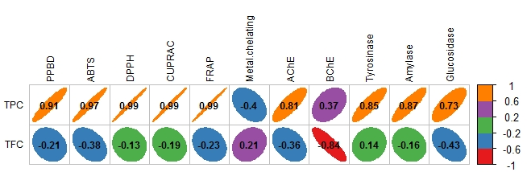
Figure 3. Pearson correlation between total bioactive component (TPC and TFC) and biological activities.

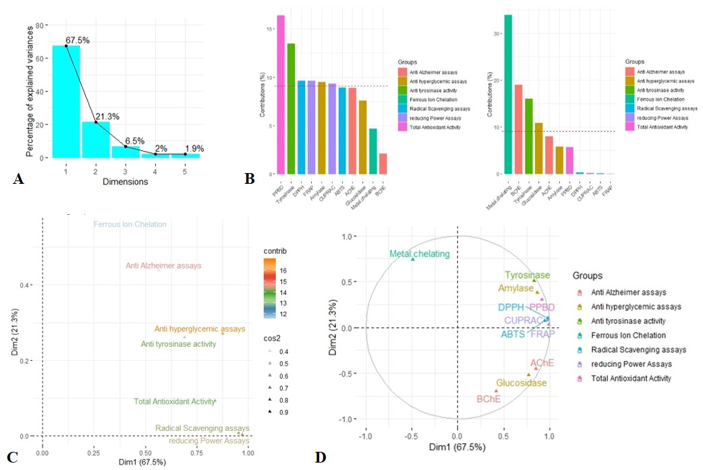

Figure 4. Multiple factor analysis of integrated bioactivities variables; A&B: Scree plot of percentage of explained variances and the contribution of biological activities to the first two retained factors; C&D: Loading plot describing the correlations of groups and modality of evaluated biological activities with the first two factors.
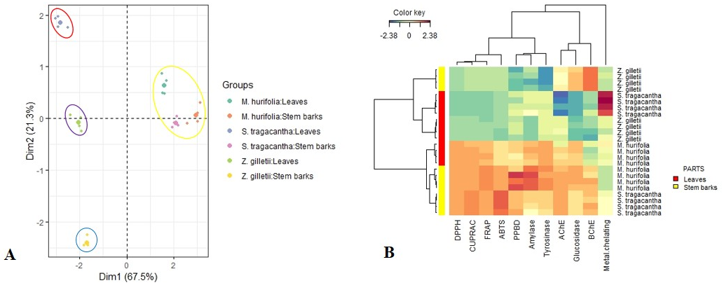

Figure 5. Typology of studied samples based on multiple factorial analysis and hierarchical clustering in according to biological activities

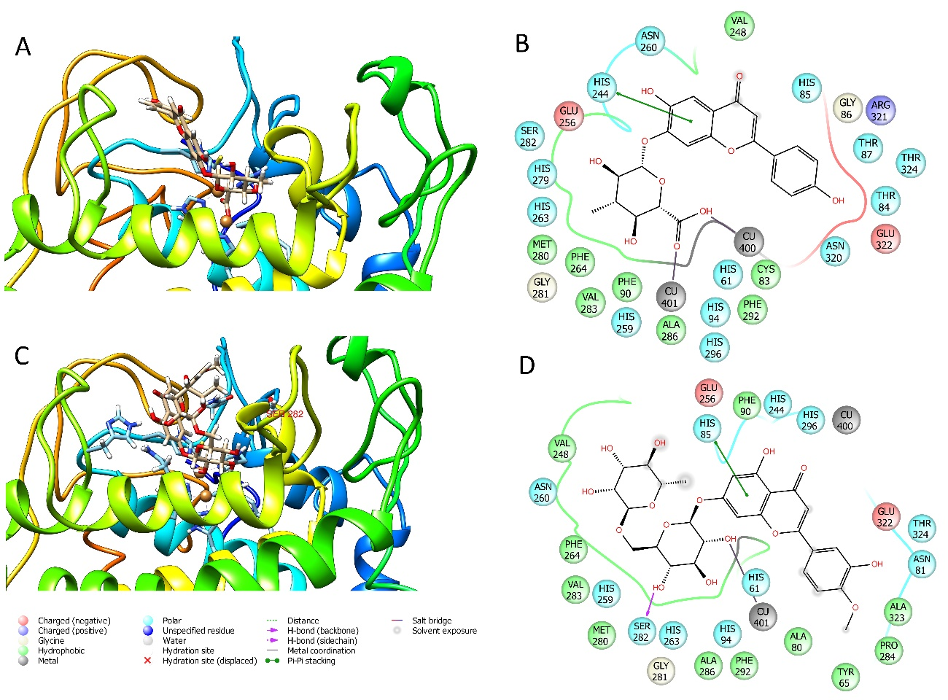
Figure 6. Best ranked pose of apigenin-7-O-glucuronide (A-B) and diosmin (C-D) docked to tyrosinase by GOLD 5.5.

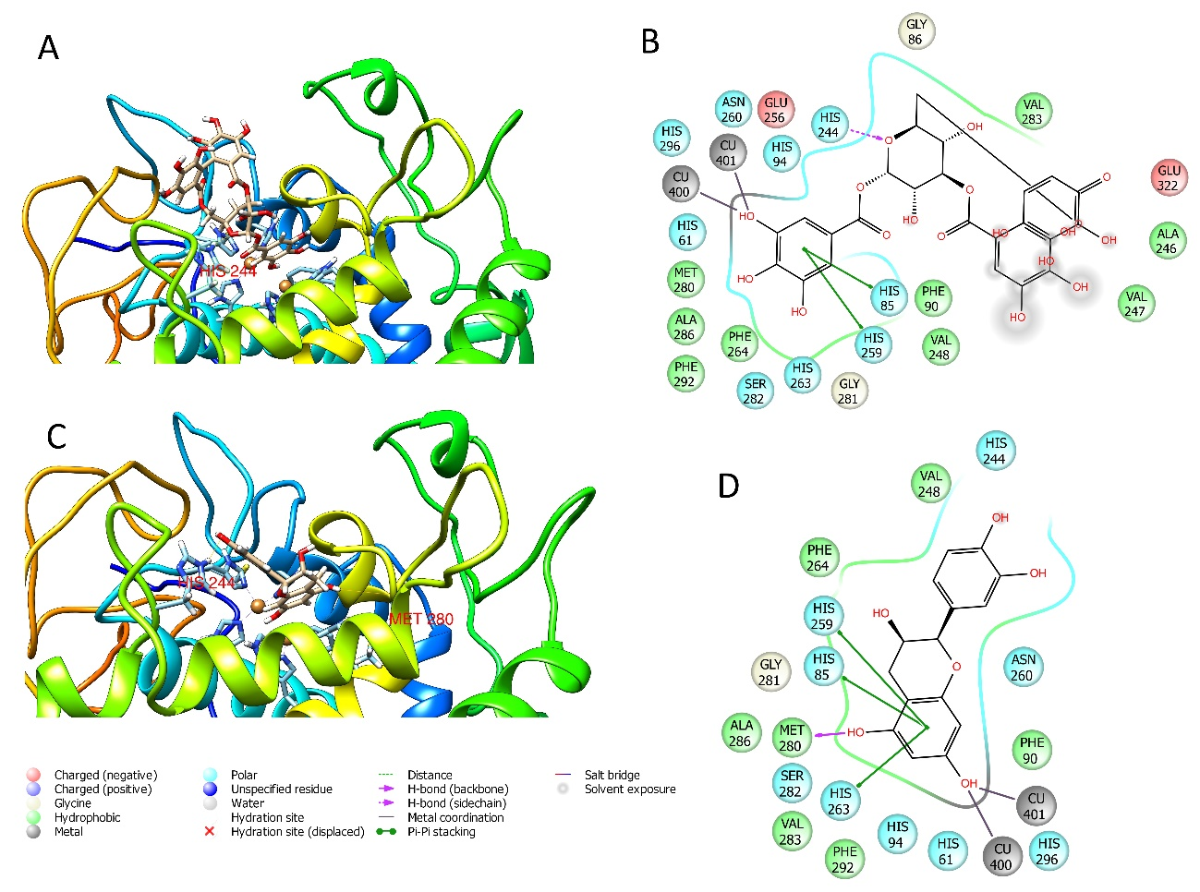
Figure 7. Best ranked pose of corilagin (A-B) and epicatechin (C-D) docked to tyrosinase by GOLD 5.5.

