Breath-holding during exhalation as a simple manipulation to reduce pain perception

Gustavo A. Reyes del Paso, Cristina Muñoz Ladrón de Guevara, and Casandra I. Montoro

University of Jaén, Spain, Department of Psychology

Professional affiliations:
Gustavo A. Reyes Del Paso, PhD, Professor of Psychology
Casandra Montoro, Research Assistant
Cristina Muñoz Ladrón de Guevara, Research Assistant

Running head: Respiration and pain perception

Address of the corresponding author:
Gustavo A. Reyes del Paso. Departamento de Psicología. Universidad de Jaén. 23071 Jaén, Spain. E-mail: greyes@ujaen.es. Fax: +34953211881.

Acknowledgements:
This research was supported by a grant from the Spanish Ministry of Science and Innovation co-financed by FEDER funds (Project PSI2012-33509).

Conflict of Interest Statement
None of the authors have any conflict of interests regarding the study

Abstract

Objective: Baroreceptor stimulation yields anti-nociceptive effects. In this study baroreceptors were stimulated by a respiratory maneuver, with the effect of this manipulation on pain perception subsequently measured. Methods: Thirty-eight healthy participants were instructed to inhale slowly (control condition) and to hold the air in lungs after a deep inhalation (experimental condition). It was expected that breath-holding would increases blood pressure and thus stimulate the baroreceptors, which in turn would reduce pain perception. Pain was induced by pressure algometry on the nail of the left-index finger, at three different pressure intensities, and quantified by visual analogue scales. Heart rate and blood pressure were continuously recorded. Results: Pain perception was lower when pain pressure was administered during the breath-holding phase vs. the slow inhalation phase, regardless of the pressure intensity. During breath-holding a rapid increase in blood pressure and decrease in heart rate were observed, demonstrating activation of the baroreceptor reflex. Conclusion: Pain perception is reduced when painful stimulation is applied during breath-holding immediately following a deep inhalation. These results suggest that a simple and easy-to-perform respiratory maneuver could be used to reduce acute pain perception.

Key words: Respiration, pain, baroreceptor reflex, blood pressure, heart rate.

Introduction
The baroreceptors are pressure-stretch receptors located within the aortic arch, carotid sinus, and lungs involved in autonomic regulation and blood pressure (BP) control (1,2). Furthermore, stimulation of the baroreceptors produces a generalized inhibitory effect on the central nervous system (CNS) (3) which included a reduction in nociception (4-7). Electrical, pharmacological or mechanical baroreceptor stimulation produces anti-nociceptive effects (4,8-10). This baroreceptor-induced CNS inhibition is one of the principal mechanisms explaining the relationship between BP and pain (7,11). The experience of pain is inversely associated with BP levels; patients with arterial hypertension experience less pain compared with normotensive individuals, and individuals with arterial hypotension have higher pain sensitivity vs. normotensive subjects (7,11-15). Furthermore, experimentally induced increases in BP reduce pain perception (16).

The baroreceptors are differentially stimulated during the breathing cycle. BP spontaneously oscillates in phase with respiration. Within each respiratory cycle, BP increases and decreases by between 4-6 mmHg. These BP changes result from intrapleural negative pressure during inhalation, positive intrapleural pressure during exhalation and variations in pressure, on the abdominal viscera, as exerted by the diaphragm (22). Accordingly, BP increases during the end stages of inhalation and during the onset of exhalation and decreases during the resting phase of the respiratory cycle, particularly at the onset of inhalation (23). Deep inhalations can increase these BP oscillations by up to 20 mmHg (24). Furthermore, the responsiveness of baroreceptors (similar to other receptors such as the chemo-receptors) are modulated by respiratory CNS afferents (25-28). Baroreceptor stimulation produces minimal heart rate (HR) responses when produced during the onset and mid-parts of inhalation, but produces maximal HR responses when stimulation is performed during the final stage of inhalation, and particularly during the onset of exhalation (25). This effect is in turn modulated by respiratory rate; the modulation exerted by respiratory phase decreases as the respiratory rate increases, and disappears with rates of > 20 breaths per minute (25).

Some respiratory maneuvers could be used to further increase the natural oscillation in the stimulation of the baroreceptors during the respiratory cycle. Breath-holding is known to produce relevant cardiovascular effects (30). Specially, when performed at the beginning of exhalation after a deep inhalation, this specific breath-holding is a powerful stimulus for general autonomic stimulation and specifically produces a baroreceptor-mediated large HR deceleration (31). This is the result of the additional rise in BP obtained from the increase in lung pressure while maintaining the inspired air within lungs.

In this study we evaluate the anti-nociceptive effect of this method for baroreceptor stimulation by analyzing the effect of the respiratory phase in which the pain stimuli is delivered on pain perception. Following a within-subject design, pain evoked by pressure algometry was presented during breath-holding after a deep inhalation (baroreceptor stimulation condition) versus during a slow inhalation (control condition). Using the first respiratory maneuver we take advantage of the increase in BP, enhanced baroreceptor responsiveness, and vagal cardiac neural traffic present at the beginnings of exhalation, further enhanced by breath-holding. As breath-holding immediately after the deep inhalation would stimulate the baroreceptors, we predicted that pain would be lower during the expiratory holding than during the slow inhalation. Furthermore, in order to evaluate the changes induced by breathing in the cardiovascular system, HR and BP were continuously recorded.

Method
Participants
Thirty-eight psychology students from the University of Jaén (19 males and 19 females), aged between 18 and 23 years, participated. Exclusionary criteria comprised the presence of pain, cardiovascular or respiratory diseases, and the use of drugs or pharmacological treatments affecting pain or the cardiovascular system. Participants received course credit for their participation.

Apparatus
Beat-to-beat HR and BP were recorded with a Task Force Monitor (CNSystems, Graz, Austria). Four electrodes were applied to the chest, two at the shoulders and two at the lower rib cage (Einthoven I and II), in order to record two bipolar ECGs. Continuous BP measurements were taken from the first phalange of the second and third fingers of the right hand. The hand was positioned at the level of the heart. Oscillometric BP was taken from the left brachial artery. The device recalibrates continuous finger BP, according to brachial artery BP, every 60 s without interrupting recording. Sampling rate was 1000 Hz for ECG and 200 Hz for continuous finger BP.

Pain was evoked by a wireless pressure algometer (Traker Freedom; JTECH Medical, Lawndale, USA) with a surface stimulation area of 1 cm². The algometer was inserted in a piston-screw, designed to fix and press the finger nails, allowing for reliable maintenance of stimulation pressure. A computer controlled the stimulation pressure and rate of increase in pressure (kg/s) administered. In healthy young adults, the intra-class correlation (reliability) for pain pressure thresholds measured in the fingers is approximately 0.75 (32).

Procedure
Before the actual experiment participants were instructed to practice the threshold (pressure at which the participant started feeling pain) and tolerance (maximum stimulation pressure tolerated) concepts and pain evaluation using the VASs. A first provisional measurement of threshold-tolerance was obtained, followed by presentation of a sequence of seven ascendant pain pressure stimuli (from 0.9 to 3.6 kg) such that the participant learnt to discern small incremental increases in pain pressure intensity. Definitive threshold-tolerance values were then obtained in the nail of the index finger of the left hand. For two left-handed participants stimulation was performed in the right hand, and the BP recordings were performed in the left hand. Pressure in the algometer was increased at a rate of 1 kg/s. The mean (± SD) value for the threshold was 2.81 ± 1.29 kg, and 7.48 ± 2.29 for tolerance. Three intermediate pain intensities were subsequently defined for each participant according to the following formula: DF = (tolerance − threshold)/4; Intensity 1 = threshold + 1DF; Intensity 2 = threshold + 2DF; and Intensity 3 = threshold + 3DF. Following this, participants were instructed to perform slow inhalations, lasting at least 7 s (control condition), and to inhale deeply and maintain the air in lungs before exhaling during 7 s without exerting any active muscular pressure (stimulation condition). This was practiced until participants felt confident in their ability to perform both tasks, following which the stimulation phase began. Participants received three pain stimuli, of 5 s duration for each pressure-pain intensity and breathing condition (18 pain stimuli in total). Half of the participants started in the breath-holding, and half in the slow-breathing, condition. In all participants, pain intensity was delivered in an identical sequence i.e., intensity 1, 2, and finally 3. This order was used to avoid any possible interference effect of temporal summation of pain which is typically observed for moderate-to-intense pain stimulation (33). During slow inhalation stimulation pressure commenced when the participant began inhalation. During exhalation, stimulation pressure started when the participant began to maintain the air in their lungs. Once the 5 s pain stimulation was discontinued, participants continued breathing normally. Following each pain stimulus, participants were presented with two 10-cm line visual analogue scales (VAS). These scales indexed the sensory and affective aspects of pain (“How strong/unpleasant was the pain?”). The anchor points of the scales were marked “not at all” and “extremely”. In acute pain contexts, intra-class correlation coefficients between repeated VAS measurements exhibited excellent reliability, with coefficients ranging between 0.95 and 0.98. With intervals of 1 min between measurements, 50% of the paired scores were within 2 mm of each other (34). Pain evaluation was followed by a period of approximately 20 s before the next trial. Participants were informed that the aim of the experiment was to evaluate the effects of breathing on pain perception; they did not receive information concerning the study hypothesis. The experimental protocol was approved by the Bioethics Committee of the University of Jaén.

Data reduction and statistical analysis
Second-by-second HR and finger-continuous systolic BP (SBP) were calculated and expressed as differential scores with respect to the mean value of the 5 s previous to the onset of pain stimulation. Pain scores and HR and SBP responses were aggregated by respiratory condition and pain intensity level. Analysis of the effect of respiratory manipulation on pain perception (VAS scores) was performed with a (2 x 3) repeated measures ANOVA, with respiratory phase (slow inhalation vs. breath-holding) and pain intensity (intensities 1, 2, and 3) as within-subjects factors. Analysis of the effect of the respiratory manipulation on HR and SBP responses were performed using a (2 x 3 x 8) repeated measures ANOVA, in which the 8 second-by-second response pattern values were included as a third within-subjects factor. The Huynh-Feldt epsilon correction was applied for the adjustment of the degrees of freedom. Results are reported with the original degrees of freedom and corrected p values. A value of p < 0.05 (two-sided) was taken to indicate statistical significance. Table 1 displays descriptive data for applied pain pressures and baseline SBP and HR.
*Table 1*

Results

- Effect of breathing condition on pain perception
Pain intensity (F(2, 36) = 89.58, p < .001, η² = .708) and unpleasantness (F(2, 36) = 80.80, p < .001, η² = .686) increased with increases in the pain pressure applied, and were greater during slow inhalation than during breath-holding (F(1, 37 ) = 6.08, p = .018, η² = .141 for pain intensity; and F(1, 37) = 8.54, p = .006, η² = .188 for pain unpleasantness (Figures 1-2). No pain intensity x breathing condition interaction was observed for intensity (p = .124) or unpleasantness (p = .544).
*Figures 1 and 2*

- Effect of breathing condition on cardiovascular variables
The observed HR response (main effect of Pattern: F(7, 31) = 83.13, p < .001, η² = .692) was modulated by the breathing condition (interaction Pattern x Breathing condition: F(7, 31) = 18.55, p < .001, η² = .334). No main or interaction effect was observed for pain pressure intensity. During breath-holding a strong-fast HR deceleration was observed up to s 4, while for the slow inhalation the deceleration response appeared later, at approximately s 4 (Figure 3). Differences between the two breathing conditions were significant from s 2 to s 7 (all ts > -2.07, all ps < .047), with lower values for the breath-holding condition.

The SBP pattern exhibited a biphasic response with an initial increase followed by a decrease (main effect of pattern F(7, 31) = 18.45, p < .001, η² = .333); this effect was dependent on the breathing condition (Pattern x Breathing condition interaction; F(7, 31) = 20.57, p < .001, η² = .357). Furthermore, the Pattern x Breathing condition x Pain pressure interaction was also significant (F (14, 24) = 3.72, p = .011, η² = .079). A SBP increase was observed during the breath-holding condition during the first few seconds (up to s 4), followed by a SBP decrease during the remainder of the response. Similar changes were observed in the slow inhalation condition, albeit delayed and reduced in magnitude (Figure 4). For pain intensity 1 SBP was greater during breath-holding compared with slow inhalation, from s 1 to 3, but was lower from s 7 to s 8 (all ts > -3.06, all ps < .005). For pain intensities 2 and 3 SBP was greater in the breath-holding condition compared with the slow inhalation condition, from s 2 to s 4, but was lower at s 8 (all ts > -2.90, all ps < .007).
*Figures 3 and 4*

Discussion
Confirming our hypothesis, during breath-holding pain perception was lower relative to the slow inhalation condition; this effect was independent of pain pressure stimulation. As expected, breath-holding produced an increase in BP (mediated by the positive intra-chest pressure) and a fast and deep HR deceleration (mediated by the activation of the baroreceptor reflex and its efferent vagal response). During the low inhalation SBP also increased, and HR decreased, but changes were delayed by 2-3 s and were reduced in magnitude. Activation of the baroreceptors due to the increase in BP, via its connections through the CNS (nucleus of the tractus solitarius, reticular formation, thalamus, hypothalamus, amygdala, hippocampus, periaqueductal gray, insula, prefrontal and cingulate cortex, etc., (3,35,10)) could produce an inhibitory effect on the CNS, with the possible related reduction in pain perception (3-9). Low pressure baroreceptors located in the lungs, which discharged in a lineal function to tidal-volume amplitude (9,26,28), could also contribute to the obtained anti-nociceptive effect. However, alternative explanations for our results cannot be ruled out, such as attention-distracting factors associated with differences in cognitive demand during the performance of the two breathing conditions. To minimize the influence of attentional effects we commenced with pain stimulation only when participants had practiced both breathing conditions and felt confident about their ability to perform them easily. The placebo effect, and participants’ general expectations pertaining to the effects of the two breathing conditions, might also have affected the results. However, it is improbable that, in the majority of participants, these unspecific effects would have been systematically biased toward the efficacy of the same breathing condition.

A method frequently used to assess the anti-nociceptive effect of baroreceptor stimulation consists of mechanical stimulation of carotid baroreceptors using neck-cuff techniques (17). These techniques induce neck suction (negative pressure) that stretches the baroreceptors and simulates an increase in BP. Although the resulting anti-nociceptive effect may depend on various factors, mechanical stimulation of the carotid baroreceptors leads to a reliable anti-nociceptive effect (3,6,10,18-21). In comparison to classical mechanical stimulation of the carotid baroreceptors through neck-chamber techniques, the respiratory manipulation performed herein appeared to produce stronger baroreceptor stimulation and a more reliable effect on pain perception. Taking the elicited HR deceleration as an index of the magnitude of baroreceptor stimulation, the usual response in studies using neck-chamber techniques is a HR deceleration of approximately 3-4 beats per minute (an increase in heart period of 30-35 ms) (3, 5-6,10,17,20). In our study we observed a HR deceleration of 10 beats per minute (100 ms of increase in heart period). An analysis of studies using mechanical stimulation of the carotid baroreceptors does not consistently reveal an anti-nociceptive effect, but rather suggests that this effect depends on a number of factors such as the mode in which the baroreceptors were stimulated, the elicitation (or not) of a concurrent baroreceptor-mediated cardiovascular response, the subjects’ level of tonic BP, etc. (10). Furthermore, neck chambers are uncomfortable, cannot be adapted to all neck sizes, and require maintenance of a particular body posture to facilitate baroreceptor stimulation and avoid air leaks, etc. All these of factors can lower the reliability of its anti-nociceptive effects. In contrast, the respiratory maneuver utilized in this study appears more ecological and secure, is straightforward to implement, and does not require the use of a specific device; rather, it only requires the collaboration of the participant and a moderate cognitive and physical condition.

This same baroreceptor-mediated anti-nociceptive mechanism could be in part implicated in the analgesic effect of slow deep breathing and HR variability biofeedback interventions (36-38). Furthermore, analgesic effects have been associated with increases in vagal cardiac activity (37, 39). The baroreceptor reflex is the main source of vagal efferent inputs to the CNS and vagal cardiac influences (1,2) and can be exercised and strengthened using slow and deep respiratory patterns (40-43).

Our respiratory manipulation, as it pertains to breath-holding, may share similarities with the Valsalva maneuver, a technique used to evaluate autonomic cardiovascular control integrity (44). In the Valsalva maneuver an expiratory pressure of 40 mmHg must be maintained for 10 s through an active strain-pressure muscular force; it is usually required that the subject be connected to a mouthpiece (44). In contrast, our breath-holding technique is simpler and markedly less intense in pressure, with participants explicitly instructed to not produce an active muscular strain-pressure force with the chest or abdomen.

In terms of limitations, our sample comprised young healthy participants only. Future studies should assess the effect of this breathing manipulation in older participants and patients with chronic pain. This is particularly relevant because baroreflex function tends to decline with age (45) and furthermore patients with chronic pain exhibit impaired baroreceptor functioning (46,47). Future research should also aim to replicate this result using other pain modalities (e.g., thermal and electrical). Regarding acute-chronic pain, given the particular characteristics of this respiratory maneuver, possible analgesics effects are limited to acute pain. Furthermore, the study provides limited evidence for a direct link between baroreceptor activation and pain. Future studies should focus on the associations between baroreceptor-related parameters and pain perception. Finally, it should be taken into account that the magnitude of the observed results is low, and the extent to which they are clinically relevant requires validation.

In conclusion, pain perception is reduced when painful stimulation is applied during breath-holding immediately following a deep inhalation. This simple and easy-to-perform respiratory maneuver may be useful as a simple method to reduce pain in cases where an acute, short-duration pain is present or expected (e.g., medical interventions involving needling, bone manipulations, examination of injures, etc.).

References

[1] Eckberg DL, Sleight P. Human baroreflexes in health and disease. Oxford: Oxford University Press; 1992.
[2] Reyes del Paso GA, Langewitz W, Robles H, Pérez N. A between-subjects comparison of respiratory sinus arrhythmia and baroreceptor cardiac reflex sensitivity as non-invasive measures of tonic parasympathetic cardiac control. Intern J Psychophysiol 1996;22:163-71.
[3] Rau H, Elbert T. Psychophysiology of arterial baroreceptors and the etiology of hypertension. Biol Psychol 2001;57:179-201.
[4] Droste C, Kardos A, Brody S, Greenlee MW, Roskamm H, Rau H. Baroreceptor stimulation: Pain perception and sensory thresholds. Biol Psychol 1994;37:101–13.
[5] Dworkin BR, Elbert T, Rau H, Birbaumer N, Pauli P, Droste C, Brunia CH. Central effects of baroreceptor activation in humans: Attenuation of skeletal reflexes and pain perception. Proc Natl Acad Sci USA 1994;91:6329–33.
[6] Rau H, Brody S, Larbig W, Pauli P, Vohringer M, Harsch B, Kroling P, Birbaumer N. Effects of PRES baroreceptor stimulation on thermal and mechanical pain threshold in borderline hype and normotensives. Psychophysiology 1994;31:480–5.
[7] Bruehl S, Chung O. Interactions between the cardiovascular and pain regulatory systems: An updated review of mechanisms and possible alterationsin chronic pain. Neurosci Biobehav R 2004;28:395–414.
[8] Bossut DF, Maixner W. Effects of cardiac vagal afferent electro stimulation on the responses of trigeminal and trigeminothalamic neurons to noxious orofacial stimulation. Pain 1996;65:101–9.
[9] D’Antono B, Ditto B, Sita A, Miller SB. Cardiopulmonary baroreflex stimulation and blood pressure related hypoalgesia. Biol Psychol 2000;53:217–31.
[10] Reyes del Paso G, Montoro C, Muñóz C, Duschek S, Jennings R. The effect of baroreceptor stimulation on pain perception depends on the elicitation of the reflex cardiovascular response: Evidence of the interplay between the two branches of the baroreceptor system. Biol Psychol 2014;101:82–90.
[11] France C. Decreased pain perception and risk for hypertension: Considering a common physiological mechanism. Psychophysiology 1999;36:683–92.
[12] Duschek S, Schwarzkopf W, Schandry R. Increased pain sensitivity in low blood pressure. J Psychophysiol 2008;22:20–7.
[13] Duschek S, Dietel A, Schandry R, Reyes del Paso GA. Increased sensitivity to heat pain in chronic low blood pressure. Eur J Pain 2009;13:28–34.
[14] Ghione S. Hypertension-associated hypalgesia: Evidence in experimental animals and humans, pathophysiological mechanisms, and potential clinical consequences. Hypertens 1996;28:494–504.
[15] Reyes del Paso GA, Perales MC. Haemodialysis curse is associated to changes in pain threshold and in the relations between arterial pressure and pain. Nefrología 2011;31:738–42.
[16] Duschek S, Heiss H, Buechner B, Schandry R. Reduction in pain sensitivity due to pharmacological elevation of blood pressure in chronically low blood pressure. J Psychophysiol 2009;23:104–12.
[17] Cooper VL, Hainsworth R. Carotid baroreflex testing using the neck collar device. Clin Auton Res 2009;19:102–12.
[18] Edwards L, McIntyre D, Carroll D, Ring C, France CR, Martin U. Effects of artificial and natural baroreceptor stimulation on nociceptive responding and pain. Psychophysiology 2003;40:762–69.
[19] Angrilli A, Mini A, Mucha RF, Rau H. The influence on low blood pressure and baroreceptor activity on pain responses. Physiol Behav 1997;62:391–7.
[20] Elbert T, Rockstroh B, Lutzenberger W, Kessler M, Pietrowsky R. Baroreceptor stimulation alters pain sensation depending on tonic blood pressure. Psychophysiology 1998;25:25–9.
[21] Brody S, Angrilli A, Weiss U, Birbaumer N, Mini A, Veit R, Rau H. Somatosensory evoked potentials during baroreceptor stimulation in chronic low back pain patients and normal controls. Int J Psychophysiol 1997;25:201–10.
[22] Wallis TW, Robothan JL, Compean R, Kindred MK. Mechanical heart-lung interaction with positive end-expiratory pressure. J Appl Physiol 1983;54:1039-47.
[23] Parati G, Izzo JL, Gavish B. Respiration and blood pressure. In JL Izzo, HR Black (Eds.), Hypertension primer (chap. A40, pp. 117–120). Baltimore: Lippincott, Williams, and Wilkins; 2003.
[24] Guyton AC. Textbook of Medical Physiology (6th ed.). Philadelphia: Saunders; 1981.
[25] Eckberg DL, Kifle YT, Roberts VL. Phase relationship between human respiration and baroreflex responsiveness. J Physiol 1980;304:489:502.
[26] Davis AL, McCloskey DI, Potter EK, Respiratory modulation of baroreceptor and chemoreceptor reflexes affecting heart rate through the sympathetic nervous system. J Physiol 1977;272:691-703.
[27] Davidson NS, Golner S, McCloskey DI. Respiratory modulation of baroreceptor and chemoreceptor reflexes affecting heart rate and cardiac vagal efferent nerve activity. J Physiol 1976;259:523-30.
[28] Raczkowska M, Eckberg DL, Ebert TJ. Muscarinic cholinergic receptor modulates vagal cardiac responses in man. J Auton Nerv Syst 1983;7:271-8.
[30] Grossman P. Respiration, stress and cardiovascular function. Psychophysiology 1983;20:284-300.
[31] Stern RM, Anschel C. Deep inspirations as stimuli for responses of the autonomic nervous system. Psychophysiol 1968;5:132-41.
[32] Cathcart S, Pritchard D. Reliability of pain threshold measurement in young adults. J Headache Pain 2006;7:21-26.
[33] Staud R, Cannon RC, Mauderli AP, Robinson MEm Price DD, Vierck CJ. Temporal summation of pain from mechanical stimulation of muscle tissue in normal controls and subjects with fibromyalgia syndrome. Pain, 2003;102: 87-95.
[34] Bijur PE, Silver W, Gallagher EJ. Reliability of the visual analog scale for measurement of acute pain. Academic Emergency Medicine 2001;8: 1153-7.
[35] Delgado LC, Vila J, Reyes del Paso GA. Proneness to worry is negatively associated with blood pressure and baroreflex sensitivity: Further evidence ofthe blood pressure emotional dampening hypothesis. Biol Psychol 2014;96:20–7.
[36] Busch V, Magerl W, Kern U, Haas J, Hajak G, Eichhammer P. The effect of deep and slow breathing on pain perception, autonomic activity, and mood processing, an experimental study. Pain Med 2012;13: 215–28.

[37] Chalaye P, Goffaux P, Lafrenaye S, Marchand S. Respiratory effects on experimental heat pain and cardiac activity. Pain Med 2009;10:1334–40.
[38] Hassett AL, Radvanski DC, Vaschillo EG, Vaschillo B, Sigal LH, Karavidas MK, Buyske S, Lehrer PM. A pilot study of the efficacy of heart rate variability (HRV) biofeedback in patients with fibromyalgia. Appl Psychophysiol Biofeedback 2007;32:1-10.

[39] Zunhammer M, Eichhammer P, Busch V. Do cardiorespiratory variables predict the antinociceptive effect of deep and slow breathing? Pain Med 2013;14:843–54.
[40] Lehrer PM, Vaschillo E, Vaschillo B, Lu S, Eckberg DL, Edelberg R, Shih WJ, Lin Y, Kuusela TA, Tahvanainen KU, Hamer RM. Heart rate variability biofeedback increases baroreflex gain and peak expiratory flow. Psychosom Med 2003;65:796–80.
[41] Bernardi L, Porta C, Spicuzza L, Bellwon J, Spadacini G, Frey AW, Yeung LY, Sanderson JE, Pedretti R, Tramarin R. Slow breathing increases arterial baroreflex sensitivity in patients with chronic heart failure. Circ 2002;105:143–5.
[42] Joseph CN, Porta C, Casucci G, Casiraghi N, Maffeis M, Rossi M, Bernardi L. Slow breathing improves arterial baroreflex sensitivity and decreases blood pressure in essential hypertension. Hypertens 2005;46:714-8.
[43] Reyes del Paso GA, Cea JI, González-Pinto A, Cabo O, González MI, Hernández JA. Short-term effects of a brief respiratory training on baroreceptor cardiac reflex function in normotensive and mild hypertensive subjects. Appl Psychophysiol Biofeedback 2006; 31:37-49.
[44] Levin AB. A simple test of cardiac function based upon the heart rate changes induced by the Valsalva maneuver. J Am Coll Cardiol 1966;18:90-9.
[45] Monahan KD. Effect of aging on baroreflex function in humans. Am J Physiol Regul Integr Comp Physiol 2007, 293: R3-R12.
[46] Reyes del Paso GA, Garrido S, Pulgar A, Duschek S. Autonomic cardiovascular control and responses to experimental pain stimulation in fibromyalgia syndrome. J Psychosom Res 2011;70:125–34.
[47] Reyes del Paso GA, Garrido S, Pulgar A, Martín-Vázquez M, Duschek S. Aberrances in autonomic cardiovascular regulation in fibromyalgia syndrome and their relevance for clinical pain reports. Psychosom Med 2010;72:462–70.
[48] Franz VH, Loftus, GR. Standard errors and confidence intervals in within-subjects designs: Generalizing Loftus and Masson (1994) and avoiding the biases of alternative accounts. Psychon Bull Rev, 2012, 19:395–404.

Table 1. Descriptive data for applied pain pressures (kg), baseline systolic blood pressure (SBP, mmHg) and heart rate (HR, bpm).

 | Mean | SD | Minimum | Maximum
Pain Intensity 1 | 3.98 | 1.39 | 1.90 | 7.10
Pain Intensity 2 | 5.24 | 1.56 | 2.70 | 8.80
Pain Intensity 3 | 6.37 | 1.94 | 3.30 | 10.60
SBP | 114.19 | 11.86 | 92.58 | 135.62
HR | 70.46 | 11.07 | 50.61 | 108.07

Figure legends:

Figure 1. Averaged pain intensity (VAS scores) as a function of pain pressure intensity and respiratory condition in which the pain stimulus was delivered (error bars represent within-subject SE (48)).
Figure 2. Averaged pain unpleasantness (VAS scores) as a function of pain pressure intensity and respiratory condition in which the pain stimulus was delivered (error bars represent within-subject SE (48)).
Figure 3. Heart rate (HR) response to the breathing manipulation aggregated for the three pain pressure intensities (error bars represent within-subject SE (48)).
Figure 4. Systolic blood pressure (SBP) response to the breathing manipulation as a function of pain pressure intensity (error bars represent within-subject SE (48)).

Figure 1.

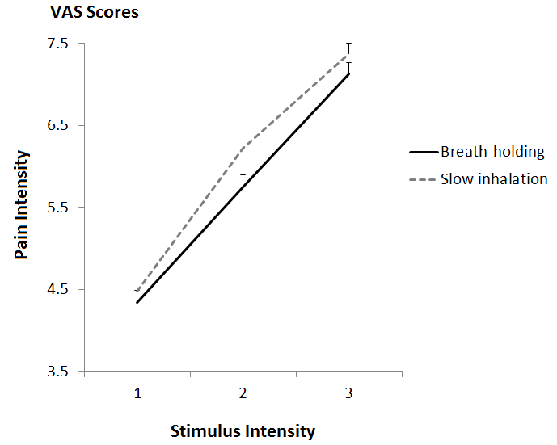

Figure 2.
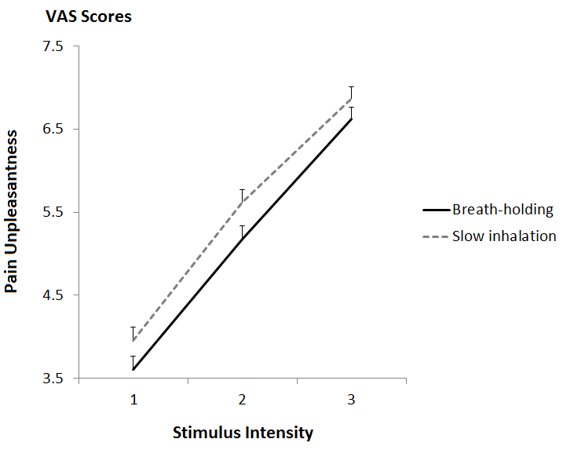

Figure 3.

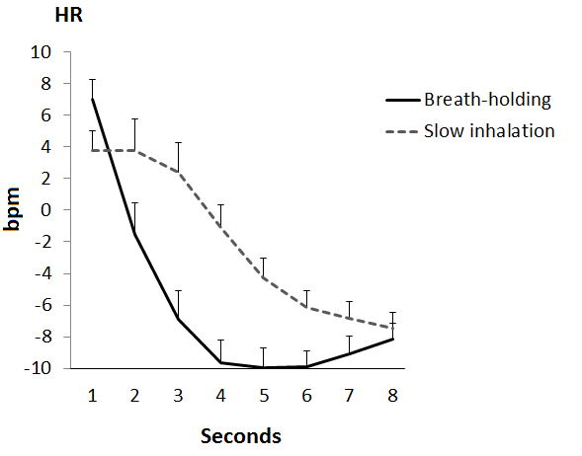

Figure 4.
