Article
Analysing the Reciprocity Law for UV-LEDs in Water
Disinfection of Escherichia coli, Enterococcus faecalis, and
Clostridium perfringens
A. Kamel, A. Palacios, M. Fuentes and M. Vivar *
Grupo IDEA, EPS Linares, Universidad de Jaén, Linares 23700, Spain; akf00001@red.ujaen.es (A.K.); apvilla@ujaen.es (A.P.); mfuentes@ujaen.es (M.F.)
* Correspondence: Corresponding author: mvivar@ujaen.es
Abstract: The aim of this study is to verify the reciprocity law in the wastewater disinfection process using UV light. The optical power UV-LEDs used were 1.6 mW and 50 mW, and the wavelengths were 265 nm and 275 nm. E. coli, Enterococcus faecalis, and Clostridium perfringens were the three microorganisms analysed in the study. The results showed lower inactivation rates around 0.063–0.065 cm²/mJ for 265 nm and 0.047–0.049 cm²/mJ for 275 nm for the Clostridium perfringens compared with the other two bacteria. For E. coli and Enterococcus faecalis, the inactivation rate was almost identical; 0.28 and 0.21 cm²/mJ, respectively, using 265 nm wavelength. There was a slightly better inactivation performance using the medium-power 275 nm UV-LEDs of 0.39 cm²/mJ and 0.29 cm²/mJ for E. coli and Enterococcus faecalis, respectively, and 0.33 cm²/mJ and 0.26 cm²/mJ using the low-power 275 nm UV-LEDs. The analysed data justify the reciprocity law for UV-LEDs disinfection using 265 nm and 275 nm UV-LEDs with two optical powers of 1.6 mW and 50 mW.
Keywords: Escherichia coli; Enterococcus faecalis; Clostridium perfringens; water treatment; disinfection; high-power UV light; light emitting diodes (LED); reciprocity

1. Introduction
Citation: Kamel, A.; Palacios, A.; Fuentes, M.; Vivar, M. Analysing the Reciprocity Law for UV-LEDs in Water Disinfection of Escherichia coli, Enterococcus faecalis, and Clostridium perfringens. Water 2023, 15, x. https://doi.org/10.3390/xxxxx
Academic Editor(s): Yaal Lester
Received: 20 December 2022
Revised: 10 January 2023
Accepted: 12 January 2023
Published: date

Copyright: © 2023 by the authors. Submitted for possible open access publication under the terms and conditions of the Creative Commons Attribution (CC BY) license (https://creativecommons.org/licenses/by/4.0/).
Water disinfection development is currently a demanding research topic, especially in water drought-suffering countries. Therefore, new disinfection methods are conducted in order to improve the disinfection process to reach higher disinfection rates and reduce power consumption. Traditionally, the two main water disinfection mechanisms are chemical and ultraviolet light. Water disinfection using chemicals such as chlorine or ozone is used because of its high efficacy and low cost. However, the formation of toxic byproducts such as trihalomethanes or haloacetonitriles has harmful effects on humans [1]. Therefore, advanced chemical disinfecting methods are also available, for instance, antibacterial hydrogels (ABHs), which are designed to attack bacterial cells. They can also be used as tablets to achieve >99.9% inactivation rates within 60 min without any harmful byproducts during the disinfection process [14].
Meanwhile, ultraviolet light is used in wastewater treatment plants using the traditional ultraviolet mercury lamps; these have numerous drawbacks, including power consumption, being available only in one wavelength, which makes it unsuitable for deactivating various harmful microorganisms, and only working for a maximum of 10,000 h. In addition, they contain harmful toxic substances such as mercury which require special treatment to be removed from the water when the lamps stop functioning [2-8]. This is why an alternative light source is required to replace ultraviolet mercury lamps. This alternative can be light-emitting diodes (LEDs) since they have various advantages compared with mercury UV lamps; for example, they are available in different wavelengths, require a low-voltage electrical power to function, have a long life span, and finally, they do not contain toxic substances.
UV disinfection usually complies with the reciprocity law, which dictates that under the same UV dose, different irradiance levels (light intensity) reach the same microbe inactivation rates.
However, as UV-LEDs are new, some studies point out that the reciprocity law might not always apply. For example, Dana et al. [9] conducted UV exposure experiments using the UV-LED system (PearlBeam) from AquiSense technologies to estimate the time–dose reciprocity effect of three different levels of irradiance at different UV-LED wavelengths (265 nm, 275 nm, 285 nm, and 295 nm) on the lab-prepared E. coli. The average power density of the LEDs was 0.11 ± 0.0033 mW/cm², 0.40 ± 0.022 mW/cm², 0.32 ± 0.0033 mW/cm², and 0.55 ± 0.013 mW/cm² for 265 nm, 275 nm, 285 nm, and 295 nm, respectively. As a result, the longer wavelengths (275 nm, 285 nm, and 295 nm) did not follow the Bunsen–Roscoe reciprocity law, and E. coli inactivation depended on irradiance and exposure time. Additionally, the indication of DNA damage of E. coli was more significant with the shorter wavelengths.
Similarly, R. Sommer et al. [10] applied UV-light irradiation over various microorganisms (three E. coli strains from sewage, MS2, ɸX174, B40-8, and Bacillus subtilis) using 253.7 nm wavelength LED with different UV dose rates (2, 0.2, and 0.02 W/m²) to verify the reciprocity law. The analysis revealed that E. coli strains and ɸX174 were the most susceptible to UV light, followed by B40-8, MS2, and Bacillus subtilis. However, a higher inactivation rate was observed with high dose rates compared with low dose rates at the same UV doses, whereas the other microorganisms did not deviate from time–dose reciprocity.
Two 43 W and 15 W LP lamps were used by Liz and Hadas [11] to apply the reciprocity law over Aspergillus niger by exposing it to 100, 250, and 350 mJ/cm² compared to 8.5 h of sunlight exposure. The results illustrated that the UV response is intensity-dependent and does not follow the Bunsen–Roscoe principle.
On the contrary, the reciprocity law was verified by R. Sommer et al. [12] when they used 10 low-pressure mercury UV lamps over artificial E. coli using three different levels of UV-dose: 0.02, 0.2, and 2 W/m². The response demonstrated no differences in inactivation rates by the selected doses; thus, the reciprocity principle is valid and cannot be rejected.
The objective of this study is to verify the reciprocity law for water disinfection using UV-LEDs. Medium-power and low-power UV-LEDs will be used for treating wastewater with the same UV dose. Microbiological content (E. coli, Enterococcus faecalis, and Clostridium perfringens) will be analysed to observe if, under the same UV dose but different initial irradiance, the bacteria inactivation is the same. UV-LEDs of 265 nm and 275 nm will be used.

2. Material and Methods

2.1. UV-LEDs Set-Up and Characteristics
Two different wavelengths of 265 nm and 275 nm were used with two different initial power values that led to different irradiance values. Table 1 shows their main characteristics. The forward voltages were between 6 V and 7 V for all LEDs; the current was around 20 mA to 30 mA for the low-power UV-LEDs, and about 440–700 mA for the medium-power UV-LEDs. Optical power for 275 nm was 1.6 mW and 50 mW, and 2.5 mW and 50 mW for the 265 nm LEDs. Manufacturers include QT-Brightek, Stanley, and Seoul Viosys. The spectra of each UV-LED were measured by a spectrophotometer from Ocean Insight (Maya 2000 Pro) to verify the wavelength given by the manufacturer.

Table 1. UV-LEDs characteristics from manufacturers datasheet.
Peak Wavelength Emission (nm) | Number of LEDs in the Board | Current (mA) | Voltage (V) | Optical Power (mW)  Radiant Flux (from datasheet) | Operating Temperature (ºC) | Angle of Emission (º) | Size (mm x mm) | Manufacturer
265 | 11 | 20–40 | 6.5 | 2.5 | −10 to 50 | 120 | 3.5 × 3.5 | QT-Brightek
265 | 4 | 440 | 6.9 | 50 | −40 to 100 | 120 | 3.6 × 3.6 | Stanley
275 | 11 | 20–30 | 6 | 1.6 | −30 to 60 | 125 | 3 × 3 | Seoul Viosys
275 | 4 | 700 | 7 | 50 | −30 to 60 | 118 | 6.35 × 6.35 | Seoul Viosys

2.1.1. UV-LEDs Electronic Board Design
Two types of printed circuit boards (PCBs) were designed and manufactured at the University laboratories: low-power UV-LEDs boards containing 11 LEDs each in a circular shape to match the Petri dish geometry and medium-power UV-LED boards with 4 LEDs in a square-shape arrangement as shown in Figure 1. The first three boards were designed using Orcad PCB designer software and manufactured by the chemical method. The last board was designed using EasyEDA PCB designer and manufactured in a PCB factory in China (JLCPCB). The LEDs were soldered to the boards using a reflow PCB oven from Hangzhou NeoDen Technology “NeoDen IN6”. Finally, each board was attached to a heat sink with an active thermal dissipation via a fan, and thermal paste was used in the board–heat sink interface.
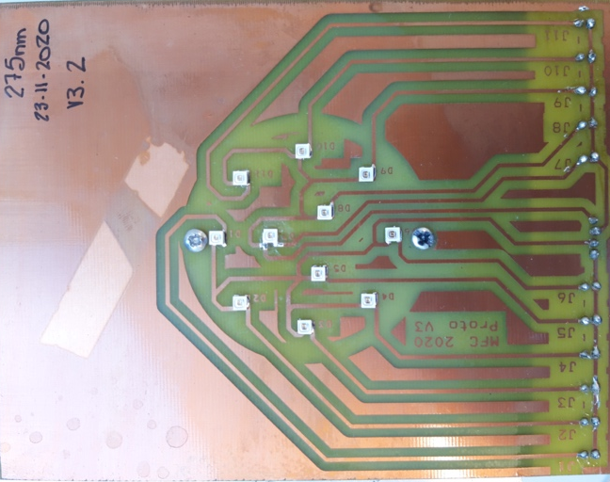 | 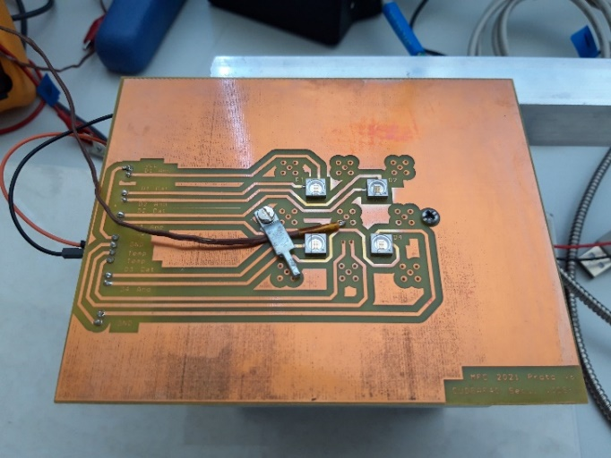
(a) | (b)
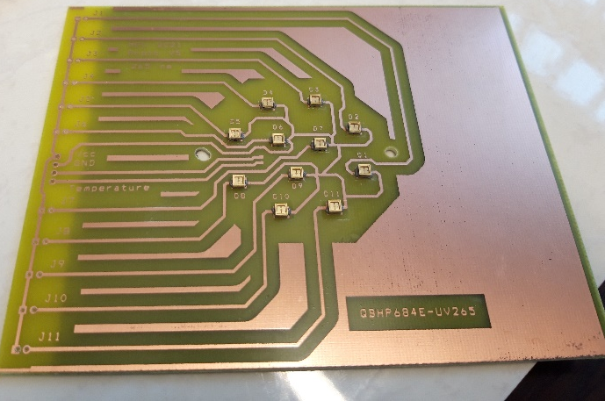 | 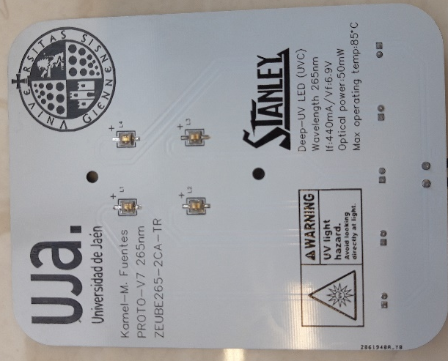
(c) | (d)
Figure 1. Example of PCB boards for the two powers used in the study: (a) low-power (1.6 mW) UV-LEDs @ 275 nm, (b) medium-power (50 mW) UV-LEDs @275 nm, (c) low-power (1.6 mW) UV-LEDs @ 265 nm, and (d) medium-power (50 mW) UV-LEDs @ 265 nm.

2.1.2. Irradiance Measurement and UV light Transmittance Losses in Water
Irradiance was measured with an ILT 2400 radiometer from International Light using the ILT-SUD005-10/U SUD detector. For measuring the transmittance of the UV light emitted from the LEDs through the water, the underwater version of the UV irradiance detector was used (SED005/WBS320/WU). The detector was placed under water at various depths to measure the loss of irradiance from 0 cm to 2 cm (Figure 2). Milli-Q water with 0 NTU was initially used, followed by the effluent of the wastewater plant, with some degree of turbidity.
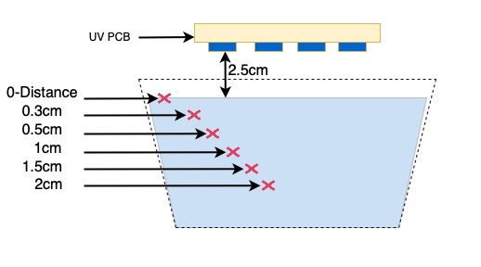
Figure 2. Measuring the UV light transmission losses from the LEDs under the water at different depths.

2.2. Water Physicochemical and Microbiological Analysis
As for previous studies on water UV-LED disinfection, physicochemical and microbiological analyses were conducted to monitor the water quality before and after each experiment. Physicochemical analyses included turbidity, pH, conductivity, biological oxygen demand (BOD), chemical oxygen demand (COD), total nitrogen, nitrates (NO₃₋), phosphates (PO⁴₃₋), sulphates (SO⁴₂₋), chromium (Cr⁶⁺), ammonium (NH⁴⁺), copper (Cu), zinc (Zn), aluminium (Al), iron (Fe), nitrites (NO₂₋), total suspended solids (TSS), and sedimentable solids (S. Sed.).
Microbiological analyses included three microorganisms: E. coli, Enterococcus faecalis, and Clostridium perfringens. For all of them, the membrane filtration method was used, followed by an incubation in the appropriate culture medium, as in previous studies, using internationally approved standards [13].

2.3. Experimental Setup
For these experiments, the wastewater treatment plant in Linares was used as the water source after the secondary treatment (Jaén, Spain), which means it is not lab-prepared but natural water containing organic matter.
Figure 3 shows the experimental setup. The 55 mm diameter Petri dish with 15 mL of wastewater was placed under the UV-LEDs board at a distance of 25 mm. A small stirrer of 2.5 mm x 2.5 mm was used to ensure homogeneous illumination. The PCBs were mounted on a stand using an aluminium bar to adjust their height over the water samples and attached to a heat sink with a fan for heat dissipation.
The experiments were conducted using a raspberry-pi-3b development board to control and save the experiment data, such as time of experiments, voltage, current, PCBs temperature, and the output optical power density of the UV-LEDs in an excel file.
Each experiment consisted first of exposing the wastewater to the low-power UV-LEDs, calculating the total UV dose, and acquiring a minimum of 5–6 intermediate points. The second part of the experiment used the medium-power UV-LEDs board. In order to expose the water sample to the same UV dose, the timing of exposure was varied and shortened accordingly by calculating it using the irradiance values and the UV dose of low-power LEDs experiments.
The time intervals for the low-power UV-LED experiments varied from 10 s to 600 s, and for the medium-power UV-LEDs, from 4 s to 221 s. Additionally, several time intervals were iterated up to four times.
UV-LEDs board temperature was measured during the experiments, and water temperature and irradiance were measured before and after all the experiments.
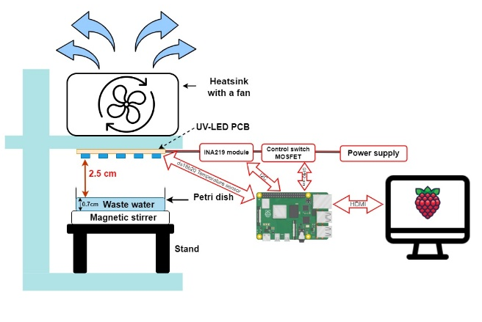
(a)
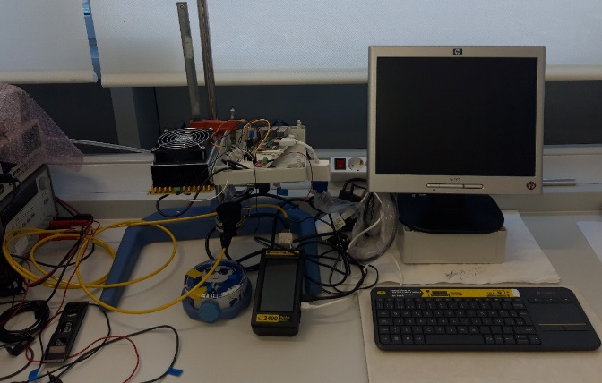
(b)
Figure 3. Experiment setup showing (a) the scheme for wastewater exposure to UV-LEDs, and (b) the photograph of actual experimentation.

3. Results and Discussion
Two wavelengths of 265 nm and 275 nm have been tested for two different irradiance levels (low and medium) but with the same final UV dose.

3.1. Irradiance Measurement and UV Transmittance Losses
The measured irradiance was 0.394 mW/cm² and 0.432 mW/cm² for the 265 nm and 275 nm UV-LEDs of low power (2.5 mW and 1.6 mW); and 1.836 mW/cm² and 0.691 mW/cm² for the 265 nm and 275 mn medium power UV-LEDs (50 mW).
UV transmittance losses are shown in Table 2. They indicate how results are similar for low and medium optical power. Under water, with 0 NTU, the 265 nm—50 mW LED performed slightly better than its counterpart at 2.5 mW, with lower losses. For example, at 2 cm, the power losses for the low-power LED were 44.5 %, and for the medium-power LED, 41.9 %. For the 275 nm LEDs, under 0 NTU, losses were higher in the medium-power LED; for example, at 2 cm, the low-power LED presented losses of 40.2 % and the medium-power one 45.6 %. This trend was also observed for both wavelengths under turbid water. In this case, using the effluent of the wastewater plant, with measured turbidity of 8 NTU, the transmittance losses were consistently higher for the 50 mW UV-LEDs (69.9 % at 2 cm vs. 73.3 % for the 265 nm and 68.5 % vs. 73.7 % for the 275 nm). More in-depth research should be conducted regarding UV transmittance losses of different UV-LEDs in raw water.
Table 2. 65. nm and 275 nm.
 | UV Irradiance Losses (%) with 0 NTU |  |  |  | UV Irradiance Losses (%) with 8 NTU
Water Depth (cm) | 265 nm  (2.5 mW) | 265 nm  (50 mW) | 275 nm  (1.6 mW) | 275 nm  (50 mW) | 265 nm  (2.5 mW) | 265 nm  (50 mW) | 275 nm  (1.6 mW) | 275 nm  (50 mW)
0.3 | 11.6 | 9 | 8.7 | 8.7 | 10.5 | 16.6 | 16.8 | 20.5
0.5 | 16 | 13.7 | 13.1 | 15.9 | 19.6 | 26.8 | 20 | 29.6
1 | 26.4 | 24.9 | 23.6 | 27.9 | 41.4 | 45 | 41.3 | 49.9
1.5 | 36.2 | 34.8 | 32.5 | 37.3 | 57.1 | 62.5 | 57.5 | 63.3
2 | 44.5 | 41.9 | 40.2 | 45.6 | 69.9 | 73.3 | 68.5 | 73.7

3.2. Raw Water Quality
Details of the raw water physicochemical quality analyses can be found in Table 3. The main results did not show significant changes in the raw water quality across the different experiments.
Table 3. Raw water Physicochemical range results.
Parameter | Minimum | Maximum
pH | 7.49 | 7.99
Conductivity (μS/cm) | 522 | 964
Turbidity (NTU) | 4.54 | 10.30
BDO (mg/L) | -- | 2
COD (mg/L) | 42 | 57
Total nitrogen (mg/L) | 34 | 40
Nitrates (mg/L) | <0.4 | <0.4
Nitrites (mg/L) | 0.054 | 0.154
Phosphates (mg/L) | 3.45 | 6.78
Sulphates (mg/L) | 72 | 84
Iron (mg/L) | 0.11 | 0.18
Aluminum (mg/L) | <0.1 | <0.1
Copper (mg/L) | <0.05 | 0.05
Amonium (mg/L) | 36.8 | 48
Zinc (mg/L) | <0.05 | <0.05
Chromium (mg/L) | <0.05 | <0.05
Regarding the initial microbiological water quality, E. coli ranged from 4.4 × 10⁵ CFU/100 mL to 4.6 × 10⁵ CFU/100 mL, Enterococcus faecalis content varied from 5.7 × 10⁴ CFU/100 mL to 6.9 × 10⁴ CFU/100 mL, and Clostridium perfringens ranged from 3.2 × 10⁴ CFU/100 mL to 4.9 × 10⁴ CFU/100 mL (Table 4).
Table 4. The initial concentration of the bacteria in the water.
Initial CFU/100 ml | Minimum | Maximum
E. coli | 4.4 × 10⁵ | 4.6 × 10⁵
Enterococcus faecalis | 5.7 × 10⁴ | 6.9 × 10⁴
Clostridium perfringens | 3.2 × 10⁴ | 4.9 × 10⁴

3.3. 265. nm
Figure 4 shows the inactivation of E. coli, E. faecalis, and C. perfringens under the same UV dose for 1.6 mW and 50 mW—265 nm UV-LEDs. The turbidity level was 8 NTU for the E. coli and E. faecalis experiments and 10.3 NTU for the C. perfringens experiment. By simple observation of the graphs, it can be concluded that, in this case, the reciprocity law is valid for the two optical power UV-LEDs and the three bacteria, as the kinetics inactivation follows the same decay for both 1.6 mW and 50 mW optical power UV-LEDs.
For E. coli, the detection limit (DL: 1 CFU/ 5 mL or 20 CFU/100 mL) is reached between 39 mJ/cm² and 58 mJ/cm² for the two optical power LEDs, showing some tailing after as fluctuation is produced by detection of about 0–1 colonies per plate. In terms of time, the 50 mW LED had to be used for 34 s to accumulate a UV dose of 58 mJ/cm², whereas, for the 2.5 mW LED, 150 s were required for the same UV dose. This means less usage of the 50 mW LED and, therefore, higher water disinfection and LED lifetime.
Regarding E. faecalis, the behaviour is similar to E. coli. The detection limit is reached practically at the same UV dose—31 mJ/cm² for the low-power LED and 34 mJ/cm² for the medium-power LED. The equivalent times of exposure were 80 s and 21 s, respectively. Finally, C. perfringens, already known as more resistant than the two previous microorganisms, reached inactivation at 100 mJ/cm² (240 s) and 124 mJ/cm² (70 s), with a turbidity level of 4.9 NTU.
It can also be observed from the graphs that for the case of E. coli and E. faecalis, for the 265 nm UV-LED and low optical power (2.5 mW), tailing appears to be more important than for the 50 mW LEDs. This is an issue that should be subject to further research.
Figure 4. UV-LED disinfection results for E. coli, E. faecalis, and C. perfringens at 265 nm under two different optical power UV-LEDs (2.5 mW and 50 mW) maintaining the same UV dose. The reciprocity law is valid. *DL—Detection limit.

3.4. 275. nm
The reciprocity law was also studied for the 275 nm UV-LED. In this case, Figure 5 shows the inactivation levels vs. UV dose for E. coli, E. faecalis, and Clostridium perfringens. E. coli reached DL after 17 mJ/cm² of UV dose (40 s) for the low-intensity UV-LED (1.6 mW) and after 13 mJ/cm² (11 s) for the medium-power UV-LED (50 mW). So, the higher-power UV-LED exhibited a slightly more rapid inactivation rate. E. faecalis showed similar behaviour, although in this case, the low-power UV-LED (1.6 mW) showed some tailing after 17 mJ/cm² (40 s), where it was close to the DL. The 50 mW UV-LED exposure reached total inactivation at a UV dose of 13 mJ/cm² (11 s). For both experiments, the turbidity level was 8 NTU.
Finally, Clostridium perfringens did not show any difference when using the low-power or the medium-power UV-LEDs. DL was reached by the low-power UV-LED at a dose of 159 mJ/cm² (360 s), and at the same dose, the experiment under the 50 mW UV-LED started to show some tailing (221 s). The turbidity value was 10 NTU.
Figure 5. UV-LED disinfection results for E. coli, E. faecalis, and C. perfringens at 275 nm under two different optical power UV-LEDs (1.6 mW and 50 mW) maintaining the same UV dose. *DL—Detection limit.

3.5. Inactivation Rates
Inactivation rates were calculated without considering the tailing phase, similar to Nyangaresi et al., 2018 [3] following the equation Equation (1):
Log (N₀/N) =—K_{UV}· UV dose | (1)
where N₀ and N are the numbers of colonies (CFU/100 mL) before and after UV exposure, K_{UV} is the inactivation rate, and UV dose is the fluence (mJ/cm²).
Figure 6 shows the calculated inactivation rates for the three different bacteria and the different wavelengths, followed by Table 5, which summarises the inactivation rate values, the R^{2,} and the turbidity value for each experiment. It can be observed that the reciprocity law is valid for Clostridium perfringens at the two studied wavelengths of 265 nm and 275 nm. As for low and medium optical power UV-LEDs, the inactivation rate is the same: 0.063–0.065 cm²/mJ for 265 nm and 0.047–0.049 cm²/mJ for 275 nm. For E. coli and E. faecalis, 265 nm exhibits identical performance, with inactivation rates of 0.28 cm²/mJ and 0.21 cm²/mJ, respectively.
Finally, 275 nm UV-LEDs show a slightly superior performance for the medium optical power UV-LEDs, in comparison with the low-power ones for E. coli and E. faecalis. In this case, inactivation rates are always higher, 0.39 cm²/mJ vs. 0.33 cm²/mJ for the 265 nm wavelength and 0.298 cm²/mJ vs. 0.26 cm²/mJ for the 275 nm wavelength. This result should also be further investigated to confirm the trend—no full confirmation of the reciprocity law—and the potential advantage of using medium-power UV-LEDs.
Figure 6. Inactivation rate constant, K(cm²/mJ) vs. microorganisms and wavelengths.

Table 5. Inactivation rates for the different bacteria and wavelengths.
Microorganism | NTU | K_{265 nm—Low Power (2.5 mW)} | R² | K_{265 nm—Medium Power (50 mW)} | R² | NTU | K_{275 nm—Low Power (1.6 mW)} | R² | K_{275 nm—Medium Power (50 mW)} | R²
E. coli | 10.3 | 0.289 | 0.950 | 0.282 | 0.927 | 8 | 0.337 | 0.997 | 0.392 | 0.978
E. faecalis | 10.3 | 0.221 | 0.977 | 0.214 | 0.973 | 8 | 0.260 | 0.999 | 0.298 | 0.995
C. perfringens | 4.9 | 0.065 | 0.998 | 0.063 | 0.998 | 10 | 0.049 | 0.999 | 0.047 | 0.999

3.6. Energy Consumption
The energy consumption of the UV-LEDs was analysed during the experiments for the same microorganism disinfection to compare the performance and potential electrical costs. The analysis is presented in this section. The following equation (Equation (2)) was used:
E= I*V*t | (2)
where E is the energy consumption (Wh), I is the electrical current (A), V is the voltage drop (V), and t is the inactivation time in seconds.
Energy consumption can be observed in Table 6, where it is shown that, in all cases, even though medium-power UV-LEDs required less time to inactivate the different microorganisms, the low-power UV-LEDs consumed less electricity for the same UV inactivation. This observation should be subjected to further research to confirm the initial results.
Table 6. Energy consumption for different bacteria using 265 nm and 275 nm wavelengths.
 | 265 nm
 | Low Power |  |  |  | Medium Power
Microorganism | Current (mA) | Voltage (V) | Time to inactivate (s) | Energy consumption (Wh) | Current (mA) | Voltage (V) | Time to inactivate (s) | Energy consumption (Wh)
E. coli | 332.4 | 6.73 | 150 | 336 | 443.1 | 25.68 | 34 | 387
E. faecalis | 332.4 | 6.73 | 80 | 179 | 443.1 | 25.68 | 21 | 239
C. perfringens | 331.5 | 6.53 | 240 | 520 | 441.7 | 25.55 | 70 | 790
 | 275 nm
 | Low Power |  |  |  | Medium Power
Microorganism | Current (mA) | Voltage (V) | Time to inactivate (s) | Energy consumption (Wh) | Current (mA) | Voltage (V) | Time to inactivate (s) | Energy consumption (Wh)
E. coli | 330 | 6.28 | 40 | 83 | 703.2 | 23.67 | 11 | 183
E. faecalis | 330 | 6.28 | 40 | 83 | 703.2 | 23.67 | 11 | 183
C. perfringens | 331.8 | 6.62 | 360 | 79 | 700.6 | 24.17 | 221 | 3742

3.7. Summary and Discussion
Lower inactivation rates belong to Clostridium perfringens, with values around 0.063–0.065 cm²/mJ for 265 nm and 0.047–0.049 cm²/mJ for 275 nm. The turbidity level for the 275 nm experiments was higher, 10 NTU vs. 4.9 NTU for the 265 nm, so lower inactivation rates for the 275 nm wavelength could be due to this fact as previous experiments under similar turbidity values showed only slightly better performance of the 265 nm UV wavelength.
Regarding E. coli and E. faecalis, 265 nm UV-LEDs had inactivation rates of 0.28 cm²/mJ and 0.22 cm²/mJ, respectively, for a turbidity level of 10.3 NTU. For 275 nm UV-LEDs, inactivation rates were higher, 0.337 cm²/mJ and 0.26 cm²/mJ for the low-power LED, but the turbidity level was lower, 8 NTU. The main remark here is the potential higher inactivation rate of the medium-power LEDs (50 mW), which could challenge the reciprocity law and therefore suggest that higher-power optical LEDs would be more effective for water disinfection.
Inactivation rate values are lower than those reported in the literature mainly because of the higher values of turbidity levels. For example, the 265 m UV-LED presented an inactivation rate of 0.28 cm²/mJ at 10.3 NTU for E. coli vs. the values in [2,3,14-17] of 0.37 cm²/mJ, 0.80 ± 0.06 cm²/mJ, 0.583 cm²/mJ, 0.43 cm²/mJ, 0.420 cm²/mJ, and 0.41 cm²/mJ using lab cultured E. coli and ranged LEDs from 265 to 267 nm wavelengths.
For the 275 nm wavelength, the inactivation rate was 0.337 cm²/mJ at 8 NTU for E. coli, in this case slightly superior or similar to the 0.29 cm²/mJ value reported by [16] using 280 nm wavelength, 0.292 cm²/mJ reported by [8] using 275 nm, 0.30 cm²/mJ using 280 nm reported by [17], and nearly lower to the 0.56 + 0.04 of 280 nm reported by [14].
Additionally, the inactivation rate was lower than in [18], which ranged from 2.50 ± 0.17 cm²/mJ to 2.63 ± 0.37 cm²/mJ because of the number of LEDs used (18 to 33 LEDs) in deactivating lab E. coli using 280 nm wavelength.
However, the inactivation rate was almost identical to that reported by [19], which was 0.29 ± 0.0081 cm²/mJ using 39 W 260 nm LED and 0.31 ± 0.016 cm²/mJ using 280 nm LED with a 31 W radiated over lab-prepared E. coli.

4. Conclusions
The reciprocity law is valid for UV-LEDs disinfection using 265 nm and 275 nm LEDs with two different optical powers of 1.6–2.5 mW and 50 mW. This has been tested for three different microorganisms in the effluent of the Linares wastewater plant, E. coli, E. faecalis, and C. perfringens. Similar inactivation rates have been calculated for the two optical powers, except for the 275 nm LEDs that showed slightly superior values for the 50 mW LEDs in the case of E. coli and E. faecalis. This result should be further investigated to confirm these initial results. Particular attention should be paid to the turbidity values of the water and the transmittance of UV light in turbid waters, which can alter the results. In our experiments, at 2 cm water depth, the UV transmittance fell practically to half or more (40–60%) of the emitted optical power.
On the other hand, initial experiments showed that for the same UV inactivation, medium-power UV-LEDs presented higher energy consumption than low-power UV-LEDs, although the times for inactivation were significantly shorter. Further research should be conducted on this issue.
Author Contributions:
Investigation: A. Kamel, A. Palacios, M. Fuentes, M. Vivar
Validation: A. Kamel, A. Palacios
Writing – original draft: A. Kamel, M. Vivar
Writing – review & editing: A. Kamel, M. Vivar
Formal analysis: M. Vivar
Funding acquisition: M. Vivar, M. Fuentes
Supervision: M. Vivar, M. Fuentes
Methodology: M. Fuentes, A. Palacios
Validation: A. Palacios
Funding: The authors acknowledge funding from the FEDER-UJA Research Programme of the University of Jaén, grant number A1123060E00010. M. Vivar acknowledges funding from the Spanish Ministry of Economy and Competitiveness, ‘Ramón y Cajal’ Programme, Grant number RYC-2015-17306. J. Torres acknowledges funding from the Spanish Ministry of Science and Innovation, ‘Contratos de Formación Predoctoral’, Grant number PRE2019-089349.
Institutional Review Board Statement: None
Informed Consent Statement: None
Data Availability Statement: The data will be sent on request
Acknowledgments:
Conflicts of Interest: None

References
1) Guo, Y.; Dundas, C.M.; Zhou, X.; Johnston, K.P.; Yu, G. Molecular Engineering of Hydrogels for Rapid Water Disinfection and Sustainable Solar Vapor Generation. Adv. Mater. 2021, 33, e2102994. https://doi.org/10.1002/adma.202102994.

2) Matsumoto, T.; Tatsuno, I.; Hasegawa, T. Instantaneous Water Purification by Deep Ultraviolet Light in Water Waveguide: Escherichia Coli Bacteria Disinfection. Water 2019, 11, 968.

3) Nyangaresi, P.O.; Qin, Y.; Chen, G.; Zhang, B.; Lu, Y.; Shen, L.Effects of single and combined UV-LEDs on inactivation and subsequent reactivation of E. coli in water disinfection. Water Res. 2018, 147, 331–341.

4) Song, K.; Taghipour, F.; Mohseni, M.Microorganisms inactivation by continuous and pulsed irradiation of ultraviolet light-emitting diodes (UV-LEDs). Chem. Eng. J. 2018, 343, 362–370.

5) Vilhunen, S.; Särkkä, H.; Sillanpää, M.Ultraviolet light-emitting diodes in water disinfection. Environ. Sci. Pollut. Res. Int. 2009, 16, 439–442.

6) Chevremont, A.-C.; Farnet, A.-M.; Sergent, M.. Coulomb, and J.-L. BoudenneMultivariate optimization of fecal bioindicator inactivation by coupling UV-A and UV-C LEDs. Desalination 2012, 285, 219–225.

7) Chevremont, A.-C.; Farnet, A.-M.; Coulomb, B.; Boudenne, J.-L.Effect of coupled UV-A and UV-C LEDs on both microbiological and chemical pollution of urban wastewaters. Sci. Total Environ. 2012, 426, 304–310.

8) Chatterley, C.; Linden, K.Demonstration and evaluation of germicidal UV-LEDs for point-of-use water disinfection. J. Water Health 2010, 8, 479–486.

9) Pousty, D.; Hofmann, R.; Gerchman, Y.; Mamane, H. Wavelength-dependent time–dose reciprocity and stress mechanism for UV-LED dis-infection of Escherichia coli. J. Photochem. Photobiol. B Biol. 2021, 217, 112129 . https://doi.org/10.1016/j.jphotobiol.2021.112129.

10) Sommer, R.; Haider, T.; Cabaj, A.; Pribil, W.; Lhotsky, M. Time dose reciprocity in UV disinfection of water. Water Sci. Technol. 1998, 38, 145–150.

11) Taylor-Edmonds, L.; Lichi, T.; Rotstein-Mayer, A.; Mamane, H. The impact of dose, irradiance and growth conditions on Aspergillus niger (renamed A. brasiliensis) spores low-pressure (LP) UV inactivation. J. Environ. Sci. Health-Part A Toxic/Hazard. Subst. Environ. Eng. 2015, 50, 341–347. https://doi.org/10.1080/10934529.2015.987519.

12) Sommer, R.; Haider, T.; Cabaj, A.; Heidenreich, E.; Kundi, M. Increased Inactivation of Saccharomyces cerevisiae by Protraction of UV Irradiation. Appl. Environ. Microbiol. 1996, 62, 1977–1983. Available online: https://journals.asm.org/journal/aem (accessed on 1 June 1996).

13) Vivar, M.; Fuentes, M.; Torres, J.; Rodrigo, M.J. Solar disinfection as a direct tertiary treatment of a wastewater plant using a photochemi-cal-photovoltaic hybrid system. J. Water Process Eng. 2021, 42, 102196. https://doi.org/10.1016/j.jwpe.2021.102196.

14) 2. Rattanakul, S.; Oguma, K. Inactivation kinetics and efficiencies of UV-LEDs against Pseudomonas aeruginosa, Legionella pneumophila, and surrogate microorganisms. Water Res. 2018, 130, 31–37.

15) 4. Sholtes, K.; Linden, K.G. Pulsed and continuous light UV LED: Microbial inactivation, electrical, and time efficiency. Water Res. 2019, 165, 114965.

16) 7. Oguma, K.; Kita, R.; Sakai, H.; Murakami, M.; Takizawa, S.Application of UV light emitting diodes to batch and flow-through water disinfection systems. Desalination 2013, 328, 24–30.

17) 6. Li, G.-Q.; Wang, W.-L.; Huo, Z.-Y.; Lu, Y.; Hu, H.-Y. HuComparison of UV-LED and low pressure UV for water disinfection: Photoreac-tivation and dark repair of Escherichia coli. Water Res. 2017, 126, 134–143.

18) 3. Kim, D.-K.; Kang, D.-H. “Investigation of a new UVC LEDs array continuous type water disinfection system for inactivating Escherichia coli O157:H7 according to flow rate and electrical energy efficiency analysis. Food Control 2021, 119, 107470.

19) 5. Beck, S.E.; Ryu, H.; Boczek, L.A.; Cashdollar, J.L.; Jeanis, K.M.; Rosenblum, J.S.; Lawal, O.R.; Linden, K.G. Evaluating UV-C LED dis-infection performance and investigating potential dual-wavelength synergy. Water Res. 2017, 109, 207–216.
Disclaimer/Publisher’s Note: The statements, opinions and data contained in all publications are solely those of the individual author(s) and contributor(s) and not of MDPI and/or the editor(s). MDPI and/or the editor(s) disclaim responsibility for any injury to people or property resulting from any ideas, methods, instructions or products referred to in the content.

