Francisco Javier Díaz-Pérez
University of Jaén, Spain

TRANSLATION PROBLEMS IN THE TRANSLATION OF TWO FILM VERSIONS OF ALICE IN WONDERLAND INTO SPANISH. A COGNITIVE-PRAGMATIC APPROACH

Introduction
Both the presence of wordplay and the presence of cultural references in a source text (ST) may be considered as translation problems. When dealing with audiovisual texts – which are by nature polysemiotic texts – the degree of complexity increases, as very often the translation will be constrained by the interplay between the audio and visual channels.
The present chapter focuses on two film adaptations of Carroll’s novels Alice’s Adventures in Wonderland and Through the Looking Glass and What Alice Found There and analyses the solution-types used to deal with the translation of puns and cultural references from the perspective of Relevance Theory (RT). Before dealing with the translation problems considered in this chapter, section 1 will be devoted to a relevance-theoretic explanation of translation. Afterwards, in section 2 – which will focus on the translation of wordplay as a translation problem (2.1) and on its peculiarities in Audiovisual Translation (AVT) (2.2) – the different solution-types used by translators to tackle that problem will be presented, resorting to RT as theoretical framework (2.3). The same type of structure may be found in section 3, which deals with the other translation problem considered in this chapter, the translation of cultural references. The chapter closes with the conclusions section and the list of bibliographical references.

1. A relevance-theoretic account of translation
It has been pointed out more than once (Gutt 1990, 1998, 2000, 2004, 2005; Rosales Sequeiros 2002, 2005; Alves and Gonçalves 2010; Martínez-Sierra 2010; Yus 2012; Díaz-Pérez 2013, 2014, 2015, 2017) that RT can be applied to translation. From a relevance-theoretic perspective, translation involves interpretive use across languages. In this connection, RT allows the study of intra- and inter-lingual verbal communication as manifestations of the same underlying concepts, and in this sense, offers a unified theory of verbal communication.
RT originated in the late 80’s and has become one of the most influential theoretical frameworks within the field of pragmatics. The basic assumption from which it departs is that human beings are programmed to address their attention to that which is relevant to them, or in other words, to that which may produce changes in their cognitive environment. Those changes are technically called cognitive effects, and according to RT, the more cognitive effects a given stimulus yields, the more relevant it will be. However, those cognitive effects must be put in relation to the effort needed to derive them, since an increase in the effort required to process a given utterance will result in a decrease in its relevance. Thus,

a. Other things being equal, the greater the positive cognitive effects achieved by processing an input, the greater the relevance of the input to the individual at that time.
b. Other things being equal, the greater the processing effort expended, the lower the relevance of the input to the individual at that time (Wilson and Sperber 2004: 609).

In this sense, one of the main principles of RT is the principle of relevance, according to which, “[h]uman cognition tends to be geared to the maximization of relevance” (Wilson and Sperber 2004: 610). In other words, an addressee will make the effort to process a given statement if s/he considers that the statement will be relevant, or in relevance-theoretic terms, will be able to modify his/her cognitive environment. As will be seen below, many of the decisions taken by a translator can be explained by resorting to the principle of relevance.
As mentioned above, from a relevance-theoretic standpoint, translation involves interpretive use across languages. In Gutt’s (1998) words,

From the relevance-theory point of view, translation falls naturally under the interpretive use of language: the translation is intended to restate in one language what someone else said or wrote in another language. In principle it is, therefore, comparable to quoting or speech-reporting in intra-linguistic use. One of its primary distinctions setting it off from intra-lingual quoting or reporting is that original text and translation belong to different languages (Gutt 1998: 46).

Unlike the descriptive use of language – in which a given utterance is intended to be taken as true of a state of affairs in some possible world – the interpretive use involves an utterance which represents what someone else has said or thought. In this sense, there is a relation of interpretive resemblance between the original utterance and that other utterance used to represent it. The degree of interpretive resemblance will depend on the amount of implicatures and explicatures shared between the two utterances.
From the perspective of RT, then, the relation between a translation and its ST is considered to be based on interpretive resemblance. After analysing the original author’s assumed intentions and assessing the cognitive environment shared by ST addresser and target text (TT) addressee, the translator may adopt different strategies to try to recreate the cognitive effects intended by the original communicator with the lowest possible processing effort by the TT receptor.
Gutt (2004) claims that when translation brings into contact a communicator and an audience with different cognitive environments, additional sophistication is required, namely the human beings’ capacity of metarepresentation. Metarepresentation involves the ability to represent in one’s mind how other human beings represent states of affairs in the world in their minds. The translator needs to metarepresent not only the shared cognitive environment between the ST communicator and his/her audience, but also the target receptors’ cognitive environment. In Gutt (2005), translation is defined as a higher-order act of communication (HOAC), “an act of communication that is about another (lower-order) act of communication” (Gutt 2005: 25). Since the lower-order act of communication consists of a stimulus and an intended interpretation, according to Gutt (2005: 34) two modes of higher-order communication can be distinguished, namely the stimulus-oriented mode (or s-mode) and the interpretation-oriented mode (or i-mode).

2. The translation of wordplay as a translation problem
The difficulty entailed by the translation of wordplay is something obvious and has been highlighted on several occasions. According to Delabastita, the reason for this difficulty is that

the semantic and pragmatic effects of source text wordplay find their origin in particular structural characteristics of the source language for which the target language more often than not fails to produce a counterpart, such as the existence of certain homophones, near-homophones, polysemic clusters, idioms or grammatical rules. (Delabastita 1994: 223)

Particularly those cases in which there is lack of symmetry between the levels of form and meaning across languages are the most challenging ones for the translator, since they demand a higher degree of creativity, as emphasized more than once (Levỳ 1969; Gutt 2000; Sanderson 2009; Marco 2010). The translator will have to decide whether it is more important to be faithful to content or to the effect produced by wordplay. It has been argued (Asimakoulas 2004; Díaz-Cintas and Remael 2014; Yus 2012) that the preferable solution in these cases is that which involves the creation of a new pun, even if (part of) the content has to be sacrificed. Using the terminology of RT, this solution-type is said to recreate the cognitive effects produced by the processing of wordplay.
Yus (2012) presents several examples of jokes based on puns. From a relevance-theoretic standpoint, he defends that a translator’s most important task is to preserve those inferential strategies which made the derivation of humorous effects possible in the source language (SL). That solution very often demands that the semantic content should be changed completely. The pragmatic scenario predicted by the SL communicator would then be preserved in the target language (TL), not only in the quantity and quality of inferential strategies, but also in the balance of cognitive effects and mental effort (Yus 2012: 144).

2.1. Peculiarities of the translation of wordplay in audiovisual translation
Apart from the well-known general constraints of subtitling and dubbing, such as time and space constraints in the case of subtitling, or lip synchrony in the case of dubbing, there are other peculiarities of AVT which are particularly pertinent to the translation of puns. Thus, the fact that AVT deals with polysemiotic texts in which a division may be established between audio and visual semiotic channels imposes certain restrictions on the solution-types which are more suitable for the translation of a given pun if the cohesion between the audio and visual channels is to be maintained in the TT. As will be seen in sub-section 2.2, at least one of the senses or semantic layers of a pun may be represented in the visual channel as well. When this intersemiotic interplay occurs (cf. Pedersen 2009: 113), the translator will normally adhere to the semantic scenario, even if this implies a sacrifice of the pragmatic scenario. Otherwise, a lack of cohesion between channels would result, which would be confusing to the target viewer, with the subsequent increase in processing effort. And, as mentioned above, the more processing effort the addressee has to invest, the less relevant the utterance will be.
In the particular case of subtitling, one of its most defining characteristics is the co-presence of ST and TT, which allows the viewer to compare both messages, something which is not possible in other types of translation, such as dubbing or literary translation. Because of this characteristic, Díaz-Cintas and Remael (2014: 57) consider subtitling an instance of ‘vulnerable translation’, subject to the scrutiny of a target audience who might have some knowledge of the SL. In this sense, as highlighted by Karamitroglou (1998: 6), according to certain studies in the psychology of viewing, when given linguistic items are recognized by the viewers, they expect those items to be literally translated into the TL in the subtitles.

2.2. Solution-types used by the translators. A relevance-theoretic approach
Difficult as it may seem, more often than expected a ST pun finds a punning counterpart in the TT. In this way, in relevance-theoretic terms, all those ST-intended cognitive effects associated with the processing of wordplay will be accessible to the TT receptor as well. Following Yus (2012), it can be said that when this is the case, the pragmatic scenario is preserved. The translator might also adhere to the ST semantic scenario if a coincidence in the relation between the levels of signifier and signified occurred across languages.
In those cases in which there is a lucky coincidence in the relation between form and content across SL and TL, the translator frequently takes the opportunity and reproduces what Delabastita (1993: 196) called a congenial pun in the TT. Previous to the application of this solution-type, which has been called punning correspondence (Jing 2010; Díaz-Pérez 2013, 2014), the translator will have to correctly metarepresent the cognitive environments of ST communicator and TT receptor.
In (1) the ST presents a horizontal and phonologic pun based on the paronymy between impossible, “[n]ot possible; that cannot be done or effected”, and impassable, “[t]hat cannot be passed along, through, or across”. A word-for-word translation into Spanish has reproduced a pun based on the same linguistic phenomenon as its ST counterpart and reflecting the same senses.

(1) Doorknob: Sorry, you’re much too big. Simply impassable.
Alice: You mean impossible?
Doorknob: No, impassable. Nothing’s impossible! Why don’t you try the bottle on the table? (Geronimi, Jackson, and Luske 1951: 00:07:49)

Pomo: Eres demasiado grande. Impasable.
Alicia: Dirá imposible.
Pomo: No, impasable. Nada es imposible. Prueba la botella de la mesa.

The ST pun in (2) is an idiomatic one, playing on two different interpretations of the set phrase lose one’s head. Although the commonest and most accessible meaning of that phrase is “[t]o lose one's presence of mind or self-control; to become irrational” (s1), another interpretation, along the lines of “[t]o have one’s head cut off; to be beheaded” (s2), also applies in this case. In fact that is the meaning that Stayne intended to transmit. Deliberately or not, the Mad Hatter misinterprets the phrase, which gives rise to humorous effects. A literal translation of the sequence into Spanish has reproduced a congenial pun in the TT, and with it, all the original cognitive effects, humorous or of any other type.

According to different studies in the field of lexical pragmatics, the meanings of words are very often pragmatically adjusted and fine-tuned in context. As stated in Wilson and Carston (2007: 238), a theory of lexical pragmatics within the framework of RT can account for pun-like cases, such as this one, by saying that the interpretation of the verb phrase lose one’s head in this context involves the construction of an ad hoc concept lose one’s head* whose denotation includes both s1 and s2.

(2) Stayne: If you’re hiding her, you’ll lose your heads.
Mad Hatter: Already lost them. (Burton 2010: 00:33:28)

Stayne: Si la escondéis, perderéis la cabeza.
Sombrerero: Ya la hemos perdido.

Similarly, the sequence kill Time in (3) can be interpreted figuratively (as “to make time seem to pass more quickly by doing something instead of just waiting”) and literally, as though Time were a living creature, in consonance with the Mad Hatter’s vision of the world and nonsensical interpretations of utterances as well as with the fantastic features of the film. In Yus’s (2003) classification of puns, both the ST and TT puns correspond to the second category, in which a first accessible interpretation is reached – the idiomatic one –, but the addressee is led to search for an alternative interpretation in search of humorous reward (Yus 2003: 1321-1322). Attardo (1994: 95) introduces the term disjunctor to refer to that element which enables ambiguity or the passing from one interpretation to the other. In this case the sequence Time became quite offended functions as the disjunctor.

(3) Mad Hatter: Well, as you can see we’re still having tea. It’s all because I was obliged to kill Time waiting for your return. You’re terribly late, you know... naughty. Well anyway, Time became quite offended and stopped altogether. Not a tick ever since. (Burton 2010: 00:30:19)

Sombrerero: En fin, como puedes ver, seguimos tomando el té. Y todo porque me he visto obligado a matar el Tiempo mientras esperaba. Llegas terriblemente tarde, ¿sabes? Niña mala. En fin, el Tiempo se ofendió y se paró del todo. Desde entonces no ha hecho ni un “tic”.

In the three previous examples, the translators have decided to keep the original puns by translating the sequences in which the puns are inscribed literally, so that the target addressees could recover from their cognitive environments the encoded meanings of the lexical items imposible and impasable and of the phrases perder la cabeza and matar el tiempo. Thus, the target audience would be able to recognize the existence of a pun and to recover the cognitive effects intended in the ST. The degree of interpretive resemblance corresponding to this solution-type is very high, because of the large amount of implicatures and explicatures shared by ST and TT.
As mentioned above, apart from the lucky coincidence that the correspondence between form and content is identical or almost identical in SL and TL, the translator decides to apply this solution-type after metarepresenting the cognitive environments of source addresser and target addressee. With regard to (3), the analysis could be summarized in the following way:

Cognitive environment and Effects (source culture)
. Existing Assumptions (EA):
- In the English sequence kill Time can be interpreted figuratively.
- Although more unlikely, a literal interpretation, as though Time were an animate being, is also possible.
- The two previous interpretations could be combined in a pun.
. Contextual Assumptions (CA):
- Both Alice’s Adventures in Wonderland and Through the Looking Glass and What Alice Found There as well as their film adaptations abound in puns.
- Much of the humour in the Alice in Wonderland films is based on puns.
- Some of the characters (and particularly the Mad Hatter) in both films interpret linguistic utterances in unusual ways, sometimes nonsensical or literal.
- The Mad Hatter’s mention of the Time’s upset indicates that his interpretation of the sequence kill Time is not the usual one.
. Cognitive Effects (CE)
- CA 1 reinforces mainly EA 3, but also EA 2 and EA 1.
- CA 2 reinforces EA 2 and EA 3.
- CA 3 reinforces EA 2.
- CA 4 reinforces EA 2.
- Contextual implication: the combination of CA 3 and CA 4 with EA 2 and EA 3 produces a surprising and amusing effect, because what might seem an unlikely interpretation is relevant in this context, and this produces humorous effects.

The five cognitive effects derived can also be accessible to the target viewer without gratuitous processing effort, as s/he will depart from the same assumptions. As a result of the solution-type adopted, then, the target receptor will have access to roughly the same cognitive effects intended by the source communicator. Had the translators opted to reflect the meaning in the previous extracts without reproducing wordplay in the TT, the target addressee would have had to invest less processing effort, but conversely the ST-intended cognitive effects would have been sacrificed. The target viewer would have then been deprived of the processing of wordplay and, consequently, of the cognitive effects – humorous or of any other type – associated with that processing.
Unlike what happened in (1), (2), and (3), more often than not the relation between form and content across SL and TL is asymmetrical. Hence, the translator has to decide whether meaning or the cognitive effects associated with the processing of wordplay should be given prevalence. If the decision involves preserving those cognitive effects produced by the processing of wordplay, a new pun will have to be created in the TT, thus sacrificing semantic content to a lower or higher degree. That was the solution adopted in (4b), the subtitled version of (4a). Whereas the ST extract plays on the literal and figurative meanings of the sequences give sb a turn – informal expression in which turn means “nervous shock, as from fright or astonishment” –, and one good turn deserves another – proverb used to indicate that when someone does a favour, the beneficiary should do something for that person in return – the TT pun introduces two new Spanish idiomatic expressions – estar de vuelta y media (“to have seen it all before”) and no darle más vueltas a algo (“not to turn something over in one’s mind”) – which are also interpreted literally and figuratively. In this case, the pragmatic scenario was preserved at the expense of a slight sacrifice of the semantic scenario. Therefore, the degree of interpretative resemblance is lower than in the case of the previous solution-type.
If in (4b) the pragmatic scenario was preserved by means of the creation of a new TT pun, in (4c) – the dubbed version of (4a) – the pragmatic scenario is also favoured, but the translation solution-type is a different one. Instead of reproducing the cognitive effects associated with the processing of wordplay by means of a new pun, some of those cognitive effects have been recreated by resorting to what Delabastita (1993: 207) called punoid. This term covers rhetorical devices such as rhyme, alliteration, repetition, etc. The rhetorical device employed in (5c) has been consonant rhyme between estrujado, cuidado and resultado. The Doorknob (Pomo) even makes fun of this resource to rhyme by saying Estrujado… cuidado. Un verso and [u]n poeta he resultado. According to Marco (2010), this solution-type – which he calls pun → related rhetorical device – “implies using some kind of rhetorical compensation for the loss of the pun proper — even though the borderline between the pun proper and such devices as rhyme or alliteration is far from clear-cut” (Marco 2010: 280). In relevance-theoretic terms, it could be said that by means of the resource to rhyme or other rhetorical devices some of the cognitive effects derivable from the processing of puns may be made accessible to the target audience. In particular, those cognitive effects related to using language in a playful way are conveyed to the TT.

(4a) Doorknob: Oh, oh, it's quite all right. But you did give me quite a turn!
Alice: You see, I was following...
Doorknob: Rather good, what? Doorknob, turn?
Alice: Please, sir.
Doorknob: Well, one good turn deserves another! What can I do for you? (Geronimi, Jackson, and Luske 1951: 00:07:28)

(4b) Pomo: No importa. Estoy de vuelta y media…
Alicia: Seguía a…
Pomo: Es bueno, ¿eh? Pomo… vuelta.
Alicia: Por favor, señor.
Pomo: Es horrible. En fin, no le demos más vueltas. ¿Qué puedo hacer por ti?

(4c) Pomo: No hay cuidado, aunque la nariz me hayas estrujado.
Alicia: Estaba siguiendo a…
Pomo: Estrujado… cuidado. Un verso.
Alicia: Pero, señor. Yo…
Pomo: Un poeta he resultado. Soy tu amigo el picaporte. ¿En qué te puedo ser útil?

If in the three translation solution-types considered so far the pragmatic scenario was preserved – thus conveying the cognitive effects associated with wordplay processing to the TT–, the solution-types used in (5a) and (5b) do not make the cognitive effects related to wordplay processing accessible to the target addressee. The ST pun in (5a) is based on the paronymy between hatter and matter. In (5b) – the subtitled version of (5a) – there is no wordplay and only the meaning corresponding to the signifier hatter is present in the TT, in the signifier sombrerero. In this sense, the semantic scenario has been favoured over the pragmatic one. In (5c) – the dubbed version of (5a) – neither of the two senses realized by the ST pun is present in the non-punning TT, which has preserved neither the pragmatic nor the semantic scenario, as sombrerería means “headgear” or “hat shop”, but not “hatter”. Therefore, the degree of interpretive resemblance is higher in (5b) than in (5c).

(5a) Mad Hatter: What’s the hatter with me? The hatter... Mmmmm. Mmmmm, ma, ma. (Burton 2010: 00:53:41)

(5b) Sombrerero: ¿Qué sombrerero me pasa? ¿Sombrerero?

(5c) Sombrerero: ¿Qué sombrerería me ocurre? Escucha.

The translator in this case must have decided that the presence of wordplay in this extract is not relevant enough to outweigh the additional processing effort required by a punning counterpart in the TT. Therefore, the principle of relevance could offer an explanation of the solution adopted by the translator. Nevertheless, other factors, such as the translator’s inability to devise a punning solution in this case should not be disregarded.
As mentioned above, one of the peculiarities of puns in audiovisual texts is that at least one of its senses or semantic layers may be visually present. This makes the translation of wordplay an even more complicated task, since the translator will have to take into consideration the cohesion between the linguistic and visual channels of the audiovisual fragment. Translators, then, will be restricted by what is represented on screen.
In the following extract there are two puns, (6) – a morphologic pun on butterfly and bread-and-butterfly – and (7) – another morphologic pun on horsefly and rocking horsefly –. In both cases, the two senses or semantic layers are present on screen, as Figure 1 and Figure 2 reflect. This imposes a restriction on the translator, who will not be able to adopt a solution which involved a target pun with completely new senses, if the cohesion between the audio and the visual channels is to be preserved in the TT. Thus, the solution-type adopted in both cases involves a non-punning fragment which sacrificed the pragmatic scenario, but preserved the semantic one, for the sake of cohesion between what is linguistically expressed and what is represented on screen. However, in spite of the achievement of semiotic cohesion, the ST-intended cognitive effects derivable from the processing of wordplay, and particularly the humorous effects yielded by the puns, are not accessible to the target audience.

(6)-(7) Alice: Wait! Please! Just a minute! Oh, dear. I’ll never catch him while I’m this small. Curious butterflies!
Rose: You mean bread-and-butterflies.
Alice: Oh, yes, of course, I... hmm? Now who do you suppose... Ah, a horse fly! I mean, a- a rocking horse fly! (Geronimi, Jackson, and Luske 1951: 00:25:18)

Alicia: Espere, por favor. Sólo un momento. Vaya… No le alcanzaré mientras sea tan pequeña. Vaya. Qué mariposas más curiosas.
Rosa: Querrás decir “mariposas pan”.
Alicia: Sí, claro. ¿Cómo crees…? Un caballo volador… Quiero decir… Un caballo volador de balancín.

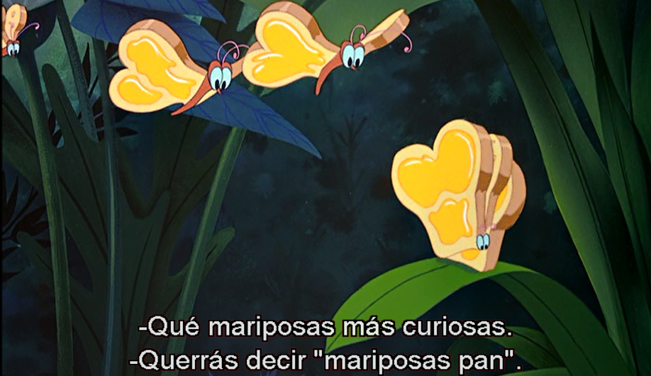
Figure 1. Visual channel related to example (6)


Figure 2. Visual channel related to example (7)

If semiotic cohesion between language and image in the translation of (6) and (7) was achieved, in (8) and (9), even if the semantic scenario was preserved to the detriment of the pragmatic one, cohesion was not achieved due to cross-linguistic differences. Whereas why and the name of the letter y are homophones in English and the same type of relation exists between not and knot, por qué (Spanish for why) and y griega (name of the letter y), on the one hand, and no (“not”) and nudo (“knot”), on the other, are not homophones in Spanish. Therefore, the TT viewer will not be able to understand the relation between what is reflected on screen and what the caterpillar is saying (See Figure 3 and Figure 4).

(8)-(9) Caterpillar: Why?
Alice: Oh, Dear! Everything is so confusing.
Caterpillar: It is not to me. (Geronimi, Jackson, and Luske 1951: 00:32:00)

Oruga: ¿Por qué?
Alicia: Vaya, todo es tan confuso…
Oruga: No lo es.


Figure 3. Visual channel related to example (8)


Figure 4. Visual channel related to example (9)

In (10) the ST pun is based on the paronymy between sweetheart and sweet Hat. It is this second interpretation that is represented on screen and in the non-punning TT (dulce sombrero), which contributes to the semiotic cohesion between the audio and the visual channels, as shown in Figure 5.

(10) Cheshire Cat: Good-bye, sweet Hat. (Burton 2010: 01:14:00)

Chess: Adiós, mi dulce sombrero.

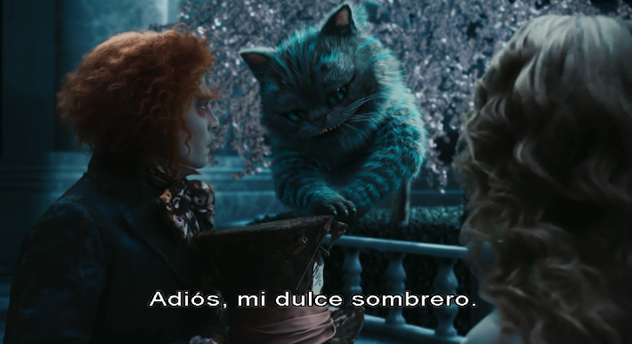
Figure 5. Visual channel related to example (10)

3. The translation of cultural references as a translation problem
Following González-Davies and Scott-Tennett (2005), a cultural reference can be defined as

Any kind of expression (textual, verbal, non-verbal or audiovisual) denoting any material, ecological, social, religious, linguistic or emotional manifestation that can be attributed to a particular community (geographic, socio-economic, professional, linguistic, religious, bilingual, etc.) and would be admitted as a trait of that community by those who consider themselves to be members of it. (González-Davies and Scott-Tennett 2005: 166)

Any expression of this type may pose a translation problem, because it may not exist in the target culture or because it may have a different value. In this sense, Franco Aixelá (1996) prefers the term culture-specific-item (CSI). In his own words, “in translation a CSI does not exist of itself, but as a result of the conflict arising from any linguistically represented reference in a source text which, when transferred to a target language, poses a translation problem” (Franco Aixelá 1996: 57). As highlighted by González-Davies and Scott-Tennett (2005: 164), translation problems demand a conscious decision on the part of the translator to apply a motivated translation solution-type from among a range of options. Those translation solution-types may be ordered along a cline –as portrayed in Figure 6–, depending on whether they are more oriented towards the source culture or towards the target culture.

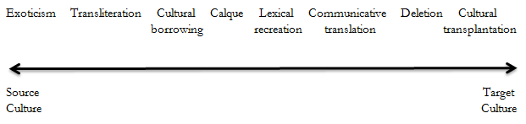
Figure 6. Cline of translation solution-types for cultural references (adapted from Haywood, Thompson and Hervey 2009: 73)

3.1. Audiovisual translation and cultural references
As discussed in sub-section 2.1 with regard to puns, the interplay between channels in a polysemiotic text such as a film is a factor which will have to be considered by the translator when dealing with cultural references. For example, if a given cultural reference appears in the verbal audio channel and at the same time is present in the visual channel – verbal or non-verbal –, the range of solution-types available to the translator will be reduced, since semiotic cohesion between both channels is normally desired. As a consequence, solution-types oriented towards the source culture, such as generalization or exoticism, would contribute to that desired semiotic cohesion, whereas solution-types oriented towards the target culture, such as cultural transplantation, could result in a polysemiotic TT lacking semiotic cohesion.
The fact that subtitling is additive, following Gottlieb’s (1997: 141) and Pedersen’s (2011: 113) terminology, that is to say, the fact that – unlike dubbing – it adds information (in the sense that both the ST and TT are present) also has important consequences for the translation of cultural references, as will be illustrated in 3.2.
Dubbing, in turn, also has its specific constraints, such as the interplay between the non-verbal audio channel – music, for instance – and the verbal audio channel in the case of a song if the song is to be translated – as normally happens in films targeted at children –, since the lyrics of the TT song will have to be adapted to the music of the original soundtrack.

3.2. Solution-types used by the translators. A relevance-theoretic approach
In the source culture extreme of the solution-types continuum is the solution-type known as exoticism (Haywood et al. 2009), loan (Díaz-Cintas and Remael 2014), repetition (Franco Aixelá 1996), or retention (Pedersen 2011). This solution-type involves leaving ST words or sequences in their original forms, in the SL, English in this case. The most obvious example in our corpus is the treatment of certain characters’ names, such as Bill or Dinah in Geronimi, Jackson and Luske’s film, Charles, Kingsleigh, Imogene, Hamish, Lowell, Margaret, or Stayne, in Burton’s film, and Tweedle Dum and Tweedle Dee in both of them. Apart from being names, Tweedle Dum and Tweedle Dee are also cultural references in another sense. There is intertextuality in the names of those two characters, since they are fictional characters of an English nursery rhyme. In (11) the presence of Tweedle Dee in the verbal visual channel has left no option to the translator but to resort to exoticism if semiotic cohesion between the visual and audio channels was to be ensured in the Spanish version (See Figure 7). However, in example (12) – corresponding to Burton’s film –, even if it was not necessary to preserve semiotic cohesion, the same solution-type was resorted to (See Figure 8).

(11) Alice: Mister Rabbit! Oh, mister Rabbit! Oh dear, I'm sure he came this way. Do you suppose he could be hiding? Hmmm... not here. I wonder... No, I suppose he must have... Oh! Why, what peculiar little figures! Tweedle Dee... and Tweedle Dum! (Geronimi, Jackson, and Luske 1951: 00:12:30)

Alicia: Señor conejo. Señor conejo. ¡Qué raro! Estoy segura que pasó por aquí. ¿Se estará escondiendo? Aquí no. Me pregunto… No, supongo que habrá… Vaya, qué personajes más curiosos. Tweedle dee… y Tweedle dum.

(12) Tweedledee: I’m Tweedledee, he’s Tweedledum.
Tweedledum: Contrariwise. I’m Tweedledum, he’s Tweedledee. (Burton 2010: 01:18:26)

Tweedledee: Yo soy Tweedledee y él Tweedledum.
Tweedledum: Al contrario, yo soy Tweedledum y él es Tweedledee.


Figure 7. Visual channel related to example (11)

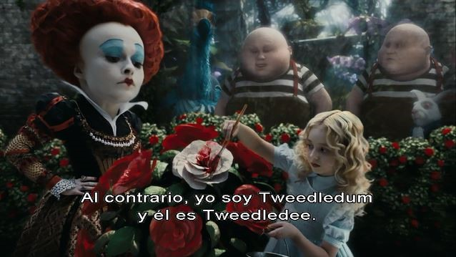
Figure 8. Visual channel related to example (12)

When exoticism involves a certain degree of orthographic adaptation to the norms of the TL, the solution-type is called transliteration. The translation of the name Absolem in (13) involves transliteration, as a graphic stress has been added to adapt the spelling of that name to the Spanish orthographic norms, as Figure 9 shows.

(13) Dodo: We should consult Absolem. (Burton 2010: 00:18:49)
Dodo: Consultemos a Ábsolem.

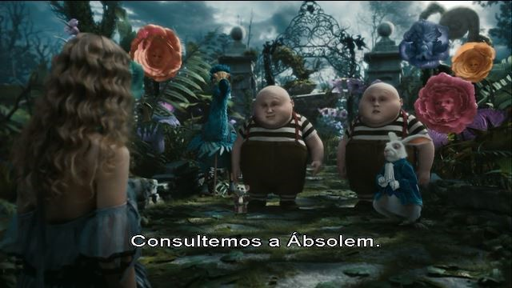
Figure 9. Visual channel related to example (13)

Some authors establish a distinction between exoticism and cultural borrowing, since the latter solution-type refers to “loan-words from the SL that are already established in the TL, retaining a degree of exoticism but combining it with familiarity and incurring a much lower risk of incomprehensibility” (Haywood et al. 2009: 76). That is the case of croquet in (14), an English noun referring to an English sport, but which has become a loan word in Spanish, as testified by its appearance in dictionaries as a word which is part of the Spanish lexicon and by the fact that there is a Federación Española de Croquet since 1994. Another example of cultural borrowing may be found in the Spanish subtitles in (15), where the word lord has been used (See Figure 10). That noun can also be found in Spanish dictionaries, such as the Spanish Royal Academy of the Language Dictionary, as portrayed in figure 11.

(14) Queen: I’ll ask the questions! Do you play croquet? (Geronimi, Jackson, and Luske 1951: 01:00:08)

Reina: Las preguntas las hago yo. ¿Juegas al croquet?

(15) Alice: But I don’t know if I want to marry Hamish.
Margaret: Who then? You won’t do better than a Lord. (Burton 2010: 00:07:26)

Alicia: Pero no sé si quiero casarme con Hamish.
Margaret: ¿Con quién, entonces? No hay nada mejor que un lord.

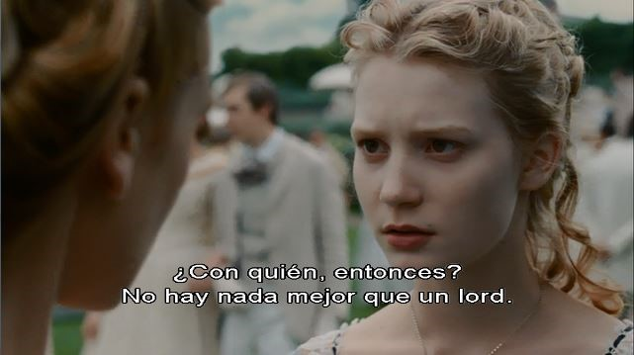
Figure 10. Visual channel related to example (14)

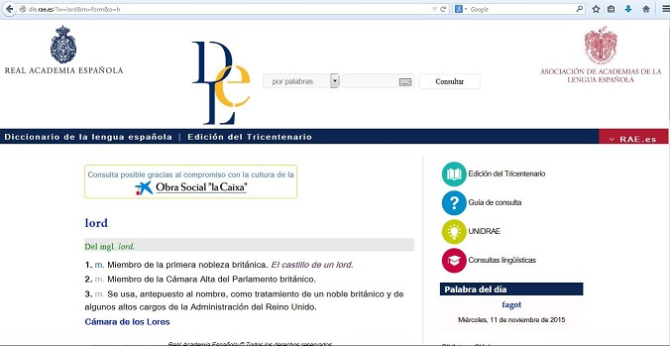
Figure 11. Lord in the Spanish Royal Academy of the Language Dictionary (http://dle.rae.es/?id=NcHQvjE)

The three solution-types dealt with so far are very clearly oriented towards the source culture and in that sense, they constitute an extreme case of what Venuti (1995: 20) has called foreignizing translation, since the cultural values or, in this case, the language of the source or foreign culture are present in the TT. In that sense, the linguistic and cultural difference of the ST is thus registered and “the cultural other is manifested” (Venuti 1995: 20), in such a way that the target viewer is sent abroad. From the perspective of RT, these solution-types can contribute to the creation of cognitive effects associated with different aspects of the source culture. This is particularly obvious in the case of the examples (14) and (15). On the other hand, the fact that the cultural reference may be felt as alien by the target viewer due to linguistic form and cultural difference may increase the processing effort, which goes to the detriment of relevance. The extent to which the target viewer derives ST-intended cognitive effects will depend on his/her knowledge of the source culture. Shared background knowledge of the world is, therefore, particularly important in this case.
As highlighted by Haywood et al. (2009: 77), the solution-type known as calque or literal translation is “a less radical form of foreignization”. In (16) there is a cultural reference, because the song is a parody of a well-known 19th century poem by Jane Taylor, “Twinkle, Twinkle, Little Star”. In (17), in turn, the March Hare is another culture-bound term, since apart from being the name of one of the characters in both Carroll’s novels and their film adaptions, it is also part of a well-known British English set-phrase both nowadays and in Carroll’s time. In the subtitles of the animated film corresponding to (16) the song has been literally translated, as also has the culture-bound term in (17), which is shown in Figure 12. All those ST-intended cognitive effects related to the intertextuality of those two fragments are not accessible to the target viewer, which results in a decrease in the relevance of the TT.

(16) Dormouse: Twinkle, twinkle, little bat, how I wonder what you’re at! Up above the world you fly, like a tea-tray in the sky! (Geronimi, Jackson, and Luske 1951: 00:42:57)

Lirón: Centellea, centellea, pequeño murciélago, me pregunto qué es lo que haces. Por encima del mundo vuelas como una bandeja de té en el cielo.

(17) Alice: Is the March Hare around? (Burton 2010: 01:05:26)
Alicia: ¿Es la Liebre de Marzo?

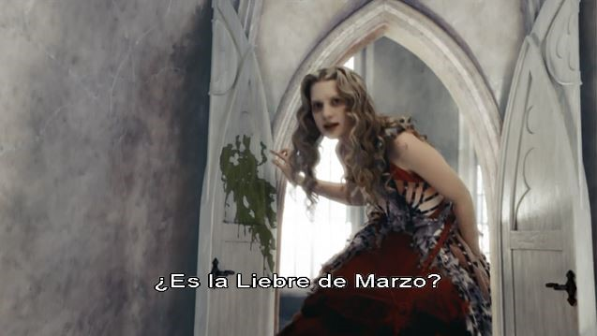
Figure 12. Visual channel related to example (17)

Another solution-type available to the translator to render a cultural reference is lexical recreation or the invention of a neologism in the TL. As stated by Díaz-Cintas and Remael (2011: 206), “[t]he neologism is placed between quotation marks in the subtitles”. In (18), apart from the toponym itself, there is a cultural reference because the name of the character comes from an idiom, to grin like a Cheshire Cat, which means “to grin broadly”. The translation involves a paraphrase consisting of the hypernym, gato (Spanish for “cat”) followed by the neologism “risón”, an adjective which is understandable by any Spanish native speaker but which does not exist in Spanish dictionaries (See Figure 13). The target viewer is thus deprived of the cognitive effects accessible to the source audience and derivable from the processing of a name in which there is intertextuality.

(18) Alice: Oh, Cheshire Cat, it’s you! (Geronimi, Jackson, and Luske 1951: 00:54:04)

Alicia: ¡El gato “risón”! ¡Eres tú!

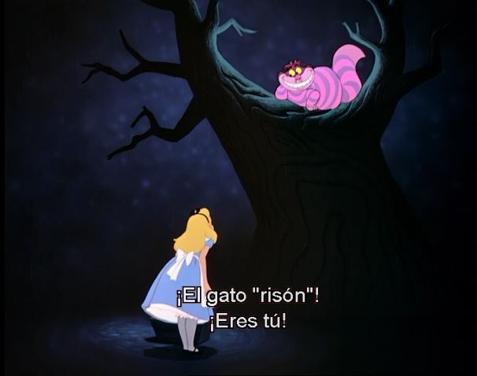
Figure 13. Visual channel related to example (18)

As defined by Haywood et al. (2009: 78), communicative translation “involves selecting those features of the TL that will convey the meanings and reproduce the textual effects of the ST in ways designed to strike the reader of the TT as idiomatic, stylistically coherent and in line with how the content would naturally be expressed by a native speaker”. Sometimes the application of this solution-type may involve great shifts from a literal translation. Whenever the register is informal or there is an idiom or proverb in the ST whose literal translation would be nonsensical in the TL – as in (19) –, communicative translation is normally resorted to by translators. In (20) and (21) – respectively the dubbed version of (16) and the TT version of the same ST poem in Burton’s film – by means of communicative translation the translators have tried to recreate the stylistic effects of the ST. In (22), the ST cultural reference corresponds to the name of a popular game which also exists in the Spanish-speaking countries, although the name it receives in Spanish – escondite – presents lexical and syntactic differences with respect to its English counterpart.

(19) Charles Kingsleigh: I’m afraid so. You’re mad. Bonkers. Off your head. But I’ll tell you a secret... all the best people are. (Burton 2010: 00:02:27)

Charles Kingsleigh: Te has vuelto loca, majareta, chiflada. Pero te diré un secreto: las mejores personas lo están.

(20) Lirón: Lindo, lindo parpadean estrellitas en el cielo. Y allá arriba están volando, con alitas de murciélago.

(21) Liebre/Sombrerero/Lirón: Brilla, brilla, reinecita. Brilla, brilla, reinecita. ¿Por qué serás tan bonita? ¿Por qué serás tan bonita? Por el… Por el… (…)
Por el cielo sueles volar como una tetera sin cerrar. (Burton 2010: 00:33:21)

(22) Dum: Do you like to play hide-and-seek? (Geronimi, Jackson, and Luske 1951: 00:13:47)

Dum: ¿Jugamos al escondite?

In relevance-theoretic terms, the application of communicative translation responds to a decision by the translator to reproduce in the TT some of the ST-intended cognitive effects, such as, for instance, cognitive effects associated with the processing of a poetic style, or cognitive effects related to an informal register.
In (23a) the term caucus is a culture-bound term which refers to “[a] private meeting of the leaders or representatives of a political party, previous to an election or to a general meeting of the party, to select candidates for office, or to concert other measures for the furthering of party interests”. After analysing the cognitive environment of ST addresser and TT addressee – considering that the target audience is mainly composed by children – the translator probably decided that the extra processing effort with which the target viewer would have been burdened if for instance exoticism or an equivalent TT cultural reference had been used would not have been outweighed by additional cognitive effects. In other words, the translator may have considered that the cultural reference would not contribute to the relevance of the TT, considering the processing effort imposed on the viewer. Therefore, the translator simply opted for getting rid of the cultural reference in the TT, which involves the application of the solution-type known as deletion (Franco Aixelá 1996; Haywood et al. 2009) or omission (Pedersen 2011; Díaz-Cintas and Remael 2014). The translator can be said to be guided by the principle of relevance to take this decision. The addition of the phrase en círculos (“in circles”) in (23b) – the subtitled version – responds to a decision by the translator to reinforce what appears on screen, and, in this sense adds to the semiotic cohesion between the audio and visual channels, as reflected on Figure 14.

(23a) Dodo: Nothing could be drier than a jolly caucus-race. (Geronimi, Jackson, and Luske 1951: 00:11:20)

(23b) Dodo: No hay nada más seco que una carrera en círculos.

(23c) Dodo: Que en esta carrera imposible es perder. (Dubbed version)

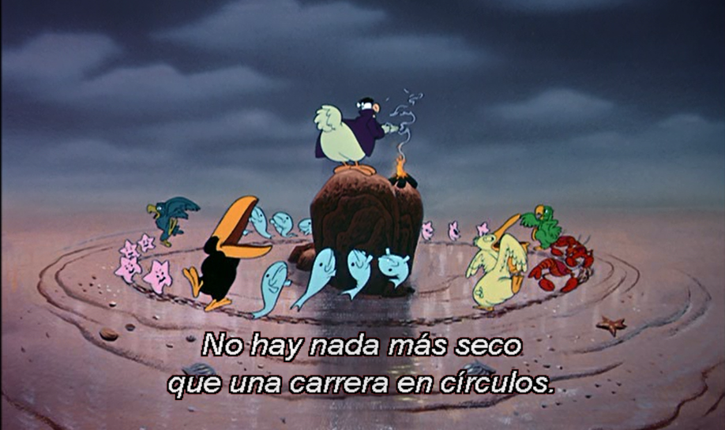
Figure 14. Visual channel corresponding to example (20)

At the target culture end of the cline is the solution-type known as cultural transplantation (Haywood et al. 2009), naturalization (Franco Aixelá 1996) or transposition (Díaz-Cintas and Remael 2014). By means of this solution-type, “culture specific elements in the ST are replaced in the TT by elements that are specific to the TL culture” (Haywood et al. 2009: 80). In Venuti’s terms, it represents an extreme case of domestication. Using his own words, a domesticating method is “an ethnocentric reduction of the foreign text to target-language cultural values, bringing the author back home” (Venuti 1995: 20). From the perspective of RT, it could be said that the translator, considering his/her metarepresentation of the target addressee’s cognitive environment, opted for a solution-type which implied a reduction in the processing effort required of the target viewer. As put forward in Haywood et al. (2009: 74), films and books which are not targeted at a relatively specialist, highbrow audience – as is the case of the two films analysed in this chapter – are more likely to resort to domesticating solution-types.
In (24b) – the dubbed version of (24a) – there are clear examples of cultural transplantation. Cultural references in the ST such as Edwin and Morcar, the earls of Mercia and Northumbria, Stigand, the archbishop of Canterbury, or William are replaced by target-culture-bound terms, namely, la Niña, la Pinta y la Santa María, Cristóbal Colón, or Los Reyes Católicos. The fact that subtitling is additive, as mentioned above, has probably favoured the adoption of solution-types more oriented to the source culture, such as exoticism (Edwin, Stigand) or calque (el arzobispo de Canterbury).

(24a) Sister: ...leaders, and had been of late much accustomed to usurpation and conquest. Edwin and Morcar, the earls of Mercia and Northumbria declared for him, and even Stigand... Alice!
Alice: Hmm...? Oh, I’m listening.
Sister: And even Stigand, the archbishop of Canterbury, agreed to meet with William and offer him the crown. William's conduct at first was mo... Alice! Will you kindly pay attention to your history lesson? (Geronimi, Jackson, and Luske 1951: 00:01:58)

(24b) Hermana: … la Niña, la Pinta y la Santa María. Y tras de una navegación de más de dos meses por mares desconocidos, en la gloriosa mañana del 12 de octubre, descubrió el Nuevo Mundo Cristóbal Colón. Ese acontecimiento conmovió profundamente a Europa, dando a Colón la glo… ¡Alicia!
Alicia: ¿mhm? Te estoy oyendo.
Hermana: … dando a Colón la gloria de su inmortal hazaña, que fue premiada con largueza por la corona de España. Los Reyes Católicos de… ¡Alicia! ¿Quieres poner atención a tu clase de historia? (Dubbed versión)

(24c) Hermana: y últimamente se había acostumbrado a usurpar el poder y conquistar. Edwin y Marco, los condes de Mercia y Northumbria, declararon a su favor, e incluso Stigand… ¡Alicia!
Alicia: Estoy escuchando.
Hermana: … e incluso Stigand, el arzobispo de Canterbury, accedió a ver a Guillermo y a ofrecerle la corona. La conducta de Guillermo fue al principio… ¡Alicia! ¿Quieres prestar atención a la lección de historia?

The selection of target-culture-bound terms – the solution adopted in (24b) – undoubtedly requires a lower processing effort from the TT viewer – which increases relevance –, but on the other hand, certain ST-intended cognitive effects may disappear from the TT. After metarepresenting the cognitive environments of ST communicator and TT receptor, the translator, in accordance with the principle of relevance, may have decided that adapting the ST to the target culture can add to the relevance of the TT, taking into account the audience at which the film is targeted.

Conclusions
As illustrated throughout this chapter, RT can give an account of the decisions adopted by translators to tackle translation problems such as wordplay or cultural references. Many of their decisions have been shown to be motivated by the principle of relevance. After metarepresenting the cognitive environments of ST addresser and TT addressee, the translator selects a translation solution-type to solve the translation problem trying to reproduce the ST-intended cognitive effects at minimal processing cost for the TT viewer.
Moreover, AVT in general, but also subtitling and dubbing in particular, have their peculiarities which can also condition the solution-types selected by the translators. Thus, for instance, the interplay between audio and visual channels may play an important role in solution-type selection both in the case of subtitling and in the case of dubbing. As regards the peculiarities of each of the sub-modes of AVT, the co-presence of ST and TT in subtitling may favour a source-culture bias, for instance, whereas in dubbing the interplay between a non-verbal audio channel – namely music – and a verbal audio channel – e.g., the lyrics of a song – may also determine the choice of solution-type and favour the adoption of communicative translation.

References:
Alves, F. and Gonçalves, J.L. (2010) “Relevance and translation”. [In:] Gambierm Y. and van Doorslaer, L. (eds.) Handbook of Translation Studies vol. 1, Amsterdam and Philadelphia: John Benjamins, 279-284.
Asimakoulas, D. (2004) “Towards a model of describing humour translation: A case study of the Greek subtitled versions of Airplane! and Naked Gun”. Meta. 49/4, 822-842.
Attardo, S. (1994) Linguistic Theories of Humor. Berlin and New York: Mouton de Gruyter.
Burton, T. (Director) (2010) Alice in Wonderland [Motion picture]. United States: Walt Disney Pictures.
Carston, R. (2002) Thoughts and Utterances. Oxford: Blackwell.
Delabastita, D. (1993) There’s a Double Tongue. Amsterdam and Atlanta: Rodopi.
Delabastita, D. (1994). “Focus on the Pun: Wordplay as a Special Problem in Translation Studies”. Target 6/2, 223-243.
Díaz-Cintas, J. and Remael, A. (2014) Audiovisual Translation: Subtitling, 2nd ed. London and New York: Routledge.
Díaz-Pérez, F.J. (2013) “The translation of wordplay from the perspective of Relevance Theory: Translating sexual puns in two Shakespearian tragedies into Galician and Spanish”. Meta 58/2, 279-302.
Díaz-Pérez, F.J. (2014) “Relevance Theory and translation: Translating puns in Spanish film titles into English”. Journal of Pragmatics 70, 108-129.

Díaz-Pérez, F.J. (2015) “From the other side of the looking glass: A cognitive-pragmatic account of translating Lewis Carroll”. [In]: Romero-Trillo, J. (ed.) Yearbook of Corpus Linguistics and Pragmatics 2015: Current Approaches to Discourse and Translation Studies. Heidelberg: Springer; 163-194.

Díaz-Pérez, F.J. (2017) “The translation of humour based on culture-bound terms in Modern Family. A cognitive-pragmatic approach”. [In]: Martínez Sierra, J.J. and Zabalbeascoa Terran, P. (eds.) The Translation of Humour/La traducción del Humor. Monografías de Traducción e Interpretacion (MonTI) 9, 49-75.
Franco Aixelá, J. (1996) “Culture-Specific Items in Translation”. [In]: Álvarez, R. and Vidal, M.C.A. (eds.) Translation, Power, Subversion. Clevedon, etc.: Multilingual Matters; 52-78.
Geronimi, C., Jackson, W. and Luske, H. (Directors) (1951) Alice in Wonderland [Animated picture] United States: Walt Disney Pictures.
González-Davies, M. and Scott-Tennett, C. (2005) “A problem-solving and student-centred approach to the translation of cultural references”. Meta 50/1, 160-179.
Gottlieb, H. (1997) Subtitles, Translation and Idioms. Copenhaguen: Centre for Translation Studies, University of Copenhaguen.
Gutt, E.A. (1990) “A theoretical account of translation—without a translation theory”. Target 2/2, 135-164.
Gutt, E.A. (1998) “Pragmatic aspects of translation: Some relevance-theory observations”. [In:] Hickey, L. (ed.) The Pragmatics of Translation. Clevedon, etc.: Multilingual Matters; 41-53.
Gutt, E.A. (2000) Translation and Relevance: Cognition and Context, 2nd ed. Oxford: Blackwell.
Gutt, E.A. (2004) “Challenges of metarepresentation to translation competence”. [In:] Fleishcmann, E. Schmitt, P.A. and Wotjak, G. (eds.) Translationskompetenz: Proceedings of LICTRA 2001: VII. Leipziger Internationale Konferenz zu Grundfragen der Translatologie. Tübingen: Stauffenburg; 77-89..
Gutt, E.A. (2005) “On the significance of the cognitive core of translation”. The Translator 11/1, 25-49
Haywood, L.M., Thompson, M. and Hervey, S. (2009) Thinking Spanish Translation. A Course in Translation Method: Spanish to English, 2nd ed. London and New York: Routledge.
Jing, H. (2010) “The translation of English and Chinese puns from the perspective of Relevance Theory”. The Journal of Specialised Translation 13, 81-99.
Karamitroglou, F. (1998) “A proposed set of subtitling standard in Europe”. Translation Journal 2/2. [available at http://translationjournal.net/journal/04stndrd.htm]
Levỳ, J. (1969) Die literarische Übersetzung: Theorie einer Kunstgattung. Frankfurt: Athenäum.
Marco, J. (2010) “The translation of wordplay in literary texts. Typology, techniques and factors in a corpus of English-Catalan source text and target text segments”. Target 22/2, 264-297.
Martínez Sierra, J.J. (2010) Using relevance as a tool for the analysis of the translation of humor in audiovisual texts. [In:] Cifuentes, J.L., Gómez, A., Lillo, A., Mateo, J. and Yus, F. (eds.) Los caminos de la lengua. Estudios en homenaje a Enrique Alcaraz Varó. Alicante: Universidad de Alicante; 189-209.
Pedersen, J. (2011) Subtitling Norms for Television. Amsterdam and Philadelphia: John Benjamins.
Rittmayer, A.M. (2009) “Translation and film: slang, dialects, accents and multiple languages”. Comparative Humanities Review. Volume 3 Translation: Comparative Perspectives, 1-11.
Rosales Sequeiro, X. (2002) “Interlingual pragmatic enrichment in translation”. Journal of Pragmatics 34/8, 1069-1089.
Rosales Sequeiro, X. (2005) Effects of Pragmatic Interpretation on Translation. Communicative Gaps and Textual Discrepancies. Munich: Lincom Europa.
Sanderson, J.D. (2009) “Strategies for the dubbing of puns with one visual semantic layer”. [In:] Díaz-Cintas, J. (ed.) New Trends in Audiovisual Translation. Bristol: Multiligual Matters; 123-132.
Sperber, D. and Wilson, D. (1995) Relevance. Communication and Cognition, 2nd ed. Blackwell, Oxford.
Venuti, L. (1995) The Translator’s Invisibility. London and New York: Routledge.
Wilson, D. (2012) “Metarepresentation in linguistic communication”. [In:] Wilson, D. and Sperber, D. (eds.) Meaning and Relevance. Cambridge: Cambridge University Press; 230-257.
Wilson, D. and Carston, R. (2007) “A unitary approach to lexical pragmatics: Relevance, inference and ad hoc concepts”. [In:] Burton-Roberts, N. (ed.) Pragmatics. Basingstoke: Palgrave Macmillan, 230-259.
Wilson, D. and Sperber, D. (2004) “Relevance Theory”. [In:] Horn, L.R. and Ward, G. (eds.) The Handbook of Pragmatics. Oxford: Blackwell; 607-632.
Yus, F. (2003) “Humour and the search for relevance”. Journal of Pragmatics 35/9, 1295-1331.
Yus, F. (2012) “Relevance, humour and translation”. [In:] Walaszewska, E. and Piskorska, A. (eds.) Relevance Theory: More than Understanding. New Castle upon Tyne: Cambridge Scholars Publishing; 117-145.
Zabalbeascoa, P. (2000) “From techniques to types of solutions.” In: Lonsdale, Allison B. and Ensinger, Dorts (eds.) Investigating Translation: Selected Papers from the 4th International Congress on Translation, Barcelona, 1998. Philadelphia: John Benjamins; 117-127.

Francisco Javier Díaz-Pérez is a senior lecturer at the English Department of the University of Jaén, where he teaches some courses in Linguistics and Translation. He has published several studies in fields such as Cross-cultural Pragmatics, Translation Studies, or Pragmatics of English. He is the author of the monograph La cortesía verbal en ingles y en español. Actos de habla y pragmática intercultural and has co-edited A World of English, a World of Translation, Global Issues in the Teaching of Language, Literature and Linguistics, and Specialisation and Variation in Language Corpora. Some of his publications have appeared in journals such as Journal of Pragmatics, Meta, Babel, Multicultural Shakespeare, Atlantis, or Revista Canaria de Estudios Ingleses.

Other applications of the cognitive-pragmatic theoretical framework used in this study –Relevance Theory– may be found in Díaz-Pérez (2013, 2014, 2015, 2017). Thus, part of the theoretical introduction to this study had already been published in those previous studies.
I use the term solution-type following Zabalbeascoa (2000).
For a relevance-theoretic analysis of the translation of wordplay in several Galician and Spanish translations of Carroll’s novels Alice’s Adventures in Wonderland and Through the Looking Glass and What Alice Found There, see Díaz-Pérez (2015).
For a full account of RT, see for instance Sperber and Wilson (1995) and Wilson and Sperber (2004).
The content explicitly communicated by means of an utterance in explicature, whereas the content which is derivable from the proposition expressed by the utterance together with the context is called an implicature.
Wilson (2012: 230) has defined metarepresentation as “a representation of a representation: a higher-order representation with a lower-order representation embedded within it”.
With respect to the translation of humour, Yus (2012) devises the existence of three parameters, which he calls scenarios, namely the cultural, pragmatic, and semantic scenarios. The same parameters could also be applied to the translation of puns, as discussed in sub-section 2.2.
As stated in Díaz-Cintas and Remael (2014: 85), for Spanish subtitles, the maximum number of lines per subtitles is 2 and the recommended maximum number of characters per line is 39, which amounts to a maximum number of 78 characters per subtitle.
See Rittmayer (2009: 4-5) for a description of the challenges involved in the translation of dialogue and narration in films.
http://www.oed.com/view/Entry/92603?redirectedFrom=impossible#eid
http://www.oed.com/view/Entry/92127?redirectedFrom=impassable#eid
In all the examples the word or sequence which involves wordplay or a cultural reference appears in bold, both in the ST and in the TT. Emphasis is mine.
When only one Spanish version is presented, this indicates that the subtitled and dubbed version coincide. Otherwise, both versions are presented.
http://www.oed.com/view/Entry/84896?redirectedFrom=lose+one%27s+head#eid329869783
For further discussion of ad hoc concept construction within the relevance-theoretic view of utterance understanding, see for instance Carston (2002) or Wilson and Sperber (2004). The standard practice represents ad hoc concepts as starred concepts, e.g. lose one’s head*.
http://www.macmillandictionary.com/dictionary/british/time#kill-time
This situation represents, in Gutt’s (2004: 83) opinion, the translator’s ideal, since, given that original communicator, translator, and receptors share a mutual cognitive environment, there is no need to overcome differences in cognitive environments.
http://dictionary.reference.com/browse/turn
http://www.spanishdict.com/translate/vuelta
The literal interpretations of vuelta y media y darle vueltas a algo are respectively “one turn and a half” and “to turn something round”.
Back translation: Estrujado, cuidado. A poem. (…) I’ve become a poet.
There are other names, however, such as that of the main character in the Spanish version of both films, Alicia, or the Spanish rendering of Iracebeth or Jabberwock in Burton’s film – respectively Iracunda and Galimatazo –, for which the translation solution-type oriented towards the target culture end of the scale has been used. According to Franco Aixelá (1996: 75), this solution-type is used only when the target audience is mainly composed by children.
http://www.rhymes.net/nursery/98
Without that conditioning factor, other options would have been possible. In fact, in Buckley’s version of Alice’s Adventures in Wonderland, published by Cátedra, the names used for those characters are Tararí and Tarará.
http://www.larousse.com/es/diccionarios/ingles-espanol/croquet/8266
http://www.fecroquet.es
http://www.poetryfoundation.org/poem/171955
In Tim Burton’s film, however, the solution-type used to translate the name of that character has been exoticism, Cheshire (Burton 2010: 00:31:18).
http://www.oed.com/view/Entry/29057?rskey=wXtphK&result=1&isAdvanced=false#eid

