Chapter 2

What do I need to know about ‘quality’ and ‘equity’ in education?
María-del-Carmen Méndez-García and Mike Fleming

First Draft

Introduction

In Chapter One of this volume the concepts of ‘equity’ and ‘quality’ were introduced in general terms in the context of the Council of Europe’s vision and values, “as guiding principles and basic tenets of education, and to ensure access to good education for all” (p. x). The aim of this chapter is to focus more specifically on the implications of these concepts for schools, other educational institutions and for teaching. It is fairly easy to recognise that the concepts of equality and equity are highly relevant to education policy at a national and regional level. For example, in order to ensure the right to education it is important that there is adequate provision, that resources are distributed fairly, that admission policies are administered justly, and so on. It is perhaps less obvious how the concepts of ‘quality’ and ‘equity’ are of relevance to everyday practice at the institution and classroom level. Injustices that may prevent access to quality education can all too easily be concealed or remain unnoticed, particularly when it comes to matters related to language and how it impacts on teaching and learning.

The concepts of ‘quality’ and ‘equity’

The concepts of ‘quality’ and ‘equity’ when employed by the Council of Europe are often mentioned together. This is entirely appropriate for they are closely related. The concept of ‘equity’ (treating people in a way that recognises their particular needs to ensure fair outcomes and processes) can usefully be distinguished from some uses of ‘equality’ (when it implies treating everyone in exactly the same way). Equity has to do with fairness and justice, which is more likely to mean recognising, and taking measures to address, the particular needs of groups and individuals. It means that personal or social circumstances such as gender, ethnic origin or family background, should not be obstacles to achieving educational potential (OECD, 2012). However, a focus on equity in education without attention to quality may result in simply ensuring fair access to poor or inadequate provision. On the other hand, a focus purely on quality measured in outcomes (for example test data) may show that average achievement in a school or education system is high but conceal the fact that some groups are disadvantaged.

Test data, of course, may be very helpful in identifying injustices in the education provision, for example if it reveals that some groups are underachieving in comparison to others. However, the focus needs to be not just on outcomes (important though they are) but also on the education process. It is important to resist a reductive and technicist interpretation of quality education as being only about achievement measured by tests. Quality also refers to pedagogy, and such issues as the ethos and nature of the relationships within an institution or class.

Recommendation CM/Rec (2012)13 of the Committee of Ministers to member States describes “quality education” as education which:

a. gives access to learning to all pupils and students, particularly those in vulnerable or disadvantaged groups, adapted to their needs as appropriate;
b. provides a secure and non-violent learning environment in which the rights of all are respected;
c. develops each pupil’s and student’s personality, talents and mental and physical abilities to their fullest potential and encourages them to complete the educational programmes in which they enrol; d. promotes democracy, respect for human rights and social justice in a learning environment which recognises everyone’s learning and social needs;
e. enables pupils and students to develop appropriate competences, self-confidence and critical thinking to help them become responsible citizens and improve their employability;
f. passes on universal and local cultural values to pupils and students while equipping them also to make their own decisions;
g. certifies outcomes of formal and non-formal learning in a transparent way based on fair assessment enabling acquired knowledge and competences to be recognised for further study, employment and other purposes;
h. relies on qualified teachers who are committed to continuous professional development;
i. is free of corruption.

This list recognises both policy and practice, as well as outcomes and process, and takes a broad view of what quality education should entail. There is recognition of the importance of teaching and learning as a critical factor in the achievement of the goals of quality and equity. In modern classrooms in democratic societies it is highly unlikely that teachers would disagree with the values described here. However, it is important to subject institutional policies and teaching practices to honest scrutiny, asking whether they are a proper reflection of those values. Everyday practice can easily become routinized and taken for granted. For example, there are dangers of over-generalising about learners and underestimating the specific needs of individuals or groups. Sometimes the language used to talk about learners, for example, that ‘they can’t keep up’, ‘have difficulty concentrating’ or ‘are easily distracted’ may prevent further questions about the appropriateness of the materials or strategies being employed. It is all too easy to underestimate the potential of some learners and not challenge them enough. This can happen when the role of language in relation to quality and equity is not fully recognised.

The importance of language

Proficiency in language is important for quality education as it is the primary means of communication, and the central medium of teaching and learning. Language is moreover the predominant means by which learners demonstrate their knowledge and understanding, and it is central to most formal assessment. However, the case for the importance of language needs to go further. It needs to recognise the wider role of language beyond communication in relation to learning, identity formation and values.

As described in Chapter One, ‘plurilingual and intercultural competence’ is a key concept for the Council of Europe in relation to language education. The term has a richer connotation than simply ‘speaking more than one language’ but, as used in the various Council of Europe documents, implies a more embedded and holistic vision of language, identity and culture (Coste et al 2009). Language needs to be seen not as a disembodied skill or a mere tool but as an integrated aspect of learning and personal development. The acquisition of additional languages or varieties of language has an impact on the understanding of self and others. Learners may be disadvantaged because of issues related to language.

Recommendation CM/Rec (2014)5 of the Committee of Ministers to member States on the importance of competences in the language(s) of schooling for equity and quality in education and for educational success highlights the importance of language not just as a separate subject in school, but in all subjects across the curriculum. It highlights the importance of being aware:

- that the right to education can only be fully exercised if the learners master the specific linguistic rules that are applied in schools and are necessary for access to knowledge;
- that such linguistic competences are one of the factors in educational success and that they are a prerequisite for undertaking further qualifying academic or vocational education and training, and therefore important for participation in society and sustainable inclusion;
- that some learners may be disadvantaged vis-à-vis mastery of these linguistic competences because of social and linguistic inequalities.
The Recommendation also states that it is desirable that those responsible for educational contents and programmes promote effective consideration of the linguistic dimensions of subjects by:

- making explicit the specific linguistic norms and competences which leaners must be able to master in individual subjects.
- making explicit in the programmes and curricula the learning modalities that should allow all learners, and in particular the most vulnerable among them, to be exposed to diversified language-learning situations in order to develop their cognitive and linguistic capacities;
- highlighting, in the programmes, convergences in the linguistic dimensions of the various subjects, in such a way as to reinforce the effectiveness of the educational project;
- recalling, in the programmes for the language of schooling as a specific school subject, the special place which this language holds because of its cross-cutting effect on all the learning processes conducted in that language;
- encouraging authors of educational materials to ensure that such materials explicitly take account of the linguistic dimensions of the different subjects;
- continuing and extending research in this field;

The Recommendation draws attention to the fact that some groups may be disadvantaged in relation to language. Some pupils are disadvantaged because they have to learn subjects and to think in subject terms at school in a language that is not their first language. Schools and classrooms have a role to play in making sure that the languages that are present in the school but not taught are welcomed and seen as a resource and not a barrier. Other pupils may struggle with the language of schooling not because it is a different language from their own but because it involves a level of formality and complexity that presents particular difficulties. Some pupils can use language informally in their daily lives well enough but struggle when it comes to understanding concepts, issues and relationships within school subjects through the ‘academic language’. For other pupils this is much easier because they have been used to using more complex, abstract, formally structured language in the home. Some learners may be doubly disadvantaged, both by the demands of the academic language and the fact that the language of instruction (or ‘language of schooling’) is not their first language.
A difficulty can arise if there is a mismatch between the academic language and the academic content familiar to a particular group (e.g. migrants) and the corresponding educational level / curriculum in the new education context (e.g. their new countries). The level may be significantly different and thus hinder migrants’ adaptation to the school and prevent their success in their learning. Language invariably needs to be considered in relation to culture. The close relationship between language and culture is emphasised in the CEFR/CV (2020, p. 124), which speaks about a comprehensive plurilingual and pluricultural competence. This includes elements such as the understanding that each society has a series of practices and norms different from each other, the recognition of similarities and differences between communities, tolerance of ambiguity when faced with cultural diversity, including the need to modify and adapt the language, or having the predisposition as a speaker to ask for and offer clarification and anticipate the risks of misunderstanding.
When considering the ways in which conscious reflection on language is important in teaching, it helps to distinguish between spoken and written forms. Spoken language is usually highly contextualized and often makes use of non-verbal clues. Written language on the other hand is usually more distant from the potential audience and needs to be more structured and precise. Too often it is assumed that learners with good spoken competences will acquire the written form quite naturally. And that learners with a migrant background only need support until they acquire the same level of informal and social communication as the others. However, the ‘academic language’, more based on the written form, is not acquired spontaneously; it must be taught to all learners throughout the education stages.

Learners may be judged to be less intelligent or not good at the subject, but it may be a matter of being disadvantaged by the language as a cognitive and conceptual tool. This has implications for the classroom, as teacher may need to adapt their practice, for example: finding ways of making new material engaging and accessible; being more attentive to clarity of explanations; allowing pupils some use of their first language to support their work; providing supportive subject-specific vocabulary; making sure that the language demands of task (e.g. writing in a specific genre) are not taken for granted but clearly explained and supported. Another practical approach is to foster visual literacy in combination with textual literacy. Whereas young learners’ education is highly visual, the relevance of visual training often declines after two or three years of schooling and shifts to alphabetic or textual literacy until the written text, reading and writing words, gains uncontested predominance in most school programmes. However, the incorporation of new technologies into education facilitates the use of images at all levels and across disciplines (García Sánchez et al., 2019). Visual literacy may develop on its own to a degree, although pedagogical guidance enhances individuals’ appraisal skills of visuals and activates the skills needed for critical engagement with images. It may provide some support for learners who struggle to gain access to the curriculum.

The current pervasiveness of visual representations of reality, due to the widespread use of the internet, enables the teacher to provide mediated encounters with otherness. But analysing images is complex, especially because deeply ingrained values in different societies may inspire a different interpretation of the same image. Therefore, guidance is needed to interpret a variety of aspects from the individuals’ cultural background and other cultures rendered through visuals.

Being aware that individuals learn about otherness and other groups, to a considerable extent, through images that appear in the media, the Council of Europe has developed the Autobiography of Intercultural Encounters through Visual Media (AIEVM) (Barrett et al., 2013) to look into images of how ‘the other’ is represented. The AIEVM has been designed to assist users in exploring a specific image they have encountered in the media and which portrays somebody different from them, guiding their analysis of images for intercultural understanding. Structured according to questions or cues divided into different areas (see figure 1), the AIEVM invites users to reflect on the composition of the image in connection with fundamental fields for intercultural reflection and development, such as their own feelings, the feelings of other people or the similarities and differences between the people represented in the images and the user.
Description of the image, the context of the image and justification.

The users’ feelings and interpretation of the other people’s feelings.

Thinking about communication.

Similarities and differences between user and person portrayed.

Thinking further about the image and the person who made the image.

Finding out about things that puzzle or raise users’ interest.

Thinking backward and looking forward.

Figure 1 Areas of questioning in the Autobiography of Intercultural Encounters through Visual Media.

In the following two examples extracts are provided from the extended responses provided by the students, addressing each of the areas of questioning in a structured way. In the first example a student has chosen a screenshot of an Indian wedding in Spain from a television programme. The student (writing in English, the language they are learning) has described the content of the image and the reasons for choosing it. The questions then focus on feelings.

Your feelings | How did you feel when you first saw the image?  I felt confused because the program shows a very biased perception of other cultures and personal relationships. Also, that this view was not promoting understanding and tolerance between the Spanish and Indian culture, as only the costs and extravagances are considered.
The feelings of the other people | Do you think they would have been preferred to be shown differently? Please explain your answer.  I think they would have the chance to greet their family and their mix of cultures, the values they respect and the traditional ceremony they chose.  How do you think other people from the same group or culture as them would feel about the image?  I think they would feel like seeing Indian wedding being popular around the world because it would make them feel proud about such a significant thing in India.
Thinking about communication | What do you think you could do to make it easier for you to understand each other?  I would like to know their reasons to get married so soon and so young?
Same and different | Thinking about the person/people in the image and yourself, what do you think are the main similarities between them and yourself?  I think I am very different from the couple in terms of ethnic background and cultural background, traditions and relationships.  Are they like anyone that you know in your own life? If so, in what ways do they resemble them?  For example, in the way they look, the way they behave, the way they think…?  They are completely different from anyone I know because of their economic status and culture.

In another example the student describes the content of the chosen image and her responses to it.

The Image | It is a photo found in an on-line newspaper.
The contents of the image | Two English police women and some people demonstrating against the unfulfilment of the Brexit at the entrance of the Parliament.  In my opinion the demonstrators seem tired and bored and also I could think they are not very supported.  They are women and men older than me and they belong to another group of countries, Great Britain where they use another language (English) and various religions. They also have different appearances and different skin colours.
Your feelings | How did you feel when you first saw the image?  I felt confused and I asked myself how could they be there if nobody is going to attend them.  What do you think caused these feelings?  These feelings could appear because I have a different concept of Europe from the one these people on the photo have as I understand it has facilities for my country to go steps forward.
Would you like to have an image made of you which looked like this? Please give your reasons.

I wouldn’t mind having a photo like this one if it represents and shows the readers of the newspaper the real reasons of standing there in front of the Parliament.

Would you like to meet the person/people shown in the image in real life? Please give your reasons.

Yes, of course. I would be pleased to share with them our opinions and points of view. I would like to understand why they are there and why they bet for this to be the most acceptable option for their culture and country. I truly believe it would be an appealing conversation which would oblige me to consider my own culture and pre-conceived ideas.

The feelings of the other people. | How do you think other people from the same group or culture as them would feel about the image?  Maybe, they would understand better the reasons of their attitudes or why they seem disinterested and at the same time annoyed.
Thinking about communication | What do you think you could do to make it easier for you to understand each other?  Firstly, not judging them at any point, trying not to dispute but to argue and having made a previous personal reflection about the reasons of their ideas comparing it with other similar situations in my own country.
Same and different | What do you think are the main differences between them and yourself?  We live in different countries, we have different ages and maybe, we haven’t lived the same things and probably we don’t have the same interests and conception about the world surrounding us.  Similarities I noticed…  Their appearances and looks are very similar to the ones in Spain. Also the use of banners and posters is similar.
Thinking further about the image | Do you think that the image is a stereotype of the person/people shown in the image? If so, why do you think it is a stereotype?  Yes, I think this photo stereotype the British as people who doesn’t want to be part of Europe and who encourage some isolation and self-sufficiency which has always been part of their culture.  Do you think this image is fair or unfair as a way of showing this person’s/these people’s group or culture? Give reasons for your answer.  I think this is unfair, because the photo does not represent a whole culture. On the other hand, it is fair, as it represents a group of people who share opinions and ideas.

In both examples the writers’ sense of ownership and engagement is enhanced by the fact that they have chosen the images themselves. The structured questions are designed to prompt critical reflection so that the images are not taken for granted. The AIEVM is intended to help promote awareness of diversity and intercultural understanding in the class. It can also be used as a technique for giving visibility to migrant pupils’ cultural background by analysing images portraying their culture(s) of origin.

Mediation
The concept of mediation appears in the first version of CEFR “as making communication possible between persons who are unable, for whatever reason, to communicate with each other directly” (p. 14). Translation and interpretation are given as examples of mediation. Distinctions are also made between mediating ‘activities’ and ‘strategies’, and between oral and written mediation (p. 87).

The concept of mediation was further developed in a Council of Europe paper by Coste and Cavalli (2015). Here the term is extended and the more integrated concept makes the relationship with equity and quality clearer, going beyond the individual and stressing the social and cross-cutting nature of the term.

Defining mediation very generally as the process of reducing the distance between two poles in a state of tension and regarding schooling as a mediation macro-system admittedly constitutes a significant extension in relation to the process of linguistic reformulation described in the CEFR. Similarly, postulating that cognitive mediation and relational mediation closely complement one another and do not simply depend on the initiative of individuals but also on the responsibility of institutions, as regards both education and social inclusion and cohesion, is tantamount to regarding mediation as being of major cross-cutting importance at different levels of the functioning of societies. (P. 62)

The companion volume of the CEFR (CEFR/CV, 2020) presents scales for mediation in three groups: mediating texts, mediating concepts and mediating communication. The accompanying discussion highlights the moral dimension, “in mediation one is less concerned with one’s own needs, ideas or expression than with those of the party or parties for whom one is mediating. A person who engages in mediation activity needs to have a well-developed emotional intelligence, or an openness to develop it, in order to have sufficient empathy for the viewpoints and emotional states of other participants in the communicative situation.” (P. 91)

The CEFR/CV specifies that mediation entails not only passing on information from one language to another (cross-linguistic mediation), but also enabling communication between individuals who are not capable of communicating with one another directly. Even if direct communication is possible, mediation may also be needed when people are not able to understand each other, irrespective of whether they share or not one or several languages.

Mediation constitutes a key element in individuals’ language proficiency, being at the heart of communicative language activities and strategies (Figure 1), the activities that enable communication and the strategies that smooth the communication process (for example, strategies to deal with misunderstandings). Mediation facilitates the act of receiving and producing messages or texts and interacting with another person.
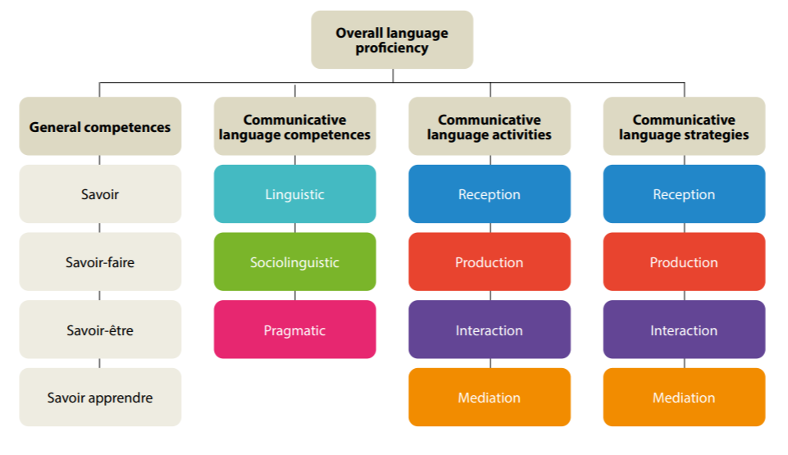
Figure 2. Mediation as a key component of overall language proficiency (European Framework of Reference for Languages – Companion Volume, 2020, p. 32)

To act as intermediaries, individuals need to be familiar with sociocultural and sociolinguistic differences, show sensitivity towards other sociocultural and sociolinguistic perspectives and norms, and anticipate, address and repair misunderstandings that arise from these discrepancies. The CEFR-/CV (2020, pp. 114-115) points to a life-long learning as regards languages and cultures:
Naturally, the mediator themselves needs a continually developing awareness of sociocultural and sociolinguistic differences affecting cross-cultural communication. Key concepts operationalised in the scale include the following:
- using questions and showing interest to promote understanding of cultural norms and perspectives between participants;
- demonstrating sensitivity to and respect for different sociocultural and sociolinguistic perspectives and norms;
- anticipating, dealing with and/or repairing misunderstandings arising from sociocultural and sociolinguistic differences.
The Guide for the development and implementation of curricula for plurilingual and intercultural education (Beacco et al., 2016) also highlights the value of mediation as a cognitive, communicative and intercultural construct entwined with understanding and production in a language and that implies the implementation of a series of competences:

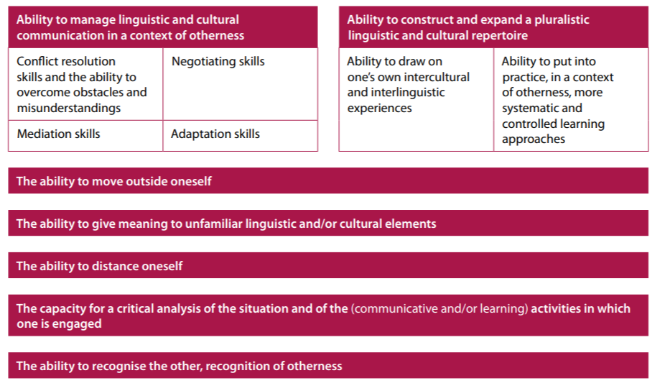
Figure 3: Mediation skills (Guide for the development and implementation of curricula for plurilingual and intercultural education, 2016, p. 58)

In a context of intercultural communication, mediation comprises a complex of skills (including the capacities of negotiation, adaptation, mediation and conflict resolution), the construction and development of a plural linguistic and cultural repertoire, the skills to go beyond of oneself and of distancing oneself from the known and the cultural fact, the capacities to give meaning to unknown linguistic and cultural aspects and to make a critical analysis of them, and the ability to recognize the other and otherness.

Conclusion

One of the perspectives offered by this chapter is that in order to further equity and quality in education, it is not just matter of adopting particular policies or prescribed practices, but it is also important to address less tangible elements to do with attitudes and ethos. For that reason we end this chapter with some questions for consideration to support self-reflection on practices in schools and classrooms.

Questions to consider

At school level

Has the school specifically analysed its own socio-linguistic context (language varieties present, perceptions of languages, etc.) and taken this into account in developing policy?

Do teachers of all subjects meet to coordinate and identify synergies between the different language elements in the curriculum?

Do subject teachers identify the language components shared by other subjects as well as those that are unique to their subject?

Do policies exist that allow pupils to maintain and develop their existing language repertoires?

Are steps taken to give relevance to migrant learners’ languages (and cultures) when they are different from the language of schooling?

At classroom level

Do all subject teachers recognise the linguistic demands of their subject and provide explicit teaching of the language elements that are necessary for pupils to learn the subject?

Are the home languages of migrant pupils seen as a valuable resource rather than as a barrier to success?

Are steps taken to provide specific support to vulnerable learners in an inclusive way to help them access the curriculum?

How can visual literacy be used to enhance migrant pupils’ textual or alphabetic literacy in the language of schooling?

Are measures taken to promote awareness of diversity and intercultural understanding in the class?

References

Barrett, M., Byram, M., Ipgrave, J., & Seurrat, A. (2013). Images of others: An Autobiography of Intercultural Encounters through Visual Media. Strasbourg, France: Council of Europe. https://www.coe.int/en/web/autobiography-intercultural-encounters/images-of-others
Beacco J. C., Byram, M., Cavalli, M., Coste, D., Cuenat, M. E., Goullier, F., & Panthier, J. (2016). Guide for the development and implementation of curricula for plurilingual and intercultural education. Strasbourg, France: Council of Europe Publishing. https://rm.coe.int/16806ae621
Coste, D., & Cavalli, M. (2015). Education, Mobility, Otherness the Mediation Functions of Schools.
https://rm.coe.int/education-mobility-otherness-the-mediation-functions-of-schools/16807367ee
Coste, D., Cavalli M., Crişan A. and van de Ven P. (2009) Pluringual and Intercultural Education as a Right. Council of Europe. https://rm.coe.int/plurilingual-and-intercultural-education-as-a-right-this-text-has- been/16805a219d
Council of Europe. (2020). Common European Framework of Reference for Languages: Learning, teaching, assessment - Companion Volume. Strasbourg, France: Council of Europe Publishing. https://rm.coe.int/common-european-framework-of-reference-for-languages-learning-teaching/16809ea0d4
García Sánchez, F., Therón, R., & Gómez-Isla, J. (2019). Alfabetización visual en nuevos medios: revisión y mapeo sistemático de la literatura. Education in the Knowledge Society, 20, 1–44. https://doi.org/10.14201/eks2019_20_a6
OECD (2012), Equity and Quality in Education: Supporting Disadvantaged Students and Schools. OECD Publishing. http://dx.doi.org/10.1787/9789264130852-en

