9. FIGURES
Figure 1: Theoretical model for the cooperative reputation-performance linkage
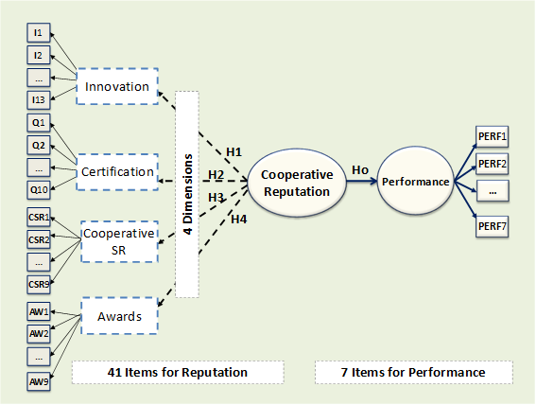
Source: Own

Figure 2: Outer model evaluation results
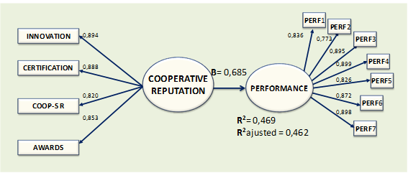
Source: Own

