“I would like to complain”: a study of the moves and strategies employed by Spanish EFL learners in formal complaint e-mails

Abstract
Complaining constitutes a face-threatening and intricate speech act for native and non-native speakers of a language. Complaining implies reacting with discontentment to an act performed by the complainee, who is often urged to redress the predicament. In this context, pragmatic skills are vital because, unless endowed with an appropriate pragmatic repertoire and the corresponding language adequacy, speakers may jeopardise the communication process. Written complaints by non-native students have attracted scholarly attention in different contexts. However, written complaints by Spanish EFL students have been mostly neglected up to date. Likewise, the influence of the writer’s gender on how complaints are performed has rendered some remarkable but few studies. This study addresses the moves, strategies and substrategies deployed by Spanish EFL students in their emails of complaint, specifically looking into how the variable of gender influences their formulation of emails of complaint. To this purpose, emails of complaint of 90 L2 Spanish students with a certified C1 level were analysed. Results show that students often transfer substrategies from their L1 and tend to delay the statement of the complaint in favour of lengthy openers, in contrast to native speakers. Furthermore, this preference for over-mitigation and over-politeness is especially employed by female students.

Keywords
complaints, EFL, Spanish learners, C1 CEFR level, email / writing

- Introduction: The speech act of complaining
Without a command of pragmatic appropriacy and language adequacy individuals may seem unaccommodating, impolite or even offensive and, therefore, may threaten the success of interaction (Hasyim and Hasyim 2020). A particularly functional although challenging area for both native and especially non-native speakers of a language is complaining, an essentially face-threatening speech act through which the speaker challenges the complainee, expressing negative sentiments and making negative evaluations towards them (Chen et al. 2011; Wijayanto et al. 2017). By complaining, the speaker holds the hearer accountable for the situation and solicits the complainee to ‘perform a corrective act’ to redress the objectionable situation (Laabidi and Bousfiha 2020). This is why complaints induce confrontation, kindle hostility and may impair rapport construction, and therefore, are not customarily utilised in relationship building (Yuan and Zhang 2018; Wijayanto et al. 2017).
Complaining has been divided into two categories (Boxer 1993). Indirect complaints represent a non-face-threatening speech act in which the individual responsible for the speakers’ discomfort is absent from the interaction (Kakolaki and Shahrokhi 2016). In contrast, through direct complaints, the complainee or malefactor (Hartford and Mahboob 2004) is accountable for the offense which dissatisfies and bothers the speaker (Hasyim and Hasyim 2020). Research on complaints commonly addresses the degree of directness in a continuum which ranges from indirect, somewhat direct and very direct complaints depending on whether the offense is not explicitly formulated, explicitly worded without reference to the hearers’ responsibility, or explicitly uttered with allusion to the addressee’s accountability (Kakolaki and Shahrokhi 2016).
Different moves and strategies of complaints have been identified. Olshtain and Weinbach (1987) distinguish five strategies: below the level of reproach or no explicit reproach, expression of annoyance/disapproval, explicit complaint, accusation and warning, and threat. Likewise, Trosborg (1994) categorises complaints into four major areas: no explicit reproach (including hints), disproval (subdivided into annoyance and consequences), accusation (indirect and direct accusations), and blame (modified blame, explicit blame on person and explicit blame on behavior). DeCapua (1998 cited by Hasyim and Hasyim 2020) proposes the five-component move structure of statement of problem, request for repair, demand for repair, justification and criticisms.
Trench (1995) discusses five moves: opener to initiate the speech act, act statement to voice the problem, justification of the speaker and the addressee, remedy to repair the wrong (including the subdivision of threat), and closing with expressions of appreciation, apology, good-bye and validation. Semantic formulae complete and refine this paradigm; for instance, openers are further subdivided into names, formulaic adjuncts, salutations, attention-getters, addressing and other subcomponents such as preaching, cursing, formulaic adjuncts; non-linguistic sounds and silence are added.
Even though complaints may be realised through a single move, this speech act often consists of poly-move complaints (Prykarpatska 2008). Chen et al. (2011), for instance, put forward a combination of six strategies, dissatisfaction + request for repair being the most frequently used pattern given that the goal of issuing a complaint is for the complainer to show displeasure toward the act performed by the addressee so that the latter abstains from this bad act or offers a compensation for it.
Complaints are further studied against the backdrop of variables such as social distance, relative power or ranking of imposition (Chen et al. 2011; Eshraghi and Shahrokhi 2016; Yuan and Zhang 2018). Hasyim and Hasyim (2020) propound a four-constituent pattern of four moves, initiating, questioning, criticising and request for repair, and concur with Moon (2001) that the social variables of power, distance and ranking of imposition determine the choice of a complaint strategy.
Research on native speakers of English mostly analyses North American complaint patterns. Hasyim and Hasyim (2020) discover that, depending on the complaint situation, native speakers’ use both, the implicit strategies of reproach and annoyance, and the explicit strategies of complaint and accusation. Chen et al. (2011) identify six chief strategies, of which opting out and threat are the least frequent, whereas dissatisfaction and request for repair constitute the commonest strategies; interrogation and accusation represent the middle ground.
The main goal and genre of the complaint, the context where it takes place, the relationship between interlocutors, their gender, the sociolinguistic/sociocultural competence of the complainer, or the difference between expressing this speech act in the individual’s L1 or L2 are crucial, as discussed below.

  - EFL students’ expression of complaints
This area, mostly investigated from cross-cultural and acquisitional perspectives, targets interlanguage studies of EFL learners, for which native speakers are largely taken as a point of reference.
As pragmatic competence is context-dependent, EFL students’ scarce exposure to socio-pragmatic specificities of the cultures of English-speaking countries yields a partial command of L2 pragmatic patterns, which may cause misunderstandings in intercultural interaction. The enormous impact and chiefly negative pragmatic transfer of learners’ native language and culture in their performance of speech acts has long been attested (Chen et al. 2011; da Silva 2014) since these socio-cultural rules or values have a marked effect on the formulation and organisational patterns of complaints (Al-Momani 2014).
Some studies underscore the tendency for EFL learners to complain more explicitly than native speakers, and the danger of pragmatic failure this fact entails (Kakolaki and Shahrokhi 2016; Trench 1995). Ezzaoua (2020) reports on Moroccan EFL learners’ pragmatic failure regarding social power and social distance, and their great degree of directness and frequent use of high complaint strategies as opposed to American speakers. Da Silva (2014) points out that, in situations that entail no power and social distance, Indonesian ELT learners are more direct in their complaints than native speakers, but both groups avoid a very direct complaint in contexts where power and social distance are present. Pragmatic transfer from Indonesian language and culture is observed in learners’ use of address terms and recurrent mitigation.
Conversely, other investigations highlight native speakers’ assertiveness and preference for explicit strategies of complaining (Önalan and Çakir’s 2018). Moroccan EFL students are reported to calibrate their complaints using strategies such as hint, annoyance, negligence, warning, modified blame, explicit blame, request for repair, justification and no answer. Likewise, they tend to use indirect strategies and employ mitigators to soften the complaint (i.e. titles and expressions of intimacy or endearment), the latter being influenced by learners’ pragmatic competence of their local culture (Laabidi and Bousfiha 2020).
The unmistakable influence of students’ language and culture in the production of mostly inappropriate complaints in English is substantiated by Li and Suleiman’s (2017) investigation on Chinese EFL learners, who are adamant to express displeasure and request for repair, often opt out and, when they choose to complain, their speech acts are mostly over-polite and include numerous instances of preparators and small talk.
Influenced by their own culture, Iranian EFL learners’ favoured strategy to prevent breaking rapport with the complainee is indirect accusation, followed by annoyance towards the situation rather than the addressee and direct accusation, with ill consequences, hints and explicit blame on the person as the least frequently utilised strategies. These complaint strategies are mostly comprehended within the complaint + request pattern first, request + complaint next, and complaint after that (Masjedi and Paramasivam 2018).
Besides, the comparative cross-cultural investigation among Iranian female EFL students and female native speakers of English on complaint strategies indicates that native speakers of English utter direct complaints more frequently and through strategies such as annoyance, explicit blame on behavior and direct accusation, areas in which there are significant differences between them and their Iranian peers (Eshraghi and Shahrokhi 2016). Data also reveal the high influence of contextual variables on complaint strategies, cross-cultural divergences in attitudes and understanding of the speech act of politeness, and cross-cultural differences of what a complaining situation entails.
In a similar vein, Usó-Juan and Martínez-Flor (2017) examine the impact of language proficiency on Spanish female EFL university students’ complaint strategies relative to social status, social distance and severity of offense. Irrespective of their proficiency, similar patterns are implemented, leaning toward the super-strategy of buffer to mitigate the message, followed by complaint.
This sample bears witness to the multifarious elements inherent to the speech act of complaining and the influential effect of the native language(s) and culture(s) of ELT students on their construction of complaints in English. The major concurrence, though, is that explicit pragmatic instruction on how to issue complaints needs to play a fundamental role in EFL teaching to provide learners with the tools to prevent impolite or even aggressive behavior that may inadvertently lead to commit faux pas that may threaten or even break the communication process.
An additional significant issue is gender, which is further discussed below.

  - The gender variances of complaining in EFL contexts
At the heart of Difference Theory lies the pervasive influence of psychological and socialisation gender differences associated to social power, the rules of language use and communication styles (Yuan and Zhang 2018, Thongtong and Srioutai 2019). Indeed, Kakolaki and Shahrokhi emphasise the linkage between socialisation, gender and language, stating that women “are maintained in a subordinate position […] because they are socialized to adopt powerless patterns of speech; and conversely men maintain their dominance by the use of verbal strategies associated with power” (2016: 3).
Women have been found to display more polite and tentative speech patterns, use standard forms, provide supportive responses and avoid disagreement because they value connections and are spurred by the need to facilitate involvement (Thongtong and Srioutai 2019).
In the context of EFL learning, the scant research into gender differentiation in complaints evince substantial differences in areas such as semantic formulae or male conciseness vs. female’s longest responses (Trench 1995). An investigation of Iranian EFL learners shows that the act of complaining is not only unequally distributed, with men displaying a higher frequency of complaints than women, but also distinctive in terms of directness and amount of mitigation; men employ direct complaints and fewer mitigation devices, hence being more aggressive, while women utilise indirect complaints and more mitigation devices (Kakolaki and Shahrokhi 2016).
Thongtong and Srioutai (2019) analyse how English major Thai undergraduate students put questions to perform face-to-face complaints to a business owner or representative. Significant differences surface in the implementation of the complaint strategies of appeal and inquiry: men are partial to ‘appeal’, asking questions to solve problems, while women lean towards ‘inquiry’, using questions to ask for information and ask about problems.
These data on gender variances in the speech act of complaining opens the door to an interesting although under-researched arena, especially in letters and emails of complaint.

  - Written complaints
Research on letters of complaints divulges essential differences in genre, style and strategies.
Hartford and Mahboob’s research on letters to editors written in the South Asian English model (2004) sheds light on users of English as a second language. These letters frequently incorporate most of the following moves, although not necessarily in this order: a usually positive introduction that may or not be related to the main topic, a praise to the newspaper, alerters/attention-getters (e.g. title name or description of the complainee), background or clues to understand the complaint, complaint, appeal to the editor, request for redress, suggestion to fix the problem, and justification for the request/suggestion to remedy the problem.
Young et al. (1998) examine international business letters of complaints between North American and Korean managers. Prior research on letters (Connor et al. 1995) disclosed a five-component pattern of identification of the problem, discussion of relevant information, request for action, topic shift and the optional constituent of buffer to mitigate a negative statement. Young et al. (1998) discovered that native speakers of English employ a direct move pattern that first introduces the problem/chief idea, then explains relevant details and finally requests action unambiguously; the closing buffer is discretionary. Interestingly, implicit style is utilised to present the complaint, although the request for action is explicitly and politely formulated. Revealing is also the use of the plural ‘we’ and the company name to avoid explicit reference to the addresser and addressee.
Similarly, Trabrizi and Masooleh (2015) investigate direct letters of complaints in American English following the four-component strategy paradigm of explanation of purpose, complaint, justification and solution. Most Americans explicitly state the purpose or reason for writing the letter in the first line, including what the complaint is about; they also incorporate pertinent details such as location, time or date. All of them offer a constructive solution/resolution to fix the problem and detail the proposed reparation/outcome. To palliate the impact of the complaint, positive features of the complainee are stated and mitigation devices are used. Besides, time is given for the complainee to solve the problem. Very few subjects use the component of warning and they do not threaten to pursue legal action. The letters end with the individuals’ contact information and the final expression of gratitude to the company.
There is a contrast between the aforementioned features and strategies displayed by native speakers of English and the findings of studies on EFL students’ emails. Emails constitute the preferred mode of computer-mediated communication employed for information purposes in long distance relationships (Halenko et al. 2021). Emails have a hybrid nature, as they share features of both speech and writing in a mode of communication that varies across cultures, contexts of interaction and addresser-addressee relationships (Amundrud 2012; Nguyen and Pham 2021). Investigations conducted on business emails point to the fact that “the pragmatics of NS [native speakers] English email writing is not yet settled” (Amundrud 2012: 185), hence the difficulty of analysing and teaching emails. Research on the pragmatics of EFL learners’ emails mainly explores students’ power-asymmetric emails addressed to their professors, revealing an apparent lack of status-congruent appropriateness leading to discourteous and inconsiderate messages (Nguyen and Pham 2021). Despite studies on EFL students’ emails, especially on forms of address (Economidou-Kogetsidis 2021) and greetings/closings formulas (Schauer 2021), there is an apparent dearth of research on EFL students’ emails of complaints.
One of these rare studies is Park’s (2001) analysis of e-mails written by Korean ELT students to complain to an instructor about their grades. Transfer from Korean pragmatics, such as the status distance between addresser and addressee, is discovered although multiple strategies are not accountable to students’ first language and culture, such as expressions of personal emotions, aggressive expressions, sarcasm and cynicism, and directive/demanding expressions that put the blame on the complainee and direct the tutor towards the action s/he needs to perform.
Nguyen and Pham (2021) reach a similar conclusion on learners’ absence of pragmatic competence after examining emails of complaints formulated by Vietnamese EFL students who were asked to react to an unsatisfactory customer service experience by writing one email to a friend also involved in this negative experience (low-distance indirect complaint) and one email to the service provider (high-distance direct complaint). Direct and indirect/“trouble sharing” complaints contain similar framing moves, namely, greetings, self-introduction, statement of purpose, pre-closing and closing. Significantly, more opening/greetings than any other type of moves are expressed. The emails to the service provider incorporate epistolary greeting formulas (‘Dear’ + Title) and closing formulas (‘Yours sincerely’, Regards’ + signature); pre-closing strategies consist in appeal for action (‘I look forward to hearing from you’), thanking and leave-taking. These content moves comprehend realisation strategies (e.g. negative emotion, statement of offensive act, interrogation, request for repair, consequence for direct complaints, and statements of possible solutions or expression of alternative plans for indirect complaints), along with request for repair, negative emotion and statement of the offensive act as preferred realisation strategies for formal emails.
Taking the above into consideration, Figure 1 illustrates the main moves and strategies that may integrate an email/letter of complaint.

Figure 1. A synthesis of moves, strategies and substrategies of emails of complaint (inspired by Trench 1995; Hartford and Manboob 2004; Prykarpatska 2008; Yuan and Zhang 2018; Nguyen and Pham 2021)
Given the dearth of studies on the role of gender in EFL learners’ speech act of complaining and, to the best of the authors’ knowledge, lack of research on letters and, in particular, emails of complaint among EFL leaners in Spain, this paper seeks to address these issues among a cohort of Spanish EFL learners.

2. Methodology
According to the Common European Framework of Reference (CEFR henceforth) (2001, 2018, 2020), making a complaint effectively is considered part of the B1 level (CEFR 2020: 78). At this level, however, complaints are limited to service encounters carried out in face-to-face contexts like making a complaint at a hotel or at a restaurant. Formal, written complaints are part of the C1 level; more specifically, the Companion Volume of the CEFR (2020: 82) states that, at C1 level, students “[c]an, with good expression and accuracy, compose formal correspondence such as letters of clarification, application, recommendation, reference, complaint, sympathy and condolence” (the authors’ emphasis). The Companion Volume descriptors acknowledge the increasing importance of email communication as part of both writing and reading competences, including letters and other types of texts (2020: 34).

2.1 Goals and research questions
As already highlighted, the paucity of studies on the role of gender in EFL learners’ speech act of complaining and, to the best of the authors’ knowledge, lack of research on written complaints by Spanish EFL students have triggered the researchers’ interest in looking into how L1 Spanish EFL learners of both genders structure their emails of complaint.
More specifically, the present research aims to answer the following research questions:
- What are the moves, strategies and substrategies deployed by students in their written production?
- To what degree do they follow native-like patterns?
- To what extent does the variable of gender influence how emails of complaint are formulated?

2.2 Setting: participants and task
The present study is framed within the research project FineDesc (funded by the Spanish Ministry of Science and Innovation) and involves a group of 90 students whose L1 is Spanish and who had a certified C1 level, 57 being female and 33 male young adults.
Students were requested to write an email to their female employer to complain about the new environmental policy of the company, which was having a negative effect on the employees’ welfare. The context involves an asymmetrical relationship with the employee occupying a lower position at the power scale as well as a relatively distant one since employer and employee do not share a personal relationship. The ranking of imposition is relatively high given that the employee, on behalf of all their colleagues, wishes to modify to some extent the office environmental policy.

2.3 Corpus description and procedure
The present dataset is a sub-corpus of the FineDesc Corpus, compiled by the FineDesc Project. This project draws on learner corpus research with the aim to fine tune the descriptors of the Common European Framework of Reference for Languages (2001) and its Companion Volume (2020). For the current study, the number of compositions amounts to 90, with a total number of 28,358 words (17,563 produced by the female participants and 10,795 by males). On average, students’ compositions amount to 280-300 words per email. To preserve the participants’ privacy, their writings were anonymised. All the examples are reproduced as they appear originally, without any modification or correction of misspellings and mistakes.
Following Nguyen and Pham (2021), the task demanded from the participants is an indirect complaint. It can be argued that complaint emails consist of four main moves: opener, statement of the predicament, remediation and closing. Each of these moves, however, involves one or a combination of different strategies which are often dependent on contextual factors such as the relationship between the writer and the recipient.
Participants’ emails were initially coded using pre-determined categories adapted from previous research (Trench 1995; Hartford and Manboob 2004; Prykarpatska 2008; Nguyen and Pham 2021), which figure 1 above illustrates, and which constitute the point of departure for the analysis of the present dataset, although new emergent strategies and substrategies were added to complete data analysis.
The corpus was tagged by the authors individually according to these moves, strategies and substrategies employed. Results were then compared, and the discrepancies were discussed until consensus was reached. The software NVivo was employed for two main reasons because it not only allows for a semi-automatic codification but also offers the possibility to correlate data to obtain quantitative results. Finally, correlations between gender and strategies were established and both a quantitative and qualitative analysis was collaboratively carried out.

3. Results
The following section presents the results, by focusing on the four main moves described above in terms of strategies, substrategies and their frequencies related to the participants’ gender. For the sake of clarity, it is divided into four subsections, each corresponding to the four moves.

3.1 Move 1: Opener
Table 1 summarises the main strategies and substrategies that may appear in isolation or combination in the first move, illustrated by examples from the corpus.

Table 1. Strategies and substrategies in the Opener
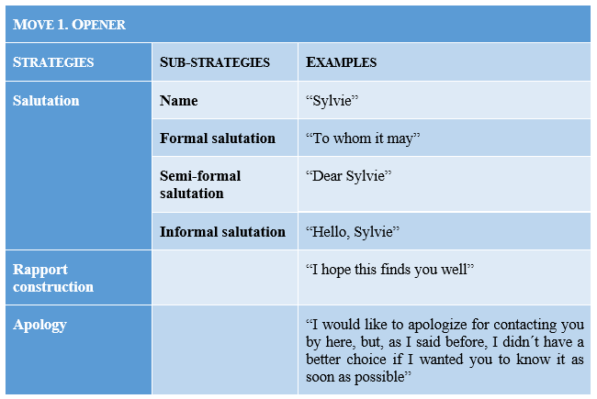
Salutation
Opening the email with a salutation formula is the most frequent strategy (98%), with only two cases where the students -both female- fail to use any kind of salutation (2%). This might be explained as an error on the learner’s part, who chooses to focus on the main ‘body’ of the email rather than include a salutation proper, as in example (1):

- First of all, I would like you to know that this is not the best way to discuss the problem that I have to talk you about, but I decided to do it this way so you clearly see why I am suggesting the following. [100221F]

Salutations can be formal, semi-formal or informal. Formal salutations, however, are underused, with 3.5% of the cases by female students and 6% among male ones, as illustrated by example (2):

- To Sylvie´s concern: [100231F]

The preferred option in both groups is the semi-formal salutation (“Dear Sylvie”), which is used by 77.2% and 66.7% of the female and male students, respectively. Informal salutations (“Hi Sylvie”) are employed by 16% female students and 25.3% of the male ones. Finally, one female student simply addresses the recipient by name (“Sylvie”), which might be considered inappropriate given its orality. Table 2 sums up these findings:

Table 2. Salutation according to gender
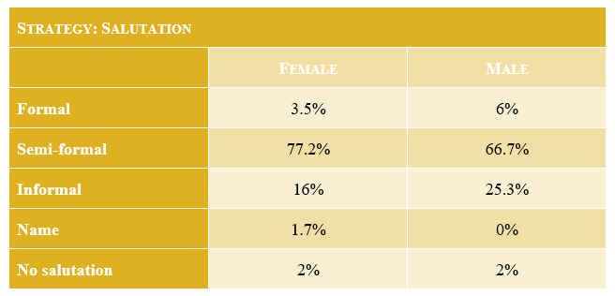

Rapport construction
Regarding rapport construction, male learners use it less frequently than their female counterparts. In fact, female students use rapport formulas either after the salutation (7%) or in four-strategy combinations (salutation, rapport construction, apology and justification), which they employ in 14% of the cases, as illustrated by example (3):

(3) Dear Sylvie,
I hope you find well. [100234F]

Thus, female speakers employ rapport construction in 21% of the cases while male learners utilise this strategy in 12.1% of the occasions; in such cases they also prefer to address the recipient in a more informal way, as in example (4):

(4) Hi Sylvie!
How are you? I haven´t seen you since last week. It´s the reason why I´m writing this email. If I had had the chance to speak with you face to face or even by phone, I´d have done it. So, it was impossibel for me and the only way to contact with you was by email. [100217M]

It can be argued that the use of rapport construction is related to positive politeness and the writer’s need to boost their personal relationship with the recipient, which might explain why male users combine it with informal salutations, to indicate a higher degree of closeness to their colleague. Table 3 summarises these results.
Table 3. Rapport construction according to gender
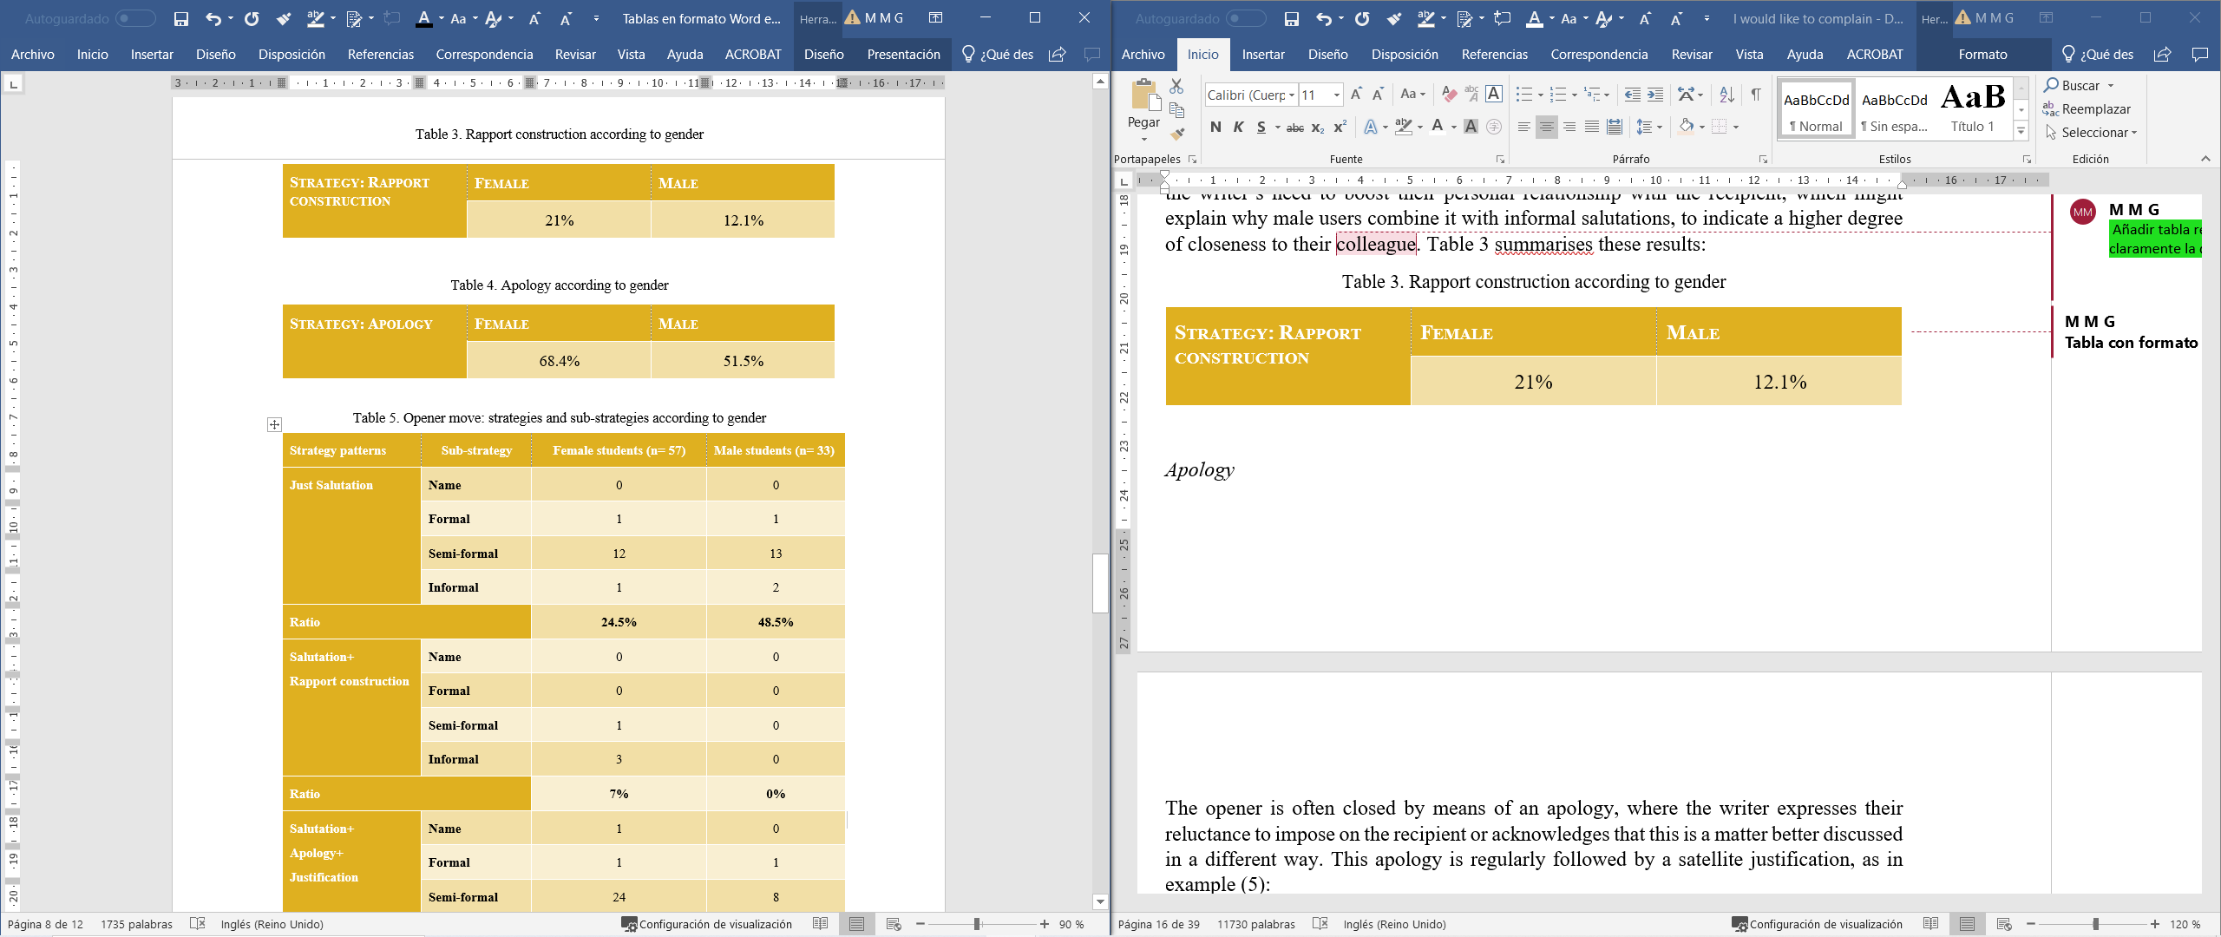

Apology
The opener is often closed by means of an apology, where the writer expresses their reluctance to impose on the recipient or acknowledges that this is a matter better discussed in a different way. This apology is regularly followed by a satellite justification, as in example (5):

(5) Sorry for writing an email, but these days are really busy for us, with your trip to Japan and the extra tasks needed for the Board Meeting, as you already know. Due to the time difference, when I´am availabel here is your night at Tokio! Therefore, as a phone call or a face-to-face discussion were not valid solutions, I´ve decided to write to you because I didn´t want to delay this issue more time. [100234F]

Apologies are used to a higher frequency by female writers (68.4%) than their male counterparts (51.5%). In terms of politeness, apologies try to redress face-threat to the recipient’s negative face, as in Table 4.

Table 4. Apology according to gender
These three strategies often appear in combination, with a preference for two main patterns. On the one hand, the combination salutation + apology + justification, as shown by example (6):

- Dear Sylvie,
First of all I beg your pardon for sending you this mail instead of having a face-to-face or a phone call. It´s just that it makes me feel more confortable sending you a mail and I´ve tought it easy to give you the reasm for writting you. [100256F]

Although this three-strategy combination is also relatively frequent among male students, the ratio descends to 39.4% in contrast to 49% of their female counterparts. Male students’ preferred option is to address their recipient in a single strategy opener consisting of just the salutation, with a clear preference for the semi-formal type (“Dear Sylvie”). As discussed in the following section, male learners seem to favour a more direct approach, where the statement of the predicament is expressed immediately after the salutation, more in line with other native speakers, while female learners appear to resort to more negative politeness strategies by means of the apology and the accompanying justification to address the recipient.
The second most frequent combination is a four-strategy move, where the salutation is followed by rapport construction attending to the recipient’s positive face and an apology together with its justification. Again, female users opt for this pattern with semi-formal and informal salutations (14%) whereas male students always prefer informal salutations before establishing rapport with the recipient (12%), as in examples (7) and (8), respectively:

- Dear Sylvie:
I hope you are well, I am contacting you by mail because I think it is the fastest way to let you know the issue we are having at the office several days ago.
Firstly, I would like to apologize for contacting you by here, but, as I said before, I didn´t have a better choice if I wanted you to know it as soon as possible. [100207F]

- Hi Sylvie!
How are you? I haven´t seen you since last week. It´s the reason why I´m writing this email. If I had had the chance to speak with you face to face or even by phone, I´d have done it. So, it was impossibel for me and the only way to contact with you was by email. [100217M]

Figure 2 summarises the two most frequent combinations of opener strategies, and Table 5 below presents this distribution in relation to gender.

Figure 2. A synthesis of opener strategies

Table 5. Opener move: strategies and substrategies according to gender
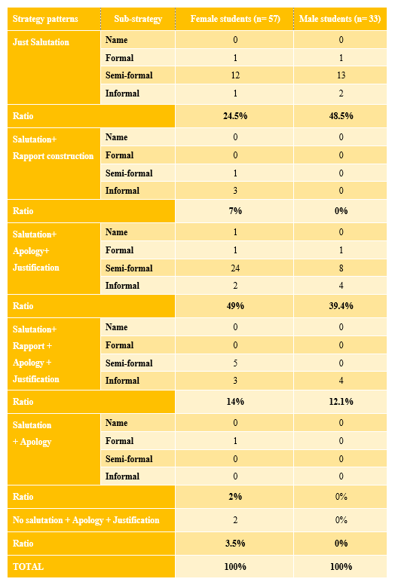

3.2 Move 2: Statement of the predicament

This move is the main body of the complaint and learners are aware of the need to introduce the topic (preparator) but also to perform more facework to mitigate their complaint and stay on good terms with the recipient. In the following paragraphs, the independent strategies are analysed, followed by the most recurrent combinations. Table 6 presents the main strategies and substrategies within the second move, statement of the predicament.

Table 6. Strategies and substrategies in the move Statement of the predicament
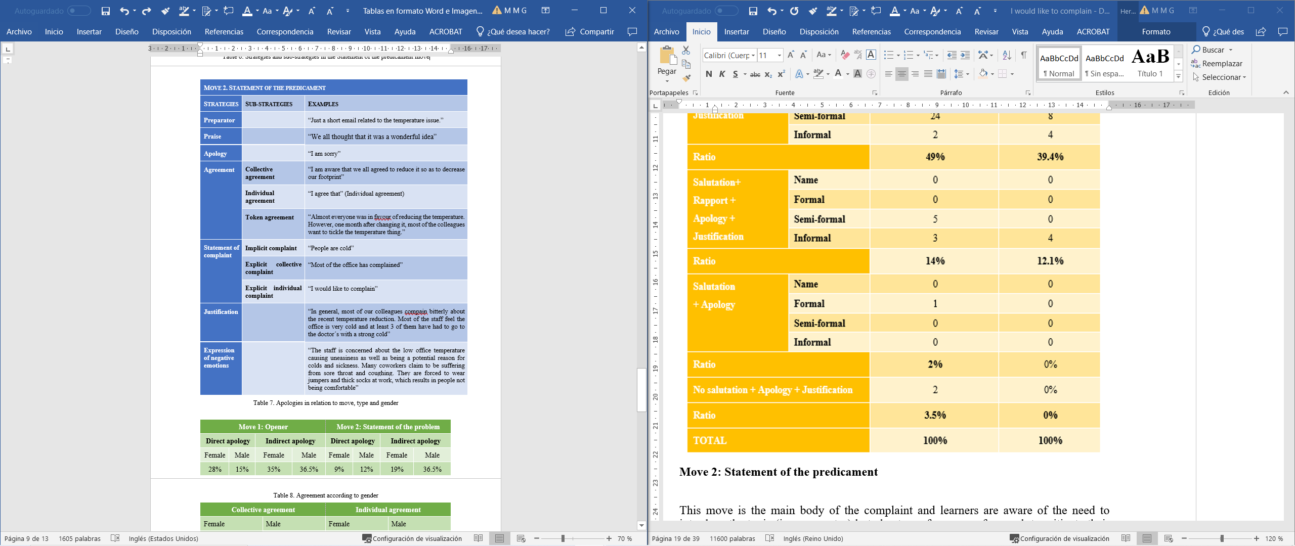

Preparators
Although both groups are aware of the importance to introduce the topic, male learners employ preparators to a higher degree. In fact, 85% of their emails include this strategy in contrast to 75% of their female counterparts. This could be related to males’ preference for more direct complaints, as in examples (9) and (10) by a female and male student, respectively:

(9) Dear Sylvie:
I hope you are well, I am contacting you by mail because I think it is the fastest way to let you know the issue we are having at the office several days ago.
Firstly, I would like to apologize for contacting you by here, but, as I said before, I didn´t have a better choice if I wanted you to know it as soon as possible.
Secondly, the main reason for writing you is that a large number of the office stuff are compaining to me, they think the temperature (20 ºC) is very cold. [100207F]

(10) Dear Sylvie,
you probably remember that we had a meeting a month ago where you proposed to reduce the office temperature. Since then, many people in the office have been complaining to me that the temperature is too low. [100280M]

Praise
Praise is directly related to positive politeness since it implies the positive evaluation of the recipient, which redresses the threat posed by the complaint. As a substrategy, praise does not seem to have a fixed position in the second move. In fact, it can be found after the preparator but also after the complaint itself. Praise is used at a ratio of 7.4% and 7.2% by female and male participants, respectively, as illustrated by (11) and (12):

(11) your arguements for reducing the spending in heating were reasonable. [100247F]

(12) First of all, I would like to tell you that I am very happy with your work. It is obvios you are a responsible and hardworking person. [100283M]

Apology
As in move 1, apologies are also frequent in the second move, plus justification, as illustrated in (13):

(13) My apologies for communicating this over mail to you instead of through a quick call, but as the complains we have received are in writting, I thought it would be more apropriate to formalize this communication, too. [100216F]

Unsurprisingly, students that opt for an apology in the first move do not include an apology in the second move and vice versa. The total number of apologies in both moves is n=83, with a predominance of indirect apologies versus direct ones in both moves and by both genders (66% versus 34%). Direct apologies include the use of a formulaic expression like “I am sorry” or performative verbs (“I apologise”). Indirect apologies are based on implicature; in other words, the writer does not employ the performative or formulaic expression but admits this is not the most suitable behaviour as in “I know that an email is not the proper [sic] way to communicate this issue, but I am having a very busy week”, and provides a justification for acting this way. Table 7 summarises the ratios of apologies according to gender.
Table 7. Apologies in relation to move, type and gender

As can be seen in Table 7, female students show a clear preference to apologise in the opener, with a slight increase in the use of indirect apologies (35%) over direct ones (28%). Male students, however, do not show that preference and may apologise equally in both moves. Their apologies, also preferably indirect, can be therefore ‘delayed’ to the second move, often following the preparator, while their female counterparts prefer to apologise from the very opening of the email, often just after the salutation (see Figure 3). Examples (14) and (15) illustrate how female students introduce their apology in contrast to male learners:
(14) Dear Sylvie,
Firstly, I want to apology because I am aware of the fact that this is not the best manner to inform you. I know that it could be better to have a meeting face to face or phone you directly to discuss it but I think it could be the best decision in this moment. [100222F]

(15) Dear Sylvie,
I am writting this email to tell you about one of the main concerns of the staff: the office temperature.
First, I want to apologize because I know this is not the best way to communicate but as you know I have had to make a work journey to Uganda, and mobile communications in this country are very bad. [100290M]

Agreement
Agreement can be considered a mitigating device given that it shows a common ground with the recipient, which also explains why both genders opt for the use of the plural pronoun “we” in what could be named as ‘collective agreement’. Thus, almost 70% of the female learners and 61% of their male counterparts choose to formulate their complaint against the backdrop of collective/staff agreement versus individual/complainer one, which is favoured only by 8 female students (n= 57) and 4 male ones (n= 33), as can be seen in Table 8.

Table 8. Agreement according to gender
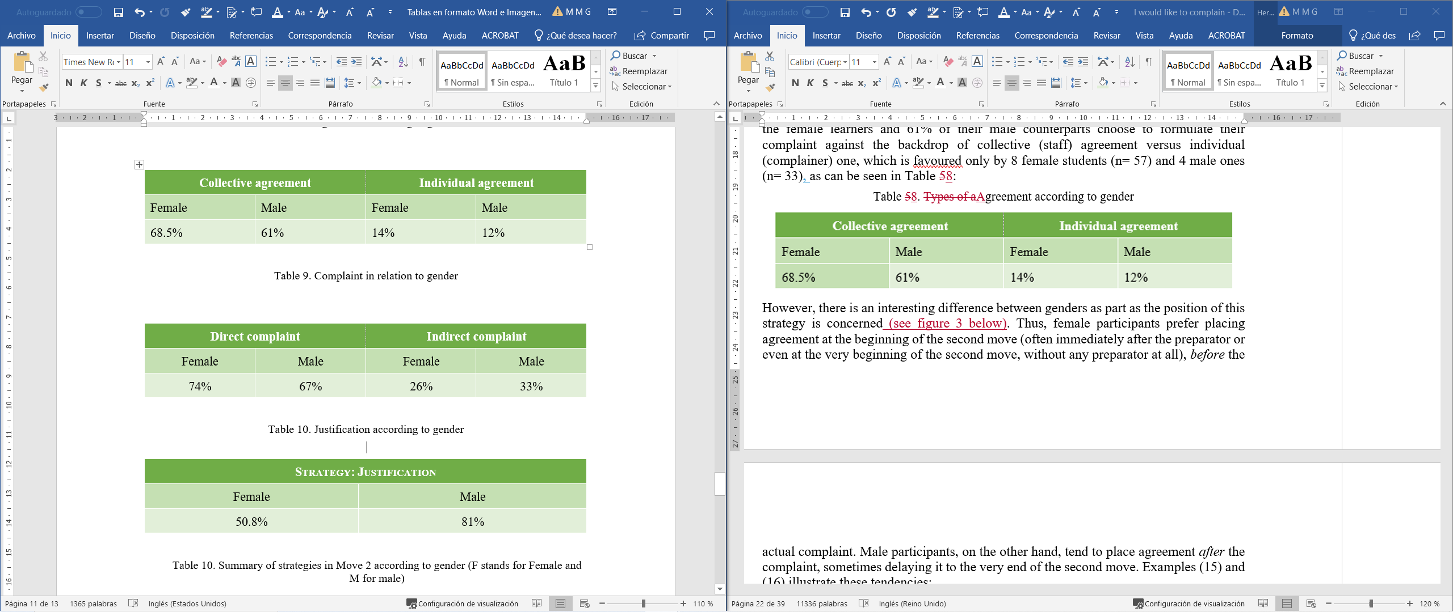
However, there is an interesting difference between genders regarding the position of this strategy (see figure 3 below). Thus, female participants prefer placing agreement at the beginning of the second move -often immediately after the preparator or even at the very beginning of the second move, without any preparator at all-, before the actual complaint. Male participants, on the other hand, tend to place agreement after the complaint, sometimes delaying it to the very end of the second move:

(16) I´m writing this email in relation to the issue of the office temperature.
You surely remember that everyone agreed to your revious request of reducing the temperature from 23ºC to 20ºC so as to lower our carbon footprint. [100284F]

(17) Dear Sylvie,
you probably remember that we had a meeting a month ago where you proposed to reduce the office temperature. Since then, many people in the office have been complaining to me that the temperature is too low. It is true that this issue was discussed largely and everyone at that moment agreed. [100280M]

Figure 3. Preferred agreement strategies according to gender

Statement of complaint
The issue at hand or predicament can be stated directly with the performative verb “complain” or indirectly, as illustrated by (18), where the writer refers to “the temperature thing”:

(18) First and foremost, I would like to remind you that the vast majority of the staff is truly concerned about the office´s carbon footprint. In fact, almost everyone was in favour of reducing the temperature. However, one month after changing it, most of the colleagues want to tickle the temperature thing. [100203F]

It is also important to point out that, as agreements, complaints can be collective (on behalf of all the work colleagues) or individual (where it is the writer that complaints about the situation). In this case, both groups opt for collective complaints, where they are mere representatives of their workmates, rather as complainants, as shown in example (19):

(19) During this last month I have received many concerns about the ofice temperature from the majority of the staff. They are complaining about the low temperature inside the company installations. [100242]

Table 9. Complaint in relation to gender

Female students prefer direct or explicit complaints to indirect ones. Male students, on the other hand, also show a preference for direct complaints but their use of indirect ones is slightly higher (33% versus 26%) (see Table 9). There is, however, a plausible explanation for this, as female students ‘delay’ the statement of the complaint until practically the end of the second move, while male students are more prone to place it at the very beginning of the move, sometimes immediately after the preparator. Furthermore, the fact that they are not complaining themselves but merely speaking on behalf of others may explain why explicit complaints are mostly preferred.

Justification
Complaints are face-threatening acts that can be mitigated when there is a justification for uttering the complaint. This explains why giving reasons or justifying the complaint often occurs as a strategy adjunct to the statement of the predicament, as in example (20):

(20) The situation in the ofifice have reached a point that some employees work wering their jackets all day, which reduces their mobility, consecuently reducing their productivity therefore. [100246M]

There is a noteworthy difference, however, between male and female students. While female speakers opt to employ this strategy in 29 out of the 57 emails (reaching 51%), their male counterparts use it in 27 out of their 33 writings (81%), as shown in Table 10.

Table 10. Justification according to gender

The reason for this might be connected to the use of the final substrategy (“expression of negative emotions”), which may be argued to overlap with providing reasons for the complaint but from a more emotional perspective, as the writers focus on negative feelings of dissatisfaction, discomfort, and unhappiness, as in example (21), which is phrased by the writer as the ‘reason’ for writing even though it includes emotion-loaded words such as “unhappy”, “drastic” or “warm feeling”.

(21) The reason I´m writing is because most of the workers of the company are a bit unhappy with the temperature change of the office. I know everyone agreed at the meeting but I think nobody espected sush a drastic variation of the "warm feeling" we had before, keeping in mind that now temperature is just 3 ªC below. [100220F]

Expression of negative emotions
As mentioned above, there seems to be an inverted proportional use of this strategy and “giving reasons for the complaint”, with female writers using it in 43 out of 57 emails (75.4%) as opposed to male students, who employ it in 15 out of 33 cases (45.5%). While male students seem to prefer giving more ‘objective’ reasons for their complaint like the lack of productivity in the office, female writers seem to resort to more emotion words, as in examples (22) and (23), where the importance of keeping a ‘good atmosphere’ may have a direct effect on the workers’ productivity:

(22) The company staff are very concern about it. Many workers are sending emails asking for a revision of the company´s temperature agrement because they feel cold at their workplace and a result of this they aren´t comfortable. [100252M]

(23) Apart from the formal complains mentioned above, this situation is also creating a bad atmosphere and unhappy feelings at the office, which may eventually affect job performance. [100216F]

Table 11 details the different strategies and substrategies employed by female and male students.

Table 11. Summary of strategies in Move 2 according to gender

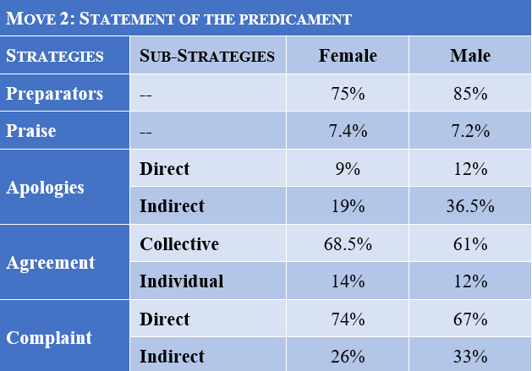

3.3 Move 3: Remediation
The third move in a conventional complaint focuses on remediating the predicament and involves different strategies that may appear in isolation or combined (see Table 12).
Table 12. Strategies and substrategies within the remediation move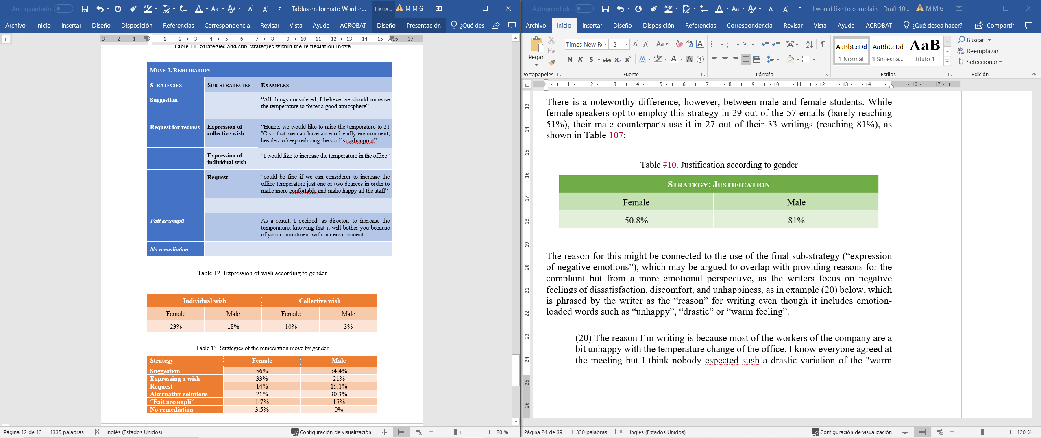
Suggestion
Suggestions to redress the situation are used in 56% of the cases by female students and 54.4% by their male counterparts, being the most common strategy in both genders. This might be explained by the fact that suggestions mitigate face-threat to the recipient’s negative face and hence, are regarded as more polite. Examples (24) and (25) illustrate this strategy:

(24) So I was thinking that one solution that satifires everybody could be to increase the temperature from 20º to 21´5, maybe this small change will be enough for everybody and, at the same time, we also contribute to reduce the company footprint. [100260F]

(25) Maybe we can increase the temperature in two degrees, or thing other better ways to save money. [100211M]

Quite frequently, suggestions tend to be followed by offers to seek alternative solutions, which helps to mitigate the recipient’s face-threat:

(26) As far as I am concerned, I recommend to come back to the initial temperature because it would be possible to find other solutions to fight climate change, for instance, using recicled office material. [100265F]

Request for redress
Within the strategy of requesting for redress, the substrategy of expressing the wish to remediate the situation is the second most commonly used, employed in 33% of the emails written by the female students and 21% of the male ones. It is interesting to distinguish, however, between expressing the wish as an individual or collective desire, as shown by (27) and (28), respectively:

(27) That’s why I would like to increase the temperature. [100295M]

(28) Hence, we would like to raise the temperature to 21 ºC so that we can have an ecofriendly environment, besides to keep reducing the staff´s carbonprint. [100203F]

Individual desires are preferred by both genders to collective desires, as summed up by Table 13.
Table 13. Expression of wish according to gender
Female speakers have a slightly higher preference for starting their remediation with a wish in contrast to male speakers (23% versus 18%).
Using a request is relatively low in frequency, with 14% and 15.1% being used by female and male students, respectively. Illustrated by example (29) below, requesting for a remediation may be seem too face-threatening by the students, who prefer more mitigating strategies (see above):

(29) These points lead me to ask you to increase the temperature in the office. We cannot afford to have the stagg so uneasy for only three degrees. [100247F]

It is interesting to notice that students avoid using the interrogative form in their requests (there are zero tokens of such use), opting for conventionally indirect questions (as in example 28 above) or by reporting a collective request, as in (30):

(30) In short people in our office are asking me for a solution to work properly, in a good atmosphere and environment. [100273F]

Fait accompli
Interestingly, another strategy emerged in the sample, “fait accompli”, as the remediation is not proposed but stated as a fact that has already been undertaken or is to be carried out regardless of the recipient’s decision, as can be seen in examples (31) and (32) by a female and male student:

(31) Please, you must take on board that the management team has already decided to get back to the previous average temperature, as the whole staff see eye to eye to this issue. [100284F]

(32) As a result, I decided, as director, to increase the temperature, knowing that it will bother you because of your commitment with our environment. [100278M]

This strategy is, however, more common among male students, who use it in 15% of their emails as opposed to 1.7% of the female students. Furthermore, their emails reflect that they often may even adopt this role for themselves, as in (32) above or (33):

(33) As the head, I am writing to you giving the last news: the Office cannot reduce the temperature, so that, the temperature will continue being in the 23 ªC. [100225M]

No remediation
Finally, two of the emails written by the female cohort lacked the third move. One of writings has not been finished, which might explain why there is neither third nor four move proper. The other case is deviant but more interesting and the writer seems to resort to implicature to mitigate face-threat to the recipient’s negative face, as shown in example (34), where after exposing the reasons why the staff are complaining, she simply writes this as a third move:

(34) Anyway, I hope you receive this email as a constructive opinion. [100266F]

Table 14 sums up the strategies employed by female and male students in the third move.

Table 14. Strategies of the remediation move by gender

3.4 Move 4: Closing
The final move in a complaint email or letter is the closing, which may be performed by one or a combination of the following strategies, as shown in Table 15.

Table 15. Strategies and substrategies in the Closing move
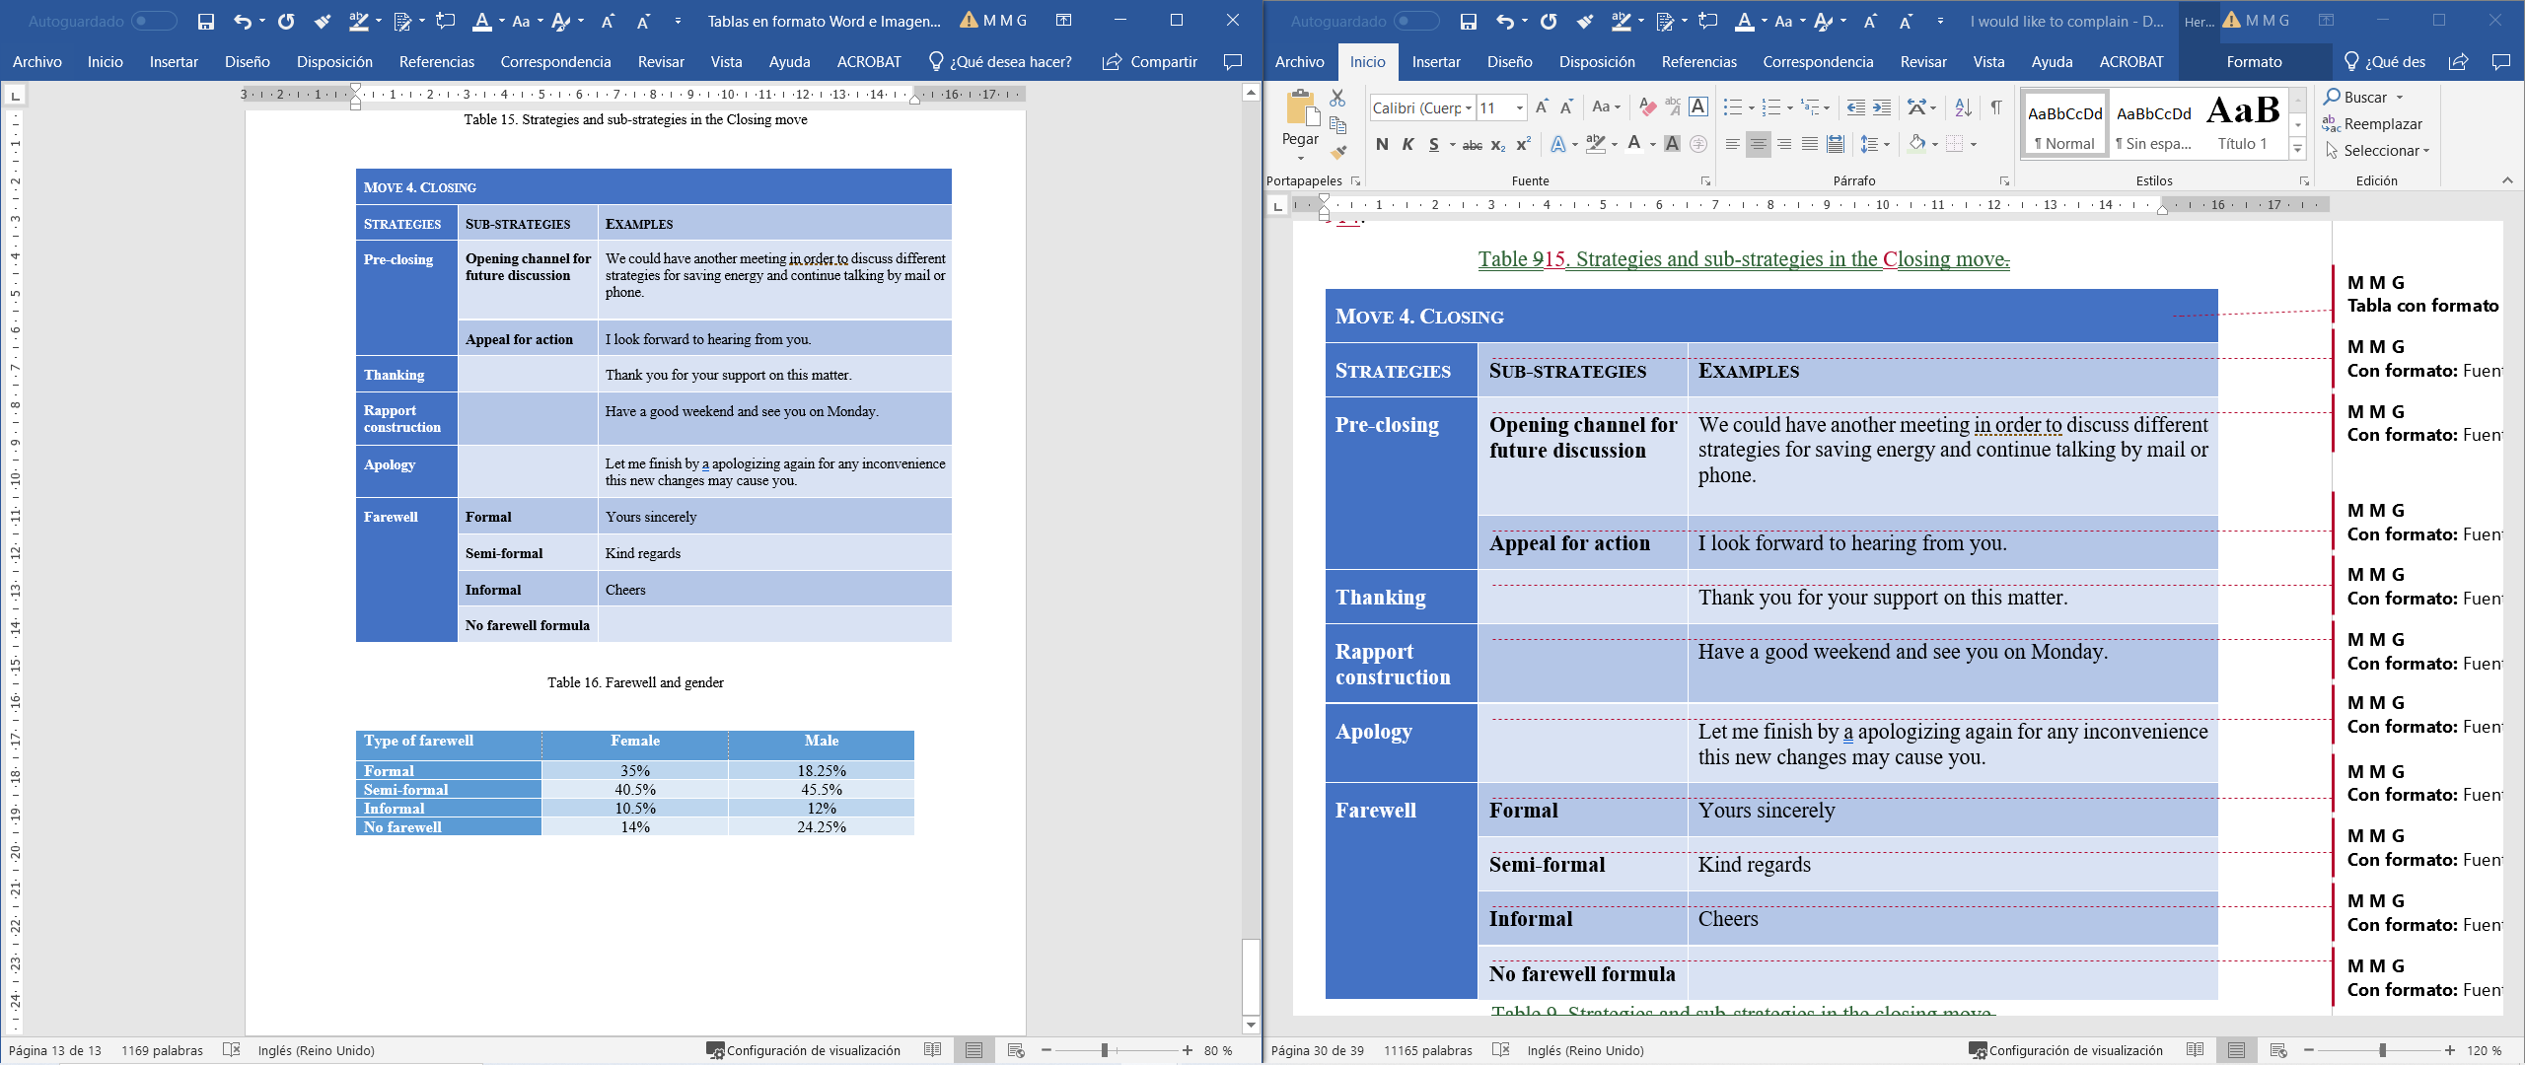

Pre-closing
Within the pre-closing, both genders seem to favour opening the channel for future communications, with 89.5% of the emails written by the female cohort including this strategy and 75.7% of the male ones. This substrategy is frequently found in combination with appeal for action, which is employed in 68.4% of the emails written by female students and 72.7% of their male counterparts:

(35) Finally, I would like to invite you to think about it and to let me know your opinion and continue talking by mail or phone. I hope to hear from you soon. [100207F]

(36) Please, let me know if you prefer to discuss further considerations with one, and, of course, if you prefer to have a meeting with me, instead a phone all or an email reply. [100268M]

Thanking
The writer shows appreciation to the recipient, for example for their time taken in reading the email or for their collaboration in advance. Thanking, however, is not so frequently used as the previous strategy, with 17.5% and 15% of the female and male students employing it. Example (37) shows a prototypical thanking strategy:
(37) Thanks for your time and attention to this mattern. [100239F]

Rapport
Establishing rapport with the recipient is a positive politeness strategy that might redress the effect of the complaint and finish the email on a positive note. Rapport is also used sparsely by both female and male students, in 19.3% and 21.2% of their writings. Examples (38) and (39) illustrate how students put an end to their email by appealing to their recipient’s positive face before performing a farewell:

(38) I really appreciate the time you took to read this email and I´m sure we will find the way to talk and find a solution. Let me know when! Thanks you very much. Have a good day!
Yours sincerely, [100240F]

(39) If by any chance you are able to get your hands on a phone. Feel free to five me a call to discuss it. If not, we will get on it once you come back next Friday. Have a nice trip back! [100211M]

Apology
This strategy is used in most of the moves in the complaint (see above). This might explain its scarcity in the closing move, where it is employed by 7% of the female students and 6% of the male ones. Example (40) illustrates apologies in the closing move:

(40) Sorry by the inconveniences [100222F]

Farewell
As in the case of salutations, most students choose to end their email with a farewell formula, which can be formal (“yours sincerely”), semi-formal (“kind regards”) or informal (“bye”). However, 10.5% and 21.2% of the female and male students choose to end their email without any farewell, which might be regarded as lack of pragmatic competence despite students’ relatively high level of linguistic proficiency (C1), as (41), where the student mistakes an appeal for action (transferred from their L1) for a farewell:
(41) I would like to know your point of view, either by email, phone or by arrenging another meeting.
Waiting for your answer,
Luke. [100231F]

Table 16. Farewell and gender

As shown in Table 16, two important differences emerge regarding gender. Female students prefer to close their email in a more formal tone, which is in line with the preference also for more formal salutations whereas male students have a slightly higher tendency to end their emails abruptly without any farewell formula or using an appeal for action to close their writing, as in (42):

(42) Please, as soon as you can, write or phone me to agree a meeting, next week if possible as I already said, for a thorough consideration of this matter of room temperature. [100272M]

4. Discussion
Despite some isolated deviations, results show that Spanish students seem to follow the customary four-move structure of opener, statement of the predicament, remediation and closing. However, a closer look at the strategies and substrategies within each move show clear transfer of pragmatic patterns of their L1. Thus, the opening move shows a higher deployment of strategies and substrategies than those employed by native speakers of English who, after a salutation, often go straight to the second move (statement of the predicament). The students in the sample, however, write over-elaborated first moves where they try to prepare the recipient for the upcoming face-threatening complaint. This is done by including apologies and their corresponding justifications and, interestingly, by means of rapport construction. Students seem to combine mitigating imposition to the recipient) with positive politeness strategies (i.e. building rapport with the recipient). The inclusion of rapport as a strategy is outstanding, as it shows a transfer of positive politeness strategies from Spanish, culturally prone to positive-politeness orientation (Lorenzo-Dus and Bou-Franch 2003; Pinto 2010). Furthermore, the expression of rapport is specially favoured by female students (21%) rather than their male counterparts (12%). Female students also tend to apologise more frequently (49% versus 39.4%).
This female recurrence to politeness strategies is in line with previous research conducted among EFL learners of different native languages. For example, Kakolaki and Shahrokhi (2016) found out that Iranian men employ direct complaints and fewer mitigation devices, hence being more aggressive, while women opt more frequent mitigation devices. This relates to the differences in the use of salutation formulas. Given the context of the complaint, where the relationship between the writer and the recipient is that of employee-boss, it is significant that male students often start their email with an informal salutation (25.3%) as opposed to their female counterparts (16%), who prefer either semi-formal or formal salutations when addressing their interlocutor. This is an interesting distinction, as male students seem to favour a closer relation to their employee, hence appealing to a more egalitarian relationship rather than an asymmetrical one.
The second move shows a similar pattern, with female students implementing less native-like, more politeness-oriented strategies than their male counterparts, who introduce the complaint immediately after the preparator. Thus, male learners follow a pattern closer to that of native speakers of English, with the presence of a preparator introducing the direct complaint (85% vs. 75%). However, despite seemingly following a more native-like pattern in the formulation of complaints in English, Spanish male students also include strategies that are related to positive politeness, such as collective agreement and the use of the inclusive pronoun “we”, to appeal to group unity and rapport. Still, female students show a slightly higher preference for this strategy, with more than 70% of the occurrences.
Within the second move, two frequent strategies deployed by both cohorts is the use of justifications for making the complaint and the expression of negative emotions such as unhappiness with the current situation. Both strategies add to the mitigation of the face-threating act. There is a noteworthy difference, however, between male and female students, with male students preferring justification (81% vs. 51%), while female learners tend to justify their complaint by expressing negative feelings of dissatisfaction, discomfort, and unhappiness (75.4% vs. 45.5%). Thus, male students seem to prefer giving more ‘objective’ reasons for their complaint such as the lack of productivity whereas female writers seem to favour more emotion words, following and perpetuating gender stereotypes (Kotek et al., 2021).
The third move (“remediation”) does not seem to follow native-like models as both genders prefer suggesting rather than uttering direct requests for repair. In fact, the interrogative form is not even employed by any of the writers. However, the use of other strategies arguably shows a marked difference between male and female students. In line with expressing their emotions, female students also resort to implicitly requesting repair by expressing a wish for the situation to change. This strategy, which is employed by 23% of the female students versus 18% of the male cohort shows both coherence with women’s higher use of expressive speech acts but simultaneously inconsistency with their preference for collective appeals to the group. In other words, both groups express their wish for the situation to be repaired as an individual rather than as a collective desire. Another remarkable difference is the fact that male students seem more pro-active than their female counterparts, with a higher tendency to provide alternative solutions to the predicament (30.3% vs. 21%). Finally, a new strategy has emerged from the data, and which can be defined as “fait accompli”. By using this strategy, the writer does not request for remediation but presents remediation as a fact that has already been carried out. Although this strategy might be the result of the specific context at hand, it is nonetheless worth pointing out that it is clearly implemented by male students (15% vs. 1.7%). This could be explained by the fact that male students choose to assert their authority irrespectively of the instructions of the task, which explicitly states that they are writing to their superior.
Finally, the closing move also shows certain discrepancies with the native-like model. Both cohorts tend to overdo politeness by displaying a combination of strategies. Thus, they often pre-close their email by appealing to future action and opening the channel for future communication with the recipient, they both thank and build up rapport with the recipient, all of them transfers from the positive politeness strategies of Spanish culture. Furthermore, they tend to include a new apology for the imposition. In fact, 64% of the male students present a three-strategy closing move (appeal for action + open future channel + farewell) in contrast to 37% of the female counterparts. This is explained by the fact that female students employ even more elaborated closing moves, with up to four (19%) five (3.6%) and six (1.7%) strategies, hence ‘overdoing’ politeness by striving to rebuild rapport and mitigate the impact of the face-threat as much as possible. There is another interesting distinction, as female students tend to close their email on a more formal tone (35% vs 18.25), which might reveal a more respectful acknowledgement of the power distance between writers/employees and the recipient/boss. In contrast, male students have a slightly higher tendency to end their emails informally (12% vs 10.5%) or, more remarkably, in a direct and abrupt way without any farewell formula or using a direct appeal for action (24.5% vs. 14%). There might be two reasons for this. On the one hand, they might be less willing than their female counterparts to acknowledge the asymmetry of the situation in terms of power, as they also revealed by using the “fait accompli” strategy. Dealing with the recipient on a more egalitarian basis might be disclosing less compliance with a more submissive attitude, once again reinforcing gender stereotypes. On the other, both cohorts of students might be linguistically competent at a C1 level but pragmatically deficient, as they might be mistaking the appeal for action formula (“I look forward to hearing from you”) with farewell.
To finish, this study leads to the reformulation or the possibility of fine-tuning substrategies in previously confirmed strategies of complaints (see boxes in orange in figure 4 below) such as name, formal, semi-formal or informal substrategies for salutation; open channel as a substrategy of preclosing; and formal, semi-formal, informal or no farewell within the strategy of farewell. Furthermore, a close analysis of data reveals that Spanish EFL learners of English calibrate their e-mails of complaints by exhibiting strategies that are not present in the literature and which may either indicate pragmatic transfer from Spanish sociocultural patterns (i.e. rapport construction or collective wishes), may stem from gender differences (males speakers’ use of fait accompli) or a combination both (for example, female speakers’ preferences for rapport construction).

Figure 4. A synthesis of moves, strategies and substrategies of emails of complaint produced by Spanish EFL learners
- Conclusions
This paper has analysed the emails of complaint of 90 L2 Spanish students, all of them with a certified C1 level to respond to three research questions. To the first question, the moves, strategies and substrategies deployed by students in their written production, results show that students often transfer substrategies from their L1 such as rapport construction and tend to delay the statement of the complaint in favour of lengthy openers, in contrast to native speakers. In response to question 2, the degree to which they follow native-like patterns, students seem to follow the customary four moves (opening, statement, repair and closing) although there is general preference for the over-use of substrategies within each of the moves produced. Results also reveal that this preference for over-mitigation and over-politeness is especially favoured by female students, which answers the third question, the extent to which the variable of gender influences how emails of complaint are formulated.
This study is not without limitations. The sample is arguably reduced as it is limited to 90 students and the number of female and male students is not balanced (57 versus 33), which does not seem to allow for the generalisation of the results. Admittedly, gender has been simplified into female and male. This is derived from the initial collection of the general FineDesc corpus, which is now being refined to include other gender variables. Furthermore, the emergence of new substrategies like fait accompli can be derived from the specific context of the task, rather than reflect actual substrategies common in all emails of complaint. However, the detailed analysis of the dataset seems to lead to a better understanding of how L2 students with high linguistic competence still make pragmatic mistakes and transfer pragmatic norms from their L1 when tackling face-threatening acts and might benefit from explicit instruction.

References
Al-Momani, Kawakib Rabwan. 2014. Strategies of persuasion in letters of complaint in academic context: The case of Jordanian university students’ complaints. Discourse Studies 16 (6). 705–728. https://doi.org/10.1177/1461445614546257
Amundrud, Thomas. 2012. Face-threatening acts (FTAs) in advanced non-native English speaker (NNES) emails: A study of interlanguage pragmatics. Bulletin of Nara University of Education 61(1). 183–190.
Boxer, Diana. 1993. Social distance and speech behavior: The case of indirect complaints. Journal of Pragmatics 19(2). 103–125.
Chen, Yuan-Shan, Chun-Yin Doris Chen & Miao-Hsia Chang. 2011. American and Chinese complaints: Strategy use from a cross-cultural perspective. Intercultural Pragmatics 8(2). 253–275. https://doi.org/10.1515/iprg.2011.012
Connor, Ulla, Kenneth W. Davis & Teun de Rycker. 1995. Correctness and clarity in applying for overseas jobs: A cross-cultural analysis of US and Flemish applications. Text 15(4). 457–475.
Council of Europe. Council for Cultural Co-operation. Education Committee. Modern Languages Division. 2001. Common European framework of reference for languages: Learning, teaching, assessment. Cambridge: Cambridge University Press.
Council of Europe. Council for Cultural Co-operation. Education Committee. Modern Languages Division. 2018/2021. Common European framework of reference for languages: Companion volume with new descriptors. Cambridge: Cambridge University Press.
Da Silva, A. M. 2014. Analyzing complaints by Indonesian EFL speakers. Celt. A Journal of Culture, English Language Teaching & Literature 1. 63–81.
DeCapua, A. 1988. Complaints: A comparison between German and English. Paper presented at the 1988 TESOL Convention, Chicago, IL, March 11.
Eshraghi, Atefeh & Mohsen Shahrokhi. 2016. The realization of complaint strategies among Iranian female EFL learners and female native English speakers: A politeness perspective. International Journal of English Linguistics 6(2). 9–20. http://dx.doi.org/10.5539/ijel.v6n2p9
Ezzaoua, Omar. 2020. The interlanguage of Moroccan EFL learners: The case of complaints. Studies in Literature and Language 20. 6–11. http://dx.doi.org/10.3968/11483
Halenko, Nicola, Milica Savić & Maria Economidou-Kogetsidis. 2021. Second language email pragmatics. Introduction. In Maria Economidou-Kogetsidis, ‎Milica Savić and ‎Nicola Halenko (eds.), Email pragmatics and second language learners, 1–12. Amsterdam: John Benjamins. https://doi.org/10.1075/pbns.328.int
Hartford, Beverly, and Ahmar Mahboob. 2004. Models of discourse in letter of complaint. World Englishes 23(4). 585–600. https://doi.org/10.1111/j.0083-2919.2004.00378.x
Hasyim, Kaharuddin & Muhammad Hasyim. 2020. The speech act of complaint: Socio-cultural competence used by native speakers of English and Indonesian. International Journal of Psychosocial Rehabilitation 24(6). 14016–14028.
Kotek, Hadas, Dockum, Rikker, Babinski, Sarah & Christopher Geissler. 2021. Gender bias and stereotypes in linguistic example sentences 97(4). 653-677.
Laabidi, Abdelfattah & Adiba Bousfiha. 2020. Speech act of complaining: Socio-pragmatic study of complaint by Moroccan EFL learners. International Journal of Language and Literary Studies 2(2). 148–155.
Laforest, Marty. 2002. Scenes of family life: Complaining in everyday conversation. Journal of Pragmatics 34. 1595–1620.
Li, Rui & Raja Rozina Raja Suleiman. 2017. Language proficiency and the speech act of complaint of Chinese EFL learners. The Southeast Asian Journal for Language Studies 23(1). 60–74. http://doi.org/10.17576/3L-2017-2301-05
Lorenzo-Dus, Nuria & Patricia Bou-Franch. 2003. Gender and politeness: Spanish and British undergraduates’ perceptions of appropriate requests. Género, lenguaje y traducción. 187-199.
Kakolaki, Leila Nasiri & Mohsen Shahrokhi. 2016. Gender differences in complaint strategies among Iranian upper intermediate EFL students. Studies in English Language Teaching 4(1). 1–15.
Masjedi, Narges & Shamala Paramasivam. 2018. Complaint and politeness strategies used by Iranian speakers of English. International Journal of Applied Linguistics & English Literature 7(4). 38–49.
Moon, Kyunghye. 2001. Speech act study: Differences between native and nonnative speaker complaint strategies. Retrieved from http://www.american. edu/tesol/Kyunghye_Moon.pdf (accessed January 2022).
Nikoobin, Atefeh & Mohsen Shahrokhi. 2017. Impoliteness in the realization of complaint speech acts: A comparative study of Iranian EFL learners and native English speakers. International Journal of English Linguistics 7(2). 32–51. http://dx.doi.org/10.5539/ijel.v7n2p32
Nguyen, Thi Thuy Minh & Thi Thanh Thuy Pham. 2021. L2 emails of complaints. Strategy use by low and high proficiency learners of English as a foreign language. In Maria Economidou-Kogetsidis, ‎Milica Savić and ‎Nicola Halenko (eds.), Email pragmatics and second language learners, 41–70. Amsterdam: John Benjamins. https://doi.org/10.1075/pbns.328.02ngu
Olshtain, Elite & Liora Weinbach. 1987. Complaints: A study of speech acts behavior among native and non-native speakers of Hebrew. In Jef Verschueren and Marcella Bertucelli-Papi (eds.), The pragmatic perspective, 195–208. Amsterdam: John Benjamins.
Önalan, Okan & Abdulvahit Çakir. 2018. A comparative study on speech acts: Formal complaints by native speakers and Turkish learners of English. Eurasian Journal of Applied Linguistics 4(2). 239–259. https://doi.org/10.32601/ejal.464128
Park, Jihyon. 2001. Korean EFL Learners ' Politeness Strategies in Their Complaints. The Linguistic Association of Korea Journal 9(1). 185–209.
Pinto, Derrin. 2010. Lost in subtitle translations: The case of advice in the English subtitles of Spanish films. Berlin: de Gruyter.
Prykarpatska, Iryna. 2008. Why are you late? Cross-cultural pragmatic study of complaints in American English and Ukrainian. Revista Alicantina de Estudios Ingleses 21. 87–102.
Schauer, Gila A. 2021. Email communication in English and in German. A contrastive pragmatic investigation of German university students’ emails sent to university staff in their native and foreign language. In Maria Economidou-Kogetsidis, ‎Milica Savić and ‎Nicola Halenko (eds.), Email pragmatics and second language learners, 179–201. Amsterdam: John Benjamins. https://doi.org/10.1075/pbns.328.07sch
Trabrizi, Hossein Heidari & Abbas Jalilnejad Masooleh. 2015. Hey I want to complain: Cross-cultural comparison of complaints in Persian and American English. Elixir International Journal 81. 31899–31905.
Taguchi, Naoko & Carsten Roever. 2017. Second language pragmatics. Oxford: Oxford University Press.
Thongtong, Tiwahporn & Jiranthara Srioutai. 2019. Gender and questions as complaints: An interlanguage pragmatic study. LEARN Journal: Language Education and Acquisition Research Network Journal 12(2). 122–140.
Trench, Mireia. 1995. Pragmatic strategies in Catalan and English complaints: A comparative study of native and EFL speakers. Language Quarterly 33(3–4). 160–182.
Trosborg, Anna. 1994. Interlanguage pragmatics: Requests, complaints, and apologies. Berlin: Mouton de Gruyter.
Usó-Juan, Esther & Alicia Martínez-Flor. 2017. Proficiency effect on EFL learners’ realization of complaints. In Chelo Vargas-Sierra (ed.), Professional and academic discourse: An interdisciplinary perspective, 75–81. Retrieved from https://easychair.org/publications/volume/AESLA_2016
Wijayanto, Agus, Aryati Prasetyarini & Mauly Halwat Hikmat. 2017. Impoliteness in EFL: Foreign language learners’ complaining behaviors across social distance and status levels. Sage Open 7(3). 1–15. https://doi.org/10.1177/2158244017732816
Young Mi, W. Tracy Dillon & Kenneth L. Mitchell. 1998. Korean business letters: Strategies for effective complaints in cross-cultural communication. The Journal of Business Communication 35(3). 328–345. https://doi.org/10.1177/002194369803500302
Yuan, Zhou-min & Runhan Zhang. 2018. Investigating longitudinal pragmatic development of complaints made by Chinese EFL learners. Applied Linguistics Review 9(1). 63–87. https://doi.org/10.1515/applirev-2016-1017
Zamborlin, Chiara. 2007. Going beyond pragmatic failures: Dissonance in intercultural communication. Intercultural Pragmatics 4(1). 21–50. https://doi.org/10.1515/IP.2007.002

All the examples are followed by the number code of the original FineDesc corpus, indicating the anonymised identity of the student and their gender, where F stands for female and M for male.
The total percentage is not 100% as many of these strategies appear in combination with others.

